Assingment 1
Hallticket no:2303A51780

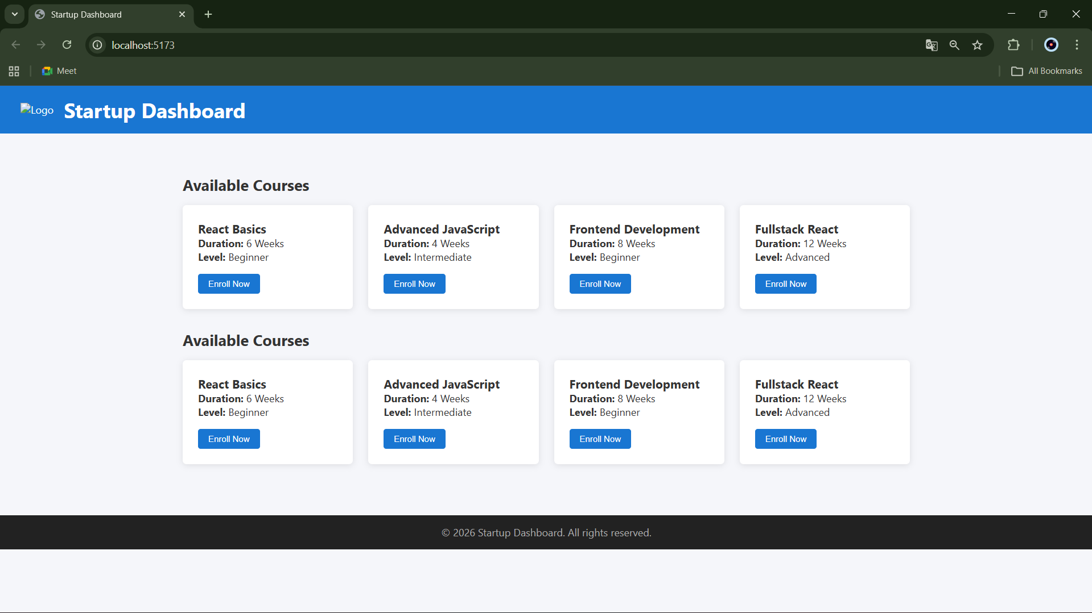

1. How would you set up a new React project using tools like Create
React App or Vite?
Ans: Vite: npm create vite@latest my-app → select React → npm install → npm run dev
2. What is the role of package.json in a React project?
Ans: package.json stores project information, dependencies, and scripts.
It tells npm which libraries to install and how to run/build the React app.
3.How do you create a functional component in React?
Ans: A functional component is a JavaScript function that returns JSX.
Example: function Welcome() {
return <h1>Welcome to the Dashboard</h1>;
}
4. How are components rendered inside the main App component?
Ans: Components are rendered by importing them and using them like HTML tags.
Example: import Welcome from './Welcome';
function App() {
return <Welcome />;
}
5.What are the benefits of breaking the UI into small reusable
components
Ans: They make the UI easier to manage and understand.
Reusable components reduce code duplication and improve maintainability.

