HIGHPERFORMANCECOMPUTING-ASS_12

NAME:R.CHAITRA

HALLTICKETNO:2303A51786

BATCH NO:12
Task 1: CUDA Host-Device Data Transfer & Vector Addition Objective: Learn how to allocate memory on the GPU (Island) andtransferdatafromtheCPU(Mainland)usingGoogleColab. Step1:OpenanewGoogleColabNotebook.GotoRuntime-> Change runtime type and select T4 GPU.
Step2:InstalltheCUDApluginbyrunningthisinthefirstcell:
!pipinstallnvcc4jupyter
%load_extnvcc4jupyter
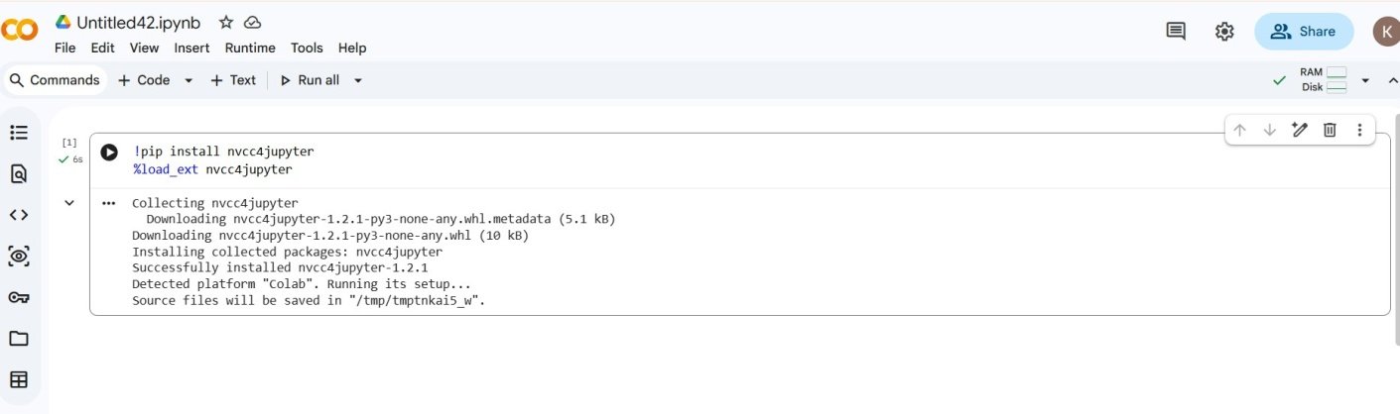
Step3:Createanewcell,type%%cudaatthetop,andpastethe following Vector Addition code:
%%cuda
#include<iostream>

global voidaddVectors(intn,float*d_A, float *d_B, float *d_C) {
intworkerID=blockIdx.x*blockDim.x+ 01-04-2026 EOD
threadIdx.x;
if(workerID<n){

d_C[workerID]=d_A[workerID]+ d_B[workerID];
}
}

int main(void) { intN=1000000;
intsize=N* sizeof(float);
float*h_A=newfloat[N],*h_B=new float[N], *h_C = new float[N];

for(inti=0;i<N;i++){h_A[i]=1.0f; h_B[i] = 2.0f; }

float*d_A,*d_B,*d_C;
cudaMalloc(&d_A,size);cudaMalloc(&d_B, size); cudaMalloc(&d_C, size);

cudaMemcpy(d_A,h_A,size, cudaMemcpyHostToDevice); cudaMemcpy(d_B,h_B,size, cudaMemcpyHostToDevice);

intblockSize= 256;

intnumBlocks=(N+blockSize-1)/ blockSize;
addVectors<<<numBlocks,blockSize>>>(N,d_A, d_B, d_C);

cudaMemcpy(h_C, d_C, size, cudaMemcpyDeviceToHost);std::cout<<"Datashippedback!First Answer: "<< h_C[0] << std::endl;

cudaFree(d_A);cudaFree(d_B);cudaFree(d_C); delete[] h_A; delete[] h_B; delete[] h_C;

return0;
}
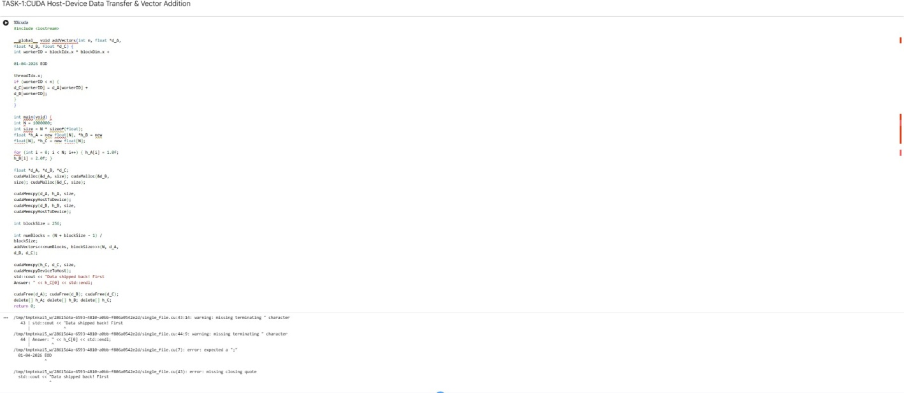
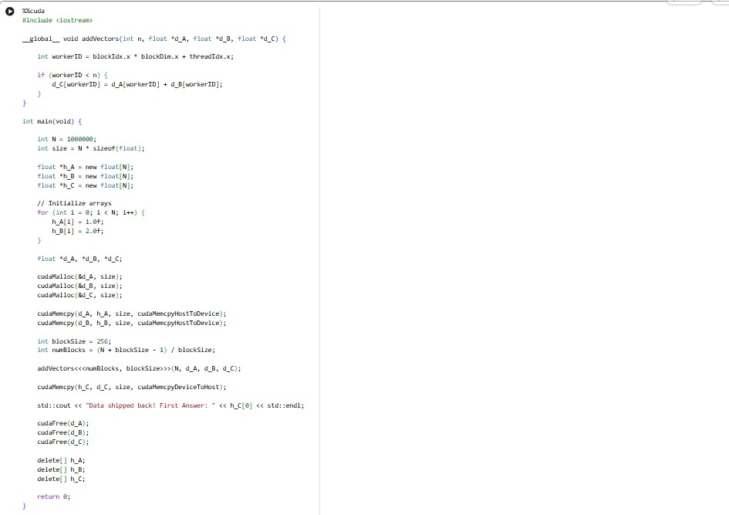

Step4:Runthecellandtakeascreenshotoftheoutput.

Task 2: OpenMP Offload (Asynchronous Execution) Objective:RunanOpenMPGPUoffloadprograminWSL Ubuntu using the nowait clause to see how the CPU can multitask.
Step1:OpenyourWSLUbuntuterminal.
Step2:Createafilenamednowait.cppusingnanonowait.cpp and paste the following code:
#include<iostream> #include <omp.h> #include <unistd.h>

intmain(){

01-04-2026EOD

intA[1000],B[1000],C[1000];
for(inti=0;i<1000;i++){A[i]=1; B[i] = 2; }

std::cout<<"1.CEO(CPU)sendspromptto GPU..."<< std::endl;

#pragmaomptargetmap(to:A,B)map(from: C) nowait
{
#pragmaompteamsdistributeparallel for simd
for(inti=0;i<1000;i++){ C[i] = A[i] + B[i];
}
}

std::cout<<"2.CEO(CPU)isNOTwaiting!

Doingotherwork..."<<std::endl; sleep(2);
std::cout<<"3.CEO(CPU)finishedother work."<< std::endl;

#pragmaomptaskwait
std::cout<<"4.GPUShipreturned!Answer:
"<<C[0]<< std::endl;

return0;
}
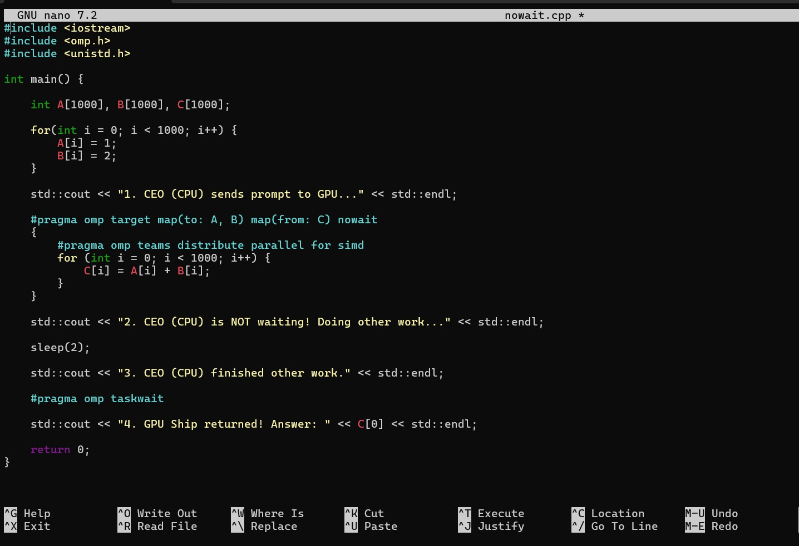
Step3:Compile using
clang++-fopenmpnowait.cpp-omy_program
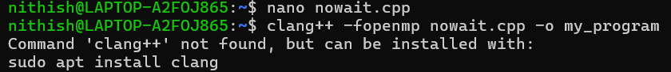

Step4:Run./my_programandtakeascreenshotoftheterminal.

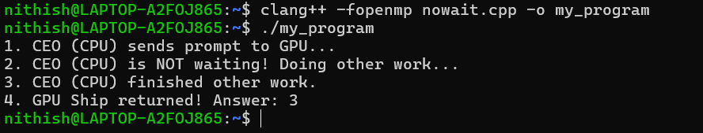

Task3:ConceptualQuestions
Answerthefollowingbasedonyourexecutions:
- InCUDA,whatspecificfunctionisusedtosenddatafromthe Mainland (CPU) to the Island (GPU)?
InCUDAprogramming,thedatatransferfromtheCPU(Host/Mainland)tothe GPU (Device/Island) is performed using the cudaMemcpy() function. This function copies data between host memory and device memory. When transferringdatafromtheCPUtotheGPU,theflagcudaMemcpyHostToDevice is used. It ensures that the input data stored in the CPU memory becomes available for computation on the GPU.

WhathappenstotheGPUmemoryifaprogrammerforgetsto write cudaFree() at the end of the program?
If a programmer forgets to call cudaFree(), the memory allocated on the GPU will not be released properly after the program finishes execution. This results in amemoryleak,whereGPUmemoryremainsoccupiedunnecessarily.Overtime, repeated executions may consume all available GPU memory, which can slow down the system or prevent other GPU programs from running correctly.
Therefore,freeingGPUmemoryusingcudaFree()isanimportantstepinCUDA programming.

IntheOpenMPnowaitprogram,whydoestheCPUprint "Doing other work..." before the GPU finishes its math?
IntheOpenMPprogram,thenowaitclauseallowstheCPUtocontinueexecuting the next instructions without waiting for the GPU computation to complete. Once the CPU sends the task to the GPU, the GPU performs the calculations independently in parallel. Meanwhile, the CPU proceeds with other operations, whichiswhythemessage"Doingotherwork..."appearsbeforetheGPUfinishes its computation. This demonstrates parallel execution and efficient utilization of system resources.

Task4:GPUPerformanceAnalysis(GlobalvsShared
Memory)
Objective:ComparetheexecutiontimeofslowGlobalmemory vs ultra-fast Shared memory in Google Colab.
Step1:InanewGoogleColabcell(with%%cudaatthetop),paste the Matrix Multiplication code that uses both matrixMulGlobal
andmatrixMulShared(TheArchitectWay).
%%cuda
#include <iostream> #include<cuda_runtime.h>

#defineN 1024
#defineTILE_SIZE16

//THEROOKIEWAY:GLOBALMEMORY
global voidmatrixMulGlobal(float*A,float
*B,float*C){
introw=blockIdx.y*blockDim.y+ threadIdx.y;
intcol=blockIdx.x*blockDim.x+ threadIdx.x;
if(row<N&&col<N){ float sum = 0.0f;
for(inti=0;i<N;i++){
sum+=A[row*N+i]*B[i*N+ col];
}
C[row*N+col]=sum;
}
}

//THEARCHITECTWAY:SHAREDMEMORY
global voidmatrixMulShared(float*A,float
*B,float*C){
shared float shared_A[TILE_SIZE][TILE_SIZE];

shared float shared_B[TILE_SIZE][TILE_SIZE];
int bx = blockIdx.x; int by = blockIdx.y; inttx=threadIdx.x;intty=threadIdx.y; int row = by * TILE_SIZE + ty;
intcol=bx*TILE_SIZE+tx;
floatsum=0.0f;

for(inti=0;i<(N/TILE_SIZE);i++){ shared_A[ty][tx] = A[row * N + (i * TILE_SIZE + tx)];
shared_B[ty][tx]=B[(i*TILE_SIZE+ ty) * N + col];
syncthreads();

for(intk=0;k<TILE_SIZE;k++){ sum += shared_A[ty][k] * shared_B[k][tx];
}
syncthreads();
}
C[row*N+col]=sum;
}

intmain(){
intsize=N*N*sizeof(float);
float*h_A=newfloat[N*N];float*h_B=

newfloat[N*N];
for(inti=0;i<N*N;i++){h_A[i]= 1.0f; h_B[i] = 2.0f; }

float*d_A,*d_B,*d_C;
cudaMalloc(&d_A,size);cudaMalloc(&d_B,

size);cudaMalloc(&d_C,size); cudaMemcpy(d_A, h_A, size, cudaMemcpyHostToDevice); cudaMemcpy(d_B, h_B, size, cudaMemcpyHostToDevice);

dim3threads(TILE_SIZE,TILE_SIZE);
dim3blocks(N/TILE_SIZE,N/TILE_SIZE); cudaEvent_t start, stop;
cudaEventCreate(&start);cudaEventCreate(&stop);

cudaEventRecord(start); matrixMulGlobal<<<blocks,threads>>>(d_A, d_B, d_C);
cudaEventRecord(stop); cudaEventSynchronize(stop); float ms_global = 0;
cudaEventElapsedTime(&ms_global,start,stop);

cudaEventRecord(start); matrixMulShared<<<blocks,threads>>>(d_A,

d_B, d_C); cudaEventRecord(stop); cudaEventSynchronize(stop); float ms_shared = 0;
cudaEventElapsedTime(&ms_shared,start,stop);

std::cout<<"TimeusingSlowGlobalMemory: "<< ms_global <<" ms\n";
std::cout<<"TimeusingFastSharedMemory: "<< ms_shared <<" ms\n";
std::cout<<"SPEEDUPFACTOR:"<<
(ms_global/ms_shared)<<"xFaster!\n";

cudaFree(d_A);cudaFree(d_B);cudaFree(d_C); delete[] h_A; delete[] h_B;

return0;
}
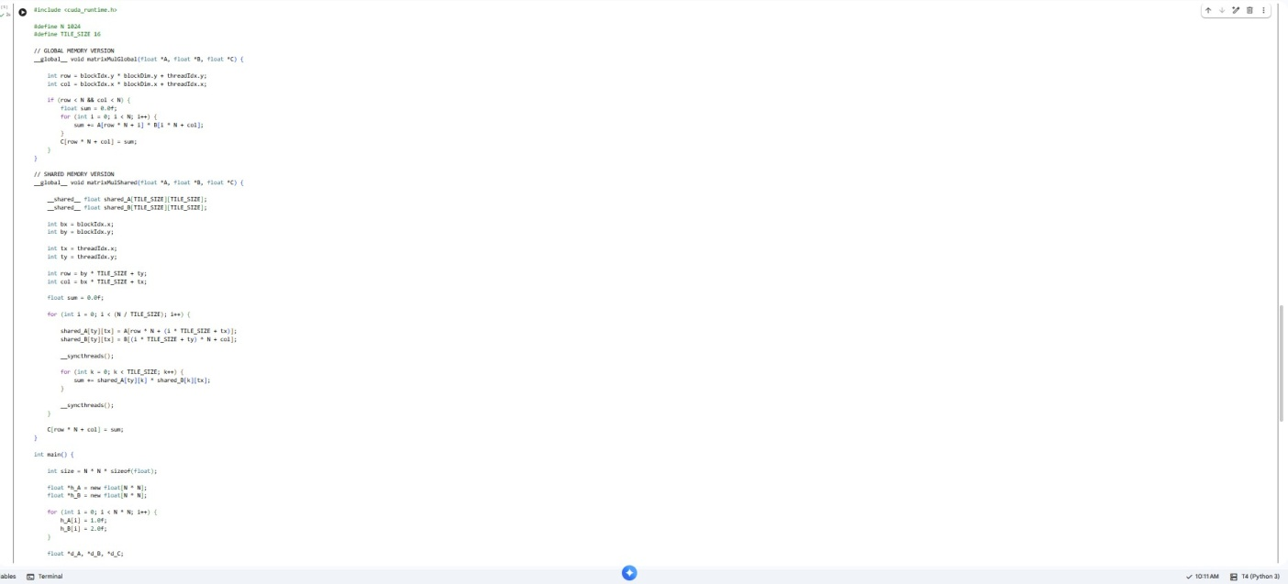

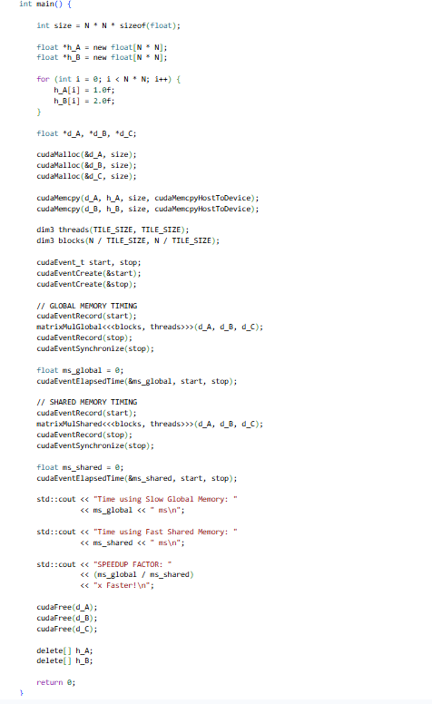

Step2:Runthecell.TheprogramusescudaEventElapsedTime to act as a stopwatch.

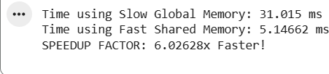

Step3:Observetheoutputatthebottomoftheterminal. Write down the following readings:
- TimeusingSlowGlobalMemory:31.015ms
- TimeusingFastSharedMemory:5.14662ms
- SPEEDUPFACTOR:6.02628xFaster
Step4:Takeascreenshotofthesetimingresults.


Task5:TheIF/ELSETrap(WarpDivergence)
Objective:ObservewhathappenswhenGPUthreadsinsidethe

sameWarptrytotakedifferentif/elsepaths.
Step1:InanewColabcell,write%%cudaandpastethiscode:
%%cuda
#include<iostream>

global voiddivergenceTest(int*data){ int workerID = threadIdx.x; // Worker 0 to 31 (One Warp)

//THEROOKIEMISTAKE:WarpDivergence if (workerID < 16) {
data[workerID]=data[workerID]*2;
}else{
data[workerID]=data[workerID]+5;
}
}

intmain(){
std::cout<<"---THEIF/ELSETRAP---"<<
std::endl;
std::cout <<"Rule: All 32 workers in a Warp MUSTsharethesamemegaphone."<<std::endl; std::cout <<"If they disagree, the GPU cuts
itsspeedinhalf!"<<std::endl; return 0;

}
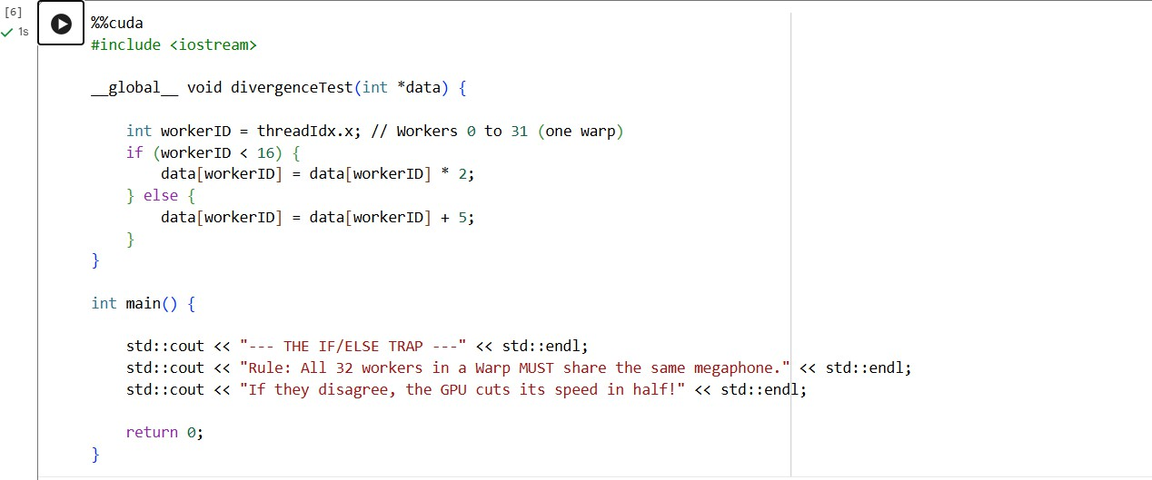
Step2:Runthecellandcaptureascreenshot.

Task6:Task3:ObservationQuestions
Basedontheperformancemetricsyoujustanalyzed,answerthe following:

Whyis"SharedMemory"(TheArchitectWay)somuchfaster than "Global Memory" (The Rookie Way) in matrix Multiplication?
Shared Memory is faster because it is placed very close to the GPU cores, allowingthreadstoaccessdataquickly.Duringmatrixmultiplication,thesame

datavaluesareusedmultipletimesbydifferentthreads.Bystoringthesevalues inSharedMemory,theGPUavoidsrepeatedlyaccessingGlobalMemory,which is slower and located farther away.
Incontrast,GlobalMemoryhashigheraccesstime,sofrequentreadsandwrites reduce performance. Using Shared Memory improves data reuse and minimizes memory access delay, resulting in much faster execution.

What is the OpenMP/CUDA command used to make sure all workersfinishloadingdataontothewhiteboardbeforetheystart doing math? ( syncthreads())
Thecommandusedis_syncthreads().
It works like a meeting point for all threads in a block. Every thread waits at this point until all other threads finish loading data into Shared Memory. Only after everyonereachesthisstagedothethreadscontinuewiththecomputation.This ensures that calculations are performed using complete and correct data.

Whatis"WarpDivergence"andwhydoesanif/else statement hurt GPU performance?
Warp Divergence happens when threads within the same warp take different executionpathsbecauseofconditionslikeif/elsestatements.SinceGPUthreads inawarpexecuteinstructionstogether,theGPUcannotrunbothbranchesatthe same time. Instead, it executes one branch while the other threads remain idle, and then switches to the second branch.
Thisreducesparallelefficiencyandslowsdownperformance.Therefore, minimizing conditional branching helps maintain better GPU speed.

