CourseTitle:HIGHPERFORMANCECOMPUTINGAss-6

Name: R.CHAITRA Batch no : 12
HallTicketNo:2303A51786

- Lab:NUMAEffectsandBandwidthMeasurement

Objective:
ToobservehowmemoryplacementandNUMAeffectsinfluence performance and to understand bandwidth limitations.
Task1:SystemNUMAInformation Lscpu | grep -i numaObservation:
Number of NUMA nodes =
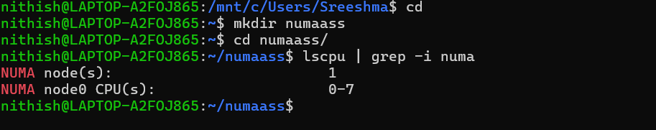

- Task2:FirstTouchMemoryInitialization
File:numa_first_touch.c #include &lt;stdio.h&gt; #include &lt;stdlib.h&gt; #include &lt;omp.h&gt;

#define N 10000000

06-02-2026 EOD

int main() {
double *A = (double*)malloc(sizeof(double)*N);

#pragmaompparallelfor for (int i = 0; i &lt; N; i++) A[i] = 1.0;

double sum = 0;
#pragmaompparallelforreduction(+:sum) for (int i = 0; i &lt; N; i++)
sum += A[i];

printf(&quot;Sum=%f\n&quot;,sum); free(A);
return 0;
}

Compile &amp; Run:
gcc -O2 -fopenmp numa_first_touch.c -o numa_first_touch
./numa_first_touch
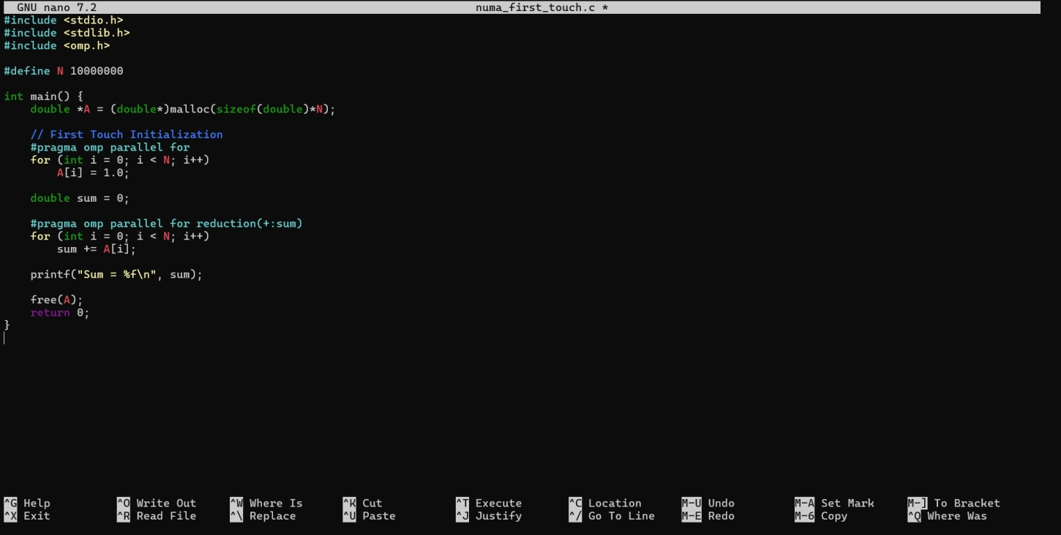

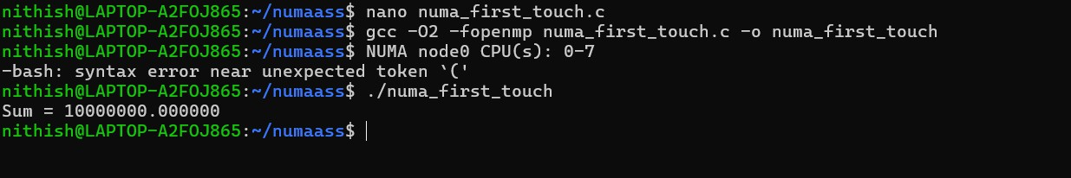

Task3:ConceptualQuestions
- What isfirst- touch policy?
First-touchpolicymeansthatmemoryisphysicallyassignedtotheNUMAnodeofthe thread that first uses (writes to) it.

When we use malloc(), memory is reserved but not actually mapped to a physical locationimmediately.Thesystemwaitsuntilathreadwritestothatmemory.TheNUMA node of that thread becomes the location where that memory page is placed.
In simple words:
The thread that first touches the memory decides where it lives.

Thishelpsimproveperformancebecausethreadscanaccessmemorythatiscloserto them.

Does NUMA affect correctness or performance?
NUMAdoes notaffect correctness —your programwill still givethe correct output.

However,itdoesaffectperformance.

IfathreadaccessesmemorythatbelongstoanotherNUMAnode(remotememory),it takesmoretimecomparedtoaccessingitsownlocalmemory.Thisincreasesmemory access delay and slows down the program.
So:

  - Correctness → Not affected
  - Performance→Canbeaffectedsignificantly

Why is memory bandwidth important in NUMA systems?
Memory bandwidth refers to how fast data can move between memory and the CPU.

In NUMA systems, each node has its own local memory with good bandwidth. If a threadaccessesitslocalmemory,datatransferisfast.Butifitaccessesmemoryfrom another node, the bandwidth is lower and the access is slower.
Whenmanythreadstrytoaccessremotememory,thesystemcanbecomeslow because memory bandwidth becomes a bottleneck.
That’swhypropermemoryplacement(likefirst-touch)isimportant—ithelpsthreads use local memory and improves overall performance

