CourseTitle:HIGHPERFORMANCECOMPUTING LabAss-5

Name:R.CHAITRA Batch no-12
HallTicket:2303A51786

Lab:LoopSchedulingComparison
Task1:Code(reuseWeek-3code,onlychangedirective) #pragma omp parallel for schedule(runtime) reduction(+:sum)
for(longi=0;i&lt;N;i++){ sum += i;
}
Runcommands:
gcc-fopenmpsum_openmp.c-osum_openmp

export OMP_SCHEDULE=static exportOMP_NUM_THREADS=8
./sum_openmp

exportOMP_SCHEDULE=dynamic 04-02-2026 EOD
./sum_openmp

exportOMP_SCHEDULE=guided
./sum_openmp
Fillthetablebelow:

SchedulingTimeObservation Static ? ?
Dynamic?? Guided ? ?

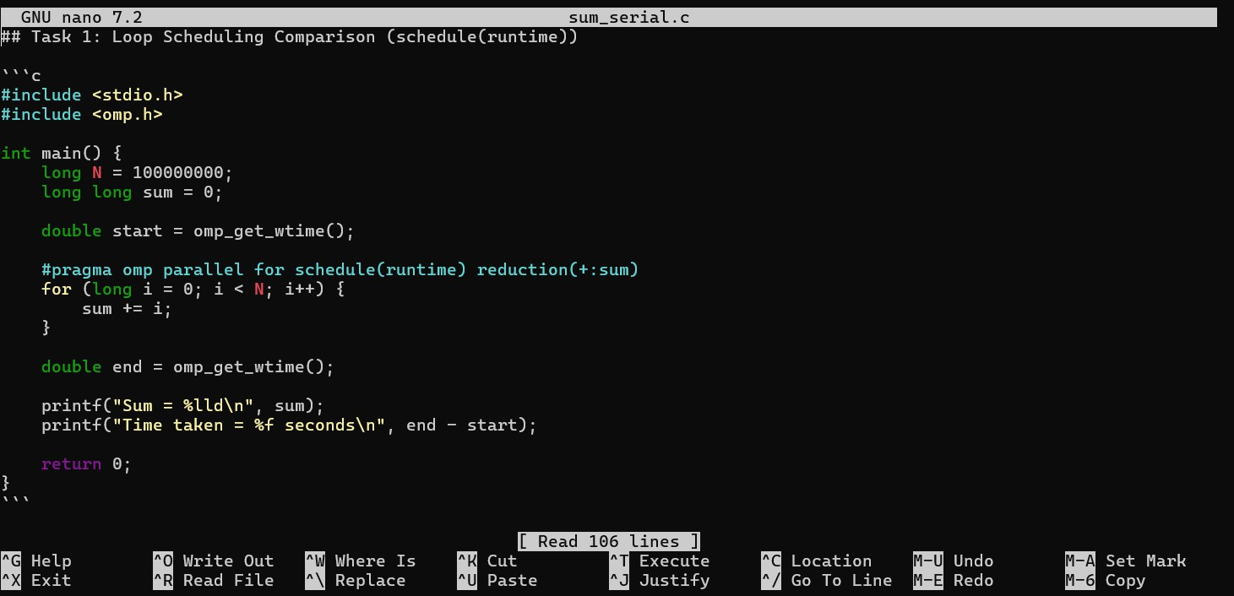
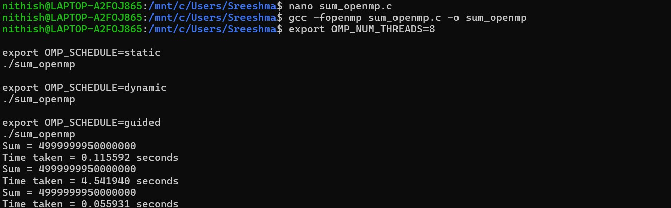

Scheduling | Time | Observation
Static | 0.115592seconds | 4999999950000000
Dynamic | 4.541940seconds | 4999999950000000
Guided | 0.055931seconds | 4999999950000000

2
Task2:SynchronizationOverheadComparison Variant-1: Reduction
#pragmaompparallelforreduction(+:sum)

Variant-2: Atomic #pragmaompparallelfor for (...) {

#pragmaompatomic sum += i;
}

Variant-3: Critical #pragmaompparallelfor

04-02-2026EOD

for(...){
#pragmaompcritical sum += i;
}

Expected trend: Reduction→fastest Atomic → slower Critical → slowest

Reduction:
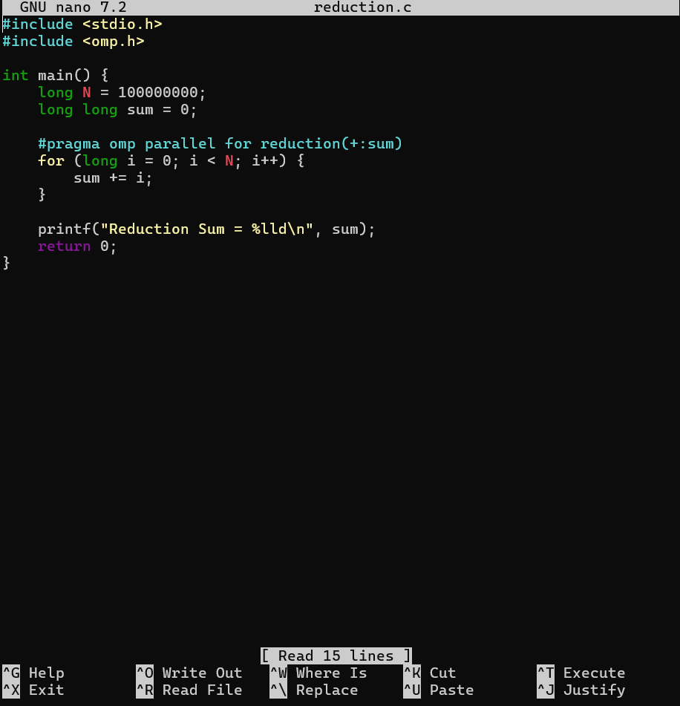
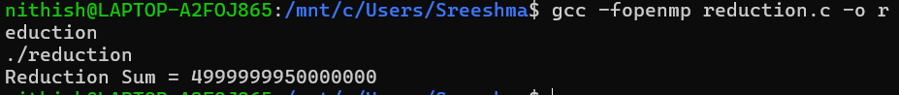

Atomic:

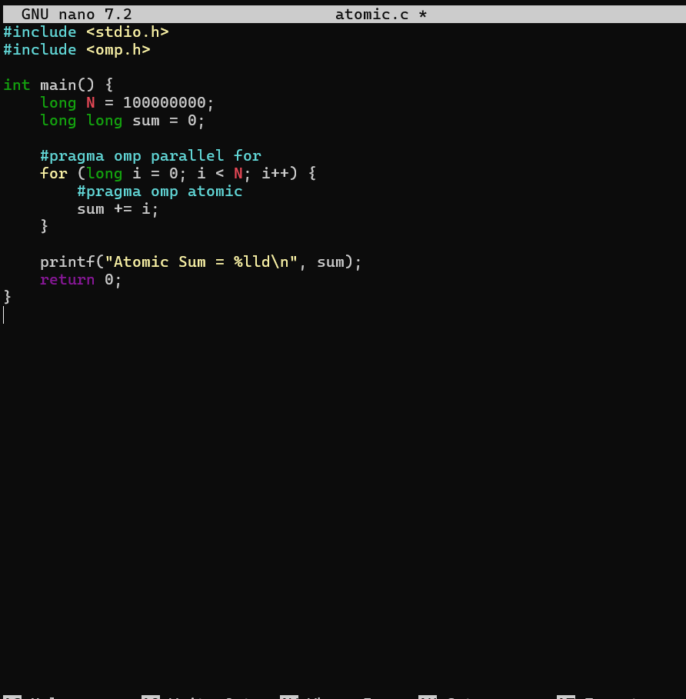
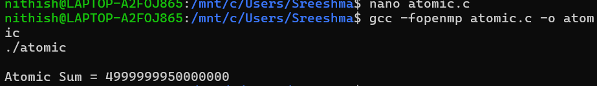

Critical:

