CourseTitle:HIGHPERFORMANCECOMPUTINGAss-7

Name: R.CHAITRA Batch no : 12
HallTicketNo:2303A51786

Lab:OpenMPSIMDVectorization Objective:
To understand SIMD vectorization and observe how OpenMP SIMD improves loop execution.
Task1:NormalLoopExecution
File: simd_serial.c #include&lt;stdio.h&gt;
#defineN100000000 int main() {
floata[N],b[N],c[N];
for(inti=0;i&lt;N;i++) c[i]=a[i]+b[i]; printf(&quot;Done\n&quot;);

06-02-2026EOD

return0;
}

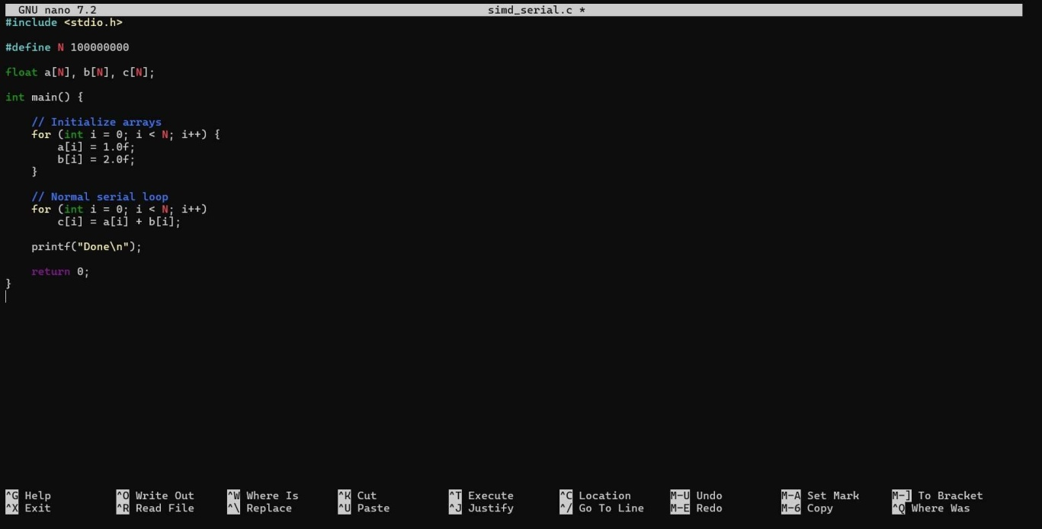


- Task2:OpenMPSIMDLoop #pragma omp simd
for(inti=0;i&lt;N;i++) c[i]=a[i]+b[i]; Compile:
gcc-O2-fopenmpsimd_serial.c-osimd_test

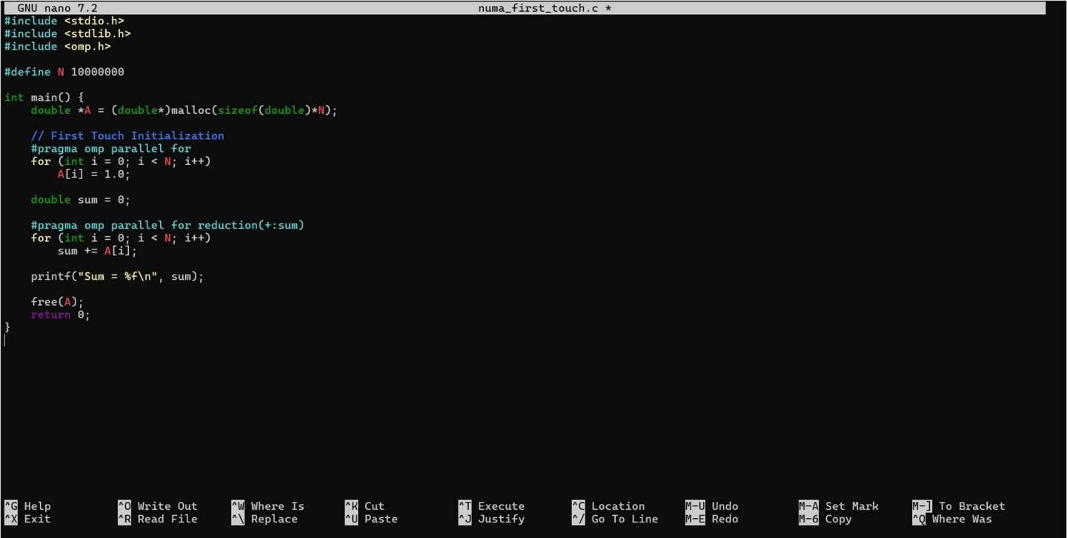

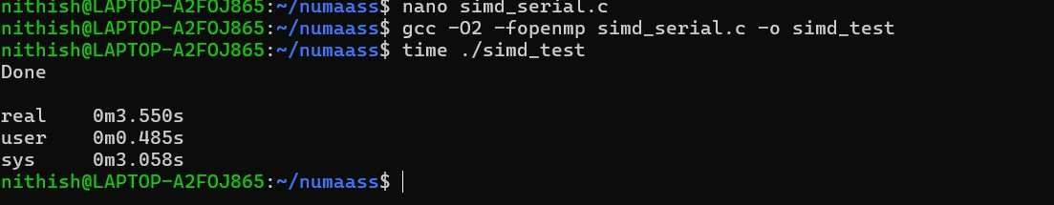

Task3:ConceptualQuestions
- WhatdoesSIMDmean?
SIMD stands for Single Instruction, Multiple Data. It means that the processor can perform the same operationonmultiple dataelementsatthe same time using a single instruction.
In Task 1 (Normal Loop Execution), the array addition was performed in a normal loop. The CPU processed one element at a time — meaning each addition c[i] = a[i] + b[i] was done sequentially.
InTask 2 (OpenMP SIMD Loop), we added #pragma omp simdbefore the loop. This tellsthecompilertovectorizetheloop.Insteadofaddingonepairofelementsatatime, the CPU can add multiple elements together in parallel using vector registers.
Sopractically:
  - Task1→One operationperstep(sequentialprocessing)

  - Task2→Multipleoperationsperstep(vectorizedprocessingusingSIMD)

Even though we may not have seen a big timing difference due to memory limitations, SIMD is designed to improve performance by utilizing the processor’s vector hardware efficiently.
In simple words,SIMD allows the computertodo thesame calculation onmany data items at once, making loops faster and more efficient.

DoesSIMDusemultiplethreads?
In Task1(Normal Loop), onethreadprocessedone elementat atime.

  - In Task2(OpenMPSIMDLoop), we used #pragma omp simd, which tells the compiler to vectorize the loop.

    - Stillonethread

    - Butmultipledataelementsprocessedperinstruction

So:
  - Multithreading(OpenMPparallelfor)→Multiplethreadsworkingsimultaneously.

  - SIMD→Onethreaddoingmultipledataoperationsatonce.

SimpleDifference
  - Threads=Parallelismacrosscores(Thread-levelparallelism)

  - SIMD=Parallelisminsideacore(Data-levelparallelism)

SoSIMDimprovesperformancewithoutcreatingextrathreads.

WhenisSIMDmost effective?

SIMD is most effective when a program performs the same operationrepeatedly on a large set of independent data.
InTask 1,weexecuteda normalloopwhereeach elementof arraysaand bwasadded one by one. The CPU handled one addition at a time.
InTask 2,weused#pragma omp simd, which allowedthe compilertoapplySIMD vectorization. This means the processor can add multiple elements of the arrays in a single instruction instead of one at a time.
SIMDworksbestinsituationslikethislabbecause:

  - Theoperation(c[i]=a[i]+b[i])isthesameforeveryelement.

  - Eachiterationisindependent.

  - Thedatasizeisverylarge(100millionelements).

However, SIMD gives the most noticeable improvement when the program is computation-heavy. If memoryaccessisthebottleneck(asin largearrayoperations), the performance gain may be limited.

