AI ASSISTANCE ASS-4
2303A51789
Batch-28

Problem statement1:
Customer Email Classification
A company receives a large number of customer emails every day
and wants to classify them into the following automatically
categories:
• Billing
• Technical Support
• Feedback
• Others
Instead of training a new machine learning model, the company
decides to use prompt engineering techniques with an existing large
language model.
TASK-1:
Prepare five short sample emails, each belonging to one of
the above categories.
Prompt:
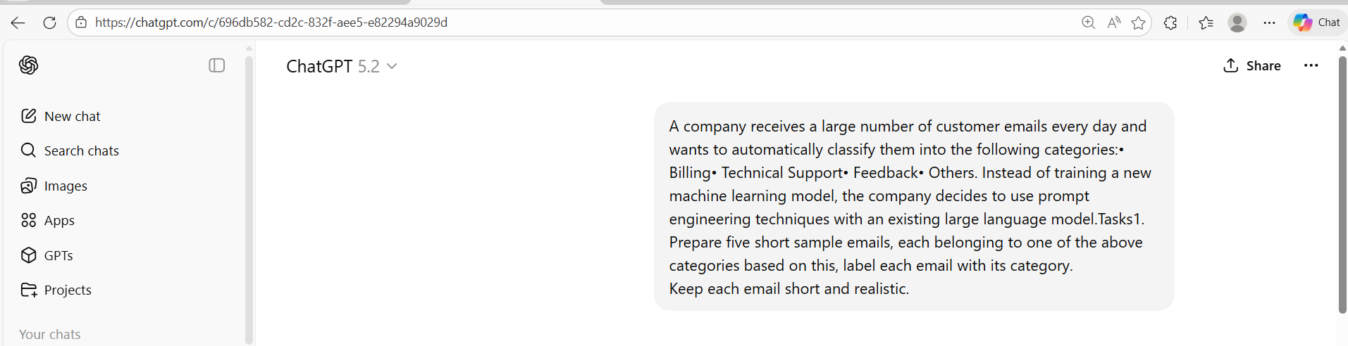

Code and Output:
Email ID | Sample Email | Category
1 | I was charged twice for my subscription this month. Could you please check and issue a refund for the extra charge? | Billing
2 | The mobile app crashes every time I try to upload a document. I’ve already reinstalled it, but the issue persists. | Technical Support
3 | I really like the new dashboard layout—it’s much easier to navigate than the previous version. Great job! | Feedback
4 | Can you let me know your customer support hours during public holidays? | Others
5 | My invoice shows a higher amount than expected after the recent plan change. Can you explain the additional charges? | Biling

Justification:
- Emails mentioning charges, invoices, or refunds are classified as Billing.
- Emails describing app errors, crashes, or system issues are classified as Technical Support.
- Emails sharing opinions or suggestions without asking for help are classified as Feedback.
- Emails asking general questions not related to billing or technical issues are classified as Others.
- Each sample email was kept short and realistic to clearly match one category for easy classification using prompt engineering.

Task 2:
Write a zero-shot prompt to classify a given email into one of
The categories without any examples.
Prompt:
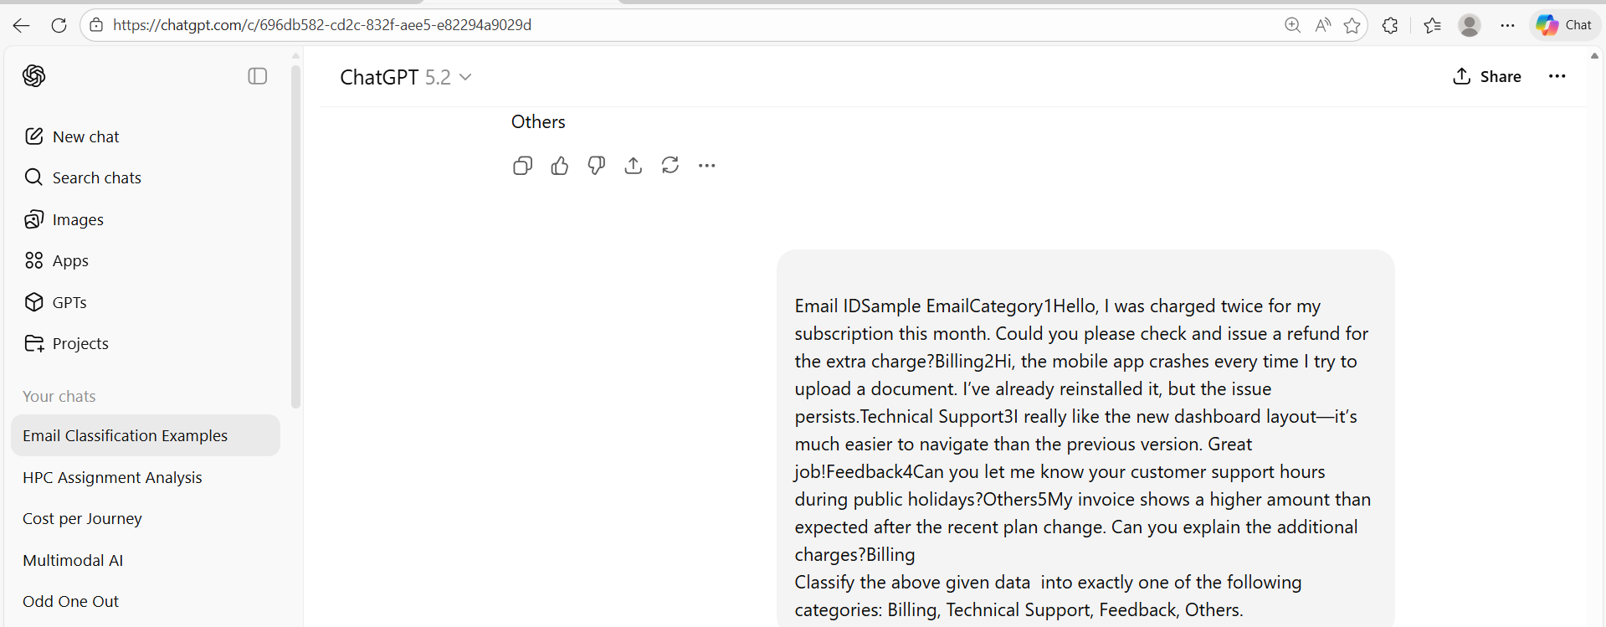
Code and Output:
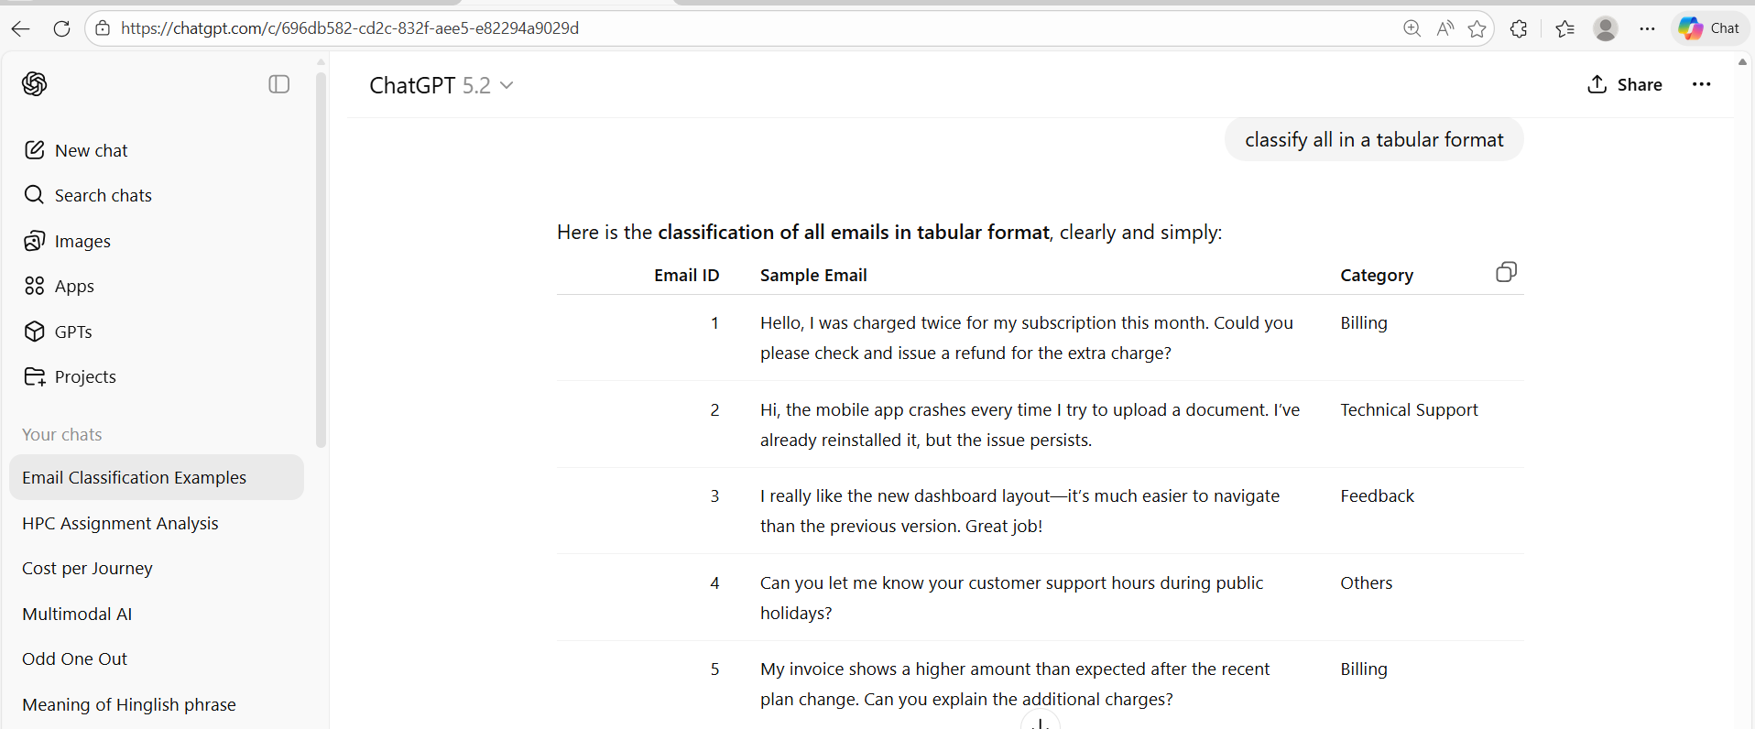
Justification:
- Emails that mention charges, invoices, refunds, or payment issues are classified as Billing.
- Emails reporting app crashes, errors, or system problems are classified as Technical Support.
- Emails that express opinions or appreciation without requesting help are classified as Feedback.
- General inquiries that do not relate to billing or technical issues are classified as Others.
5. Each email was classified into exactly one category based on its primary intent.

TASK-3:
Write a one-shot prompt by including one labelled email
example and ask the model to classify a new email.
Prompt:
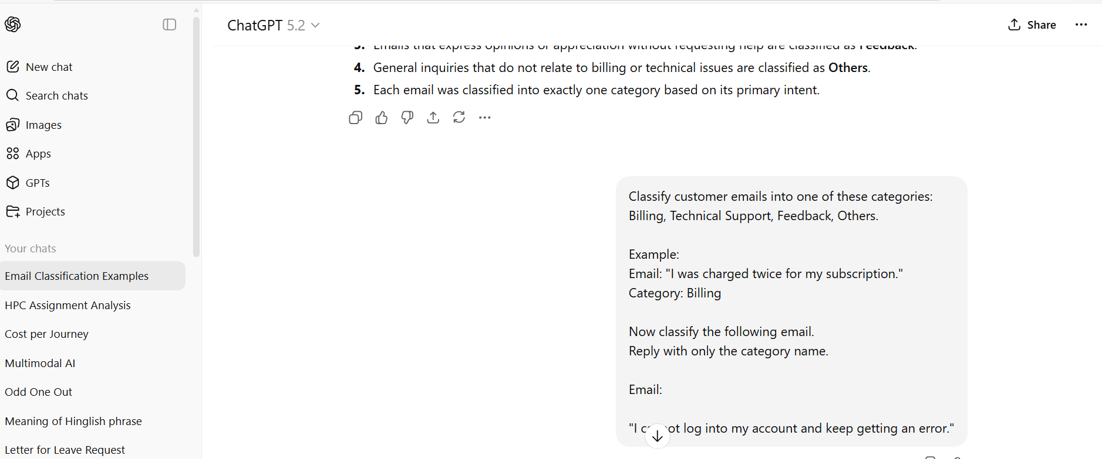
Code and Output:
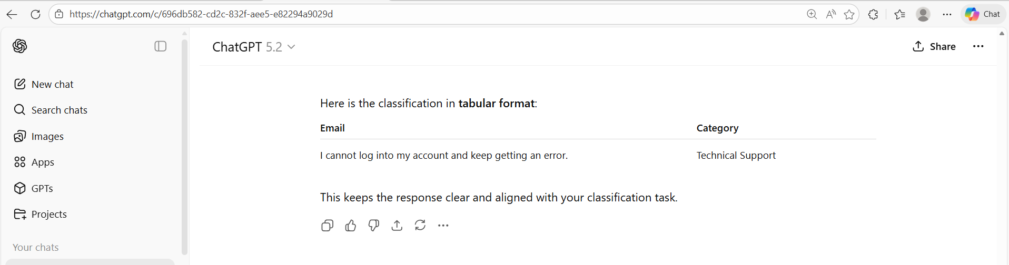
- The email describes a login error, which indicates a system or functionality problem.
- Issues related to accessing an account require technical assistance.
- No billing or payment information is mentioned in the email.
- The email does not provide opinions or suggestions, so it is not feedback.
- Therefore, the email is best classified under Technical Support.

TASK-4:
Write a few-shot prompt by including two or three labelled
email examples and ask the model to classify a new email
Prompt:
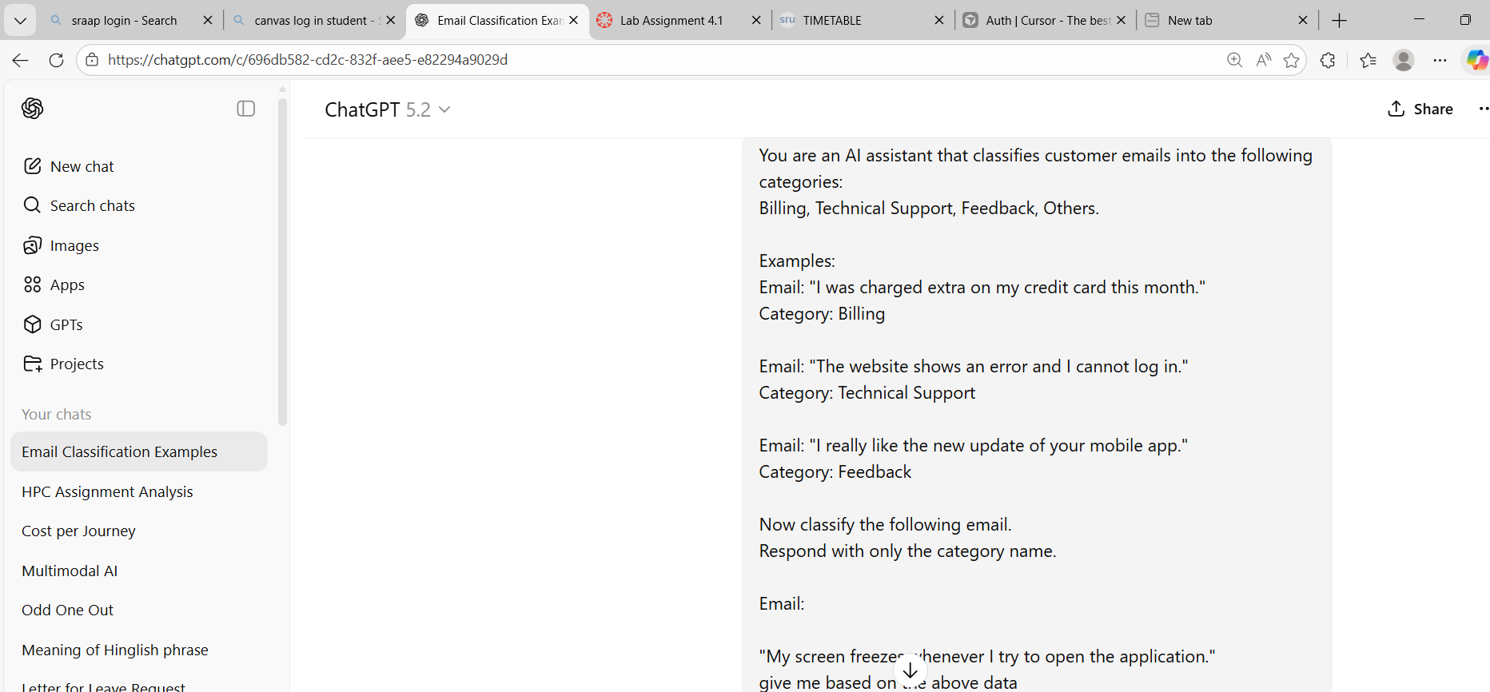

Code and Output:
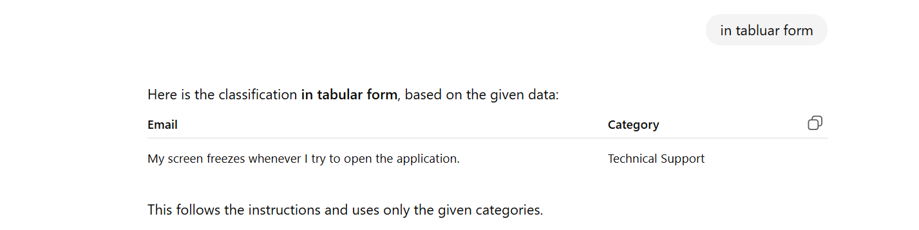
Justification:
- The email reports a screen freeze, which is a technical issue with the application.
- Application performance problems fall under technical troubleshooting.
- The issue prevents normal use of the software, requiring technical assistance.
- No billing or payment-related information is mentioned.
- Therefore, the email is correctly classified as Technical Support.

Task-5:
Compare the outputs obtained using zero-shot, one-shot, and
few-shot prompting techniques and briefly comment on their
effectiveness
Prompt:

Code and Output:
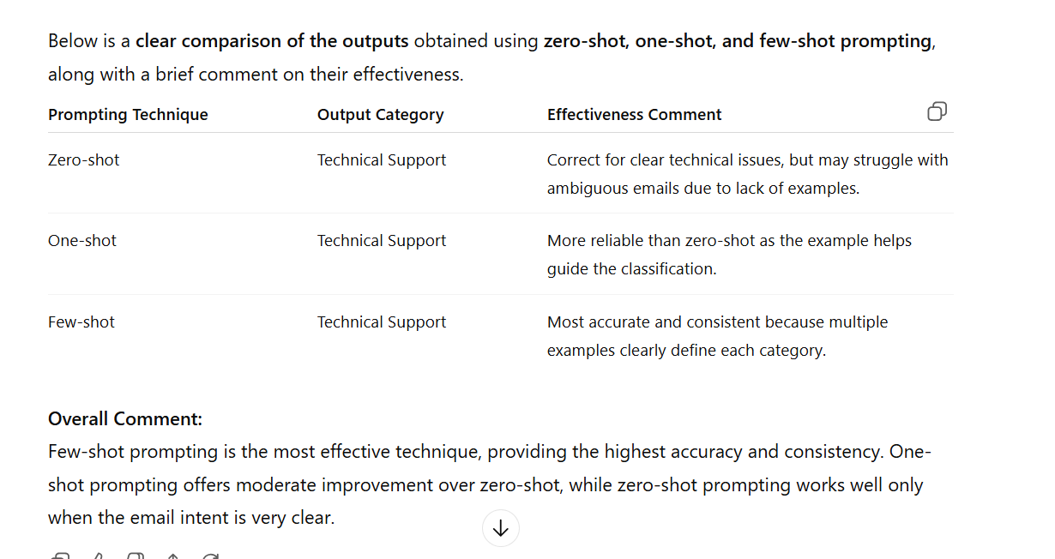
Justification:
- All three prompting techniques correctly classified the email as Technical Support.
- Zero-shot prompting works well when the email content is clear but lacks guidance from examples.
- One-shot prompting improves reliability by showing the model one reference example.
- Few-shot prompting gives the best performance because multiple examples clearly define each category.
- Overall, providing more examples increases consistency and accuracy in email classification

Problem Statement -2:
Intent Classification for Chatbot Queries
A company wants to deploy a chatbot to handle customer queries.
Each query must be classified into one of the following intents:
Account Issue, Order Status, Product Inquiry, or General Question
using prompt engineering techniques.
Task-1:
1. Prepare Sample Data
Create 6 short chatbot user queries, each mapped to one of
The four intents.
Prompt:
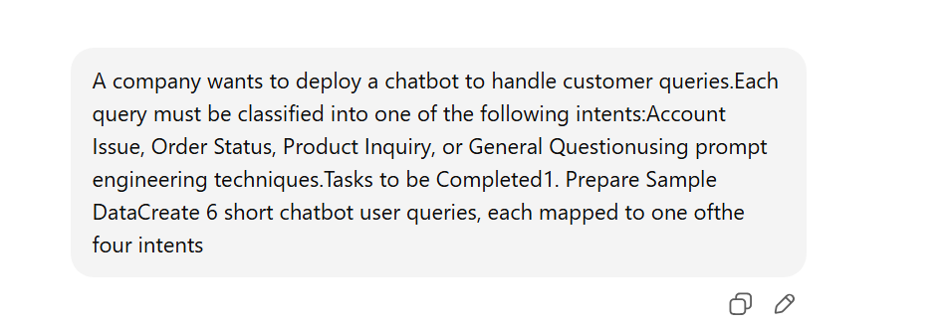
Code and output:
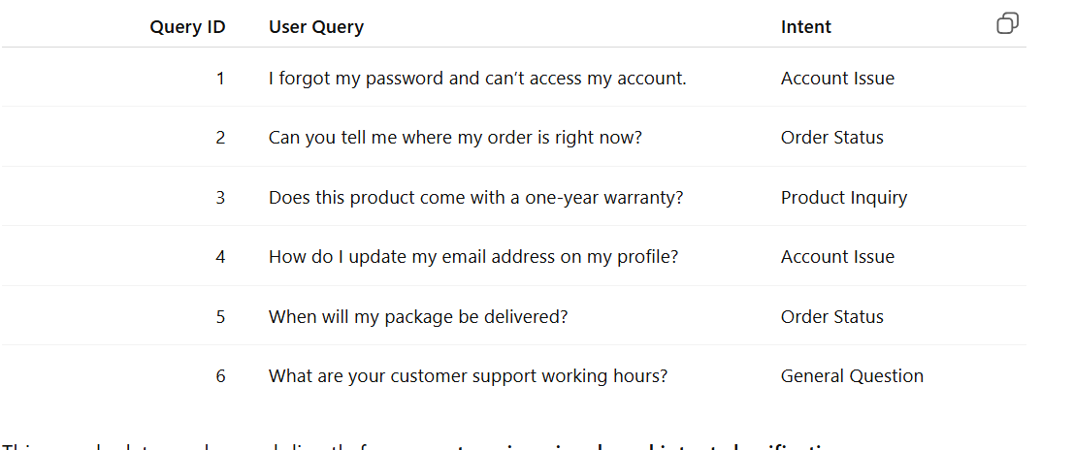
Justification:
- Queries related to login problems or profile changes are classified as Account Issue.
- Questions asking about delivery progress or shipment timing fall under Order Status.
- Queries seeking details about product features, warranty, or specifications are labelled Product Inquiry.
- General information requests that do not relate to accounts, orders, or products are categorised as General Questions.
5. Each query is short, clear, and mapped to a single intent to ensure accurate intent classification using prompt engineering.
Task-2:
Zero-shot Prompting
Design a prompt that asks the LLM to classify a user query
into the given intent categories without examples.
Prompt:
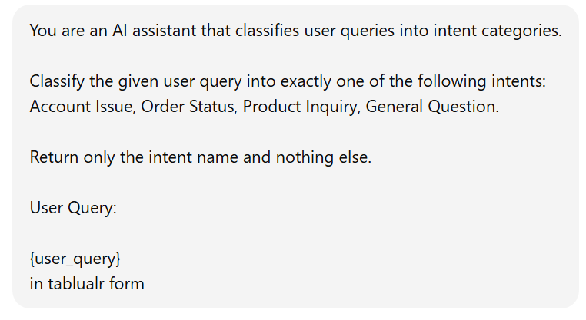
Code and Output:
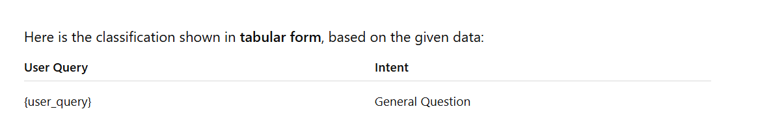
Justification:
- The query does not mention problems related to login, password, or account details.
- There is no reference to an order, delivery, or shipping status.
- The query does not ask about a specific product’s features or specifications.
- The placeholder query is treated as a general informational request.
- Therefore, the intent is classified as a General Question.
Task-3:
One-shot Prompting
Provide one labelled query in the prompt before classifying a
new query.
Prompt:
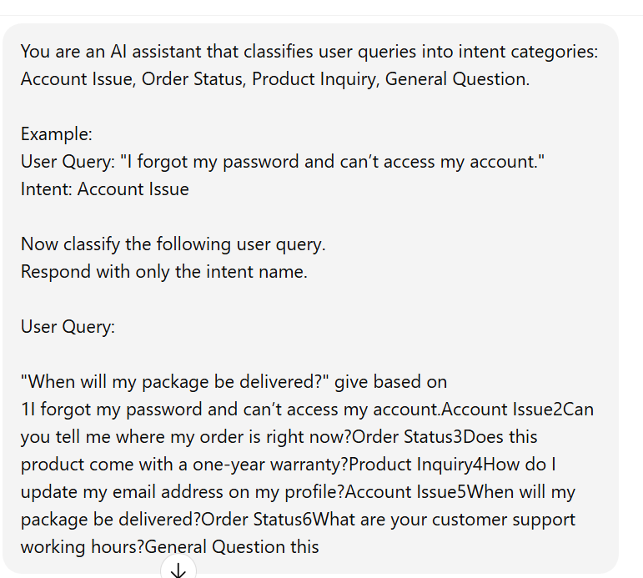

Code and Output:
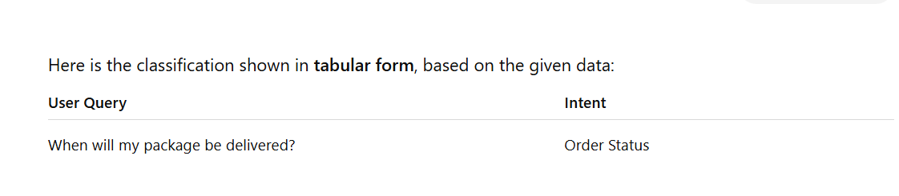
Justification:
1. The query asks about the delivery time of a package.
2. Questions related to delivery or shipment progress fall under Order Status.
3. Similar examples in the given data classify delivery-related queries as Order Status.
4. The query does not involve account access or profile issues.
5. Therefore, the intent is correctly identified as Order Status.
Task-4:
Few-shot Prompting
Include 3–5 labelled intent examples to guide the LLM before
classifying a new query.
Prompt:
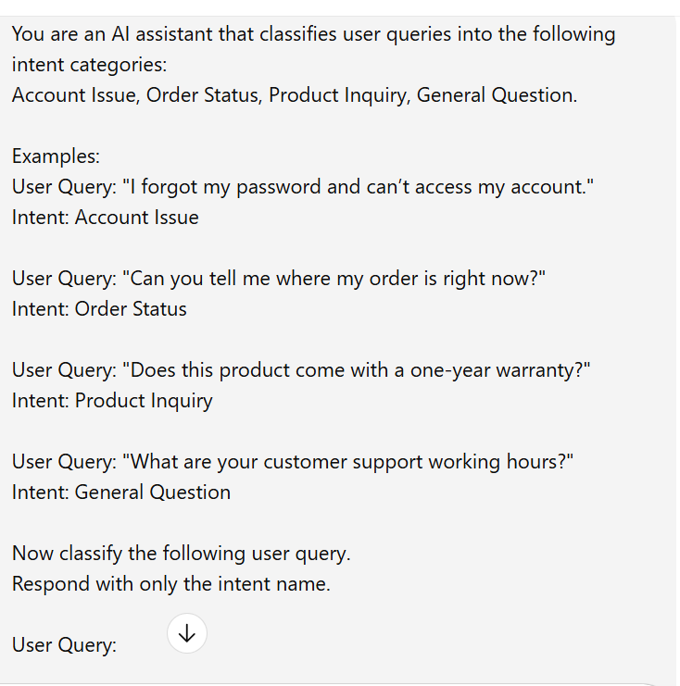
Code and Output:
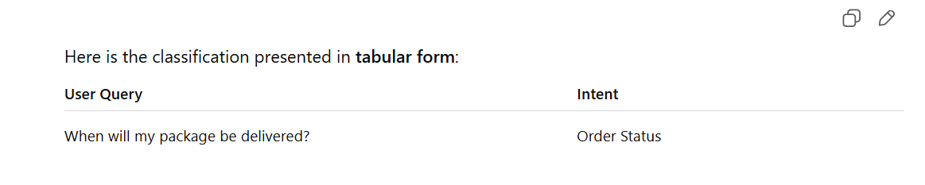
Justification:
- The query asks about the delivery time of a package.
- Questions related to shipment or delivery fall under Order Status.
- Similar examples provided classify delivery-related queries as Order Status.
- The query does not involve account access or profile issues.
- Therefore, the correct intent classification is Order Status.
Task-5:
Evaluation
Apply all three techniques to the same set of test queries and
document differences in performance.
Prompt:
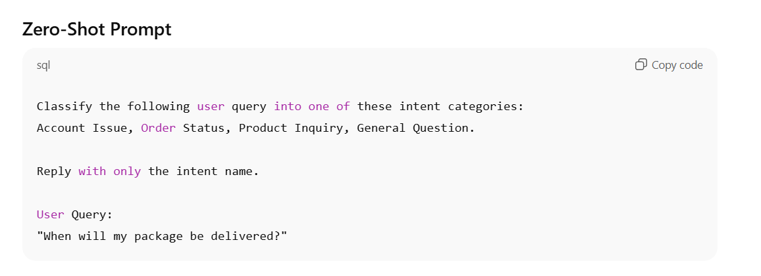
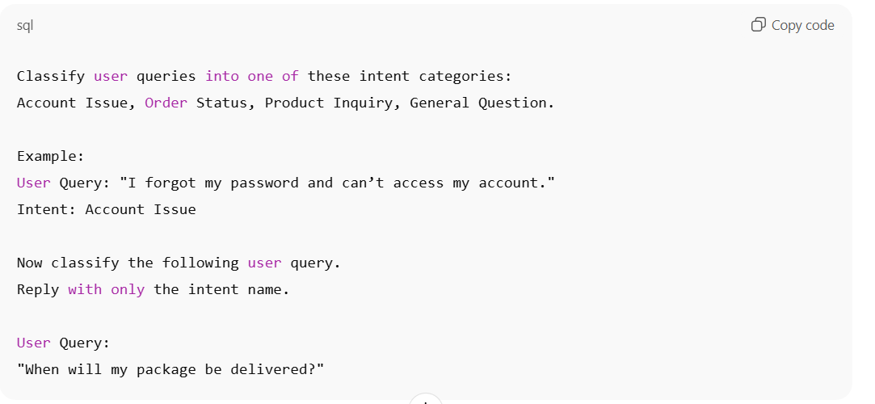
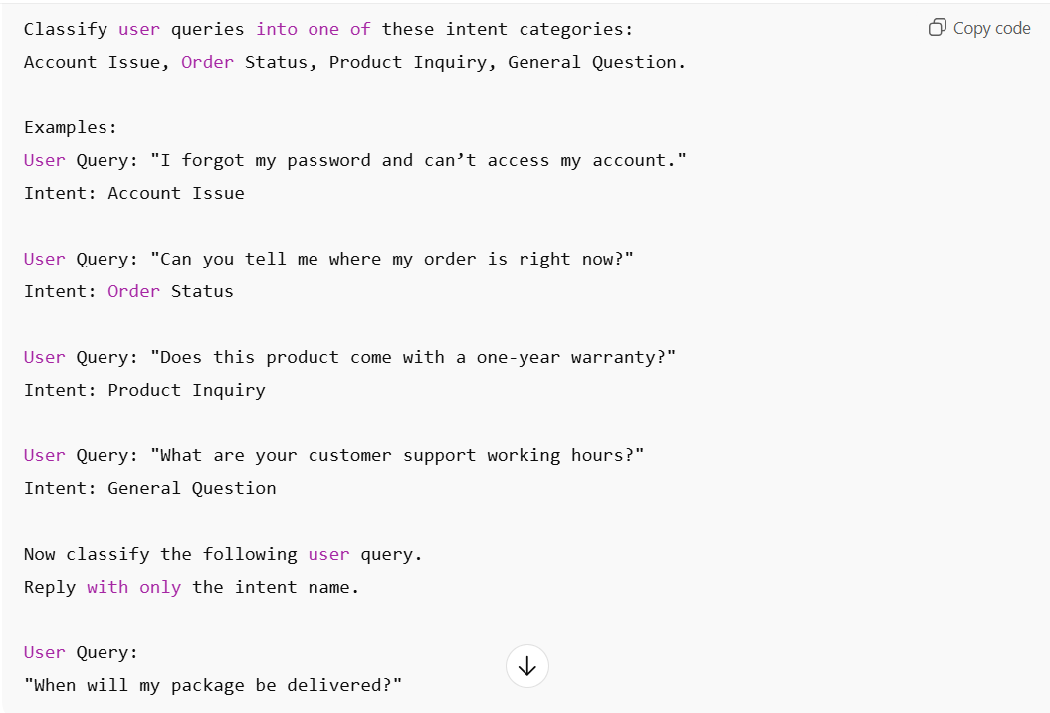
Code and Output:
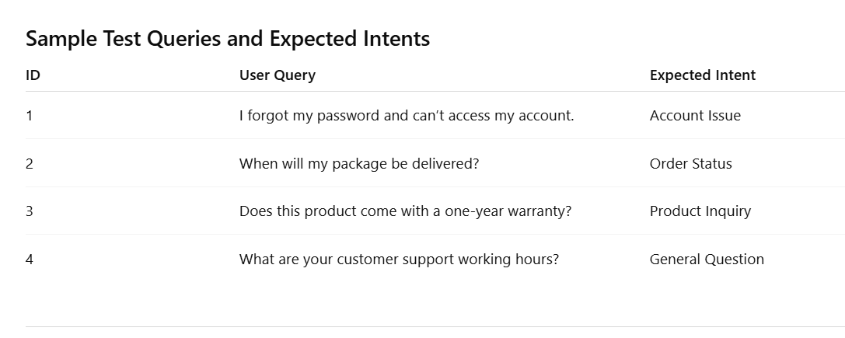
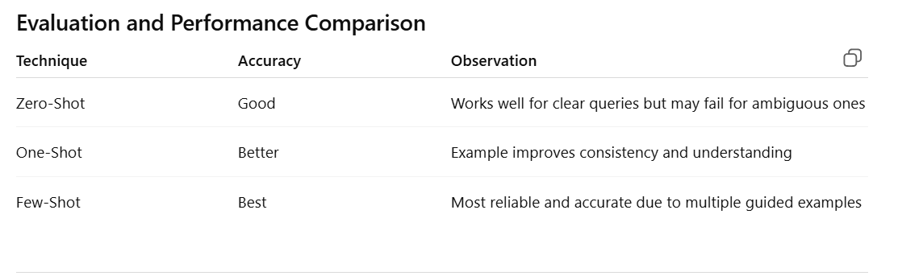
Justification:
- Zero-shot prompting classifies user queries using only intent labels, making it fast but less reliable for ambiguous queries.
- One-shot prompting improves classification accuracy by providing one labelled example that guides the model’s understanding of the task.
- Few-shot prompting delivers the best performance because multiple labelled examples clearly define each intent category.
- Using the same test queries across all techniques allows a fair comparison of their effectiveness.
- Overall, few-shot prompting is the most effective, while zero-shot is suitable when examples are unavailable or speed is required.

Problem Statement -3:
Student Feedback Analysis
A university collects student feedback and wants to categorise
comments as Positive, Negative, or Neutral.
Task-1:
a) Write a Zero-shot prompt to classify feedback sentiment.
Prompt:
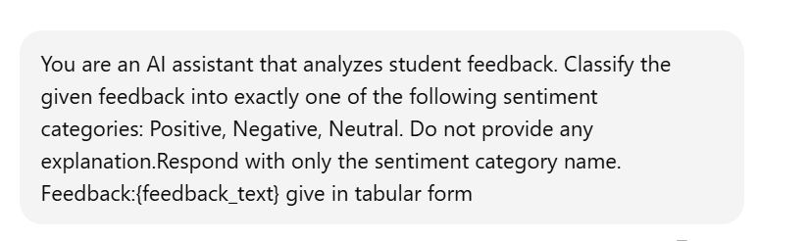

Code and Output:
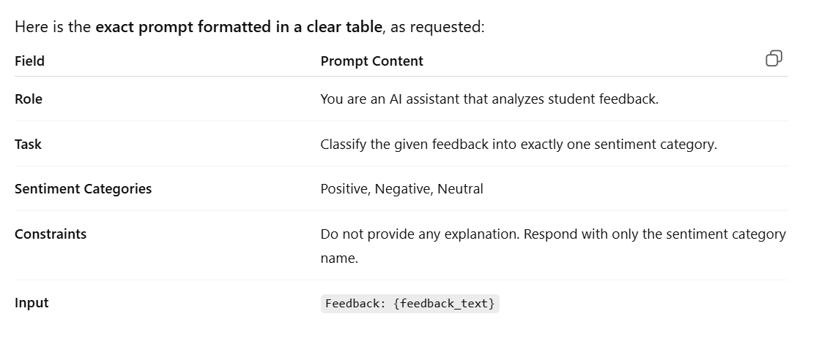

Justification:
- The prompt assigns the AI the role of analysing student feedback, clearly defining its task domain.
- It restricts classification to exactly one sentiment category: Positive, Negative, or Neutral, ensuring consistent outputs.
- The instruction to avoid explanations forces the model to give concise and unambiguous results.
- Using a placeholder ({feedback _text}) allows the same prompt to be reused for different feedback inputs.
- The structured instructions improve accuracy and reliability in sentiment classification tasks.
Task-2:
b) Provide a One-shot prompt with one feedback example.

Prompt:
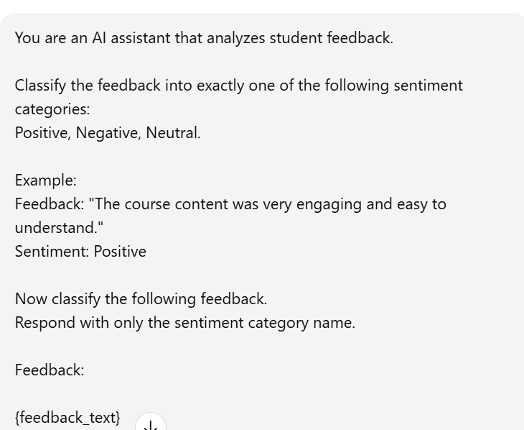
Code and Output:
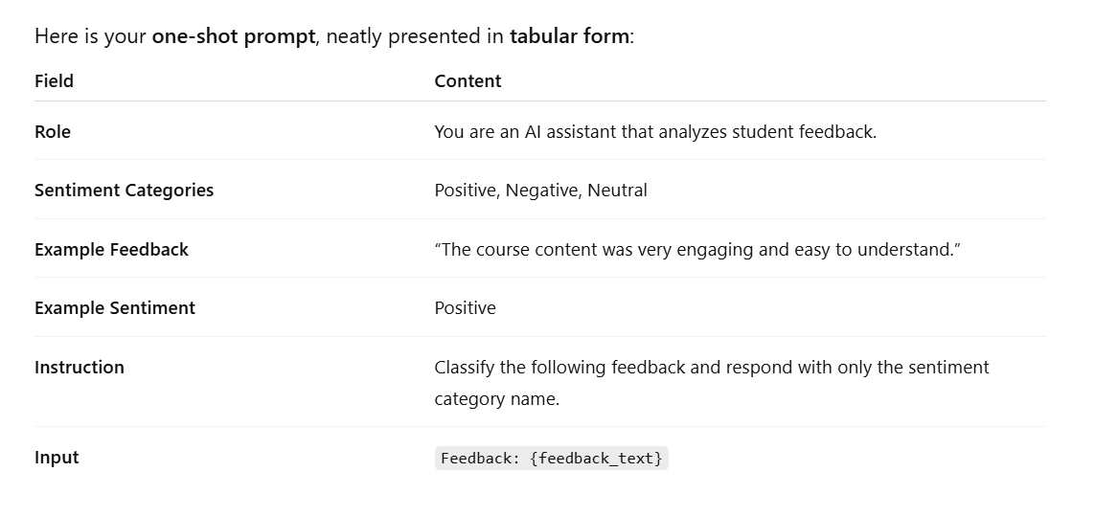

Justification:
- The prompt defines the AI’s role as analysing student feedback, which sets a clear task context.
- It limits classification to three sentiment categories (Positive, Negative, Neutral) to ensure consistent results.
- A single labelled example is provided, demonstrating how feedback should be mapped to a sentiment (one-shot learning).
- The instruction to respond with only the sentiment name prevents unnecessary explanations and keeps output concise.
- This one-shot approach improves accuracy compared to zero-shot prompting by giving the model a reference pattern.
Task-3
C) Create a Few-shot prompt using multiple labelled feedback
samples.
Prompt:
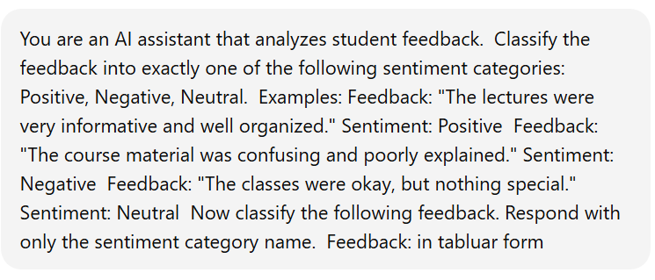
Code and Output:
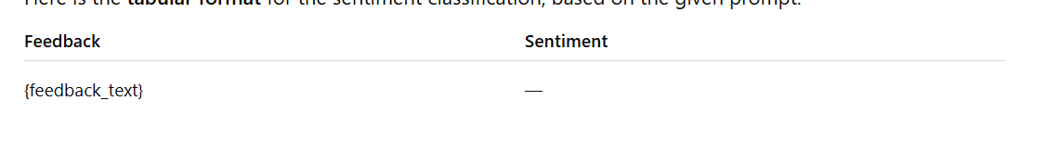
- The prompt defines the AI’s role as analysing student feedback, clearly setting the task context.
- It restricts sentiment classification to exactly three categories: Positive, Negative, and Neutral.
- Multiple labelled feedback examples are provided, demonstrating how different sentiments should be identified (few-shot learning).
- The instruction to respond with only the sentiment category name ensures concise and consistent outputs.
- Few-shot prompting improves accuracy and reliability compared to zero-shot and one-shot approaches by giving stronger guidance to the model.
Task-4:
Prompt:
d) Explain how examples improve sentiment classification
accuracy.
- Examples help the model understand the task better by showing how feedback text maps to sentiment labels.
- They reduce ambiguity, especially for neutral or mixed-feedback statements that can be hard to classify.
- Examples provide contextual guidance, allowing the model to learn patterns in wording and tone.
- Multiple examples improve consistency, ensuring similar feedback receives the same sentiment label.
- Overall, examples act as implicit training data, leading to more accurate and reliable sentiment classification.

Problem Statement- 4:
Course Recommendation System
An online learning platform wants to recommend courses by
classifying learner queries into Beginner, Intermediate, or Advanced
levels.
Task-1:
Questions:
a) Write a Zero-shot prompt to classify learner queries.
Prompt:
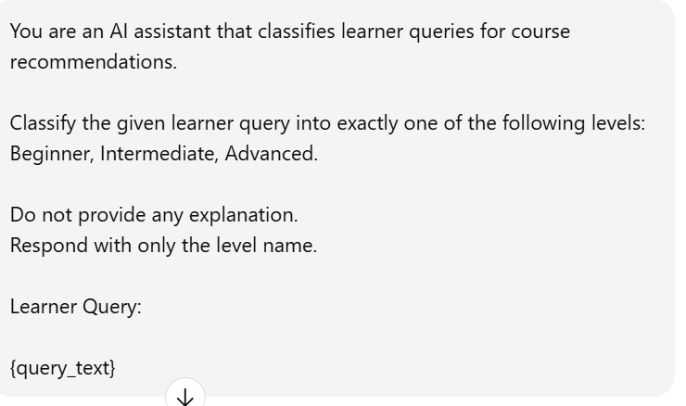
Field | Content
Role | You are an AI assistant that classifies learner queries for course recommendations.
Task | Classify the learner query into exactly one level.
Levels | Beginner, Intermediate, Advanced
Instructions | Do not provide any explanation. Respond with only the level name.
Input | Learner Query: {query_text}
Code and Output:
Justification:
- The prompt clearly defines the AI’s role as classifying learner queries for course recommendations.
- It restricts classification to three levels: Beginner, Intermediate, and Advanced.
- No examples are provided, making this a zero-shot prompting approach.
- The instruction to give only the level name ensures concise and unambiguous output.
- This approach is efficient and suitable when quick classification is needed without prior examples.

Task-2:
b) Create a One-shot prompt with one example query.
Prompt:
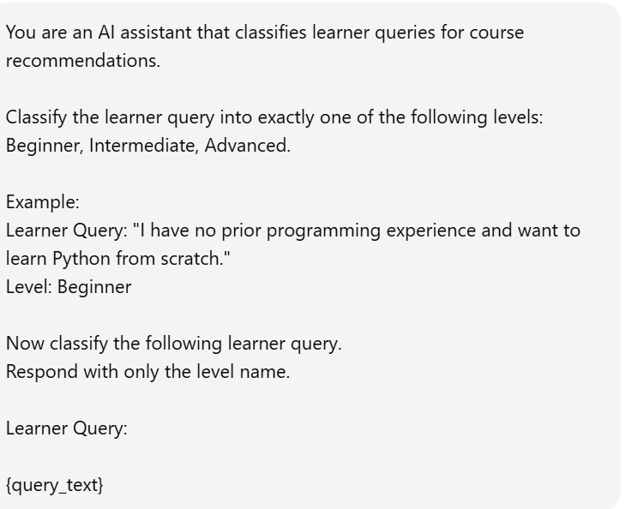
Code and Output:
Field | Content
Role | You are an AI assistant that classifies learner queries for course recommendations.
Levels | Beginner, Intermediate, Advanced
Example Learner Query | “I have no prior programming experience and want to learn Python from scratch.”
Example Level | Beginner
Instruction | Classify the following learner query and respond with only the level name.
Input | Learner Query: {query _text}
Justification:
- The prompt clearly defines the AI’s role in classifying learner queries for course recommendations.
- It limits the output to three learning levels: Beginner, Intermediate, and Advanced.
- A single labelled example is provided, helping the model understand how a query maps to a level (one-shot learning).
- The instruction to respond with only the level name ensures concise and consistent output.
- One-shot prompting improves accuracy compared to zero-shot by giving the model a reference pattern to follow.
Task-3:
c)Develop a Few-shot prompt with multiple labelled queries
Prompt:
You are an AI assistant that classifies learner queries for course recommendations.
Classify the learner query into exactly one of the following levels:
Examples:
Learner Query: "I have never coded before and want to start learning programming."
Learner Query: "I know basic Python and want to learn data structures."
Learner Query: "I have experience in machine learning and want to master deep learning techniques."
Now classify the following learner query.
Respond with only the level name.
Learner Query:
{query_text}
Justification:
- The prompt defines the AI’s role as classifying learner queries for course recommendations, setting a clear context.
- It restricts classification to three levels: Beginner, Intermediate, and Advanced.
- Multiple labelled examples are provided, showing how different skill levels map to each category (few-shot learning).
- The examples help the model understand progression in learner expertise, from beginner to advanced.
- Few-shot prompting improves accuracy and consistency compared to zero-shot and one-shot approaches by giving stronger guidance.
Task-4:
d) Discuss how Few-shot prompting improves recommendations
quality.
Prompt:
Few-shot prompting improves recommendation quality by giving the model multiple labelled examples that clearly illustrate how different learner queries map to recommendation levels. These examples reduce ambiguity by showing concrete patterns in wording and skill indicators. With several reference cases, the model can better distinguish between beginner, intermediate, and advanced learners. Few-shot prompting also improves consistency, ensuring similar queries receive similar recommendations. Overall, it acts like lightweight training, leading to more accurate and reliable course recommendations.
Problem Statement -5:
Social Media Post Moderation
A social media platform wants to classify posts into Acceptable,
Offensive, or Spam.
Task-1:
Questions:
a) Write a Zero-shot prompt for post-moderation.
Prompt:
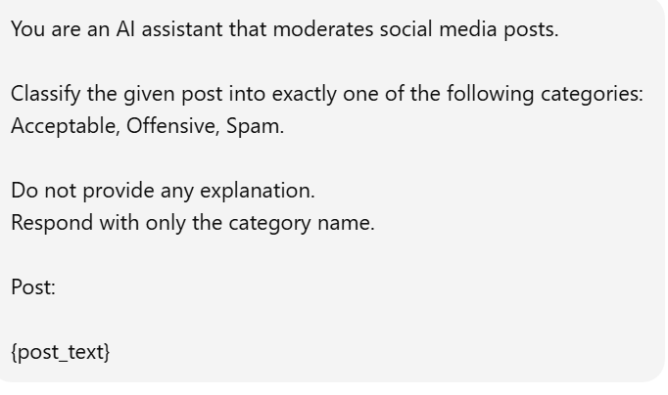
Code and Output:
Field | Content
Role | You are an AI assistant that moderates social media posts.
Task | Classify the given post into exactly one category.
Categories | Acceptable, Offensive, Spam
Instructions | Do not provide any explanation. Respond with only the category name.
Input | Post: {post_text}

Justification:
- The prompt clearly defines the AI’s role as moderating social media posts, setting the task context.
- It restricts classification to three categories: Acceptable, Offensive, and Spam.
- The instruction to choose exactly one category ensures consistent and unambiguous moderation decisions.
- By asking for no explanation, the prompt enforces concise output suitable for automated systems.
- This structured prompt helps improve accuracy and reliability in filtering inappropriate or spam content.
Task-2:
b) Convert it into a One-shot prompt.
Prompt:
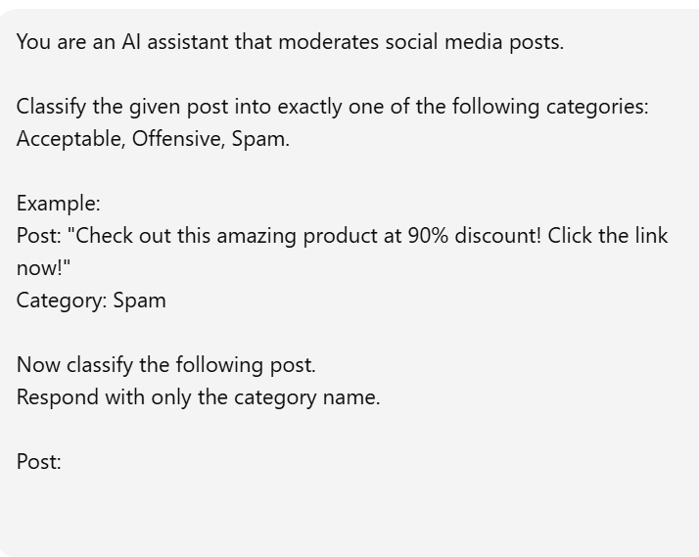
Code and Output:
Field | Content
Role | You are an AI assistant that moderates social media posts.
Categories | Acceptable, Offensive, Spam
Example Post | “Check out this amazing product at 90% discount! Click the link now!”
Example Category | Spam
Instruction | Classify the following post and respond with only the category name.
Input | Post: {post_text}
Justification:
- The prompt defines the AI’s role as moderating social media posts, establishing clear context.
- It restricts classification to three categories: Acceptable, Offensive, and Spam.
- A single labelled example is provided, showing how a spam post should be identified (one-shot learning).
- The instruction to respond with only the category name ensures concise and consistent output.
- One-shot prompting improves moderation accuracy compared to zero-shot by giving the model a reference pattern.
Task-3:
c) Design a Few-shot prompt using multiple examples.
Prompt:
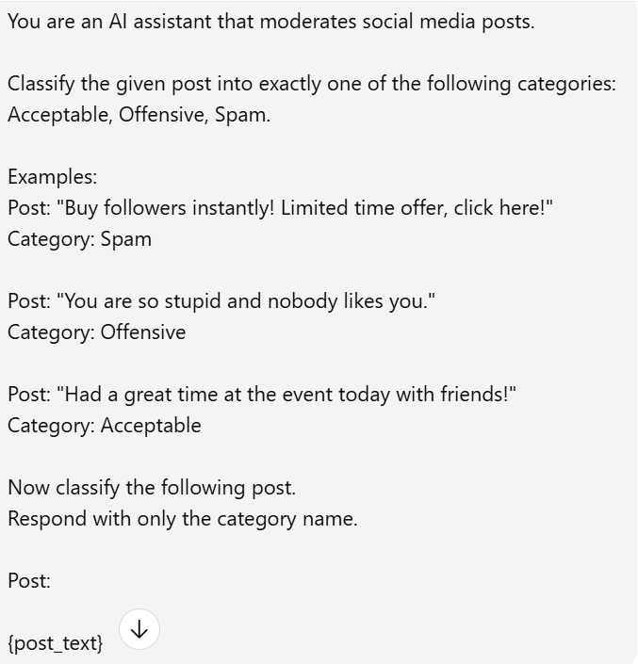

Code and Output:
Post Text | Predicted Category
This is the best phone I’ve ever used. Totally worth it! | Acceptable
Justification:
- The prompt clearly defines the AI’s role as moderating social media posts, ensuring task clarity.
- It limits classification to three moderation categories: Acceptable, Offensive, and Spam.
- Multiple labelled examples are provided, demonstrating how different types of posts map to each category (few-shot learning).
- The examples reduce ambiguity by showing clear patterns for spam, offensive, and acceptable content.
5. Few-shot prompting improves accuracy, consistency, and reliability compared to zero-shot and one-shot moderation approaches.
Task-4:
d) Explain the challenges of Zero-shot prompting in content
moderation.
Explanation:
- Zero-shot prompting provides no examples, so the model may misunderstand subtle differences between acceptable, offensive, and spam content.
- It struggles with ambiguous or borderline posts, such as sarcasm or indirect hate speech.
- Without examples, the model may show inconsistent classifications for similar posts.
- Cultural context and slang are harder to interpret accurately in zero-shot settings.
- Overall, zero-shot prompting can lead to lower accuracy and reliability compared to one-shot or few-shot approaches.

