WEEK-ASS-5.3
2303A51789
Batch-28
TASK-1:
AI tools can sometimes generate insecure authentication logic.
Task Description
Use an AI tool to generate a simple login system in Python. Analyse the generated code to check:
- Whether credentials are hardcoded
- Whether passwords are stored or compared in plain text
- Whether insecure logic is used
Then, revise the code to improve security (e.g., avoid hardcoding, use input validation).
Prompt:
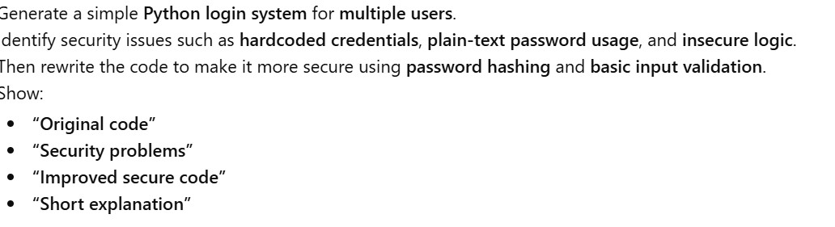
Code and Output:
AI-generated login code
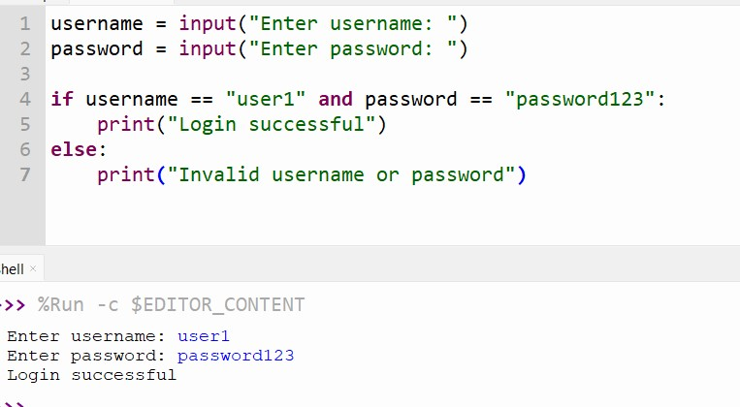
Identification of security risks 1. Hardcoded Credentials if username == "user1" and password == "admin123":
- The username and password are written directly in the source code.
- Anyone who sees the code can know the login credentials.

2. Plain Text Password Handling
- The password is entered, stored, and compared in plain text.
- If the code or memory is exposed, the password can be easily stolen.

3. Single User Only
- The system supports only one fixed user.
- Not scalable and not suitable for real applications.

4. No Input Validation
- Empty usernames or passwords are allowed.
- No checks for invalid or unexpected input.

5. Insecure Authentication Logic
- Direct string comparison for passwords.
- No protection against brute-force attacks.

6. No Error Handling or Logging
- The system does not handle unexpected errors.
- No audit or security logging.

➢ Revised secure version of the code

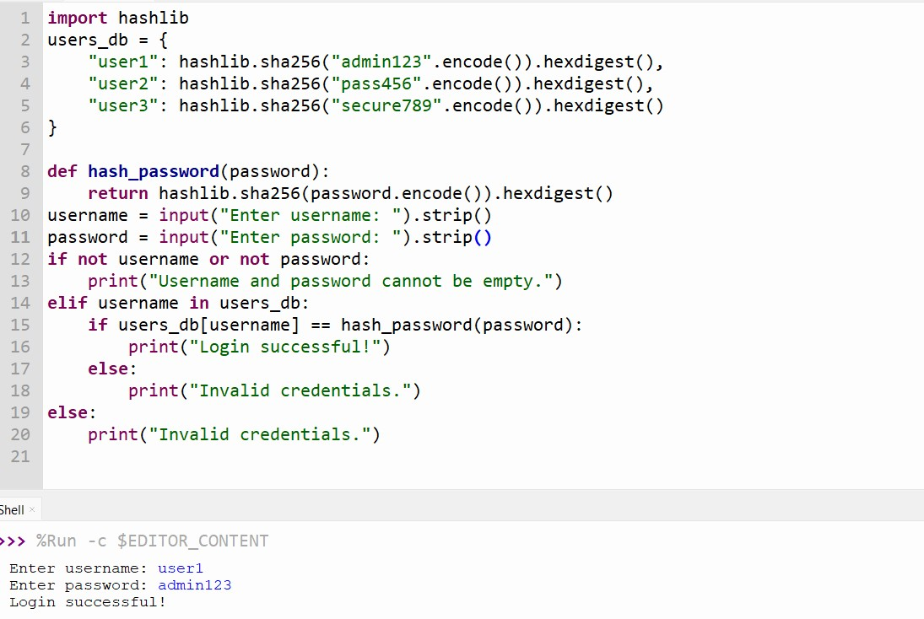

Explanation:
- Removed hardcoded credentials: Usernames and passwords are no longer directly checked in if statements.
- Password hashing used: Passwords are hashed before storage and comparison, so plain-text passwords are not exposed.
- Multiple user support: The system now works for more than one user.
- Input validation added: Empty usernames or passwords are rejected.
- Safer authentication logic: Generic error messages prevent revealing whether a username or password is incorrect.
Task-2:
Scenario
AI systems may unintentionally introduce bias.
Task Description
Use AI prompts such as:
- “Create a loan approval system”
- Vary applicant names and genders in prompts Analyse whether:
- The logic treats certain genders or names unfairly
- Approval decisions depend on irrelevant personal attributes Suggest methods to reduce or remove bias.
Expected Output
- Python code generated by AI
- Identification of biased logic (if any)
- Discussion on fairness issues
- Mitigation strategies Prompt:
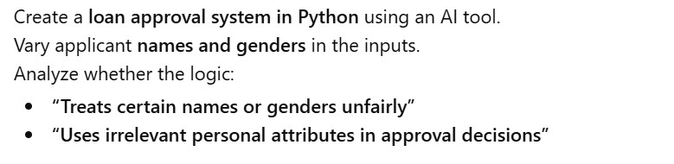
Code and output :
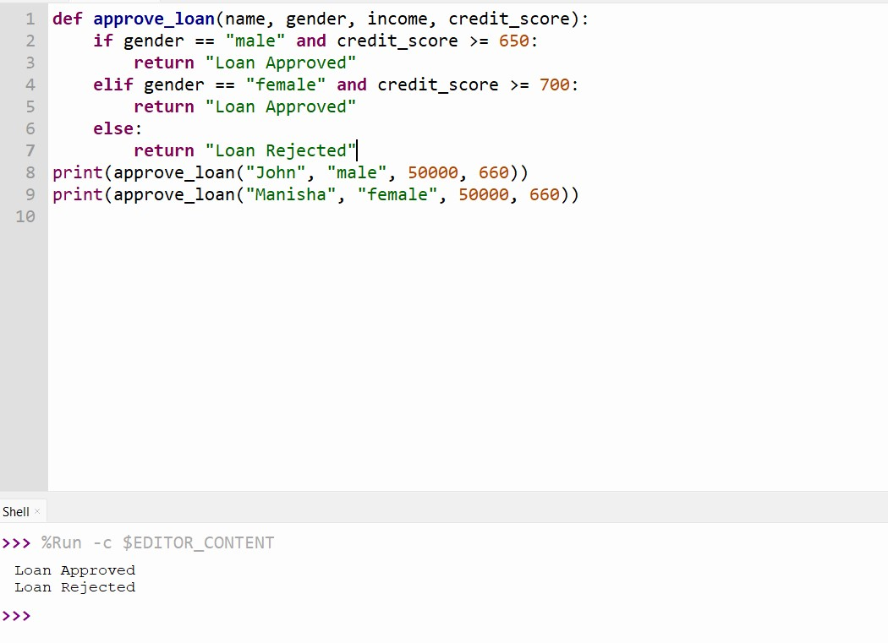

Revised code:
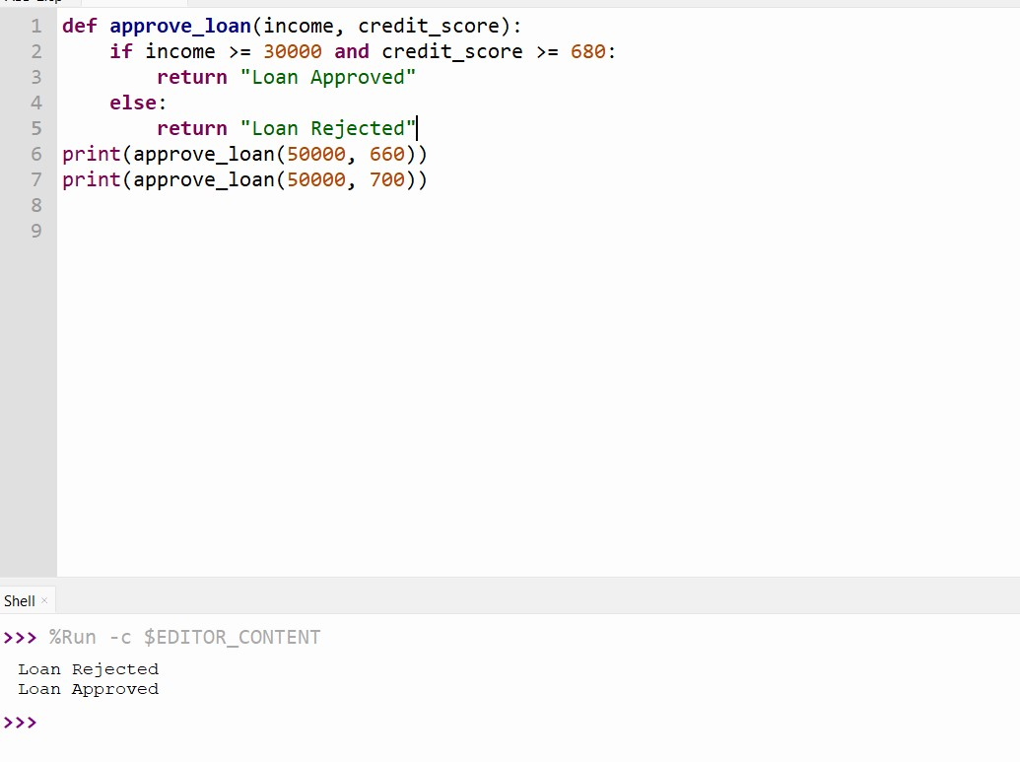
Explanation:
- The AI-generated loan approval system shows bias by treating applicants differently based on gender or name.
- Personal attributes like gender and name are irrelevant to loan repayment ability.
- Applicants with the same income and credit score may receive different decisions, which is unfair.
- Such biased logic can reinforce discrimination and violate ethical and legal fairness principles.
- To reduce bias, remove sensitive attributes (gender, name) from decision-making.
- Use only objective financial factors such as income and credit score.
- Perform regular fairness testing and audits to ensure equal treatment.

Task-3:
AI-generated code should be transparent, well-documented, and easy for humans to understand and verify.
Task Description
Use an AI tool to generate a Python program that:
- Implements Binary Search using recursion • Searches for a given element in a sorted list • Includes:
- Clear inline comments
- A step-by-step explanation of the recursive logic After generating the code, analyse:
- Whether the explanation clearly describes the base case and recursive case

- Whether the comments correctly match the code logic
- Whether the code is understandable for beginner-level students
Expected Output
- Python program for recursive binary search
- AI-generated comments and explanations
- Student’s assessment on clarity, correctness, and transparency Prompt:
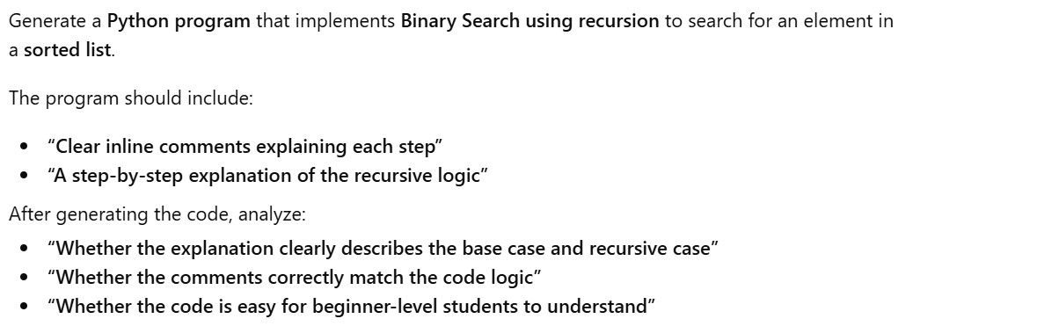

Code and Output:
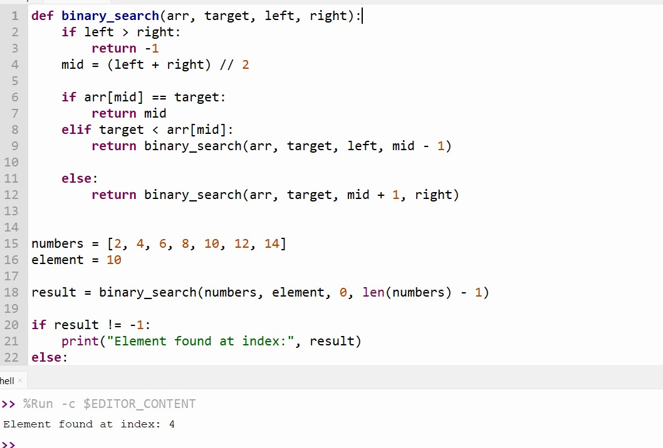
Revised code:
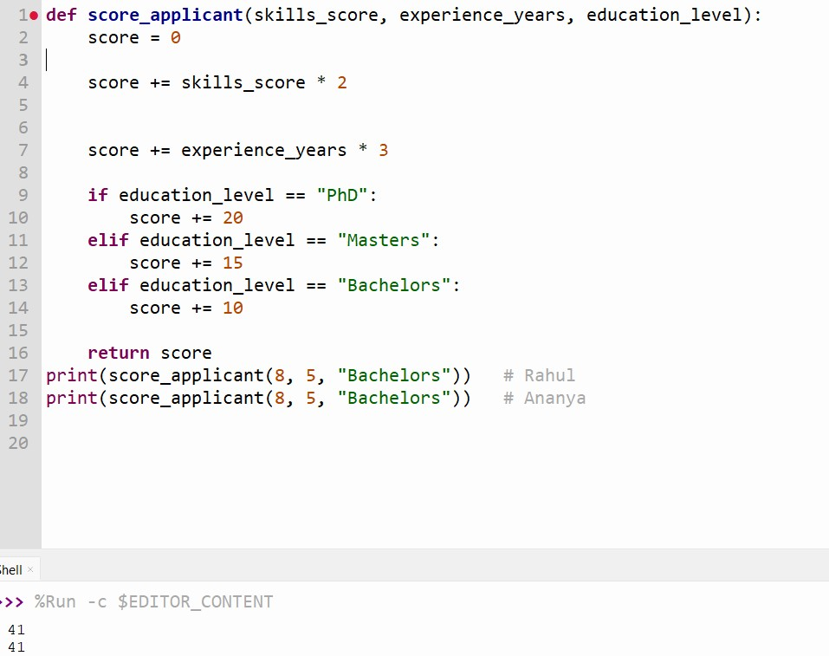

Explanation:
- Binary Search works on a sorted list by repeatedly dividing the search space into two halves.
- The base case occurs when the left index becomes greater than the right index, meaning the element is not present.
- The middle element is calculated using (left + right) // 2.
- If the middle element matches the target, its index is returned.
- If the target is smaller than the middle element, the function recursively searches the left half.
- If the target is larger, the function recursively searches the right half.
- This process continues until the element is found or the base case is reached.
****Student’s assessment on clarity, correctness, and transparency
Clarity
- The code is easy to read and understand.
- Variable names (array, left, right, mid) are clear and meaningful.
- Suitable for beginner-level students.
Correctness
- The base case (left > right) is correctly implemented.
- The recursive cases correctly reduce the search space.
- The algorithm correctly finds the element or reports if it is not found.
Transparency
- Inline comments accurately explain each step of the code.
- The explanation clearly distinguishes between the base case and the recursive case.
- The logic is easy to verify and trace step-by-step.
Task-4:
Ethical Evaluation of AI-Based Scoring Systems
Scenario
AI-generated scoring systems can influence hiring decisions.
Task Description
Ask an AI tool to generate a job applicant scoring system based on features such as:
- Skills
- Experience
- Education
Analyse the generated code to check:
- Whether gender, name, or unrelated features influence scoring
- Whether the logic is fair and objective
Expected Output
- Python scoring system code
- Identification of potential bias (if any)
- Ethical analysis of the scoring logic
Prompt:
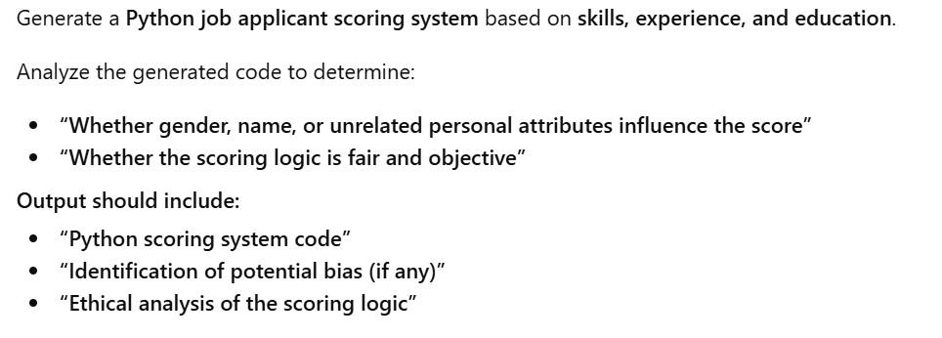

Code and Output:
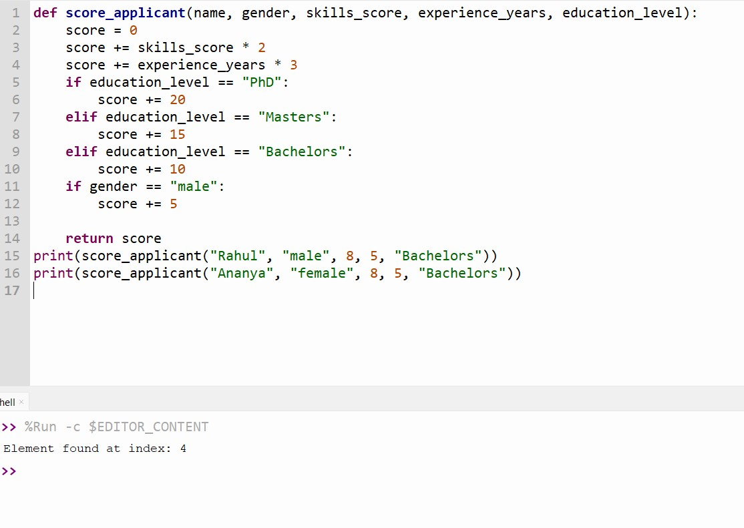
Identification of Potential Bias
- The scoring logic adds extra points based on gender, which is unrelated to job performance.
- Applicants with identical skills, experience, and education receive different scores.
- Gender and name are irrelevant attributes and should not influence hiring decisions.
- This introduces systematic bias favouring one group over another.
Ethical Analysis of the Scoring Logic
- The system violates fairness and equal opportunity principles.
- Using gender in scoring can reinforce workplace discrimination.
- Such logic may lead to unethical hiring decisions and legal risks.
- AI systems used in hiring must be transparent, objective, and justifiable.
- Decisions should be based only on job-relevant criteria.

Explanation:
- The AI-generated job applicant scoring system may introduce bias if it uses personal attributes such as gender or name in scoring.
- These attributes are irrelevant to job performance and should not influence hiring decisions.
- When applicants with the same skills, experience, and education receive different scores, the system becomes unfair and discriminatory.
- Such bias can lead to ethical concerns, including unequal opportunity and potential legal violations.
- AI systems used in hiring must be transparent, objective, and explainable.
- To ensure fairness, scoring should rely only on job-relevant factors like skills, experience, and education.
- Regular audits and bias testing can help detect and reduce unfair outcomes.
Task-5:
Inclusiveness and Ethical Variable Design
Scenario
Inclusive coding practices avoid assumptions related to gender, identity, or roles and promote fairness in software design.
Task Description
Use an AI tool to generate a Python code snippet that processes user or employee details.
Analyse the code to identify:
- Gender-specific variables (e.g., male, female)
- Assumptions based on gender or identity
Prompt:
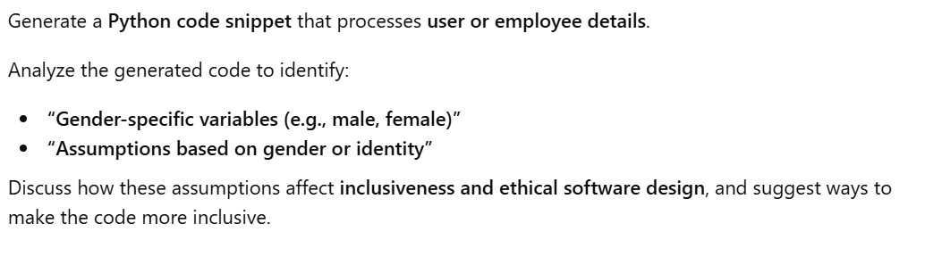
Code and output:
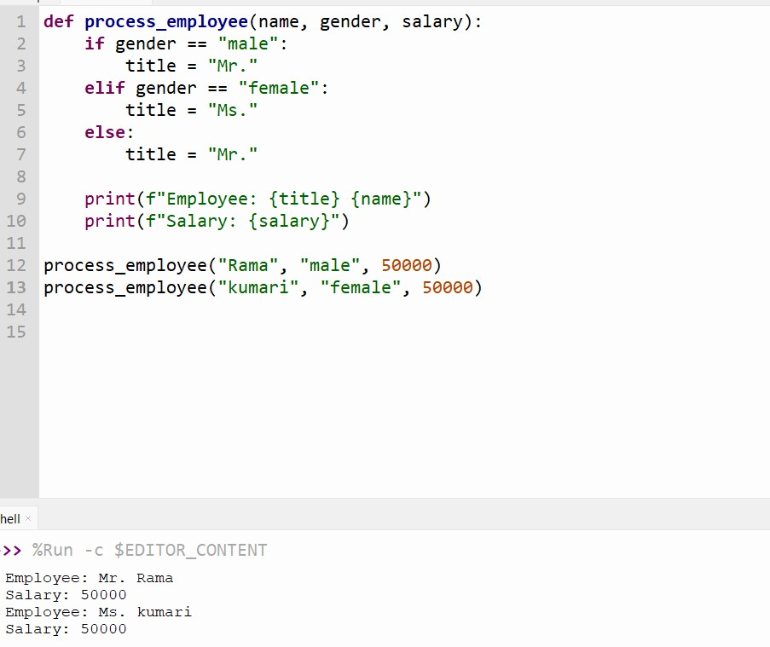

Revised code:
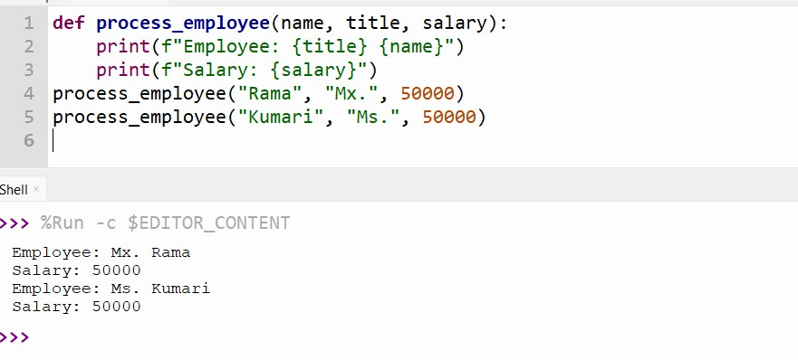
Explanation:
- The code uses a gender-specific variable with only binary values: male and female.
- Titles such as Mr. and Ms. are assigned based on gender, making the code genderdependent.
- The code assumes all users fit into binary gender categories, excluding non-binary identities.
- A default masculine title is used, which reinforces gender bias.
- These assumptions ignore personal identity and user preference.
- Such design reduces inclusiveness and can lead to discrimination or discomfort.
- Ethical software design should avoid unnecessary gender-based logic and promote fairness and respect.

