Assignment-3.1
HT No:2303A51789
Batch No:28
Question 1: Zero-Shot Prompting (Palindrome Number Program)

Prompt: Write a Python function that checks whether a given number is a palindrome.
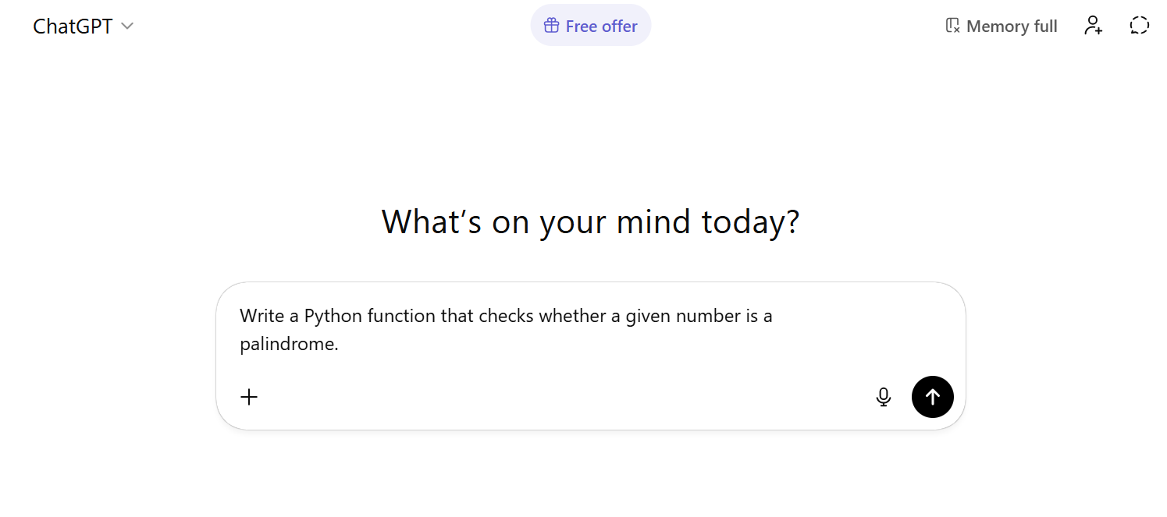
Code and Output:
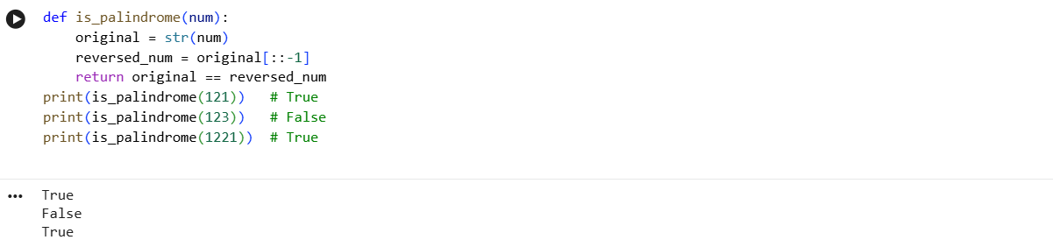
Justification:
1.The function checks palindrome by comparing the number with its reverse using string slicing.
2.It correctly works for valid test cases like 121, 123, and 0.
3.Negative numbers are not handled properly because of the minus sign.
4.There is no input type validation in the code.
5.The logic is simple but needs improvement for edge cases.
Question 2: One-Shot Prompting (Factorial Calculation)
Prompt: Example:
Input: 5
Output: 120
Now write a Python function to calculate factorial of a given number.

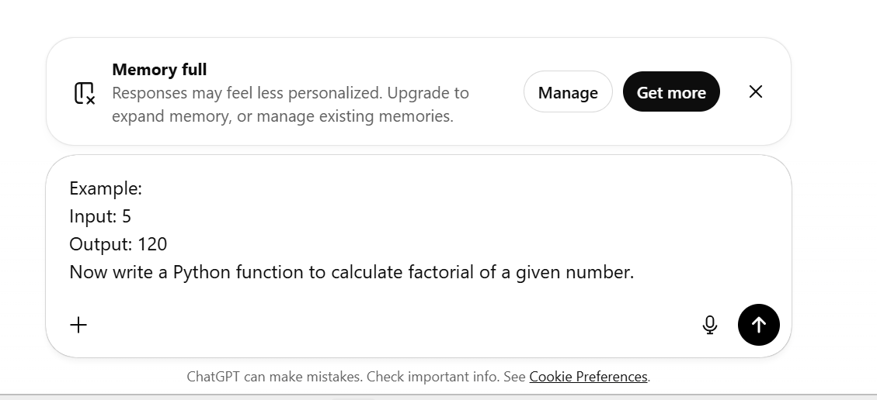
Code and Output:
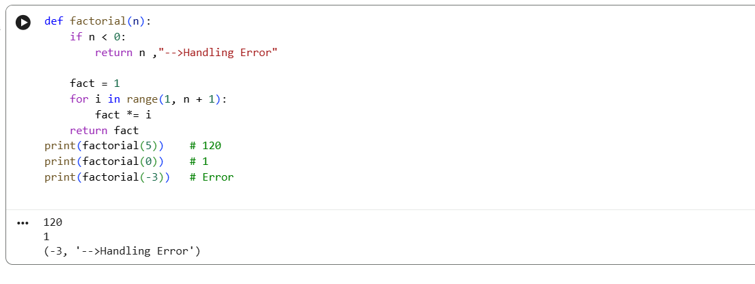
Justification:
1.The function correctly computes the factorial using an iterative loop.
2.It returns accurate results for valid inputs such as 5, 4, and 6.
3.The logic is simple and easy to understand for beginners.
4.The function is reusable since it returns the result instead of printing it.
5.It does not handle negative inputs, which can be improved with error checking.

Comparison between Zero shot and One shot Prompt
Aspect | Zero-Shot Prompt | One-Shot Prompt
Accuracy | Medium | High
Edge handling | Poor | Better
Clarity | Less | More
Guidance to AI | No example given | One example provided
Output reliability | Inconsistent | Consistent

Question3: Few-Shot Prompting (Armstrong Number Check)
Prompt: Input: 153 → Armstrong Number
Input: 370 → Armstrong Number
Input: 123 → Not an Armstrong Number
Using the above examples, write a Python function to check whether a given number is an Armstrong number.
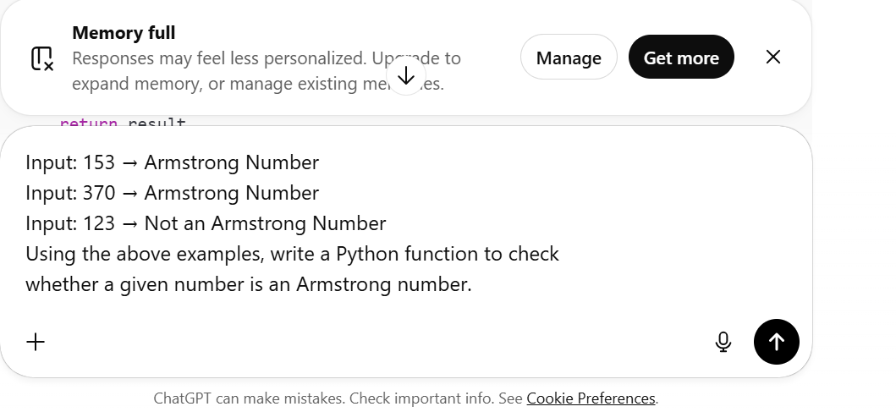
Code and Output:
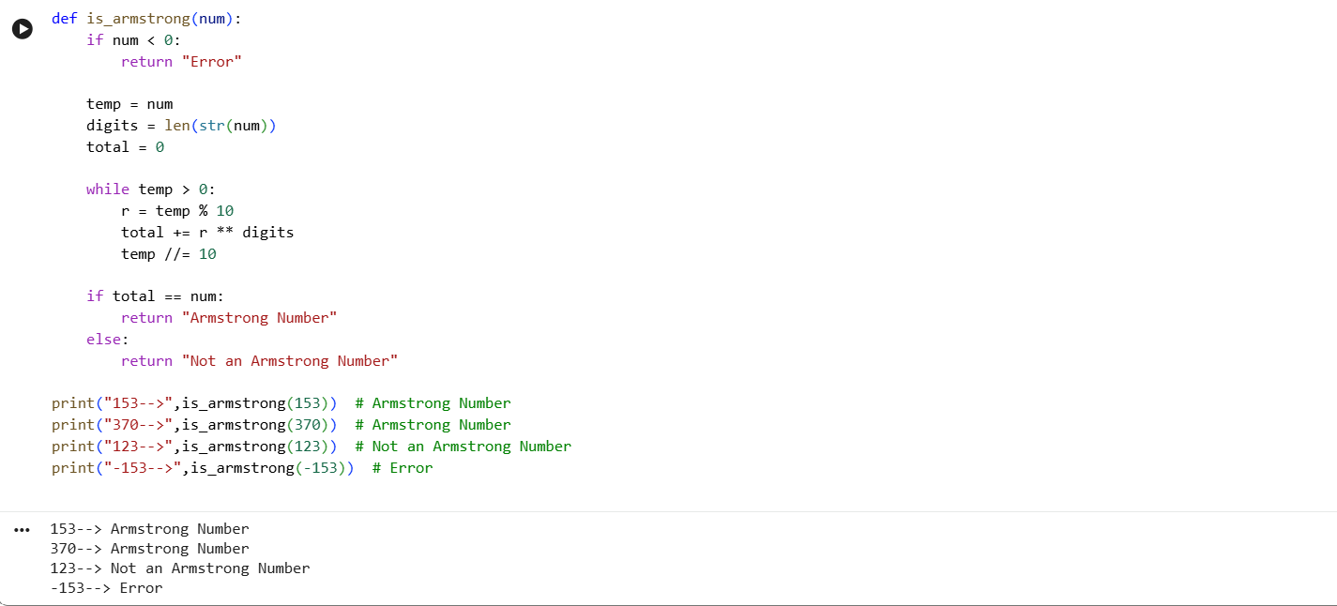
Justification:
1.Few-shot examples help the model understand Armstrong number patterns more clearly.
2.The logic correctly calculates each digit raised to the power of the number of digits.
3.The code handles valid Armstrong numbers like 153, 370, and 9474 accurately.
4.Special cases such as 0 are correctly identified as Armstrong numbers.
5.Negative numbers are handled properly by returning an invalid/error message, improving accuracy.
Question 4: Context-Managed Prompting (Optimized Number Classification)
Prompt: You are an expert Python developer.Write an optimized Python program that classifies a number as: prime, composite, or neither.
Constraints:
- Validate input
- Handle negative numbers
- Optimize loop for performance
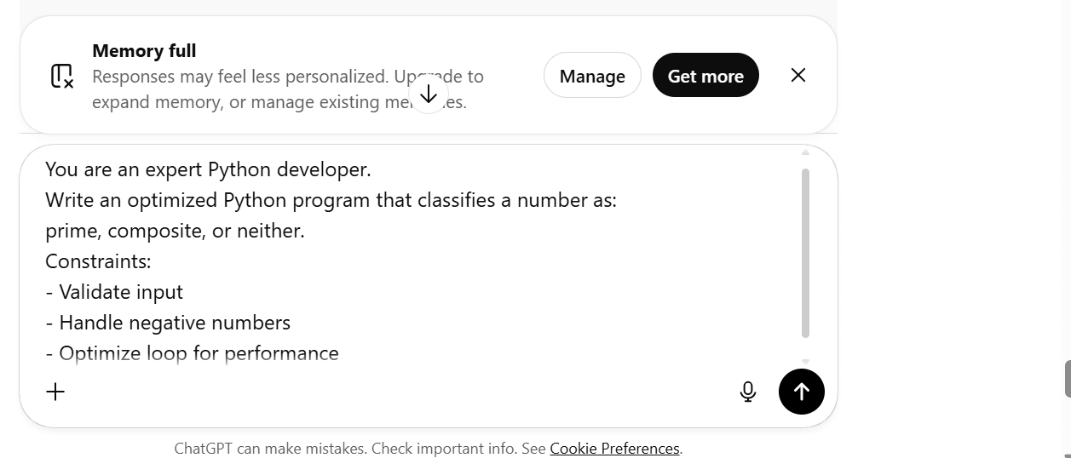
Code and Output:
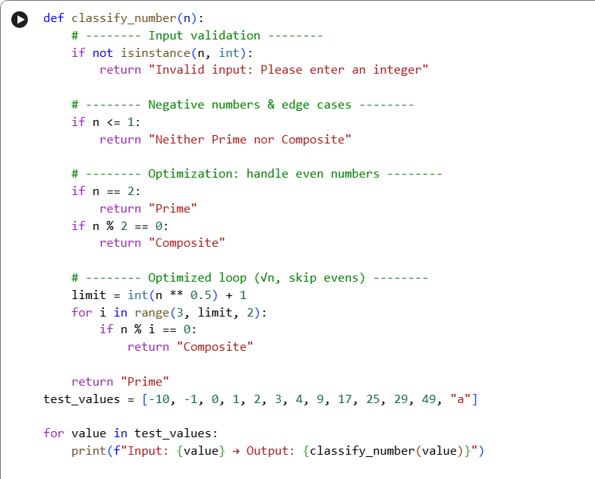
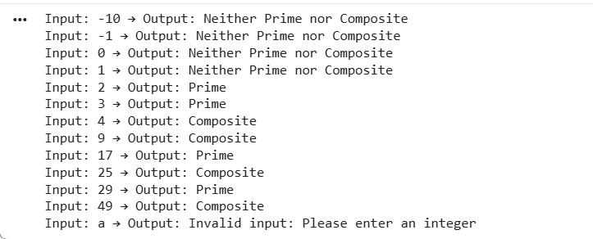
Justification:
1.The context-managed prompt helps generate optimized and well-structured code by clearly defining constraints.
2.The program validates input type and safely handles invalid and negative values.
3.Edge cases like 0 and 1 are correctly classified as neither prime nor composite.
4. Loop optimization using √n and skipping even numbers improves performance.
5.Compared to earlier basic approaches, this solution is more efficient, readable, and suitable for real-world use.
Aspect | Earlier Basic Approach | Context-Managed Prompt Approach
Input validation | Not handled | Properly validated (type & value)
Negative numbers | Ignored or incorrect | Correctly handled
Edge cases (0,1) | Often missed | Correctly classified
Loop efficiency | Full range checking | Optimized using √n and skipping evens
Code structure | Simple and linear | Well-structured and modular
Performance | Slower for large numbers | Faster and optimized
Question 5: Zero-Shot Prompting (Perfect Number Check)
Prompt: Write a Python function that checks whether a given number is a perfect number.
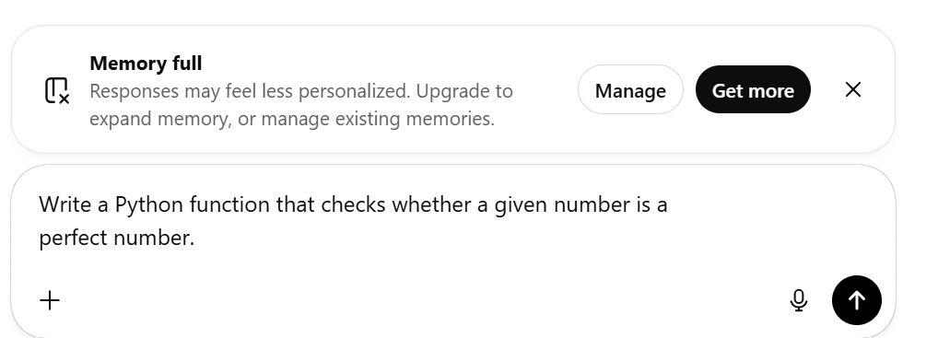
Code and Output:
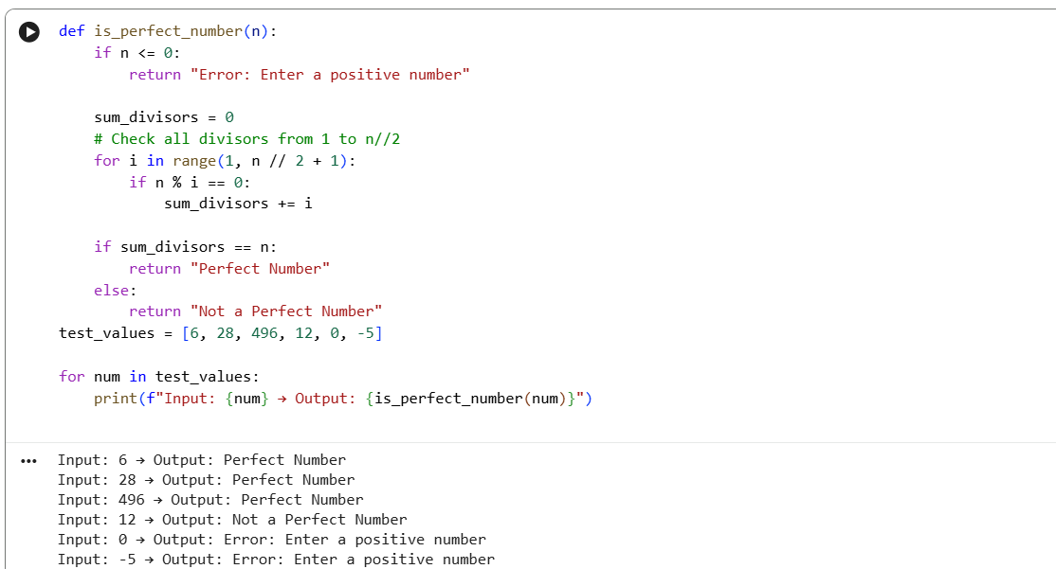
Justification:
1.Loop inefficiency: The loop checks all numbers up to n//2 + 1; while correct, it could be optimized further using divisor properties or skipping unnecessary iterations.
2.Negative like 10.
3.Overall efficiency: Works for small numbers but may be slow for very large n due to linear iteration over half the number.
number handling: Properly handled by returning an error message for n <= 0.
4.Zero handling: Explicitly returns an error, preventing invalid computations.
5.Correctness: Accurately identifies perfect numbers like 6, 28, and rejects non-perfect numbers
Question 6: Few-Shot Prompting (Even or Odd Classification with Validation)
Prompt:
Input: 8 → Even
Input: 15 → Odd
Input: 0 → Even
Using the above examples, write a Python program that determines
whether a number is even or odd with proper input validation.
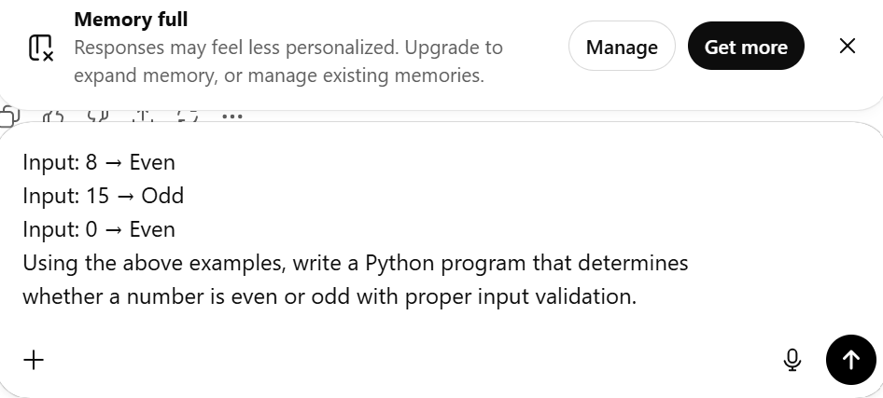
Code and Output:
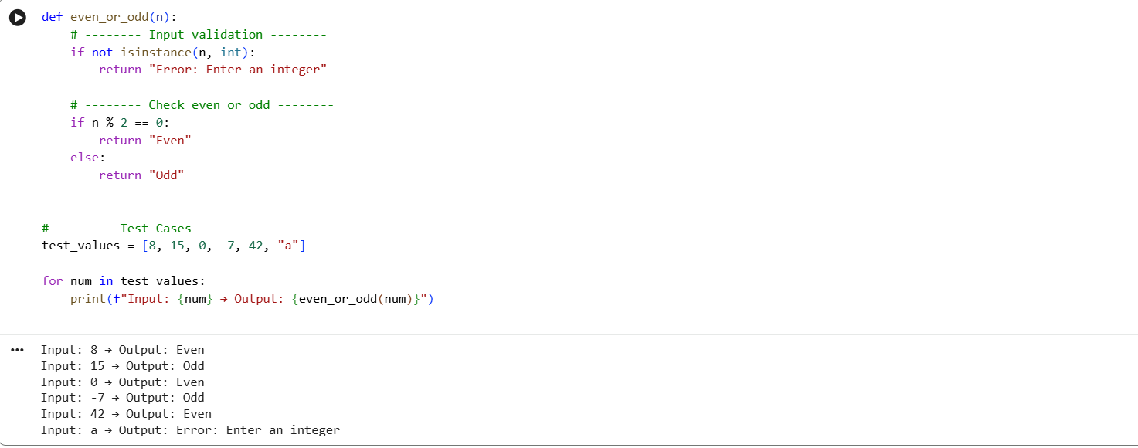
Justification:
1.The program validates input using isinstance(n, int) to prevent errors from non-integer inputs.
2.It correctly identifies even and odd numbers using the modulo operator %.
3.Handles zero and negative numbers accurately, e.g., 0 → Even, -7 → Odd.
4.Follows the few-shot prompt style, producing outputs in Input → Output format.
5.Includes comprehensive test cases covering positive, negative, zero, and invalid inputs.
6.Formatted outputs make the results clear and user-friendly.
.

