2303A51797
Batch:26
Task 1: Smart Contact Manager (Arrays & Linked Lists)
Scenario
SR University’s student club requires a simple Contact Manager Application
to store members’ names and phone numbers. The system should support
efficient addition, searching, and deletion of contacts.
Tasks
1. Implement the contact manager using arrays (lists).
2. Implement the same functionality using a linked list for dynamic
memory allocation.
3. Implement the following operations in both approaches:
o Add a contact
o Search for a contact
o Delete a contact
4. Use GitHub Copilot to assist in generating search and delete methods.
5. Compare array vs. linked list approaches with respect to:
o Insertion efficiency
o Deletion efficiency
Expected Outcome
• Two working implementations (array-based and linked-list-based).
• A brief comparison explaining performance differences.
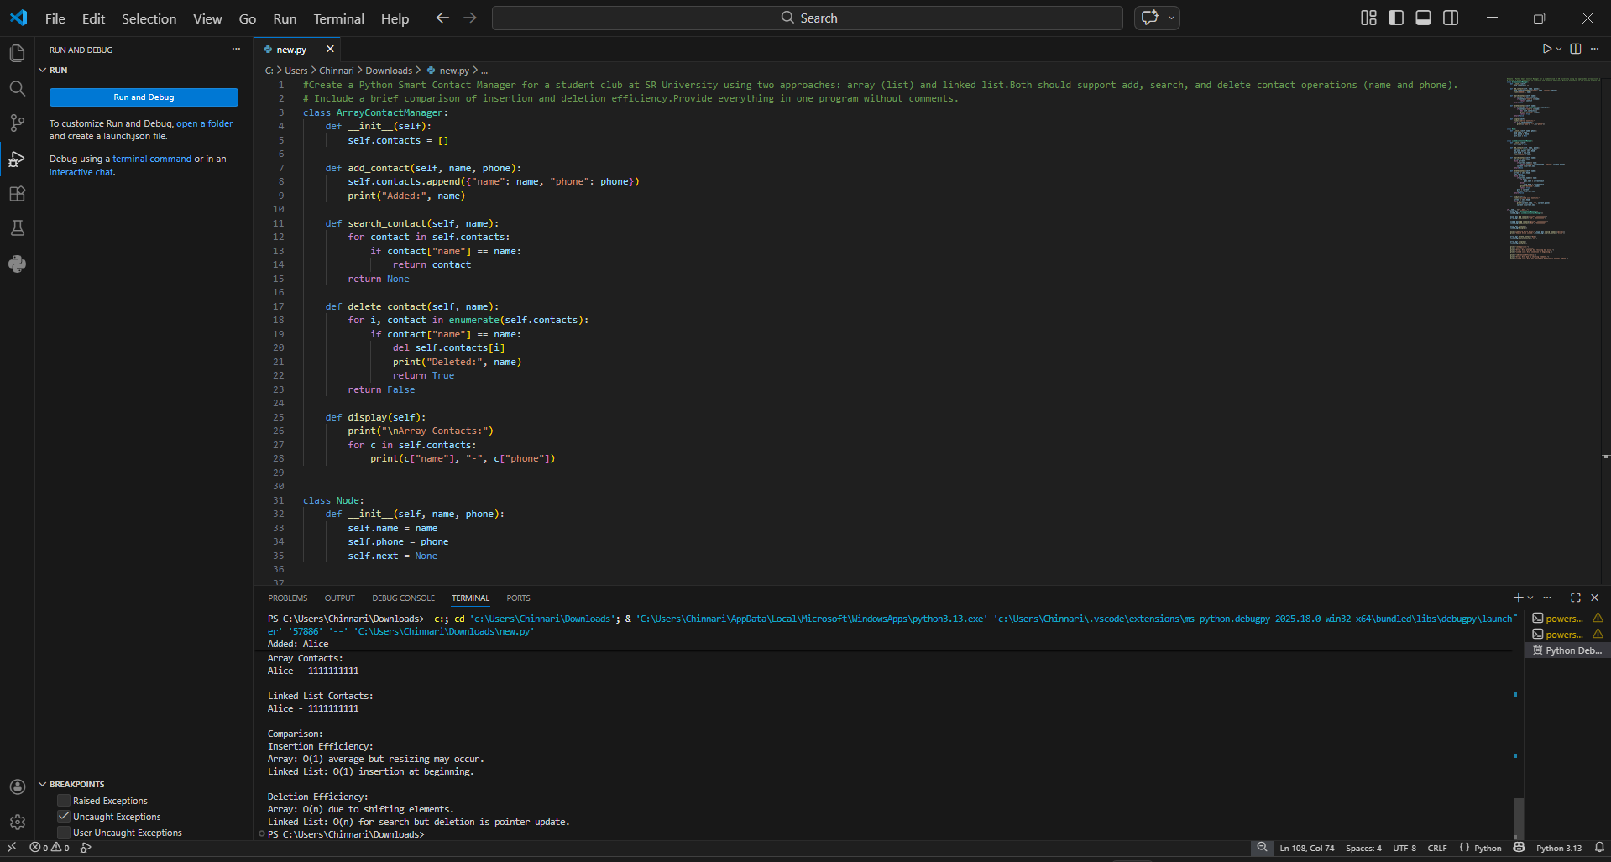

Task 2: Library Book Search System (Queues & Priority Queues)
Scenario
The SRU Library manages book borrow requests. Students and faculty submit
requests, but faculty requests must be prioritized over student requests.
Tasks
1. Implement a Queue (FIFO) to manage book requests.
2. Extend the system to a Priority Queue, prioritizing faculty requests.
3. Use GitHub Copilot to assist in generating:
o enqueue() method
o dequeue() method
4. Test the system with a mix of student and faculty requests.
Expected Outcome
• Working queue and priority queue implementations.
• Correct prioritization of faculty requests
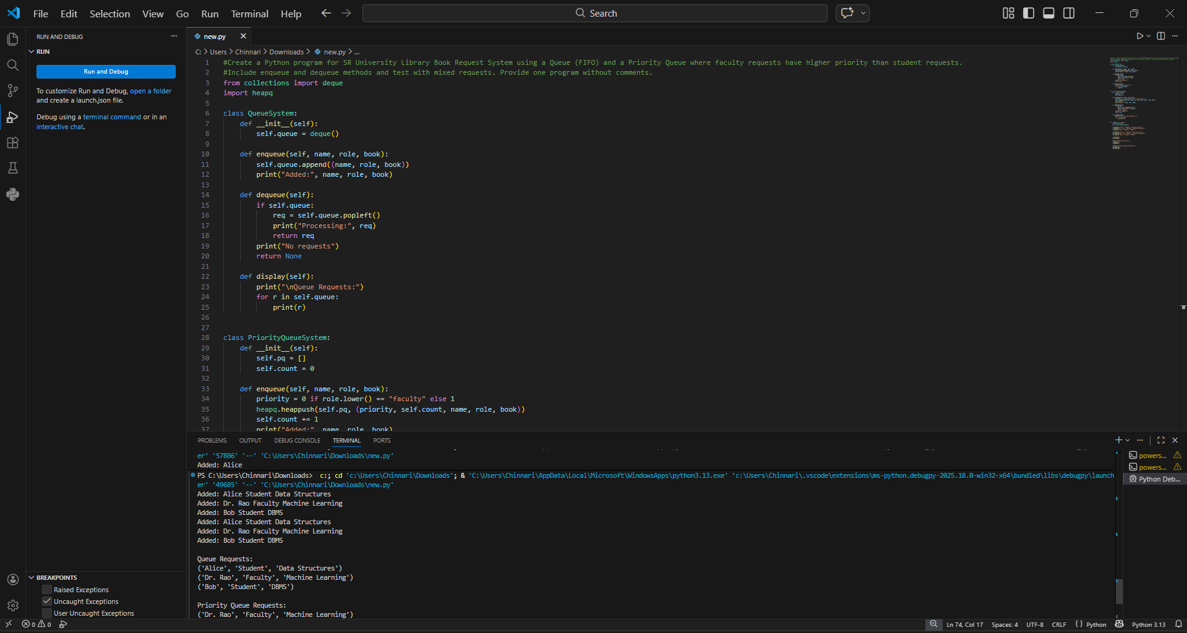
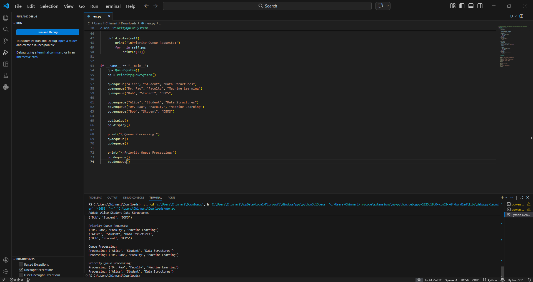
Task 3: Emergency Help Desk (Stack Implementation)
Scenario
SR University’s IT Help Desk receives technical support tickets from students
and staff. While tickets are received sequentially, issue escalation follows a
Last-In, First-Out (LIFO) approach.
Tasks
1. Implement a Stack to manage support tickets.
2. Provide the following operations:
o push(ticket)
o pop()
o peek()
3. Simulate at least five tickets being raised and resolved.
4. Use GitHub Copilot to suggest additional stack operations such as:
o Checking whether the stack is empty
o Checking whether the stack is full (if applicable)
Expected Outcome
• Functional stack-based ticket management system.
• Clear demonstration of LIFO behavior.
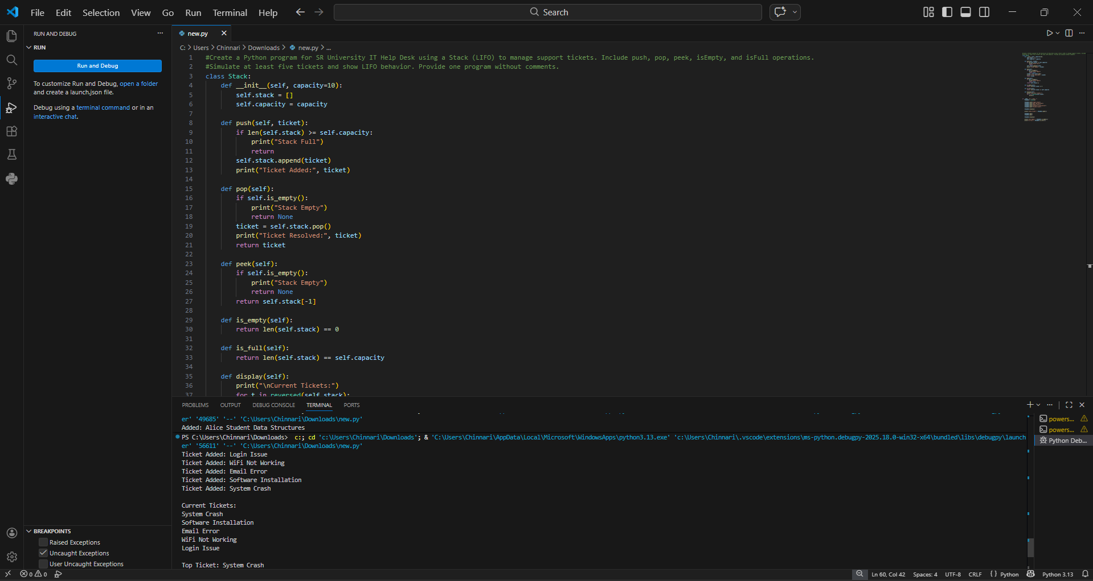
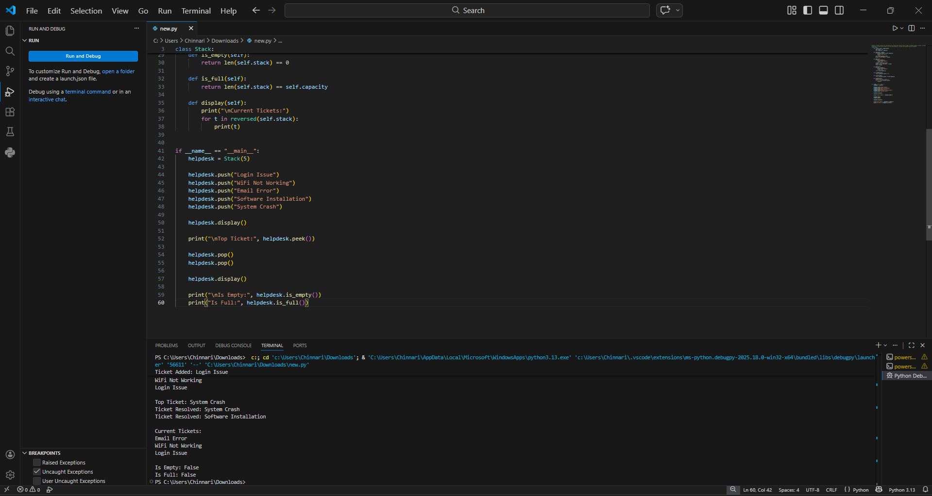
Task 4: Hash Table
Objective
To implement a Hash Table and understand collision handling.
Task Description
Use AI to generate a hash table with:
• Insert
• Search
• Delete
Starter Code
class HashTable:
pass
Expected Outcome
• Collision handling using chaining
• Well-commented methods
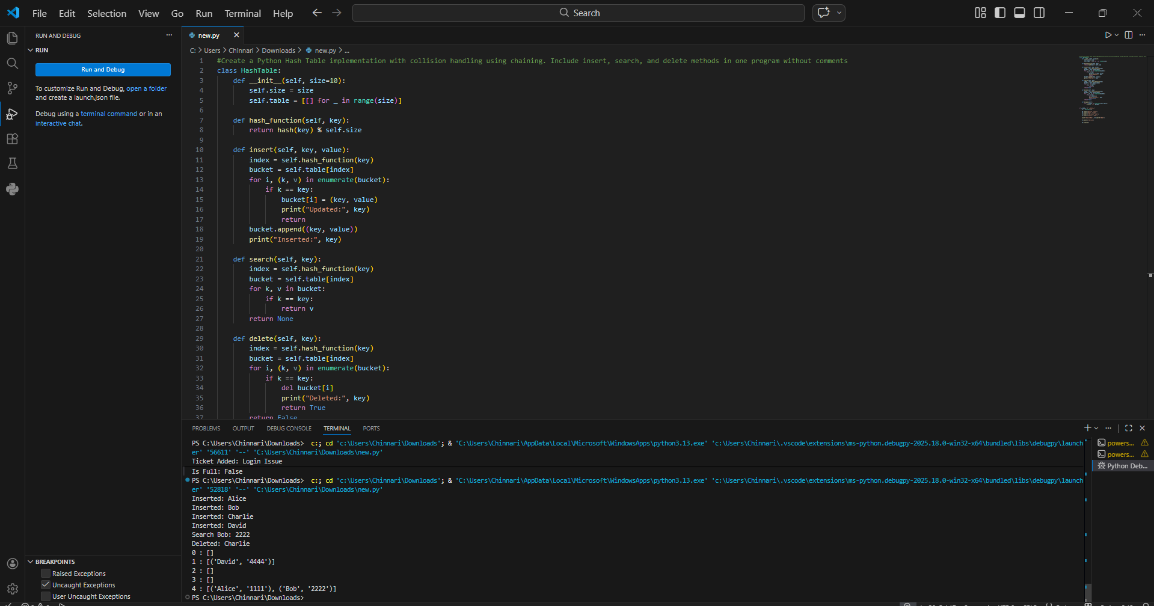
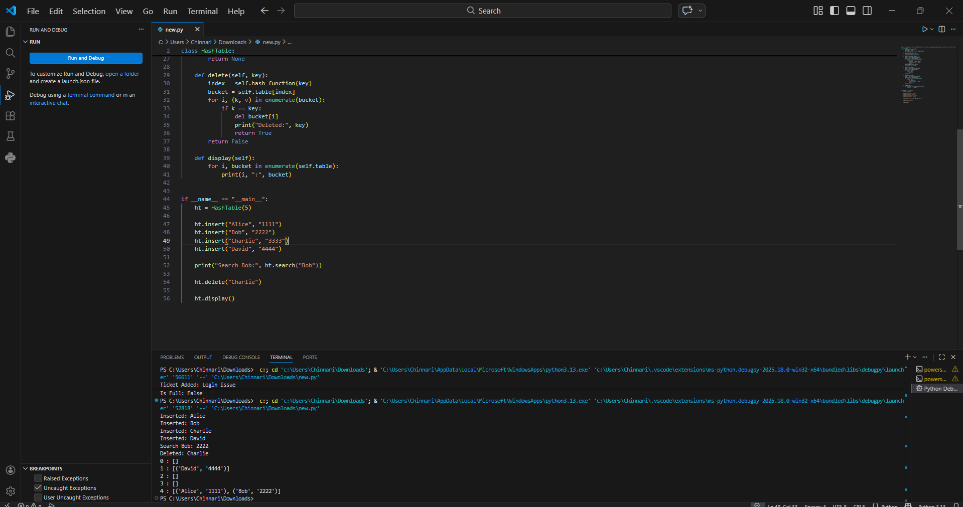
Task 5: Real-Time Application Challenge
Scenario
Design a Campus Resource Management System with the following
features:
• Student Attendance Tracking
• Event Registration System
• Library Book Borrowing
• Bus Scheduling System
• Cafeteria Order Queue
Student Tasks
1. Choose the most appropriate data structure for each feature.
2. Justify your choice in 2–3 sentences.
3. Implement one selected feature using AI-assisted code generation.
Expected Outcome
• Mapping table: Feature → Data Structure → Justification
• One fully working Python implementation
