Assignment-01
2303A51827
P.ABHIRAM REDDY
BATCH 26
Task 1: AI-Generated Logic Without Modularization (Factorial without
Functions)
Prompt: // generate a code to print a factorial of a number

CODE:
import java.util.Scanner; // Used to take input from user

public class Assignment1 {
public static void main(String[] args) {

Scanner scanner = new Scanner(System.in); // Create Scanner object

System.out.print("Enter a number to calculate its factorial: ");
int number = scanner.nextInt(); // Read number from user

long factorial = 1; // Store factorial result

// Loop to multiply numbers from 1 to given number
for (int i = 1; i <= number; i++) {
factorial *= i;
}

// Print the final factorial result
System.out.println("The factorial of " + number + " is: " + factorial);

scanner.close(); // Close scanner
}
}
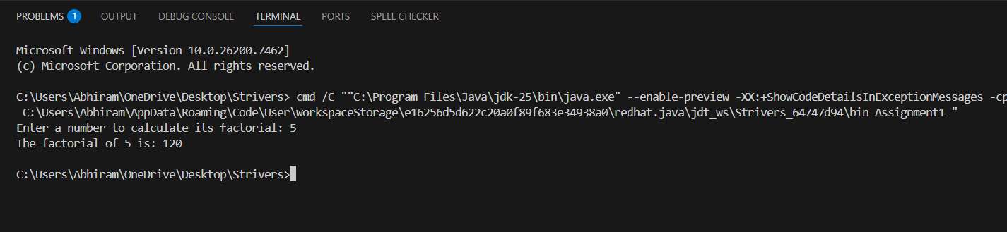
Brief reflection:

1. GitHub Copilot helped me generate the code quickly without writing everything manually.
2.It reduced syntax errors and made the program easier to complete.
3. The suggestions were easy to understand for a beginner.
4.Sometimes Copilot adds extra lines, so checking the code is important.
5.it follows good coding practices but still needs human verification.
6.Overall, Copilot improves speed and learning but should not replace logical thinking

Task 2: AI Code Optimization & Cleanup (Improving Efficiency)
Promot: //Optimize this Java code for factorial of numbers
// by reducing unnecessary variables, simplifying the loop logic, and improving readability and efficiency
Code:
import java.util.*; // Import utility classes like Scanner

public class Assignment1 {
public static void main(String[] args) {

Scanner scanner = new Scanner(System.in); // Create Scanner to take input

System.out.print("Enter a number: ");
int n = scanner.nextInt(); // Read number from user

long factorial = 1; // Variable to store factorial result

// Loop to multiply numbers from 1 to n
for (int i = 1; i <= n; i++) {
factorial *= i;
}

// Display the factorial result
System.out.println("The factorial of " + n + " is: " + factorial);
}
}
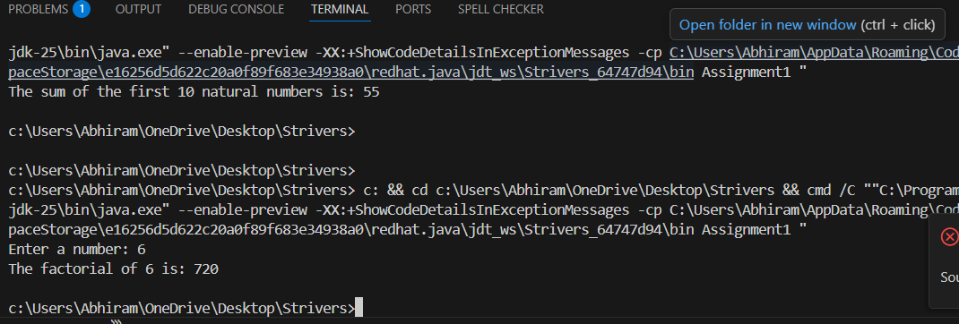
Brief reflection:

1. GitHub Copilot helped me generate the code quickly without writing everything manually.
2.It reduced syntax errors and made the program easier to complete.
3. The suggestions were easy to understand for a beginner.
4.Sometimes Copilot adds extra lines, so checking the code is important.
5.it follows good coding practices but still needs human verification.
6.Overall, Copilot improves speed and learning but should not replace logical thinking

Task 3: Modular Design Using AI Assistance (Factorial with Functions)
Prompt: //Generate a modular Java program to calculate factorial using a user-defined function with meaningful variable names, inline comments, and call the function from the main method.

Code:
import java.util.Scanner;
public class Assignment1 {

// Function to calculate factorial of a number
public static long calculateFactorial(int number) {
long factorial = 1; // Initialize factorial to 1
// Loop from 1 to the given number
for (int i = 1; i <= number; i++) {
factorial *= i; // Multiply factorial by the current number
}
return factorial; // Return the calculated factorial
}

public static void main(String[] args) {
Scanner scanner = new Scanner(System.in); // Create a Scanner object for user input

System.out.print("Enter a non-negative integer to calculate its factorial: ");
int userInput = scanner.nextInt(); // Read user input

// Check if the input is a non-negative integer
if (userInput < 0) {
System.out.println("Factorial is not defined for negative numbers.");
} else {
long result = calculateFactorial(userInput); // Call the function to calculate factorial
System.out.println("The factorial of " + userInput + " is: " + result); // Display the result
}

scanner.close(); // Close the scanner
}
}

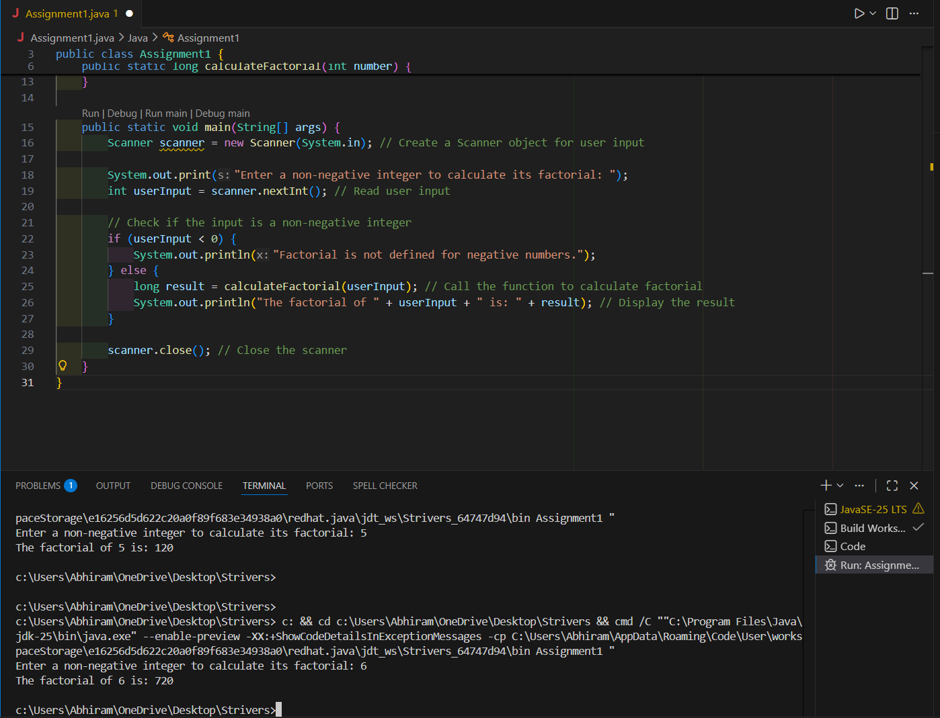

1. GitHub Copilot helped me generate the code quickly without writing everything manually.
2.It reduced syntax errors and made the program easier to complete.
3. The suggestions were easy to understand for a beginner.
4.Sometimes Copilot adds extra lines, so checking the code is important.
5.it follows good coding practices but still needs human verification.
6.Overall, Copilot improves speed and learning but should not replace logical thinking

Task 4: Comparative Analysis – Procedural vs Modular AI Code (With vs
Without Functions)
Prompt: //Create a comparison between a non-function Java program and a function-based Java program based on logic clarity, reusability, debugging ease, suitability for large projects, and AI dependency risk in a table or short technical report.
Code:
import java.util.Scanner;

public class Assignment1 {

// Function to calculate factorial of a number
public static long calculateFactorial(int number) {
long factorial = 1; // Initialize factorial to 1
// Loop from 1 to the given number
for (int i = 1; i <= number; i++) {
factorial *= i; // Multiply factorial by the current number
}
return factorial; // Return the calculated factorial
}

public static void main(String[] args) {
Scanner scanner = new Scanner(System.in); // Create a Scanner object for user input

System.out.print("Enter a non-negative integer to calculate its factorial: ");
int userInput = scanner.nextInt(); // Read user input

// Check if the input is a non-negative integer
if (userInput < 0) {
System.out.println("Factorial is not defined for negative numbers.");
} else {
long result = calculateFactorial(userInput); // Call the function to calculate factorial
System.out.println("The factorial of " + userInput + " is: " + result); // Display the result
}

scanner.close(); // Close the scanner
}
}
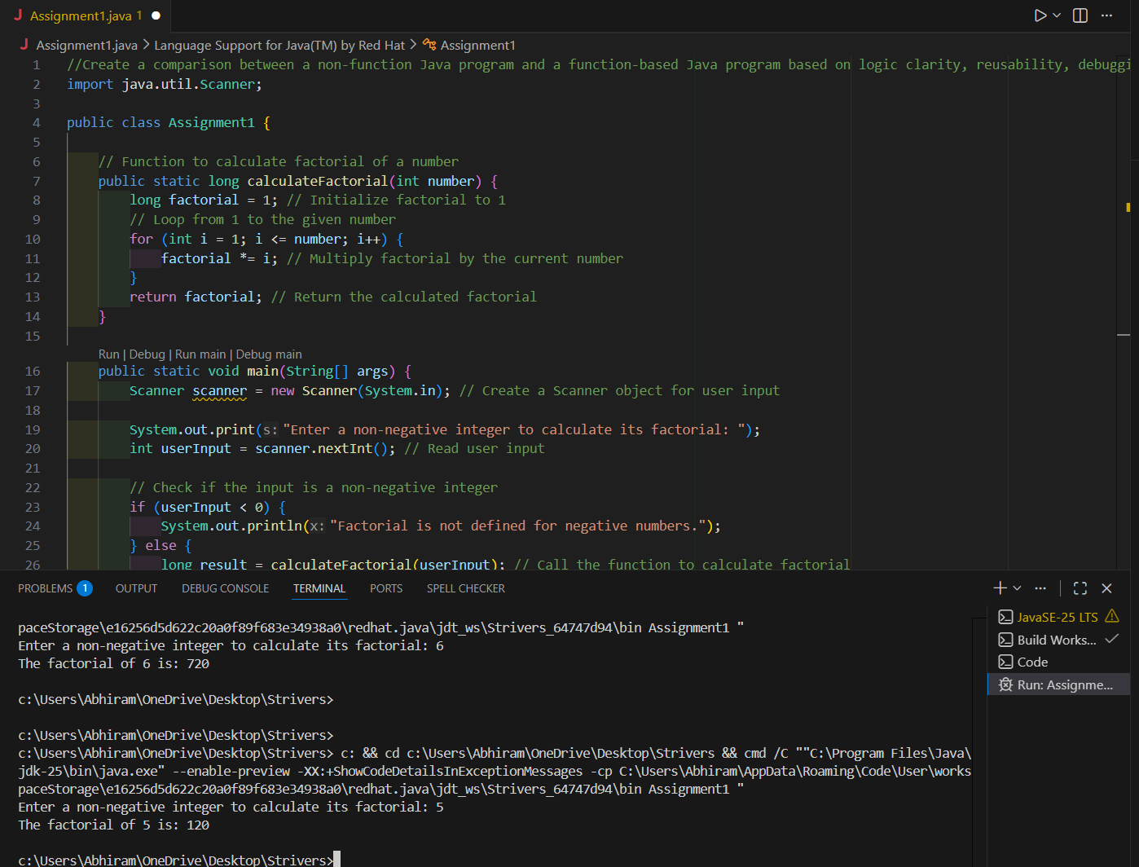

1. GitHub Copilot helped me generate the code quickly without writing everything manually.
2.It reduced syntax errors and made the program easier to complete.
3. The suggestions were easy to understand for a beginner.
4.Sometimes Copilot adds extra lines, so checking the code is important.
5.it follows good coding practices but still needs human verification.
6.Overall, Copilot improves speed and learning but should not replace logical thinking

Task 5: AI-Generated Iterative vs Recursive Thinking
Prompt: Generate two Java implementations of factorial: one iterative using loops and one recursive using a function, both producing identical outputs, with comments and an explanation comparing readability, stack usage, performance, and when recursion is not recommended.
Code:
//Generate two Java implementations of factorial: one iterative using loops and one recursive using a function, both producing identical outputs, with comments and an explanation comparing readability, stack usage, performance, and when recursion is not recommended.
public class Assignment1 {

// Iterative implementation of factorial using loops
public static long factorialIterative(int n) {
long result = 1;
for (int i = 2; i <= n; i++) {
result *= i;
}
return result;
}

// Recursive implementation of factorial using a function
public static long factorialRecursive(int n) {
if (n == 0 || n == 1) {
return 1;
}
return n * factorialRecursive(n - 1);
}

public static void main(String[] args) {
int number = 5; // Example input

// Calculate factorial using iterative method
long iterativeResult = factorialIterative(number);
System.out.println("Iterative Factorial of " + number + " is: " + iterativeResult);

// Calculate factorial using recursive method
long recursiveResult = factorialRecursive(number);
System.out.println("Recursive Factorial of " + number + " is: " + recursiveResult);
}
}

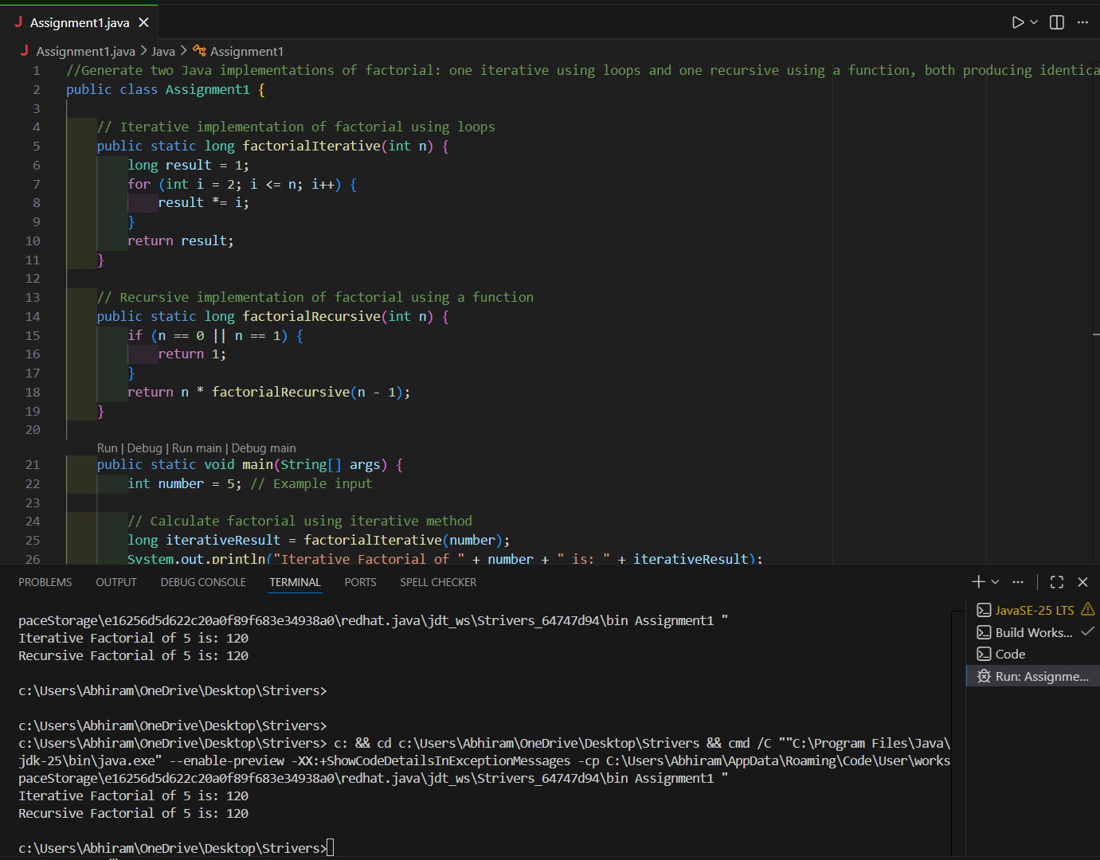

1. GitHub Copilot helped me generate the code quickly without writing everything manually.
2.It reduced syntax errors and made the program easier to complete.
3. The suggestions were easy to understand for a beginner.
4.Sometimes Copilot adds extra lines, so checking the code is important.
5.it follows good coding practices but still needs human verification.
6.Overall, Copilot improves speed and learning but should not replace logical thinking

