AssignmentNumber : 12.4
 | Q.No. | Question
 | 1 | Lab 12 – Algorithms with AI Assistance – Sorting, Searching, and Optimizing Algorithms  Lab Objectives  - Apply AI-assisted programming to implement and optimize sorting and searching algorithms.  - Compare different algorithms in terms of efficiency and use cases.  - Understand how AI tools can suggest optimized code and complexity improvements.  Learning Outcome  After completing this assignment, students will be able to:  - Implement classical algorithms with AI assistance  - Compare algorithm efficiency using real-world scenarios  - Understand when optimization is necessary  - Critically evaluate AI-generated suggestions instead of blindly accepting them

Task 1: Bubble Sort for Ranking Exam Scores

Scenario
You are working on a college result processing system where a small list of student scores needs to be sorted after every internal assessment.

Task Description
- Implement Bubble Sort in Python to sort a list of student scores.
- Use an AI tool to:
  - Insert inline comments explaining key operations such as comparisons, swaps, and iteration passes
  - Identify early-termination conditions when the list becomes sorted
  - Provide a brief time complexity analysis

Expected Outcome
- A Bubble Sort implementation with:
  - AI-generated comments explaining the logic
  - Clear explanation of best, average, and worst-case complexity
  - Sample input/output showing sorted scores
Prompt : 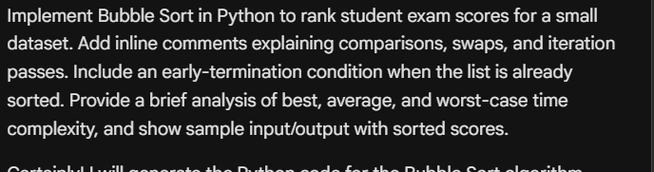
Code : 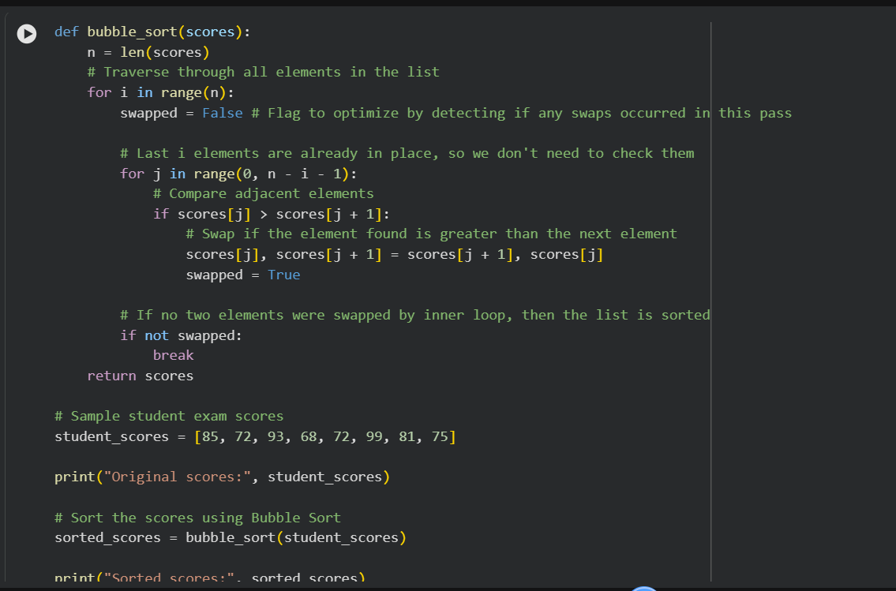
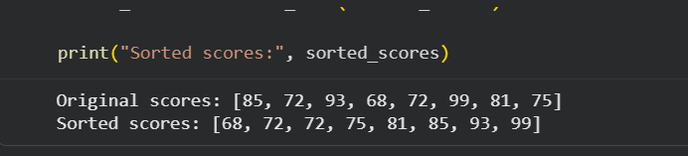
Explanation : O(n) Occurs when the array is already sorted. The algorithm makes one pass, detects no swaps, and terminates early due to the swapped flag. It performs n-1 comparisons. Average-Case Complexity: O(n^2) For a randomly ordered array, on average, the algorithm still performs approximately n^2/2 comparisons and n^2/4 swaps.

Task 2: Improving Sorting for Nearly Sorted Attendance Records

Scenario
You are maintaining an attendance system where student roll numbers are already almost sorted, with only a few late updates.

Task Description
- Start with a Bubble Sort implementation.
- Ask AI to:
  - Review the problem and suggest a more suitable sorting algorithm
  - Generate an Insertion Sort implementation
  - Explain why Insertion Sort performs better on nearly sorted data
- Compare execution behavior on nearly sorted input

Expected Outcome
- Two sorting implementations:
  - Bubble Sort
  - Insertion Sort
- AI-assisted explanation highlighting efficiency differences for partially sorted datasets
Prompt : 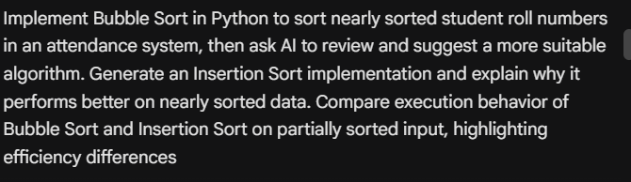
Code : 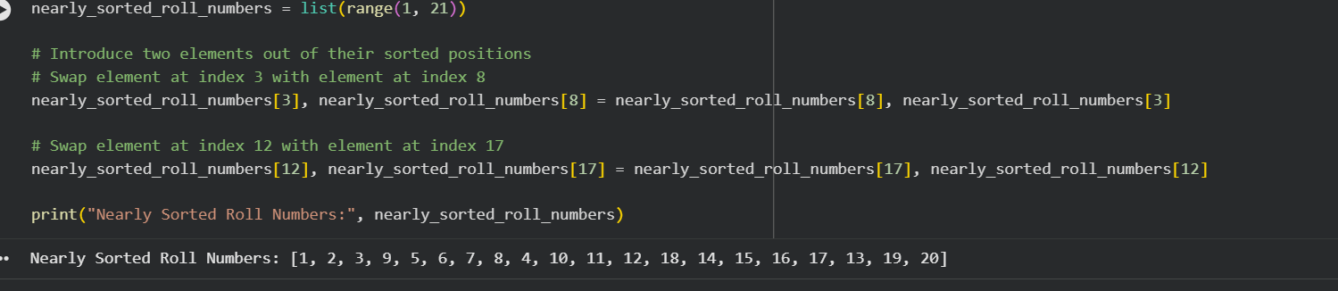
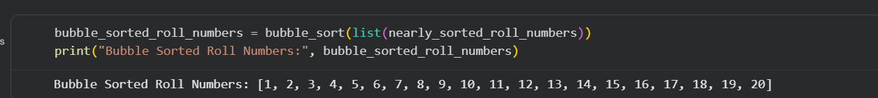
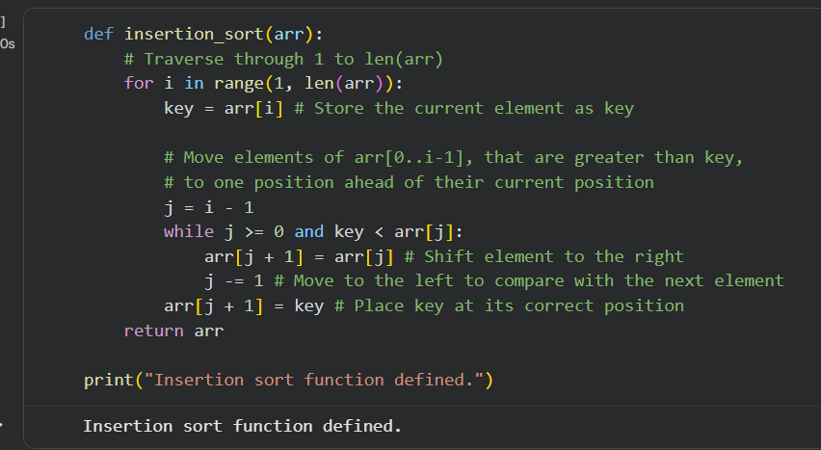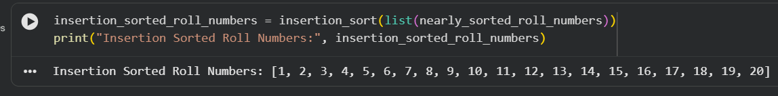
Explanation : A nearly sorted list of 20 student roll numbers was successfully generated, with two pairs of elements intentionally displaced.Both Bubble Sort and Insertion Sort were successfully applied to the nearly sorted data, and both algorithms correctly sorted the list into ascending order: [1, 2, 3, 4, 5, 6, 7, 8, 9, 10, 11, 12, 13, 14, 15, 16, 17, 18, 19, 20].Insertion Sort's efficiency on nearly sorted data: Its adaptive nature allows it to achieve performance close to O(n) because elements are already close to their final positions, resulting in minimal shifts and comparisons (the inner while loop terminates early).

Task 3: Searching Student Records in a Database

Scenario
You are developing a student information portal where users search for student records by roll number.

Task Description
- Implement:
  - Linear Search for unsorted student data
  - Binary Search for sorted student data
- Use AI to:
  - Add docstrings explaining parameters and return values
  - Explain when Binary Search is applicable
  - Highlight performance differences between the two searches

Expected Outcome
- Two working search implementations with docstrings
- AI-generated explanation of:
  - Time complexity
  - Use cases for Linear vs Binary Search
- A short student observation comparing results on sorted vs unsorted lists
Prompt : 
Code : 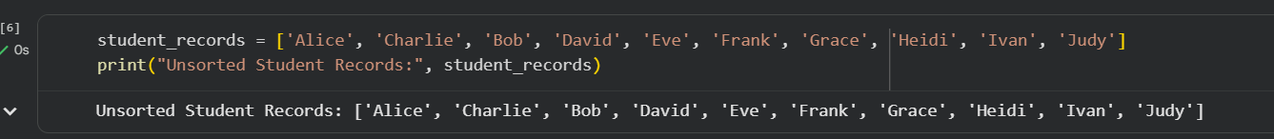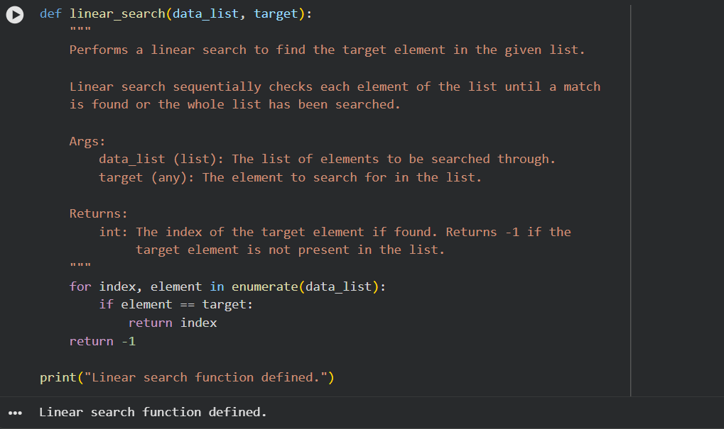
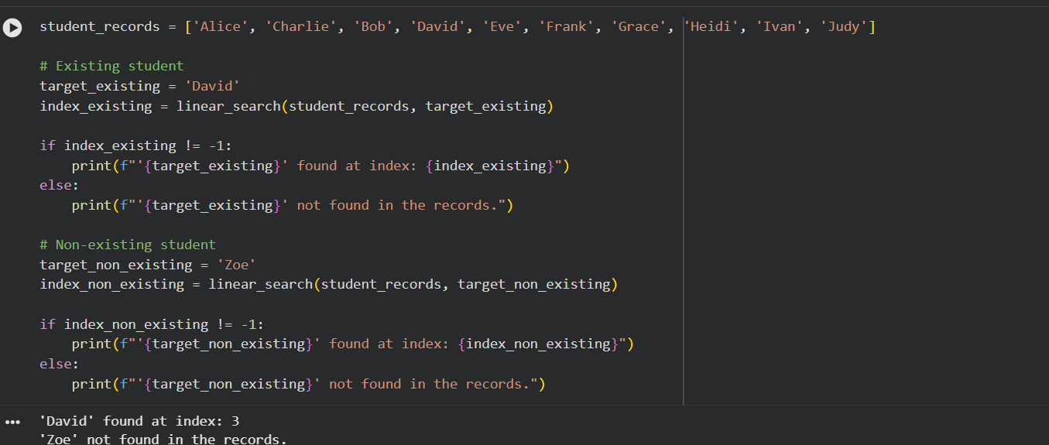
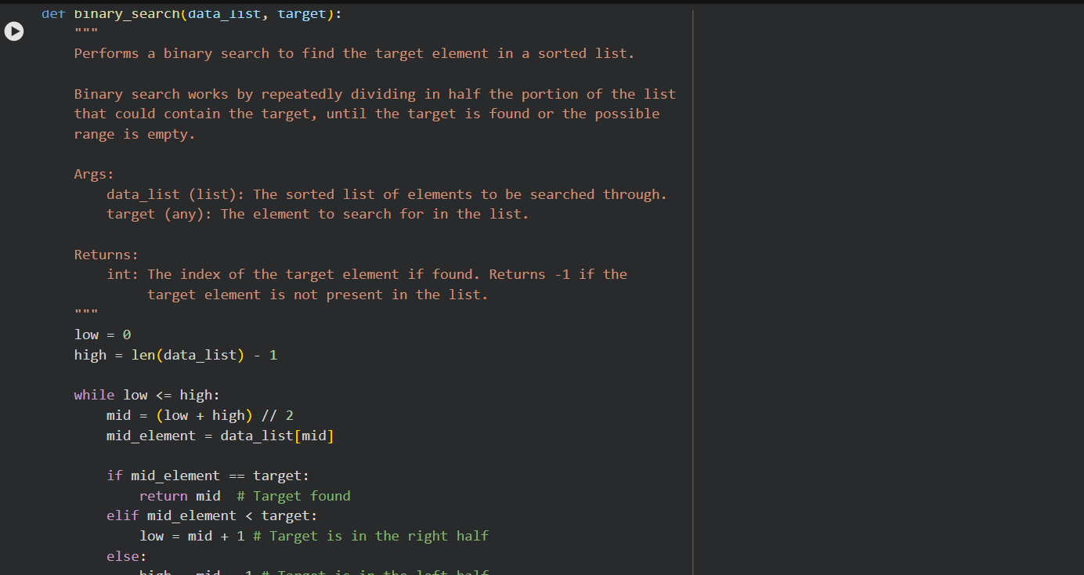
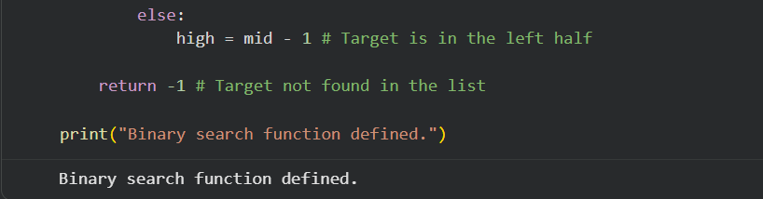
Explanantion : hile both algorithms correctly find existing elements and identify non-existing ones, Binary Search offers a significant performance advantage for large, sorted datasets due to its divide-and-conquer strategy, requiring far fewer comparisons than Linear Search. However, the requirement for sorted data is its primary limitation.

Task 4: Choosing Between Quick Sort and Merge Sort for Data Processing

Scenario
You are part of a data analytics team that needs to sort large datasets received from different sources (random order, already sorted, and reverse sorted).

Task Description
- Provide AI with partially written recursive functions for:
  - Quick Sort
  - Merge Sort
- Ask AI to:
  - Complete the recursive logic
  - Add meaningful docstrings
  - Explain how recursion works in each algorithm
- Test both algorithms on:
  - Random data
  - Sorted data
  - Reverse-sorted data

Expected Outcome
- Fully functional Quick Sort and Merge Sort implementations
- AI-generated comparison covering:
  - Best, average, and worst-case complexities
  - Practical scenarios where one algorithm is preferred over the other
  - Prompt :
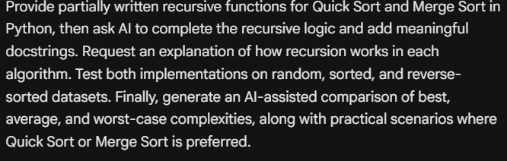
Code : 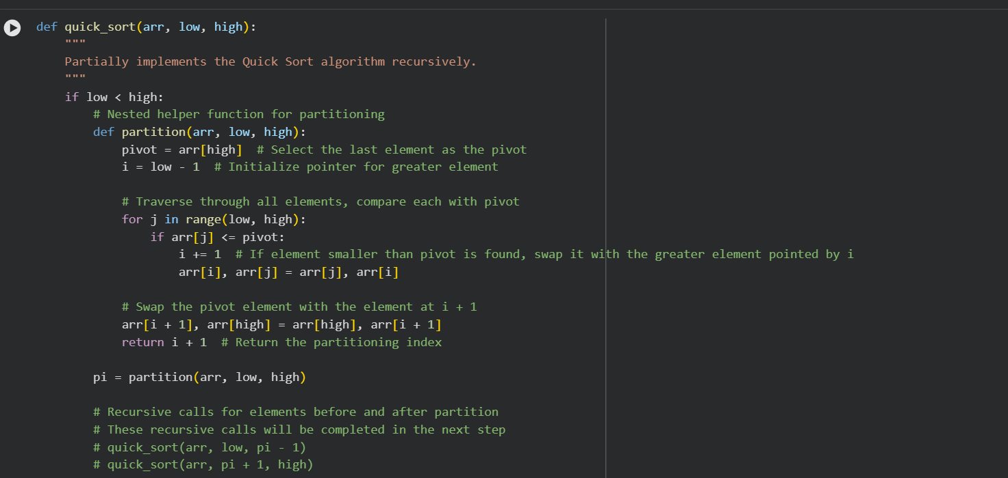
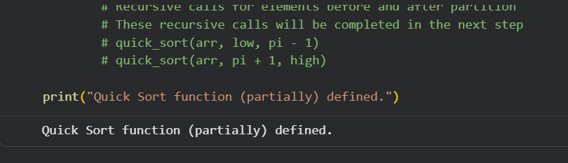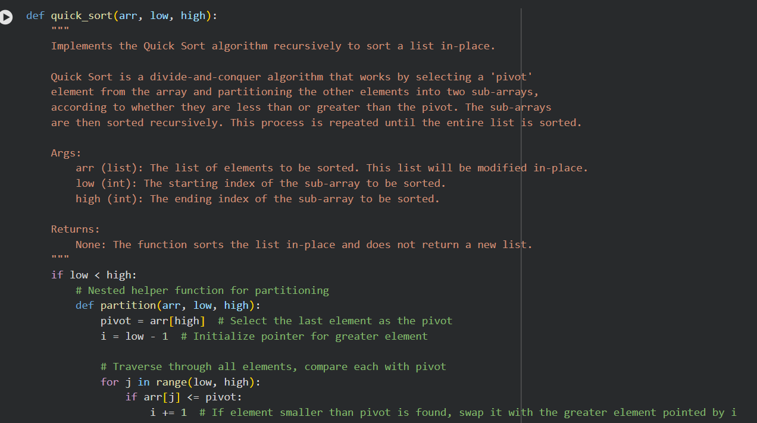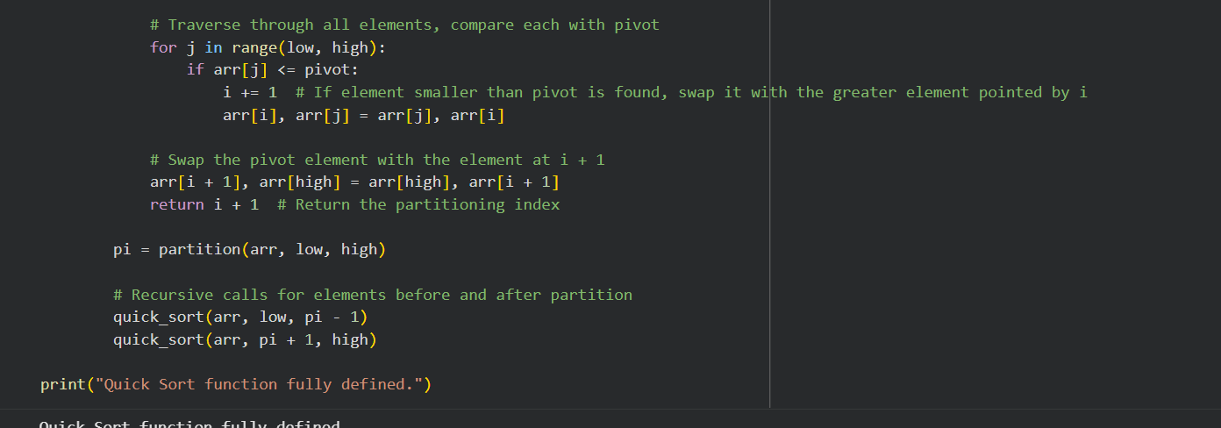
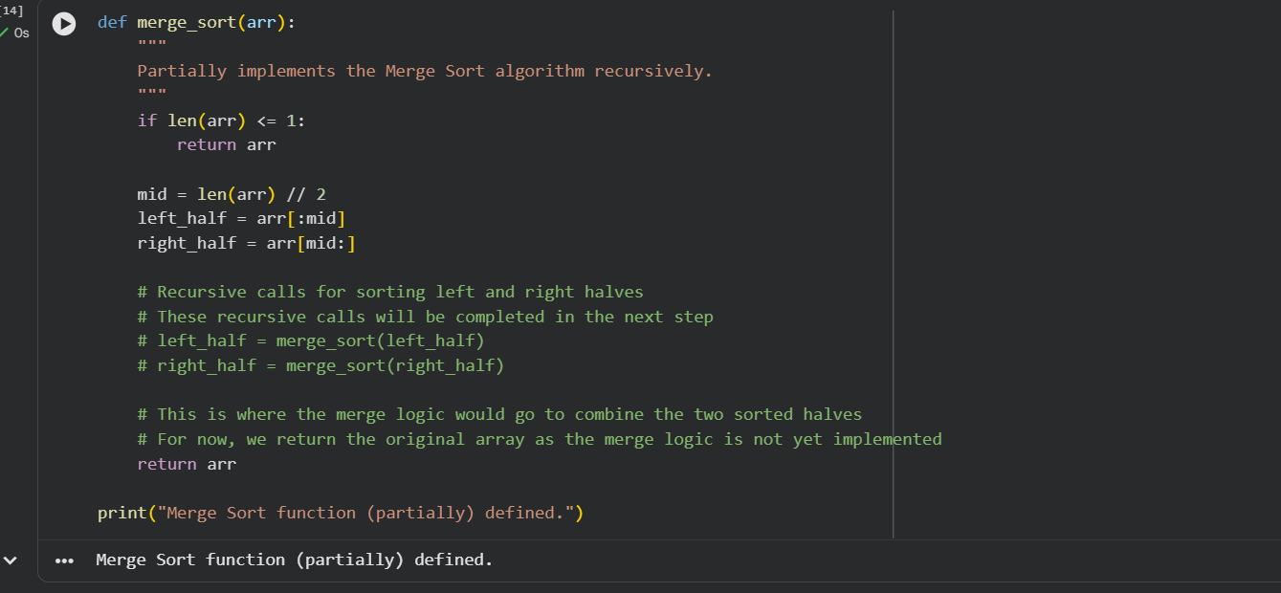
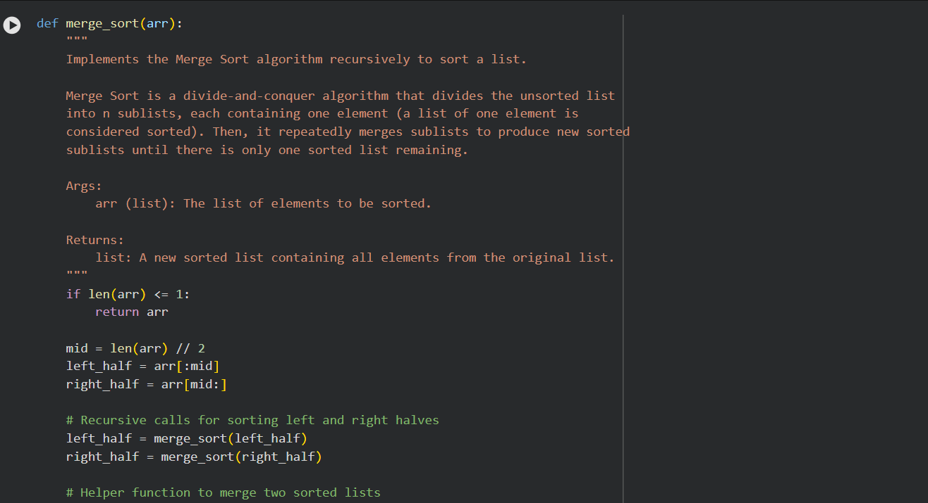
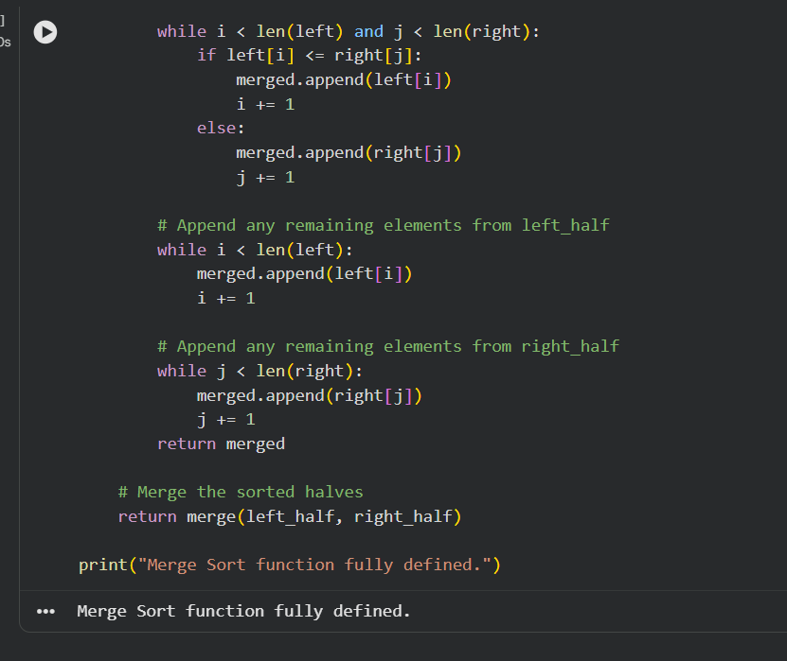
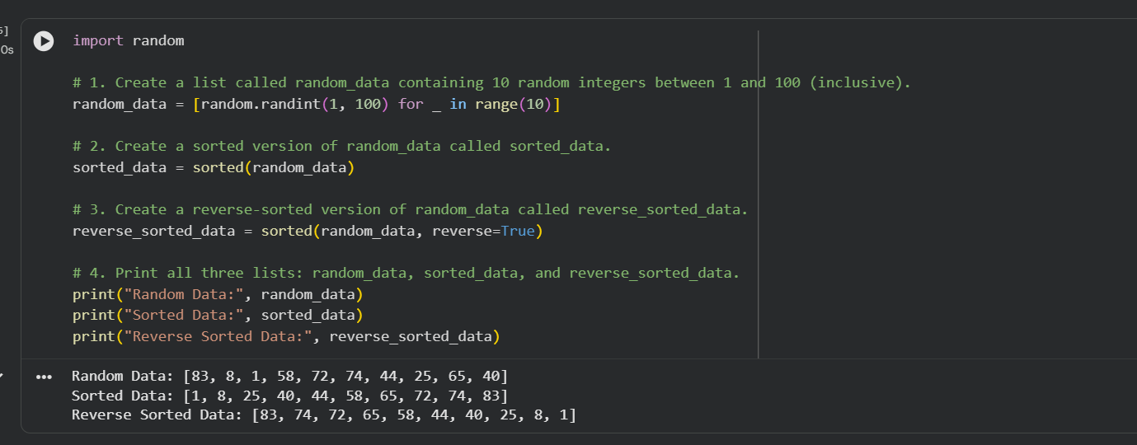
Explanation : Both Quick Sort and Merge Sort are efficient comparison-based sorting algorithms with an average time complexity of O(n log n). Quick Sort is often faster in practice due to a smaller constant factor in its average-case O(n log n) performance and its in-place nature (better cache performance).

Task 5: Optimizing a Duplicate Detection Algorithm

Scenario
You are building a data validation module that must detect duplicate user IDs in a large dataset before importing it into a system.

Task Description
- Write a naive duplicate detection algorithm using nested loops.
- Use AI to:
  - Analyze the time complexity
  - Suggest an optimized approach using sets or dictionaries
  - Rewrite the algorithm with improved efficiency
- Compare execution behavior conceptually for large input sizes

Expected Outcome
- Two versions of the algorithm:
  - Brute-force (O(n²))
  - Optimized (O(n))
- AI-assisted explanation showing how and why performance improved Prompt : 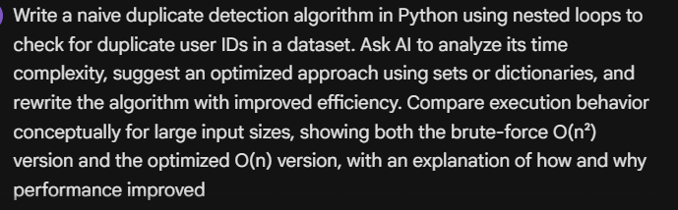
Code : 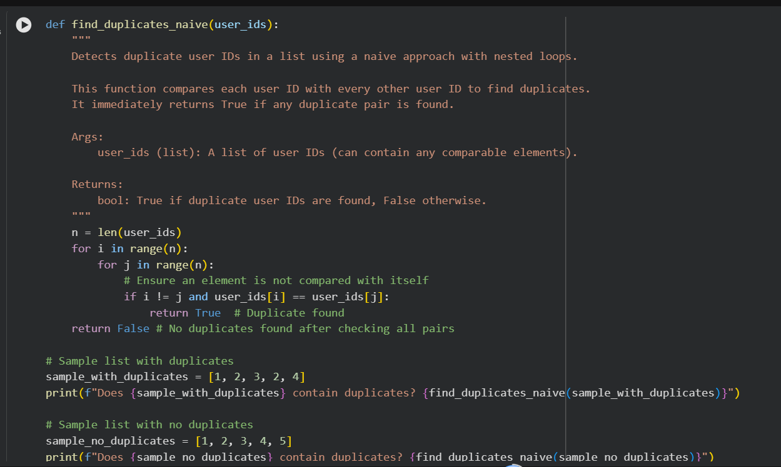
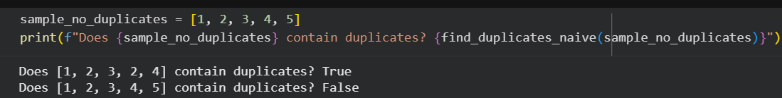
Explanation : The find_duplicates_naive function, which uses nested loops, has a significant inefficiency. It compares each element with every other element in the list. This leads to n * (n-1) comparisons in the worst case (or n*(n-1)/2 if avoiding self-comparison and redundant pairs), resulting in a time complexity of O(n^2). For small lists, this might be acceptable, but as the size of the list (n) grows, the number of comparisons increases quadratically, making it very slow and inefficient.

