ASSIGNMENT 13.1
2303A51839
BATCH 27
TASK 1:
Prompt:
Use AI to refactor the given python script that contains multiple repeated code blocks
Before Code Refactoring:
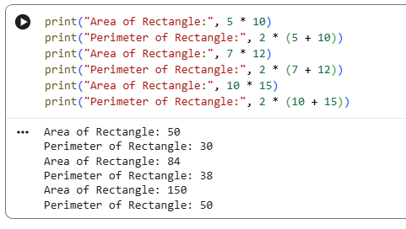

After Code Refactoring:

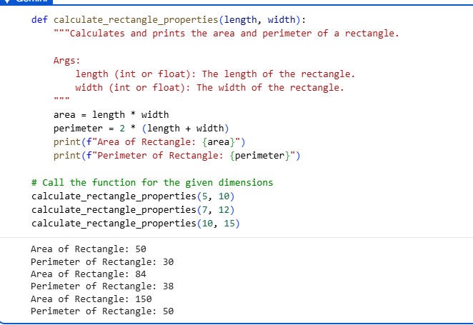

TASK 2:
Prompt:
Use AI to analyze a Python script with nested loops and complex conditionals.
Before Code Refactoring:

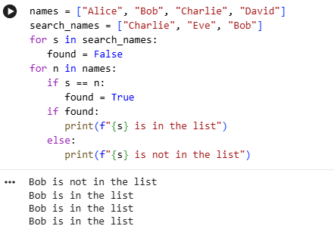

After Code Refactoring:
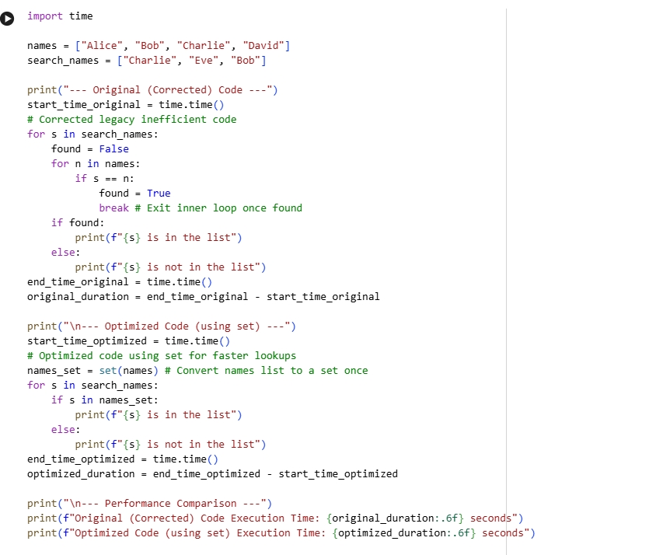
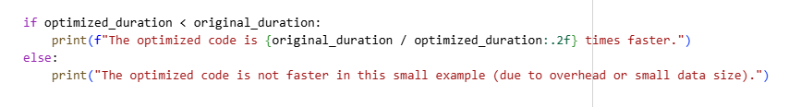
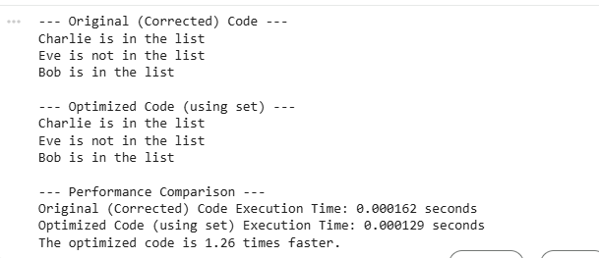
TASK 3:
Prompt:
Use AI to refactor a legacy script where multiple calculations are embedded directly inside the main code block.
Before Code Refactoring:
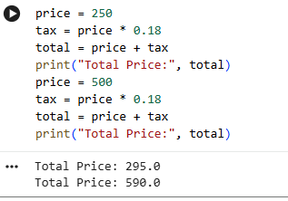
After Code Refactoring:
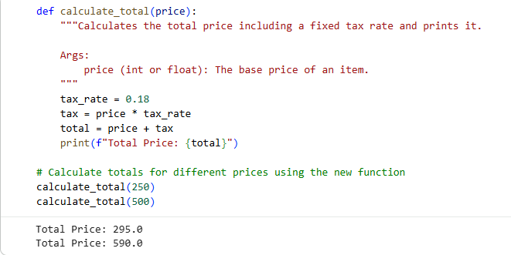
TASK 4:
Prompt:
Use AI to identify and replace all hardcoded “magic numbers” in the code with named constants.
Before Code Refactoring:
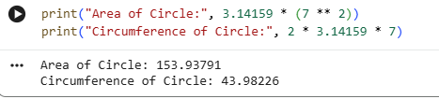
After Code Refactoring:
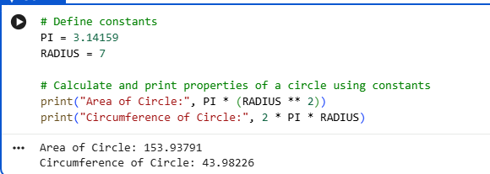
TASK 5:
Prompt:
Use AI to improve readability by renaming unclear variables and adding inline comments.
Before Code Refactoring:
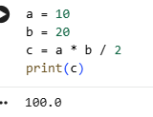
After Code Refactoring:
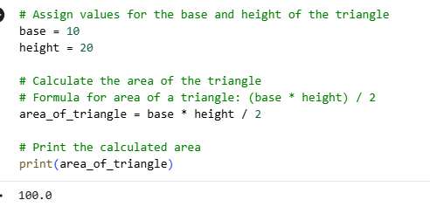
TASK 6:
Prompt:
Use AI to refactor a Python script that contains repeated if–else logic for grading students.
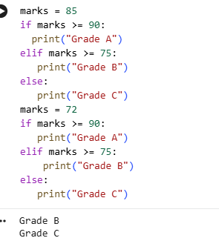
Before Code Refactoring:

After Code Refactoring:
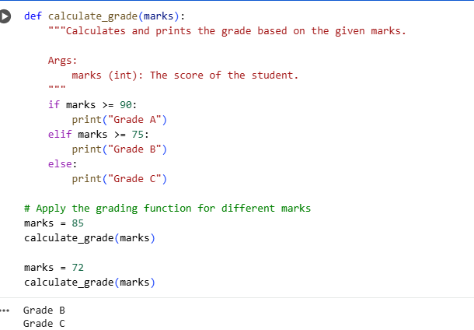
TASK 7:
Prompt:
Use AI to refactor procedural input–processing logic into functions.
Before Code Refactoring:
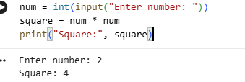
After Code Refactoring:
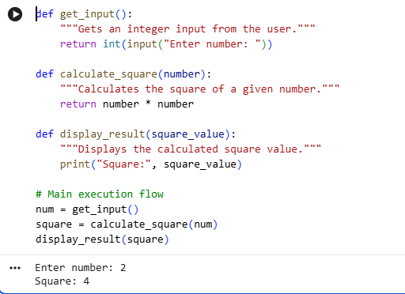

TASK 8:
Prompt:
Use AI to refactor inefficient list processing logic.
Before Code Refactoring:
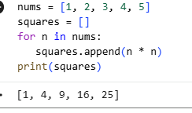
After Code Refactoring:
