ASSIGNMENT – 2.4

Name: K . ABHINAV
HT.NO. : 2303A51856
BATCH : 13

TASK-4
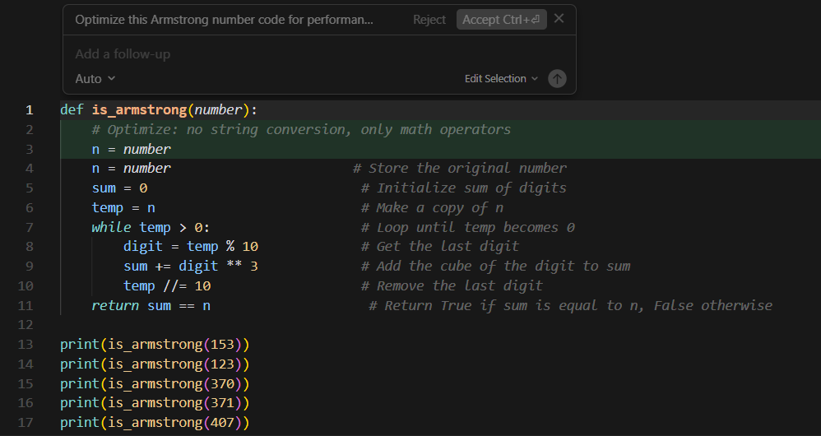

TASK-3
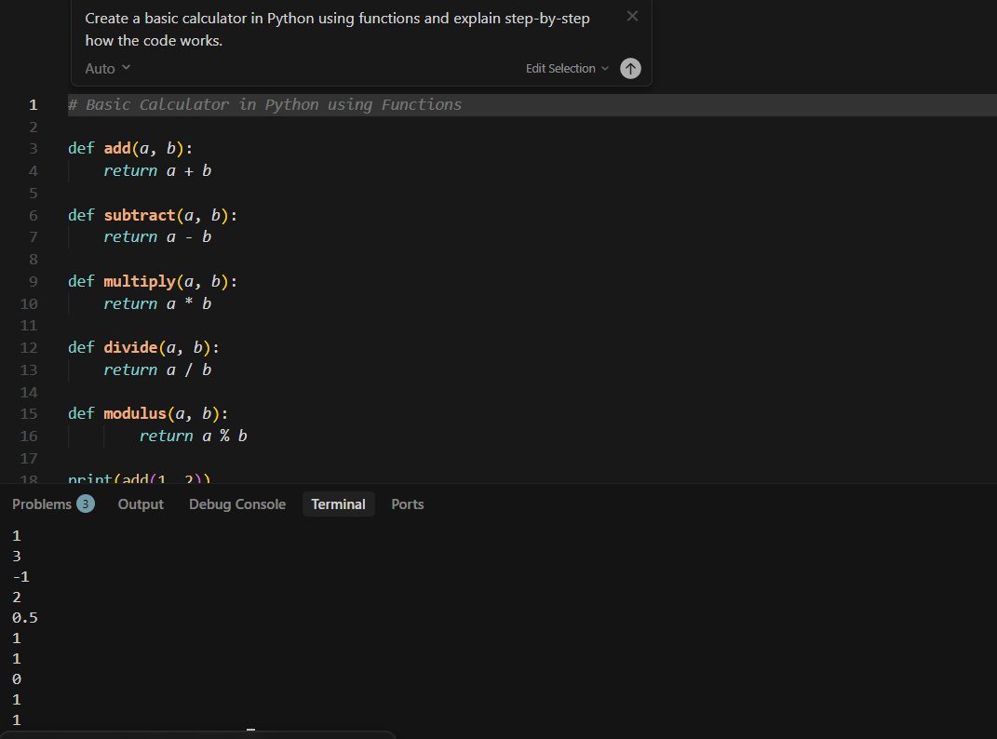
TASK-2
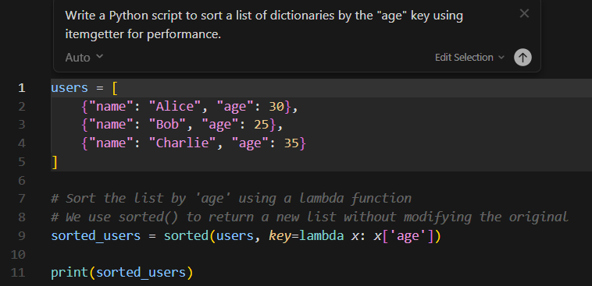
TASK-1
