ASSIGNMENT-7.5
2303A51859
BATCH NO:24
Tamanna

Task 1: (Mutable Default Argument – Function Bug)
Task: Analyze given code where a mutable default argument causes unexpected behavior. Use
AI to fix it.
# Bug: Mutable default argument def add_item(item, items=[]):
items.append(item) return items print(add_item(1)) print(add_item(2))
Expected Output: Corrected function avoids shared list bug.

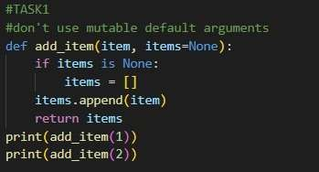

OUTPUT:
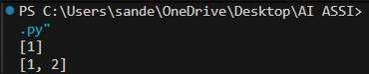

Task 2 :(Floating-Point Precision Error)
Task: Analyze given code where floating-point comparison fails. Use AI to correct with tolerance.
# Bug: Floating point precision issue def check_sum():
return (0.1 + 0.2) == 0.3 print(check_sum())
Expected Output: Corrected function

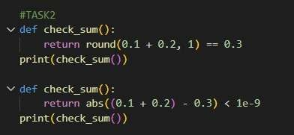

OUTPUT:
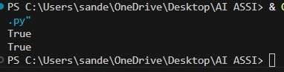

Task 3: (Recursion Error – Missing Base Case)
Task: Analyze given code where recursion runs infinitely due to missing base case. Use AI to fix.
# Bug: No base case def countdown(n):
print(n)
return countdown(n-1) countdown(5)
Expected Output : Correct recursion with stopping condition.

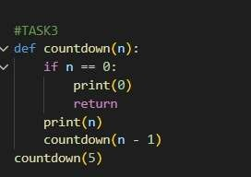

OUTPUT:
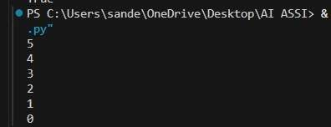

Task 4 (Dictionary Key Error)
Task: Analyze given code where a missing dictionary key causes error. Use AI to fix it.
# Bug: Accessing non-existing key def get_value():
data = {"a": 1, "b": 2} return data["c"] print(get_value())
Expected Output: Corrected with .get() or error handling.

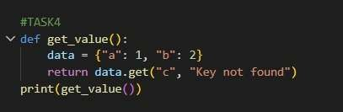

OUTPUT:
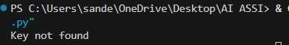

Task 5: (Infinite Loop – Wrong Condition)
Task: Analyze given code where loop never ends. Use AI to detect and fix it.
# Bug: Infinite loop def loop_example():
i = 0 while i < 5: print(i)
Expected Output: Corrected loop increments i.

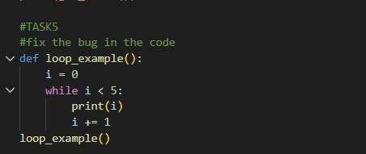

OUTPUT:
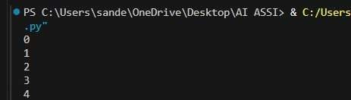

Task 6 (Unpacking Error – Wrong Variables)
Task: Analyze given code where tuple unpacking fails. Use AI to fix it.
# Bug: Wrong unpacking
a, b = (1, 2, 3)
Expected Output: Correct unpacking or using _ for extra values.

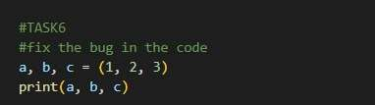

OUTPUT:
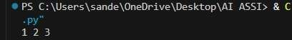

Task 7 (Mixed Indentation – Tabs vs Spaces)
Task: Analyze given code where mixed indentation breaks execution. Use AI to fix it.
# Bug: Mixed indentation def func():
x = 5 y = 10
return x+y
Expected Output : Consistent indentation applied.

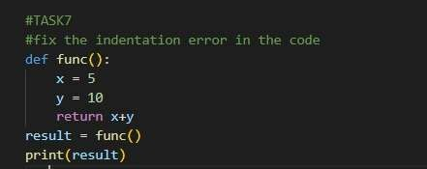

OUTPUT:
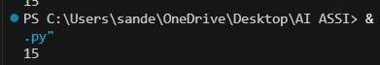

Task 8 (Import Error – Wrong Module Usage)
Task: Analyze given code with incorrect import. Use AI to fix.
# Bug: Wrong import import maths print(maths.sqrt(16))
Expected Output: Corrected to import math

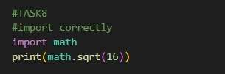

OUTPUT:
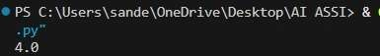

Task 9 (Unreachable Code – Return Inside Loop)
Task: Analyze given code where a return inside a loop prevents full iteration. Use AI to fix it.
# Bug: Early return inside loop def total(numbers): for n in numbers: return n print(total([1,2,3]))
Expected Output: Corrected code accumulates sum and returns after loop.

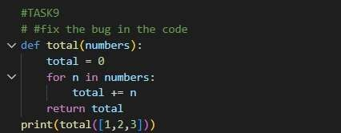

OUTPUT:
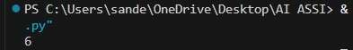

Task 10 (Name Error – Undefined Variable)
Task: Analyze given code where a variable is used before being defined. Let AI detect and fix the error.
# Bug: Using undefined variable def calculate_area(): return length * width print(calculate_area()) Requirements:
- Run the code to observe the error.
- Ask AI to identify the missing variable definition.
- Fix the bug by defining length and width as parameters.
- Add 3 assert test cases for correctness.
Expected Output :
- Corrected code with parameters.
- AI explanation of the bug.
Successful execution of assertions.

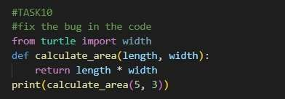

OUTPUT:

Task 11 (Type Error – Mixing Data Types Incorrectly)
Task: Analyze given code where integers and strings are added incorrectly. Let AI detect and fix the error.
# Bug: Adding integer and string def add_values(): return 5 + "10" print(add_values()) Requirements:
- Run the code to observe the error.
- AI should explain why int + str is invalid.
- Fix the code by type conversion (e.g., int("10") or str(5)).
- Verify with 3 assert cases.
Expected Output #6:
- Corrected code with type handling.
- AI explanation of the fix.
Successful test validation.

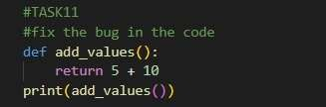
OUTPUT:

Task 12 (Type Error – String + List Concatenation)
Task: Analyze code where a string is incorrectly added to a list.
# Bug: Adding string and list def combine():
return "Numbers: " + [1, 2, 3] print(combine()) Requirements:
- Run the code to observe the error.
- Explain why str + list is invalid.
- Fix using conversion (str([1,2,3]) or " ".join()).
- Verify with 3 assert cases.
Expected Output:
- Corrected code
- Explanation
Successful test validation

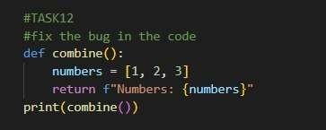

OUTPUT:
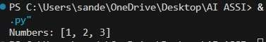

Task 13 (Type Error – Multiplying String by Float)
Task: Detect and fix code where a string is multiplied by a float.
# Bug: Multiplying string by float def repeat_text(): return "Hello" * 2.5 print(repeat_text()) Requirements:
- Observe the error.
- Explain why float multiplication is invalid for strings.
- Fix by converting float to int.
Add 3 assert test cases

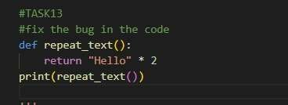

OUTPUT:
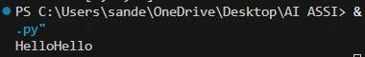

Task 14 (Type Error – Adding None to Integer)
Task: Analyze code where None is added to an integer.
# Bug: Adding None and integer def compute(): value = None return value + 10

print(compute()) Requirements:
- Run and identify the error.
- Explain why NoneType cannot be added.
- Fix by assigning a default value.
- Validate using asserts.
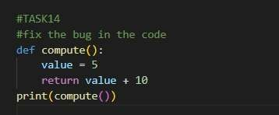

OUTPUT:

Task 15 (Type Error – Input Treated as String Instead of Number) Task: Fix code where user input is not converted properly.
# Bug: Input remains string def sum_two_numbers():
a = input("Enter first number: ") b = input("Enter second number: ") return a + b

print(sum_two_numbers()) Requirements:
- Explain why input is always string.
- Fix using int() conversion.
Verify with assert test cases

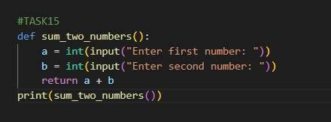

OUTPUT:
