AI Assisted Coding

ASSIGNMENT 19.3
Name: B Vrindha
HT No: 2303A52003
Batch: 31

Task 1 – Python to C++ Conversion
Task:
Translate a simple Python class into C++ using AI assistance.
Instructions:
• Prompt AI to convert a Python class representing a Student with
attributes and methods into equivalent C++ code
• Ensure proper handling of:
o Constructors
o Data types
o Access specifiers
• Compile and run both versions to verify output consistency
Expected Output:
An equivalent working C++ class translated from Python.

Prompts:

1st Prompt
Write a Python program to create a Student class with attributes name and age, including a constructor and a display() method.

2nd Prompt
Convert the following Python Student class into equivalent C++ code. Ensure proper use of constructors, data types, and access specifiers.
Code:
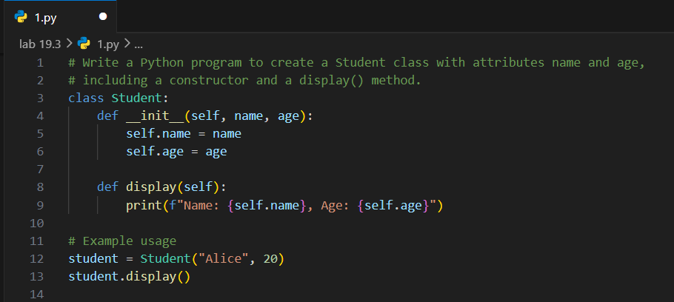
Output:


Code:
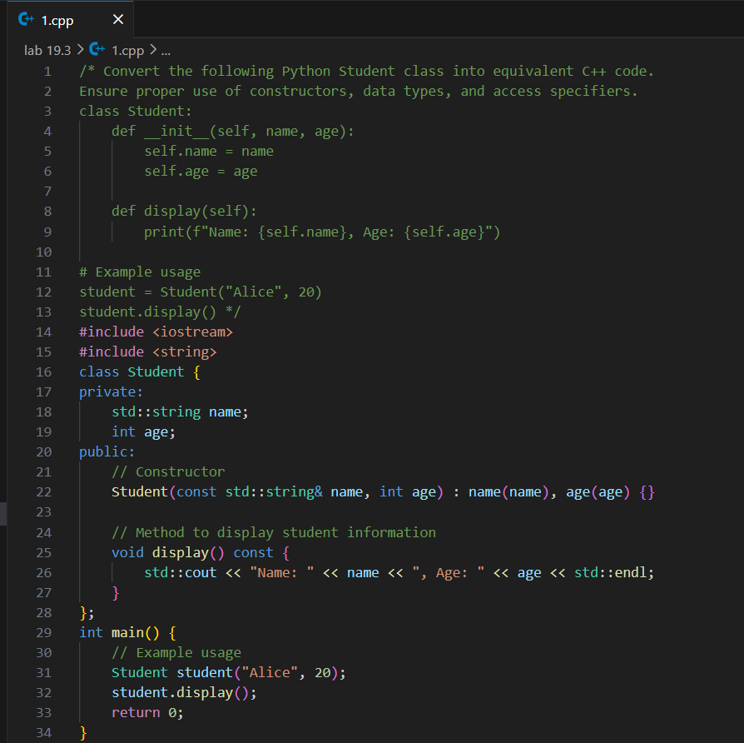
Output:


output consistency verified.

Task 2 – Java to Python Function Conversion
Task:
Convert a Java method that checks whether a number is prime into
Python.
Instructions:
• Ask AI to translate a Java isPrime() method into Python
• Test the function with multiple inputs
• Ensure the Python version follows Pythonic syntax and logic
Expected Output:
A correct Python function equivalent to the original Java prime-
checking method.

Prompts:
1st Prompt
Write a Java program with a method isPrime() that checks whether a given number is prime. Include a main method to test it with at least 3 different numbers.

2nd Prompt
Convert the following Java isPrime() method into equivalent Python code.
Make sure to follow Pythonic syntax and test with multiple inputs including edge cases.

Java Code:
public class Prime {
public static void main(String[] args) {
int num1 = 7;
int num2 = 10;
int num3 = 13;

System.out.println(num1 + " is prime: " + isPrime(num1));
System.out.println(num2 + " is prime: " + isPrime(num2));
System.out.println(num3 + " is prime: " + isPrime(num3));
}

public static boolean isPrime(int number) {
if (number <= 1) {
return false;
}
for (int i = 2; i <= Math.sqrt(number); i++) {
if (number % i == 0) {
return false;
}
}
return true;
}
}

Code:
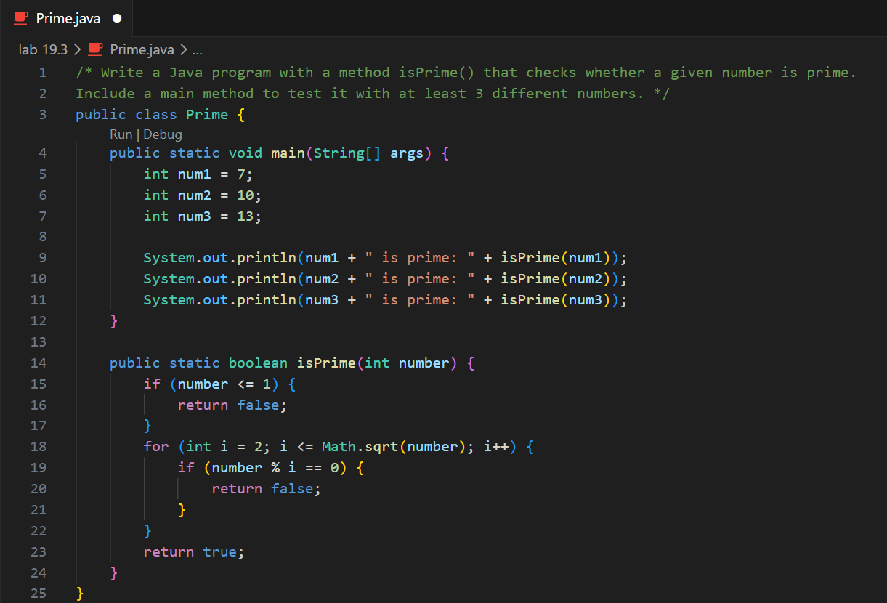
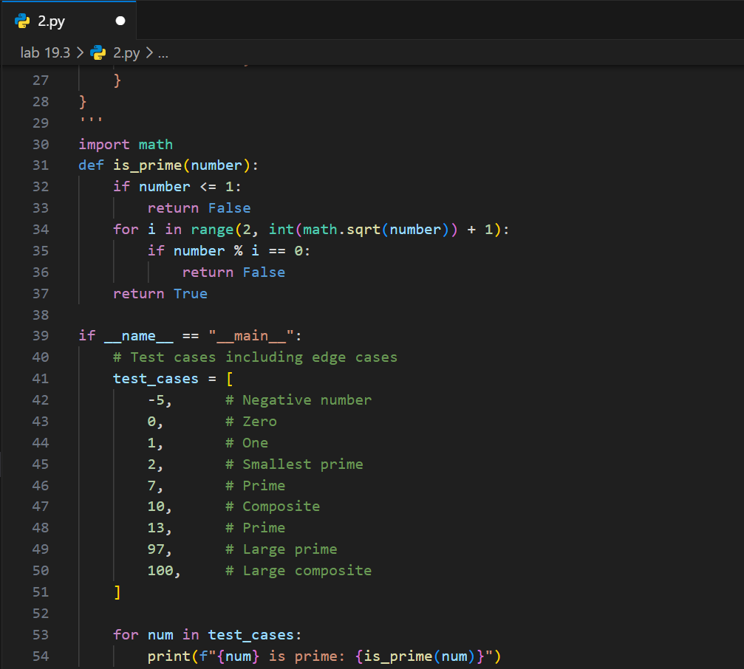
Output:
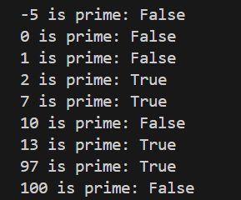

Task 3 – Pseudocode to Python Implementation
Task:
Translate a given pseudocode algorithm into Python using AI.
Instructions:
• Provide AI with pseudocode for sorting numbers (e.g., bubble
sort or selection sort)
• Ask AI to convert it into executable Python code
• Validate correctness using sample input lists
Expected Output:
A working Python program that correctly implements the pseudocode
logic.

Prompt:

Pseudo code for bubble sort
for i from 0 to n-1
for j from 0 to n-i-2
if arr[j] > arr[j+1]
swap arr[j] and arr[j+1]
convert pseudocode into Python with Sample input lists.

Code:
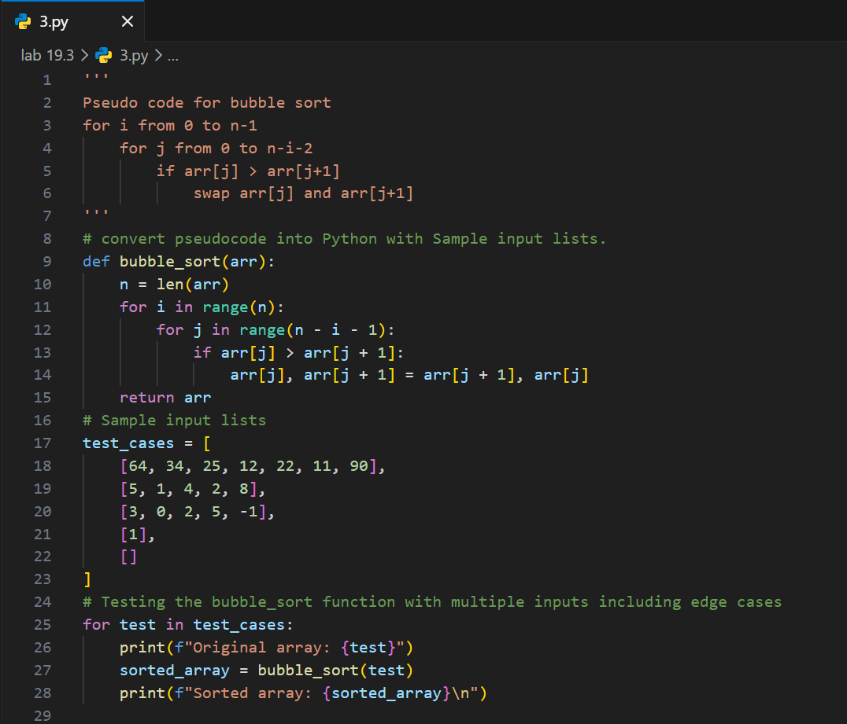
Output: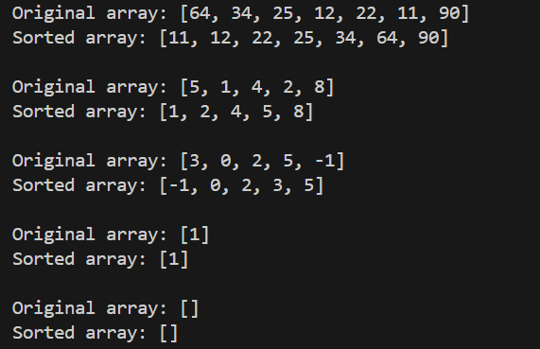
Task 4 – SQL to Pandas Query
Task:
Translate a SQL query into a Pandas DataFrame operation in
Python.
Instructions:
• Provide AI with a SQL query (e.g., SELECT name, salary FROM
employees WHERE salary > 50000).
• Ask AI to generate equivalent Pandas code.
• Test the generated code on a sample DataFrame.
Expected Output:
• Equivalent Pandas query that retrieves the correct subset of data.

Prompt:
Convert the following SQL query into equivalent Pandas DataFrame operations in Python.

SQL Query:
SELECT name, salary, department
FROM employees
WHERE salary > 50000;

Include:
Sample employees DataFrame with columns: name, salary, department
The equivalent Pandas query using DataFrame operations
Display the filtered results

Code:
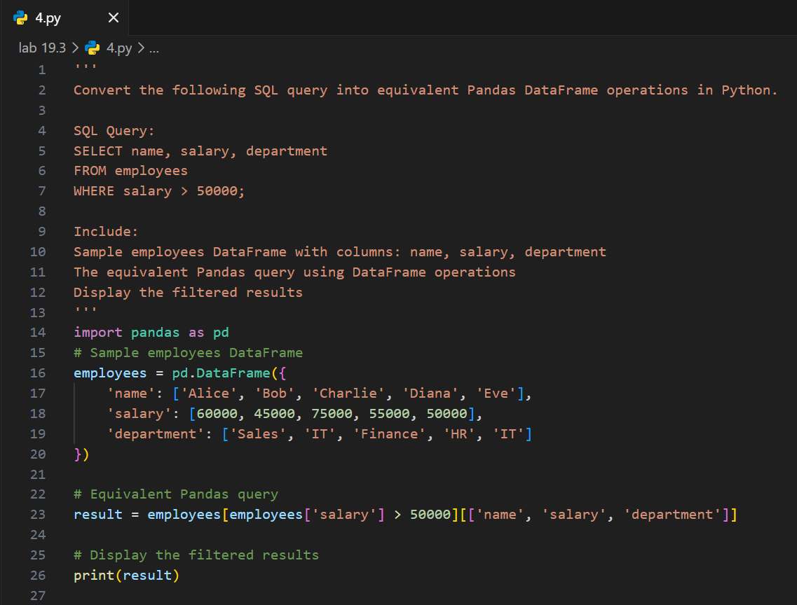
Output:
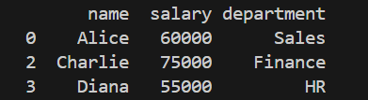
Task 5 – Real-Time Application: Algorithm Translation Across
Languages
Scenario:
A company maintains algorithms written in different programming
languages.
Examples:
• Converting a Python searching algorithm into C
• Translating a Java sorting program into JavaScript
Instructions:
• Use AI to translate a selected algorithm between two
programming languages
• Execute and test both versions
• Document translation challenges such as:
o Syntax differences
o Library support
o Memory management
Expected Output:
Equivalent, tested code implementations in two different programming languages.

Prompt:
Prompt 1
Write a Python program that implements linear search to find an element in a list.

Prompt 2
Translate the following Python linear search algorithm into equivalent C code.
def linear_search(arr, target):
for i in range(len(arr)):
if arr[i] == target:
return i # Return the index of the target element
return -1 # Return -1 if the target element is not found
# Example usage
my_list = [5, 3, 2, 8, 1]
target_element = 12
result = linear_search(my_list, target_element)
if result != -1:
print(f"Element {target_element} found at index: {result}")
else:
print(f"Element {target_element} not found in the list.")

Code:
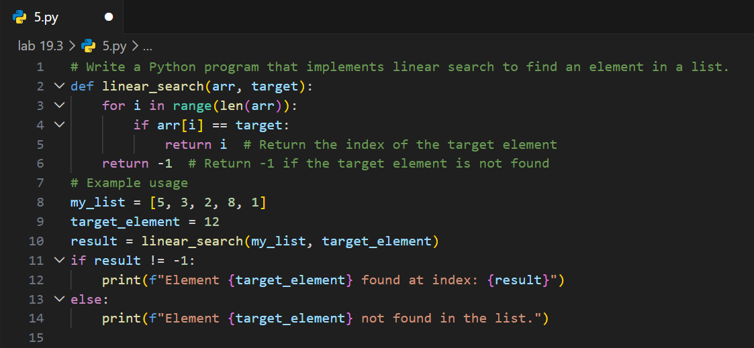
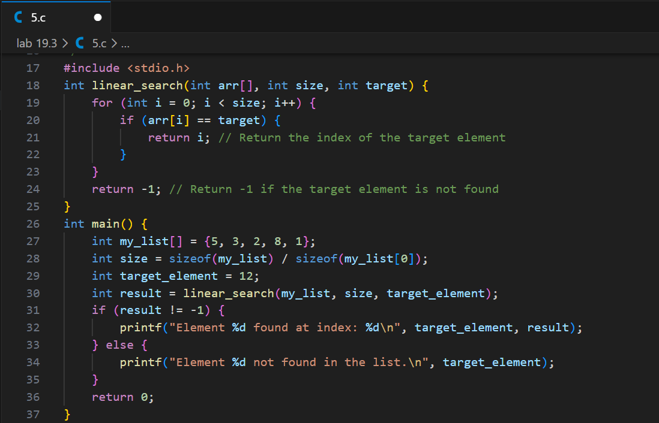
Output:

Field | Details
Algorithm | Linear Search
Languages | Python → C
Objective | Translate and test algorithm in both languages
Input | List: [5, 3, 2, 8, 1], Target: 12
Output | Not found (-1)
Python Result | Element 12 not found in the list
C Result | Element 12 not found in the list
Syntax Difference | Python simple, C strict with types
Loop Difference | range(len(arr)) vs for (int i=0; i<size; i++)
Function | Python no type, C requires return type
Memory | Python automatic, C manual
Libraries | Python none, C uses stdio.h
Output Method | print() vs printf()
Conclusion | Both give same result, Python easy, C faster

