AI ASSISTED CODING

ASSIGNMENT 1.2

Name:Bijjala Vrindha

HT NO:2303A52003

Batch:31

Question 1:

Task 1:

AI-Generated Logic Without Modularization (Factorial without Functions)

Scenario You are building a small command-line utility for a startup intern onboarding task. The program is simple and must be written quickly without modular design.

Task Description Use GitHub Copilot to generate a Python program that computes a mathematical product-based value (factorial-like logic) directly in the main execution flow, without using any user-defined functions.

• Constraint:

Do not define any custom function Logic must be implemented using loops and variables only

Prompt:
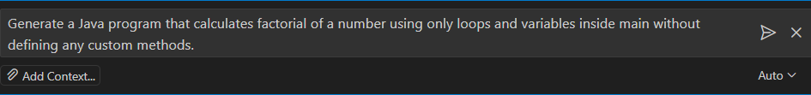

Code:
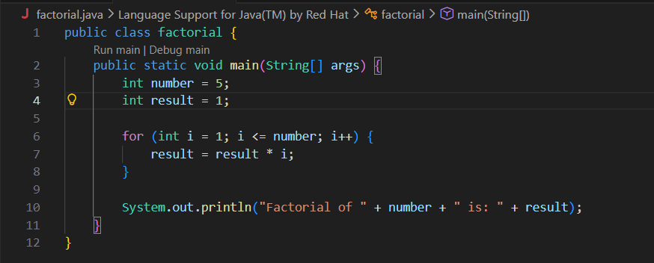

Output:
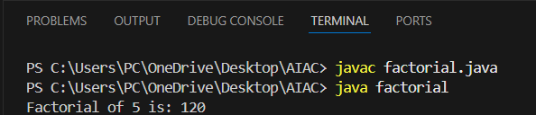

Justification:

GitHub Copilot generates code by understanding a prompt. It identifies the language and constraints, then automatically creates the program structure and logic. This reduces coding time and effort while producing correct output quickly.

Question 2:

Scenario Your team lead asks you to review AI-generated code before committing it to a shared repository.

Task Description Analyze the code generated in Task 1 and use Copilot again to: Reduce unnecessary variables Improve loop clarity Enhance readability and efficiency

Hint: Prompt Copilot with phrases like “optimize this code”, “simplify logic”, or “make it more readable”

Prompt:

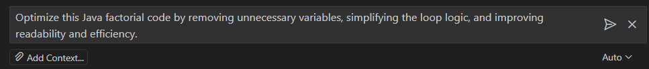

Code:
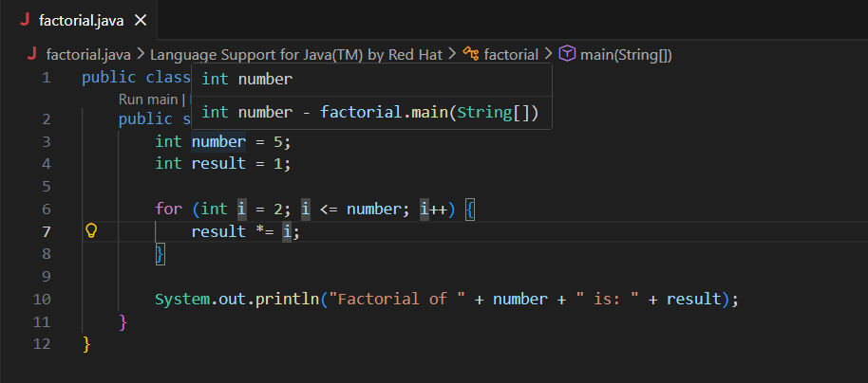

Output:
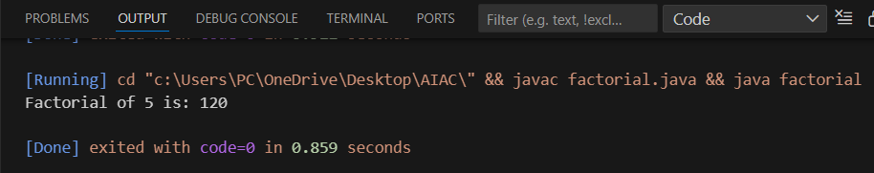

Justification:

In this task, GitHub Copilot was used to review and improve the previously generated code. By providing prompts such as optimize this code and simplify logic, Copilot analyzed the existing implementation and identified areas for improvement. It reduced unnecessary variables, simplified the loop structure, and enhanced overall readability. This helped make the code more efficient, cleaner, and easier to understand before committing it to the shared repository.

Question 3:

Scenario:

The same logic now needs to be reused in multiple scripts.

Task Description Use GitHub Copilot to generate a modular version of the program by:

Creating a user-defined function Calling the function from the main block

Constraints:

Use meaningful function and variable names Include inline comments (preferably suggested by Copilot)

Prompt:


Code:
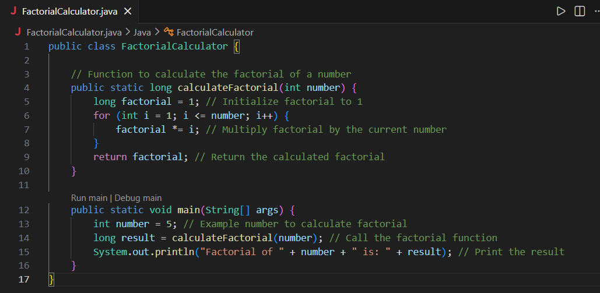

Output:
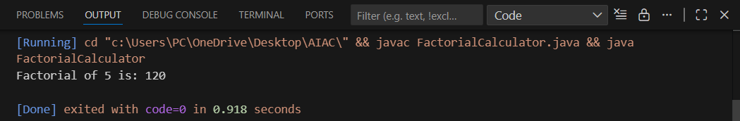

Justification:

GitHub Copilot was used to convert the factorial code into a reusable function. It suggested meaningful function and variable names, added inline comments to explain the logic, and ensured the function could be called from the main method. This made the code modular, easier to read, maintain, and reuse across multiple scripts.

Question 4:

Scenario As part of a code review meeting, you are asked to justify design choices.

Task Description Compare the non-function and function-based Copilot-generated programs on the following criteria:

Logic clarity

Reusability

Debugging ease

Suitability for large projects

AI dependency risk

Prompt:
Code:
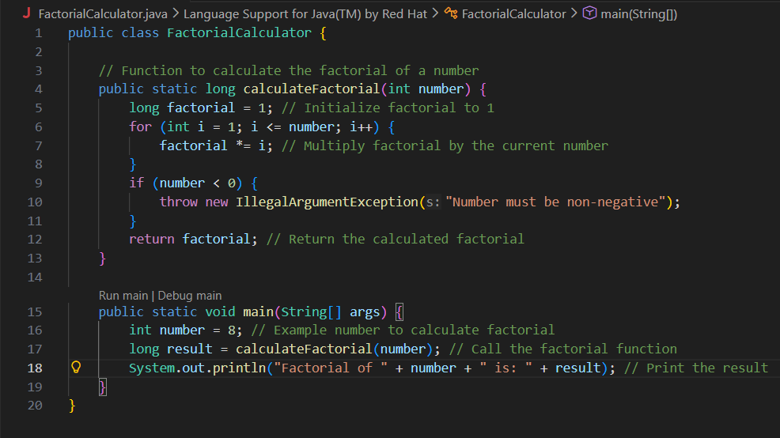

Output:
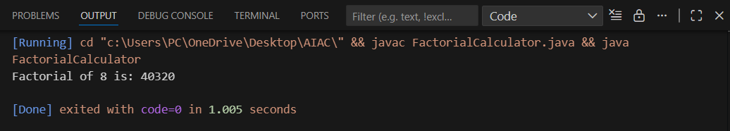

Justification:

The function-based program is clearer, reusable, and easier to debug, making it suitable for large projects. Non-function code is less organized. AI-generated code still needs review to avoid inefficiencies.

Question 5:

Scenario:

Your mentor wants to test how well AI understands different computational paradigms. Task Description:

Prompt Copilot to generate:

An iterative version of the logic A recursive version of the same logic Constraints: Both implementations must produce identical outputs Students must not manually write the code first

Prompt:
For Iteration

Code:
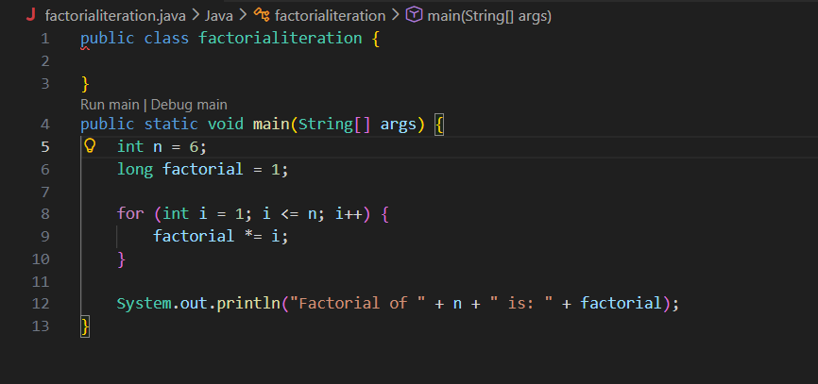

Output:
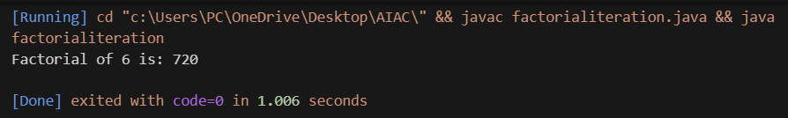

Justification:

GitHub Copilot generated the iterative factorial program using loops. It calculates the factorial step by step, produces the correct output, and demonstrates the iterative computational approach without manual coding.

Prompt:
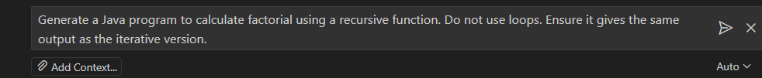

Code:
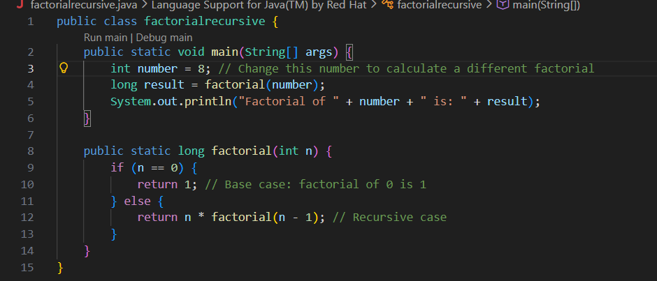

Output:
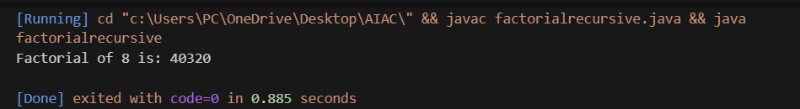

Justification:

In the iterative version, GitHub Copilot generated a Java program that calculates factorial using loops. The program multiplies numbers step by step from 1 up to the given number. This approach is straightforward, easy to follow, and efficient for small to medium-sized inputs. Copilot ensured correct syntax and logic without manually writing the code.

