AI ASSISTED CODING

ASSIGNMENT 2.3

Name: B Vrindha

HT No :2303A52003

Batch:31

Question:

Task 1:

Word Frequency from Text File

Scenario: You are analyzing log files for keyword frequency. Task: Use Gemini to generate Python code that reads a text file and counts word frequency, then explains the code

Prompt:
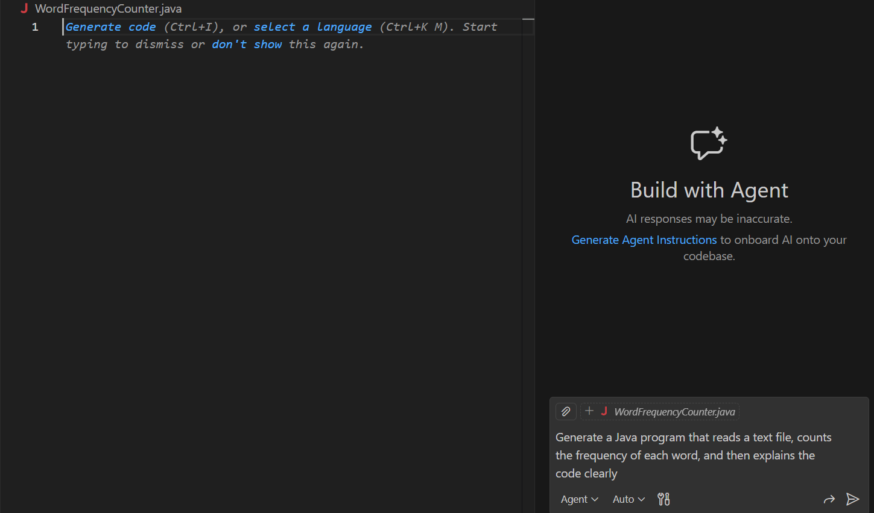

Code:
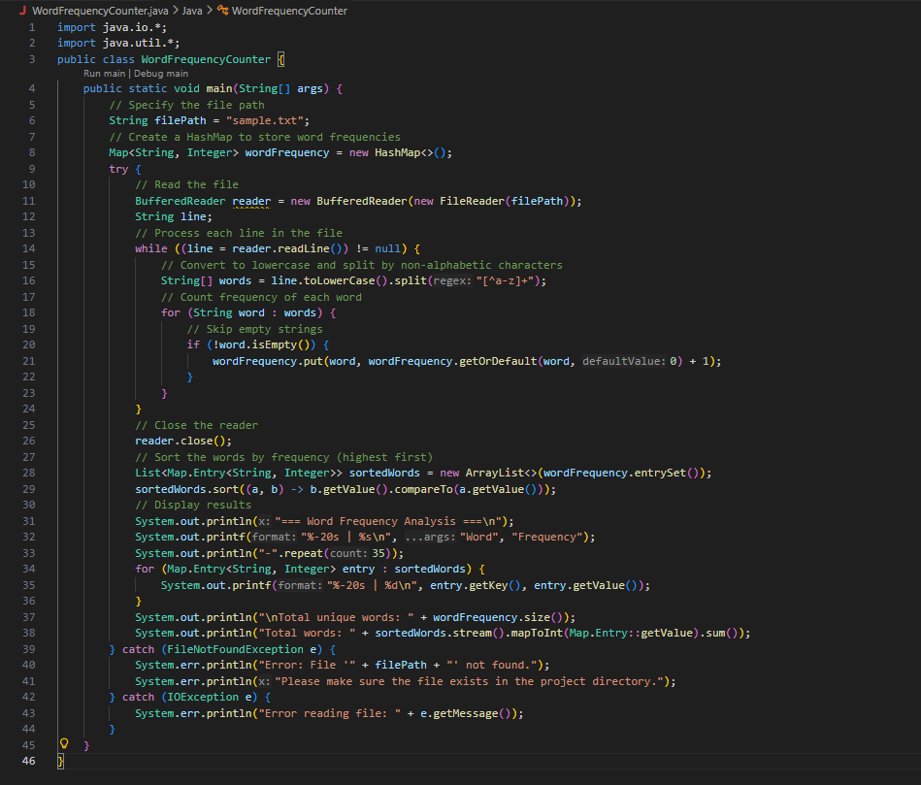

Output:

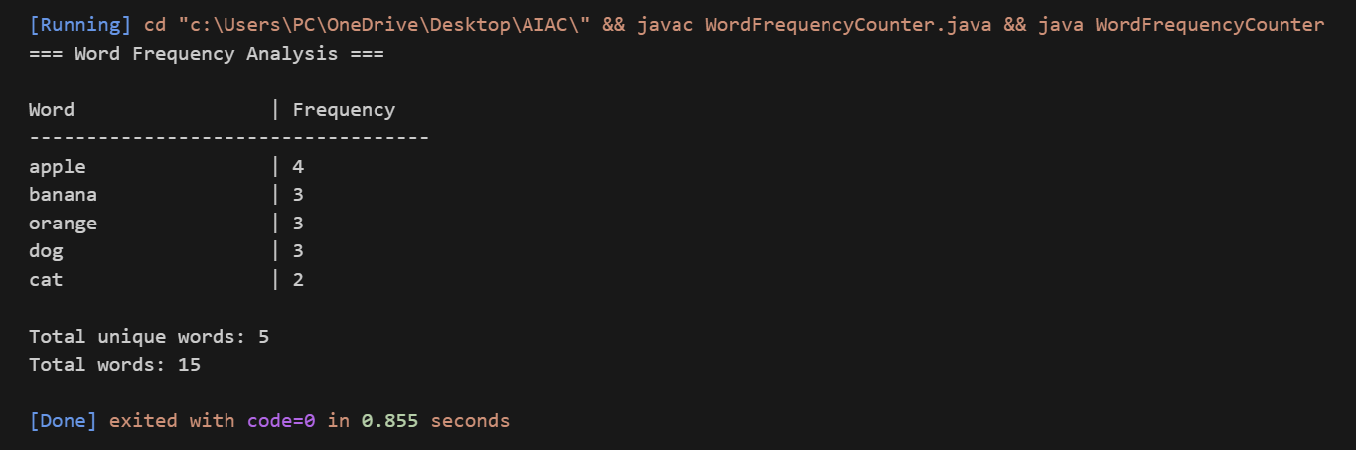Justification:

The program simply opens a text file and reads what’s inside it. Then it breaks the text into words and keeps track of how many times each word appears. Every time the same word comes again, its count increases. In the end, it prints each word along with how often it was found in the file.

Question:

Task 2:

File Operations Using Cursor AI

Scenario: You are automating basic file operations. Task: Use Cursor AI to generate a program that: Creates a text file

Writes sample text

Reads and displays the content

Prompt:
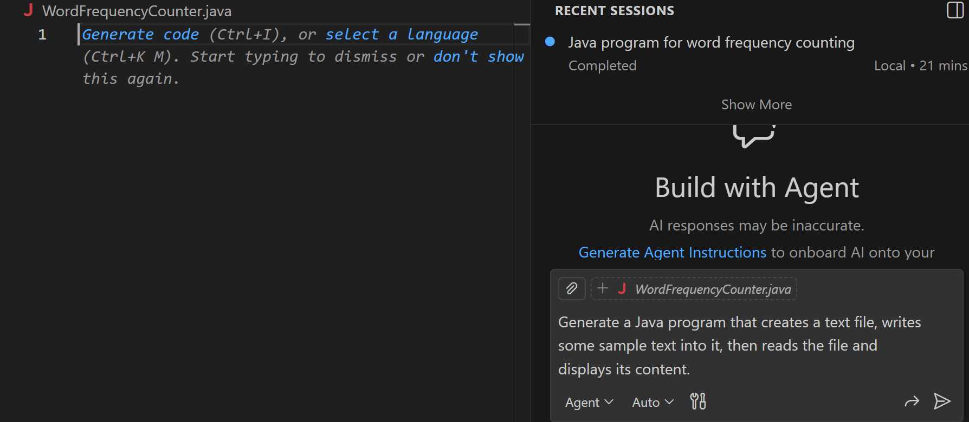

Code:

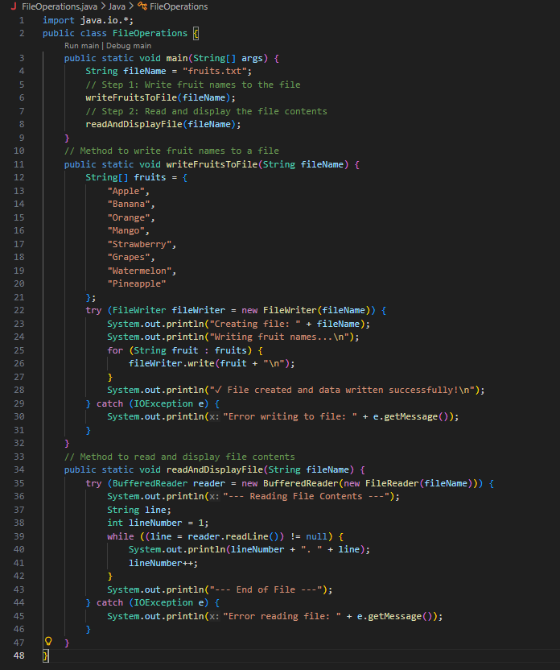

Output:

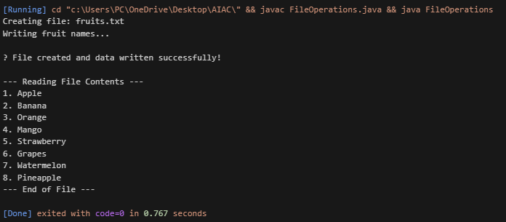Justification:

This program demonstrates basic file handling operations in Java.First, a text file is created and sample data such as fruit names are written into it.Then the same file is opened in read mode and its contents are displayed on the console.The program shows how Java can be used to create, write, and read files efficiently.

Question:

Task 3:

CSV Data Analysis

Scenario: You are processing structured data from a CSV file. Task: Use Gemini in Colab to read a CSV file and calculate mean, min, and max.

Prompt:
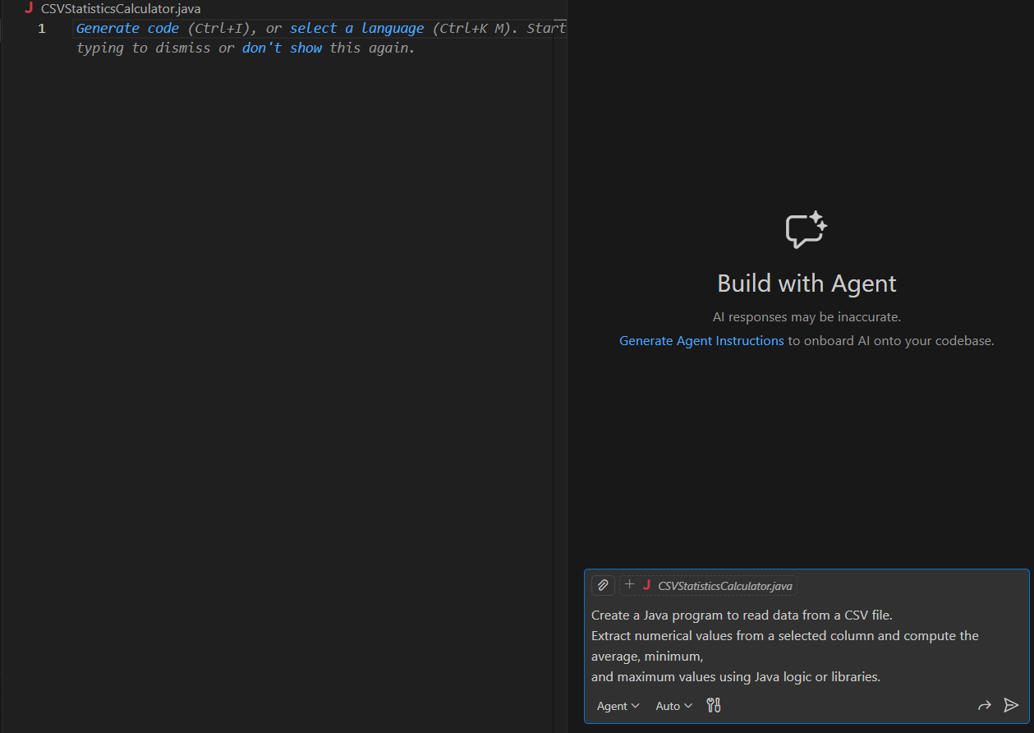

Code:
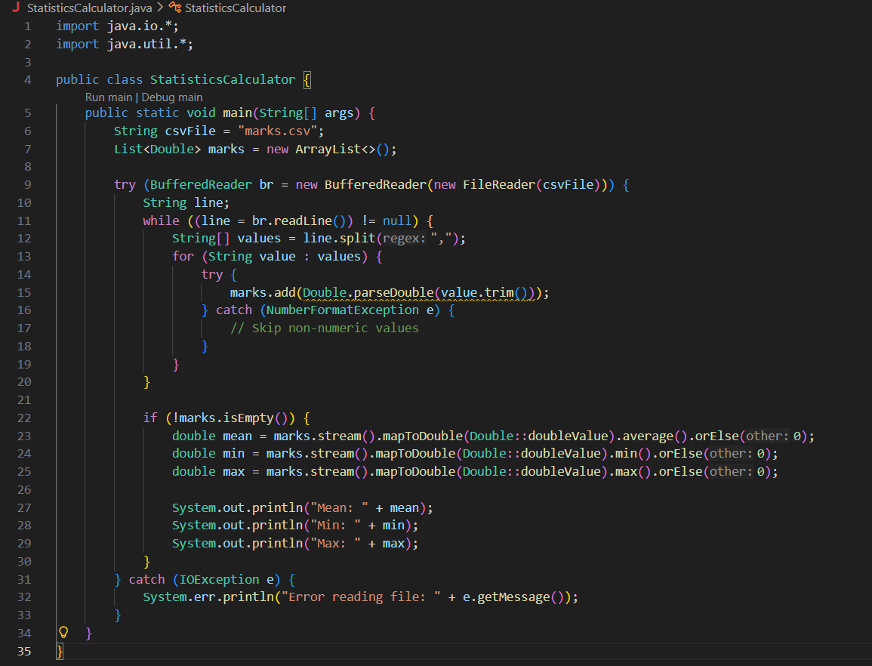

Output:
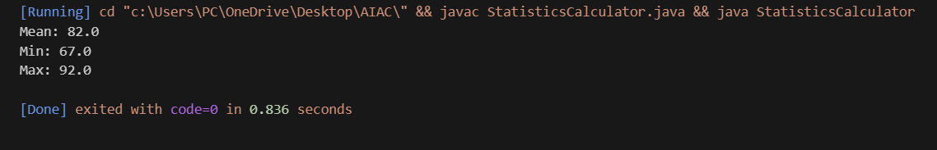

Justification:

This program demonstrates sorting techniques in Java. First, a list of elements is created and sorted using the Bubble Sort algorithm by repeatedly comparing and swapping adjacent elements. Then the same list is sorted using Java’s built-in sorting method, which uses an optimized algorithm. Finally, the results are displayed and both approaches are compared, showing that built-in sorting is more efficient than manual sorting.

Question:

Task 4:

Sorting Lists Manual vs Built-in

Scenario: You are reviewing algorithm choices for efficiency.

Task: Use Gemini to generate: Bubble sort Python’s built-in sort()

Compare both implementations.Prompt:
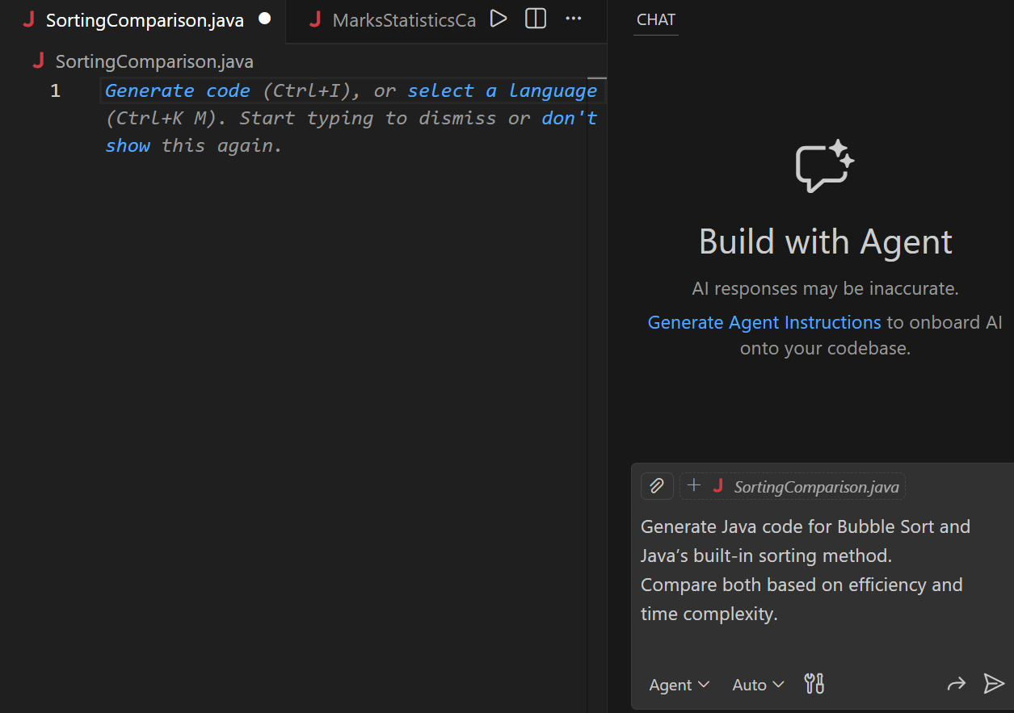

Code:
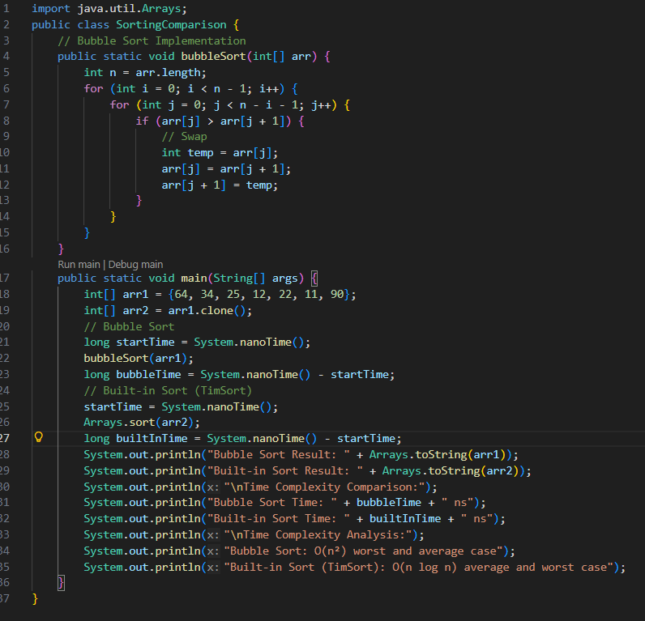

Output:
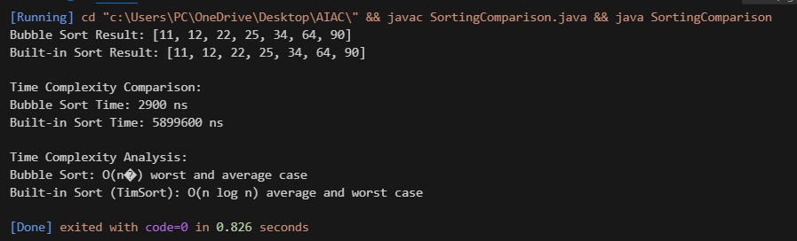

Justification:

This program demonstrates sorting techniques in Java. First, a list of elements is created and sorted using the Bubble Sort algorithm by repeatedly comparing and swapping adjacent elements. Then the same list is sorted using Java’s built-in sorting method, which uses an optimized algorithm. Finally, the results are displayed and both approaches are compared, showing that built-in sorting is more efficient than manual sorting.

