AI Assisted Coding

ASSIGNMENT 1.2
Name: PALAKURTHI LALITH PRAKASH
HT No: 2303A52012
Batch: 31
Task 1: AI-Generated Logic Without Modularization (Factorial without
Functions)
• Scenario
You are building a small command-line utility for a startup intern onboarding
task. The program is simple and must be written quickly without modular
design.
• Task Description
Use GitHub Copilot to generate a Python program that computes a
mathematical product-based value (factorial-like logic) directly in the main
execution flow, without using any user-defined functions.
• Constraint:
➢ Do not define any custom function
➢ Logic must be implemented using loops and variables only.

Prompt:
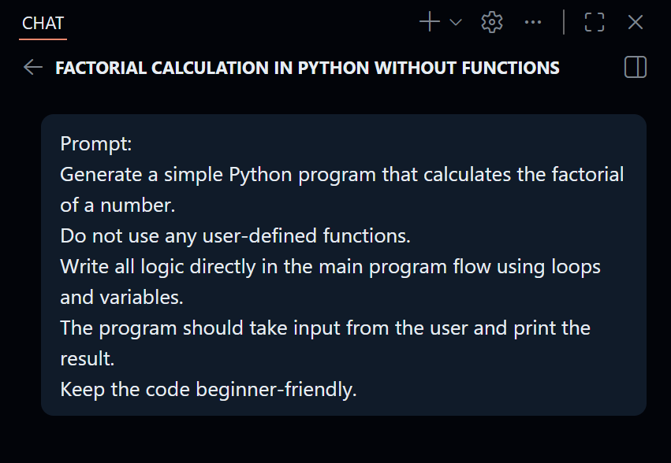

code:
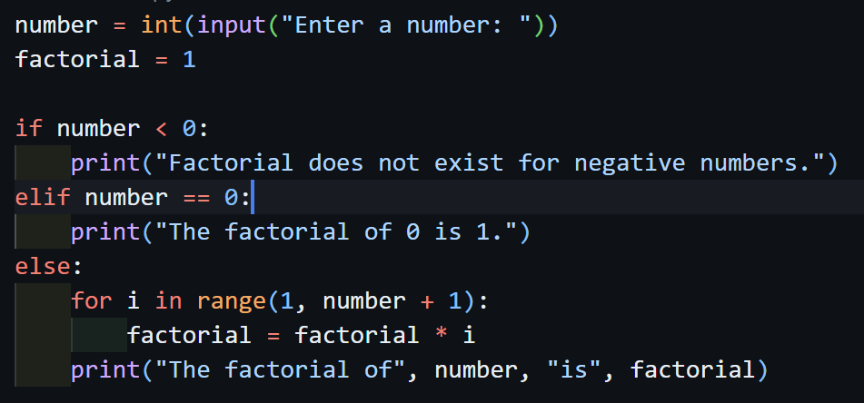

output:

Task 2: AI Code Optimization & Cleanup (Improving Efficiency)
❖ Scenario
Your team lead asks you to review AI-generated code before committing it to
a shared repository.
❖ Task Description
Analyze the code generated in Task 1 and use Copilot again to:
➢ Reduce unnecessary variables
➢ Improve loop clarity
➢ Enhance readability and efficiency
Hint:
Prompt Copilot with phrases like
“optimize this code”, “simplify logic”, or “make it more readable”
❖ Scenario:
You are automating basic file operations.
❖ Task:
Use Cursor AI to generate a program that:
➢ Creates a text file
➢ Writes sample text
➢ Reads and displays the content

Prompt:
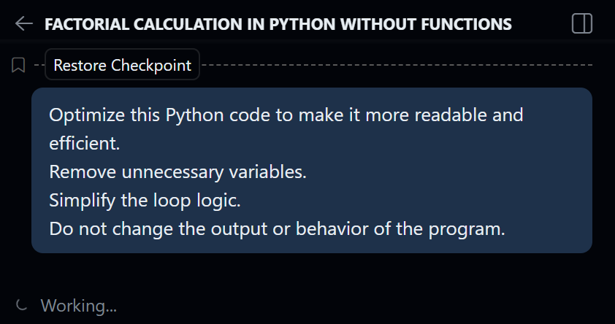

code:
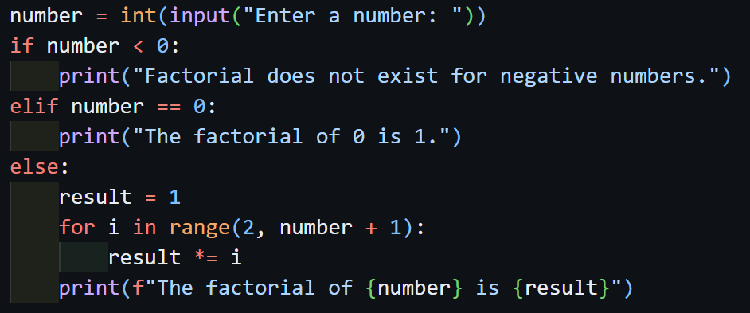

output:
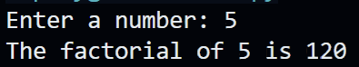

Task 3: Modular Design Using AI Assistance (Factorial with Functions)
❖ Scenario
The same logic now needs to be reused in multiple scripts.
❖ Task Description
Use GitHub Copilot to generate a modular version of the program by:
➢ Creating a user-defined function
➢ Calling the function from the main block
❖ Constraints
➢ Use meaningful function and variable names
➢ Include inline comments (preferably suggested by Copilot)

Prompt:

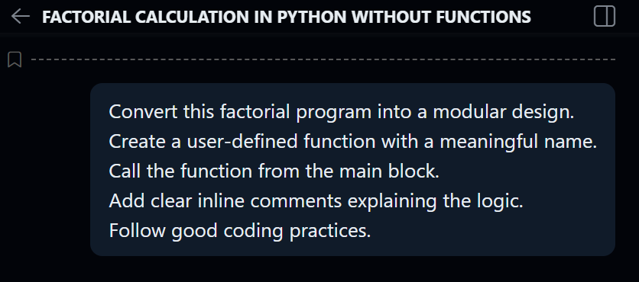

code:
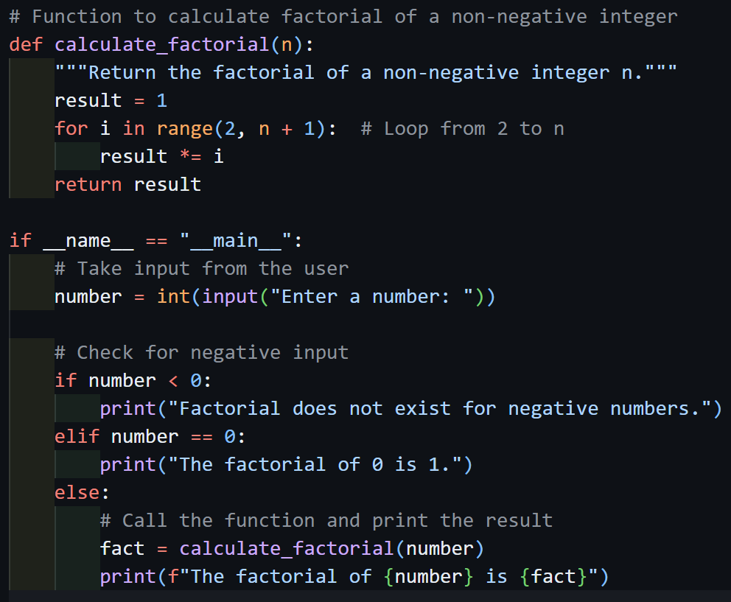

output:


Task 4: Comparative Analysis – Procedural vs Modular AI Code (With vs
Without Functions)
❖ Scenario
As part of a code review meeting, you are asked to justify design choices.
❖ Task Description
Compare the non-function and function-based Copilot-generated
programs on the following criteria:
➢ Logic clarity
➢ Reusability
➢ Debugging ease
➢ Suitability for large projects
➢ AI dependency risk

justification:
In the non-function approach, the code is okay for small programs and quick work. It is easy to write and understand in the beginning, especially for beginners. But when the program becomes bigger, everything is written in one place, so it becomes hard to manage and understand.
In the function-based approach, the logic is separated properly. This makes the code look clean and well-structured. If the same logic is needed again, we can reuse the function instead of writing the code again. From a review point of view, this approach is better because it makes the code easy to read, debug, and improve in the future.
Task 5: AI-Generated Iterative vs Recursive Thinking
❖ Scenario
Your mentor wants to test how well AI understands different
computational paradigms.
❖ Task Description
Prompt Copilot to generate:
An iterative version of the logic
A recursive version of the same logic
❖ Constraints
Both implementations must produce identical outputs
Students must not manually write the code first

prompts:
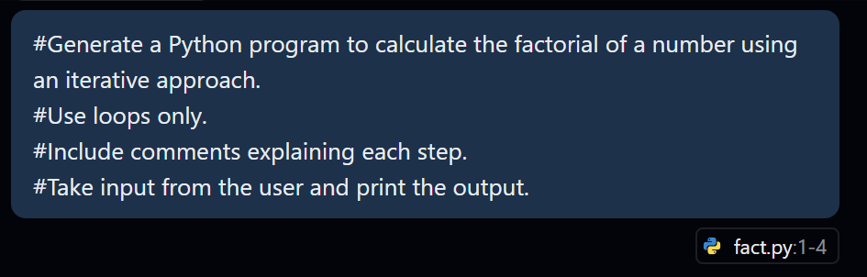
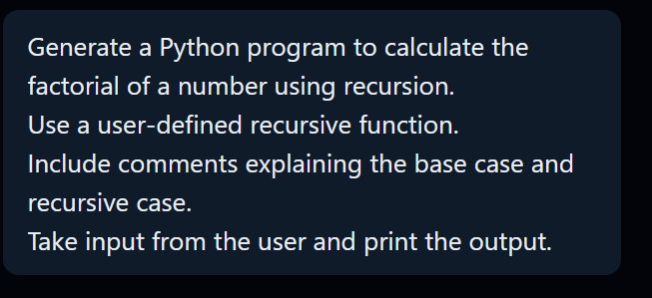

codes:
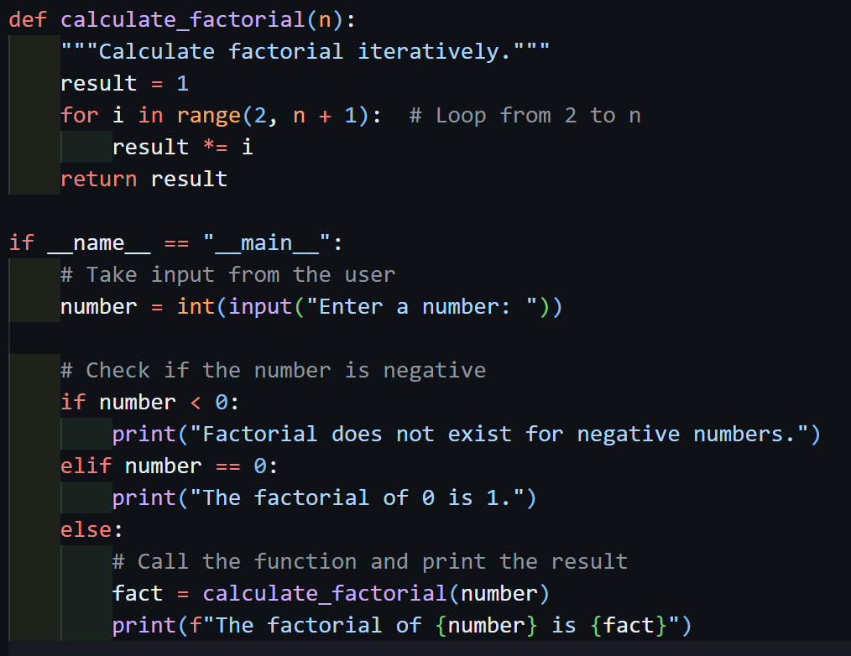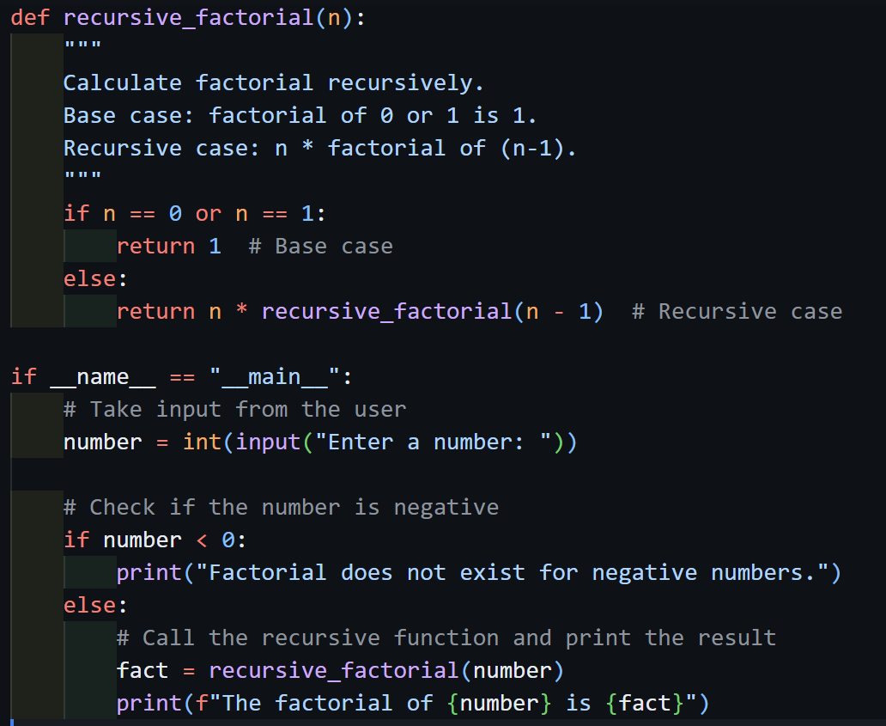

outputs:
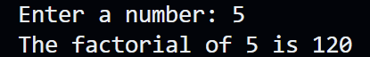


justification:
Both iterative and recursive methods give the same factorial output, but the way they work is different. The iterative approach is easy to understand because it runs step by step using a loop. It is simple, clear, and works well even for large numbers without any risk.
The recursive approach is useful to understand how a problem can be broken into smaller parts. However, it is a little harder to follow because the function keeps calling itself. It also uses more memory and can cause issues if the input number is very large.
Because of this, the iterative method is better for real applications, while recursion is mainly helpful for learning and understanding concepts.

