AI Assisted Coding

ASSIGNMENT 2.3
Name: PALAKURTHI LALITH PRAKASH
HT No: 2303A52012
Batch: 31
Task 1: Word Frequency from Text File
❖ Scenario: You are analyzing log files for keyword frequency.
❖ Task: Use Gemini to generate Python code that reads a text file and counts word frequency, then explains the code.

Prompt:
- Create a Python program that creates a text file, writes sample text into it, then reads the file and displays its contents.
- now generate a py code that reads the txt file and prinsta the word frequency

code:
1. 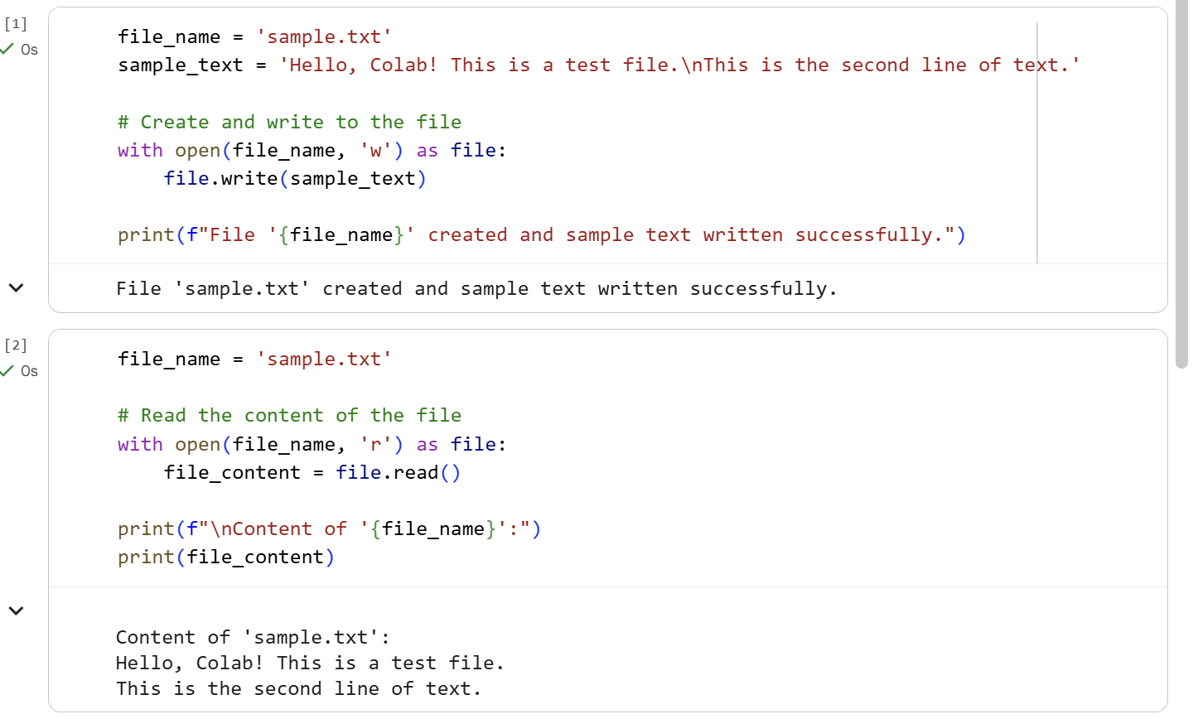
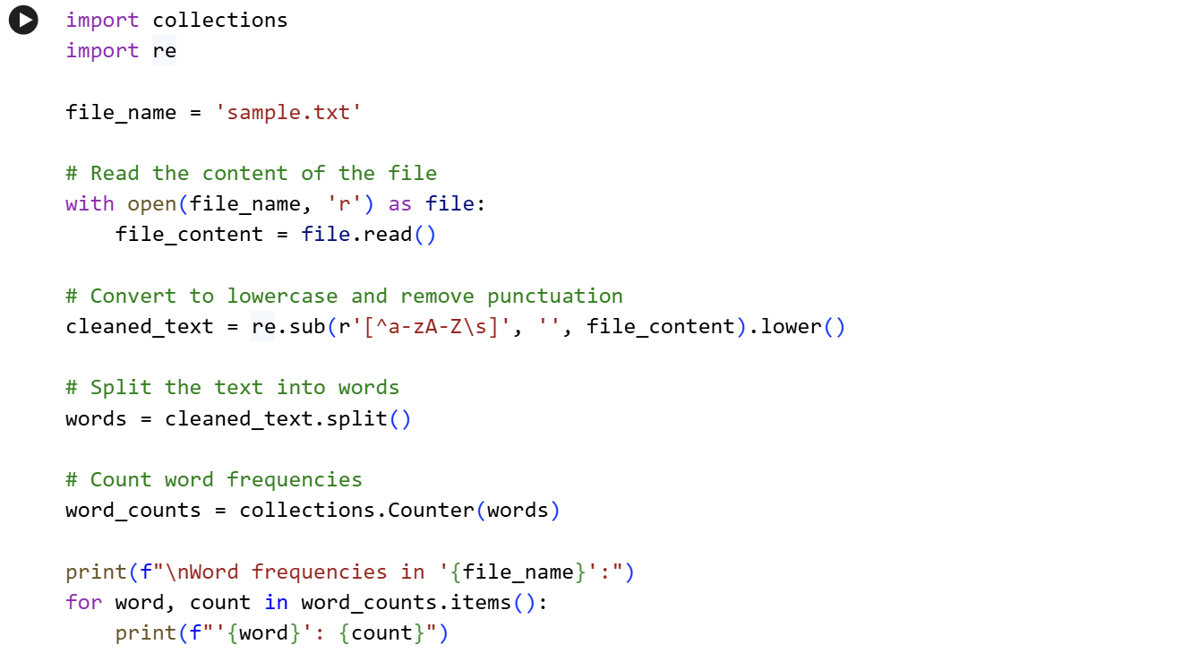

output:
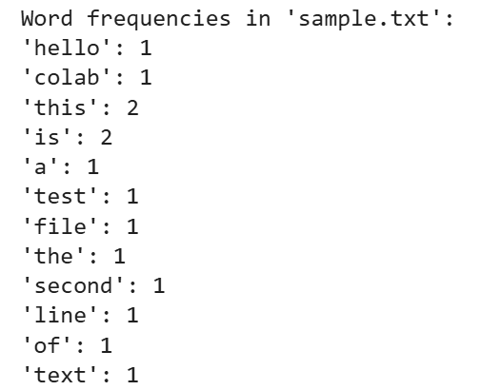

justification:
the generated code reads the code from the file created earlier generation and thean next using a methods from the collections class it counts all the word frequency.
Task 2: File Operations Using Cursor AI
❖ Scenario:
You are automating basic file operations.
❖ Task:
Use Cursor AI to generate a program that:
➢ Creates a text file
➢ Writes sample text
➢ Reads and displays the content

Prompt:
generate a python program, which creates a text file, write sample txt eg.fruits in that, read
and display that content.

code:
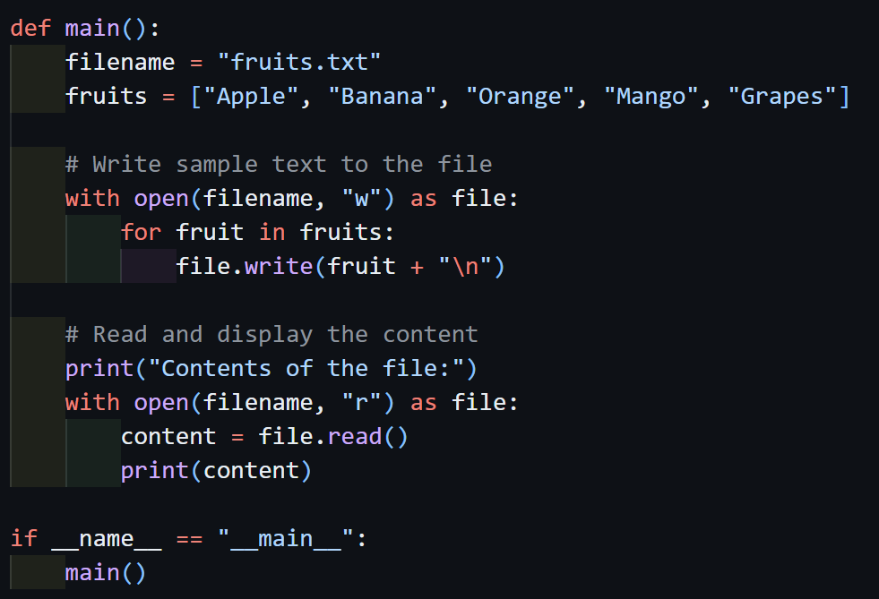

output:
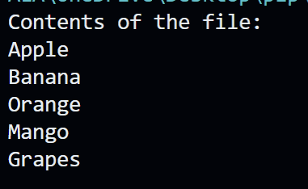

justification:
the program made a file named as fruits.txt and a list with different fruits names and in a loop each fruit name is enter inside the file line byline and then using read() method all the contant is read and printed on to the screen.
Task 3: CSV Data Analysis
❖ Scenario:
You are processing structured data from a CSV file.
❖ Task:
Use Gemini in Colab to read a CSV file and calculate mean, min, and max.

Prompt:
Generate Python code to read marks CSV file and calculate the mean, minimum, and maximum values of a numeric column.

code:
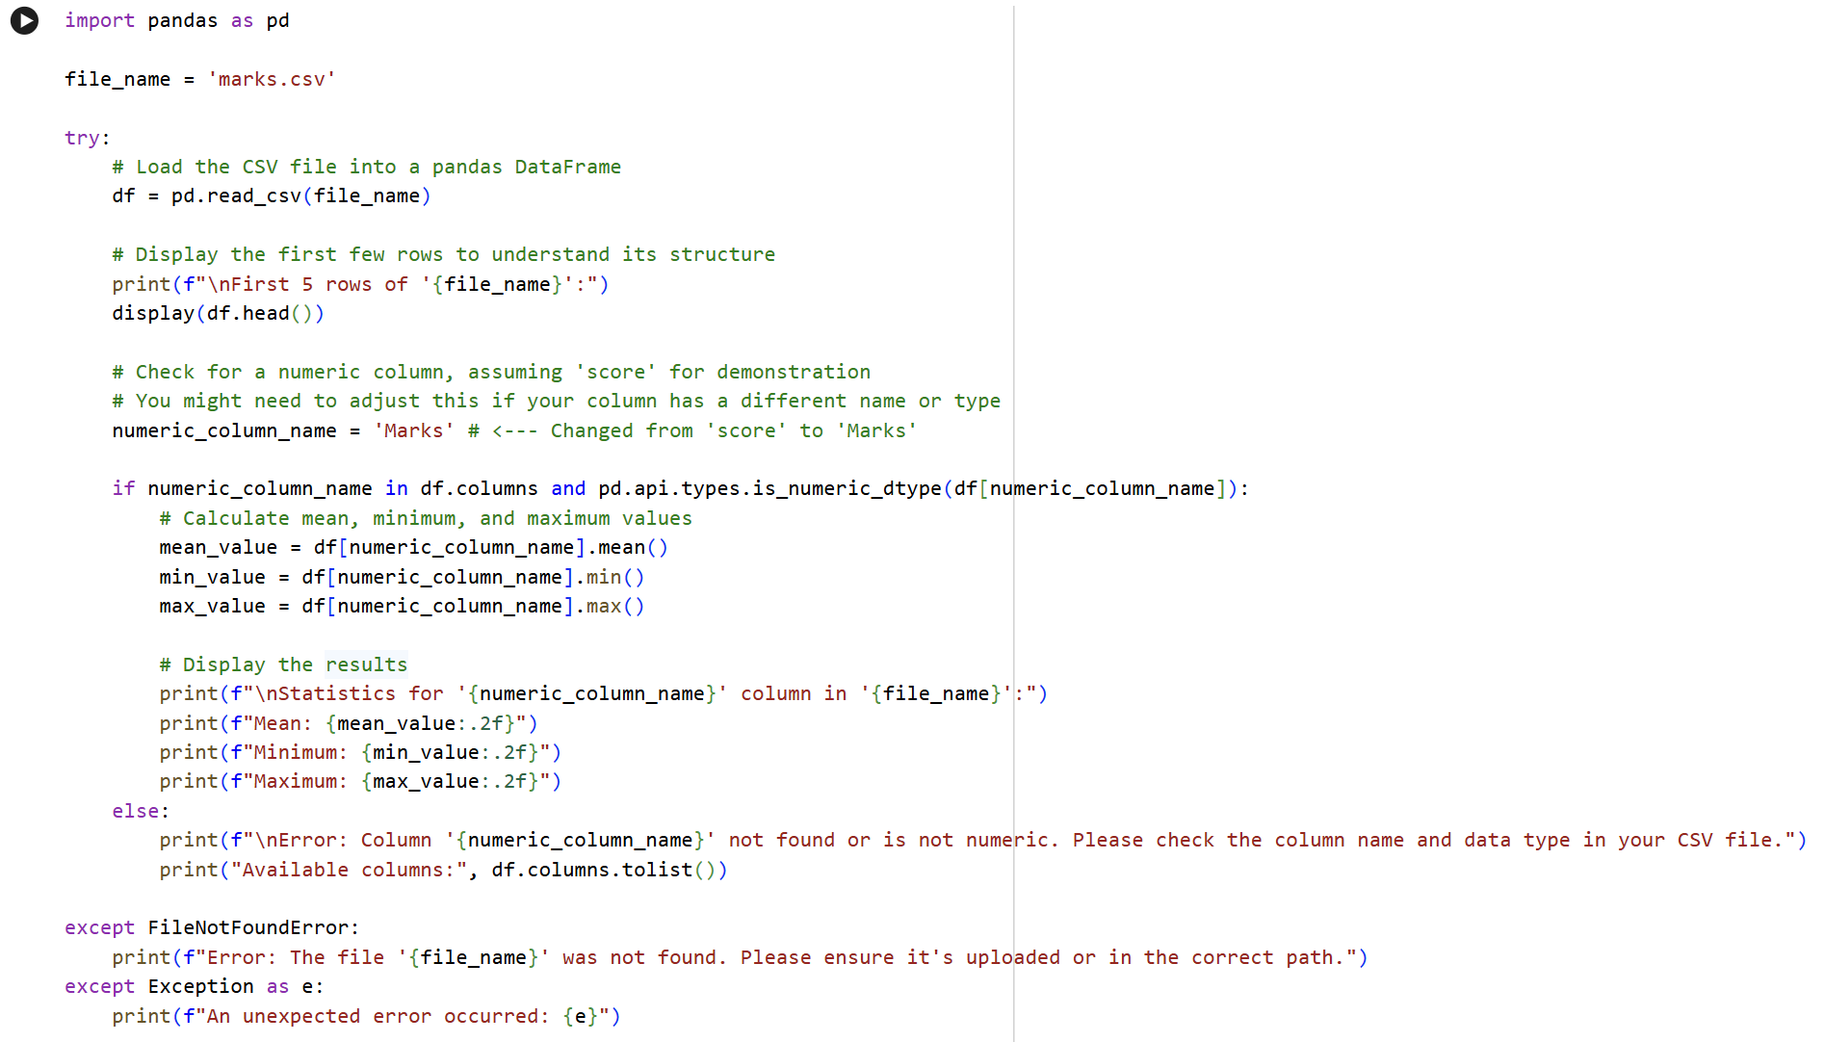

output:
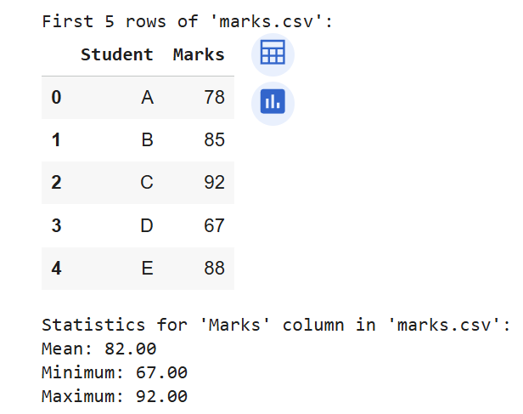

justification:
This code reads a CSV file (marks.csv) using pandas and shows the first few rows to understand the data. It then checks whether the Marks column exists and is numeric, and calculates the mean, minimum, and maximum values from it. If the file or column is missing (or invalid), it prints a clear error message instead of crashing.

Task 4: Sorting Lists – Manual vs Built-in
❖ Scenario:
You are reviewing algorithm choices for efficiency.
❖ Task:
Use Gemini to generate:
➢ Bubble sort
➢ Python’s built-in sort()
➢ Compare both implementations.

Prompt:
a. generate python code for bubble sort
b. generate python code for built-in sort

code:
a.
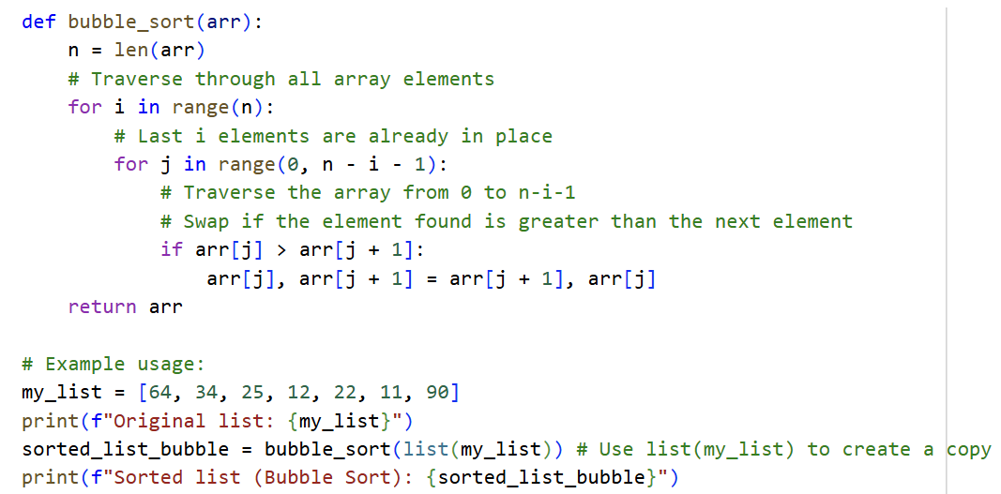
b.
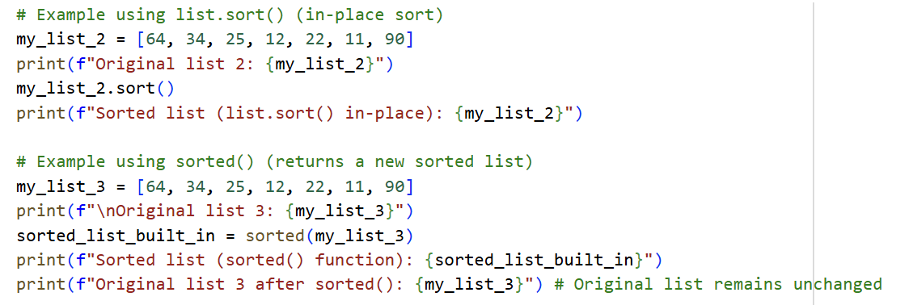

output:
a.
b.
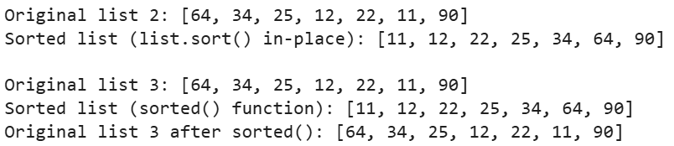

justification:
list.sort() sorts the list in place, meaning it changes the original list itself.
sorted() creates a new sorted list and keeps the original list unchanged.
Use sort() when you don’t need the original order, and sorted() when you want to preserve it.

