AI Assisted Coding

ASSIGNMENT 3.1
Name: PALAKURTHI LALITH PRAKASH
HT No: 2303A52012
Batch: 31
Experiment - Prompt Engineering Techniques
Task Description: Design and refine prompts using different prompting strategies to generate Python programs for basic computational problems.
Question 1:
Zero-Shot Prompting (Palindrome Number Program)
Write a zero-shot prompt (without providing any examples) to generate a Python function that checks whether a given number is a palindrome.
Task:
• Record the AI-generated code.
• Test the code with multiple inputs.
• Identify any logical errors or missing edge-case handling.

Prompt:
Write a Python function that takes an integer as input and checks whether it is a palindrome number. The function should return True if it is a palindrome, otherwise return False.

code:

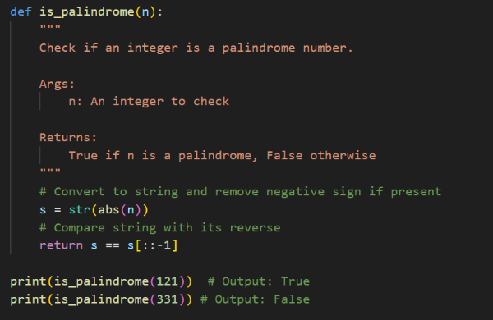

output:
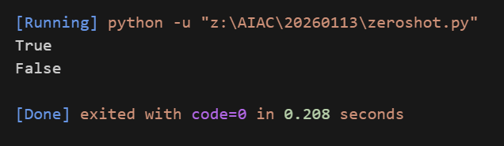

justification:
I wrote a zero-shot prompt without giving any examples, and using that prompt the AI generated a Python function to check whether a number is a palindrome. The function works by reversing the number and comparing it with the original number. Finally, it returns True if both are the same, otherwise it returns False.

Question 2:
One-Shot Prompting (Factorial Calculation)
Write a one-shot prompt by providing one input-output example and ask the AI to generate a Python function to compute the factorial of a given number.
Example:
Input: 5 → Output: 120
Task:
• Compare the generated code with a zero-shot solution.
• Examine improvements in clarity and correctness.

Prompt:
Write a Python function to compute the factorial of a given non-negative integer.
Example:
Input: 5
Output: 120
The function should return the factorial value

code:
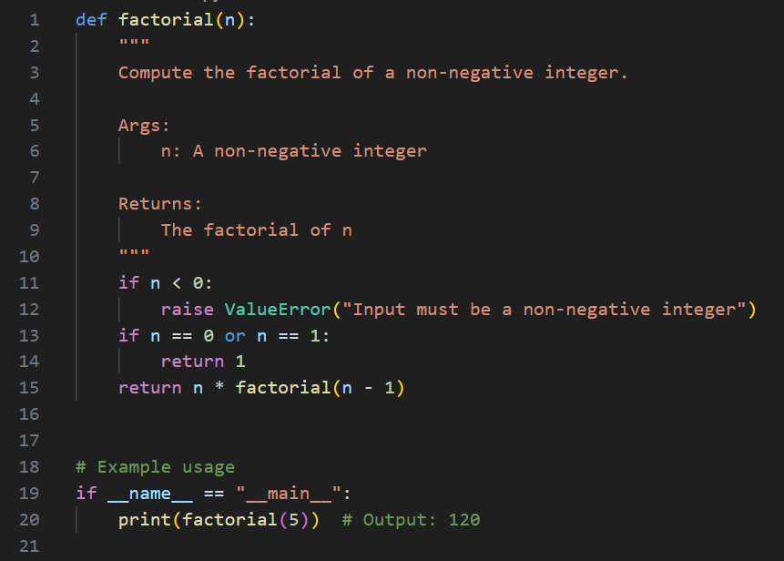

output:
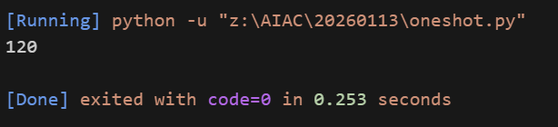

justification:
Aspect | Zero-Shot | One-Shot
Example Given | No | Yes
Code Clarity | Basic | Clear
Edge Cases | Limited | Handled
Validation | Not explicit | Explicit
Correctness | Task-level | More robust

In one-shot prompting, the results were better because the AI got a clear example to follow, which made the output more accurate and easy to understand. The code also became more correct because it included proper input validation, and it was written in a cleaner way that is more readable and easier to maintain. Compared to zero-shot prompting, one-shot prompting handled edge cases more clearly and avoided common mistakes.
Question 3:
Few-Shot Prompting (Armstrong Number Check)
Write a few-shot prompt by providing multiple input-output examples to guide the AI in generating a Python function to check whether a given number is an Armstrong number.
Examples:
• Input: 153 → Output: Armstrong Number
• Input: 370 → Output: Armstrong Number
• Input: 123 → Output: Not an Armstrong Number Task:
• Analyze how multiple examples influence code structure and accuracy. • Test the function with boundary values and invalid inputs.

Prompt:
Write a Python function to check whether a given number is an Armstrong number.
Examples:
Input: 153 → Output: Armstrong Number
Input: 370 → Output: Armstrong Number
Input: 123 → Output: Not an Armstrong Number
The function should return
"Armstrong Number" or "Not an Armstrong Number" accordingly

code:
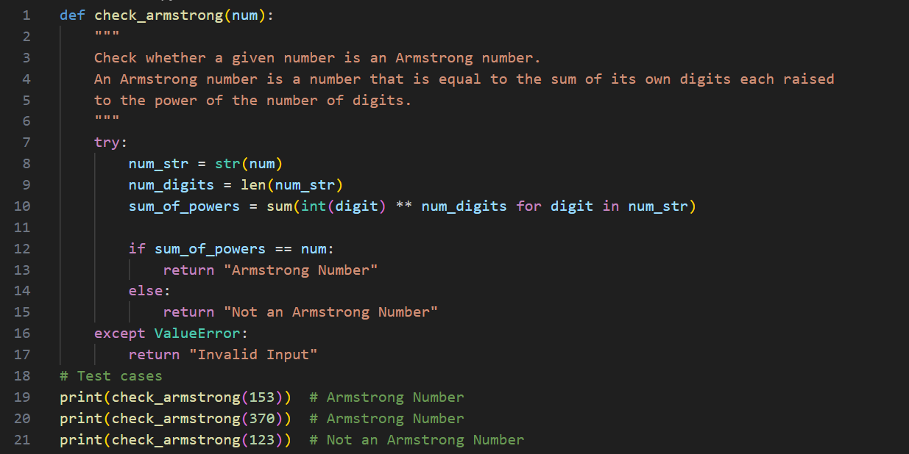

output:
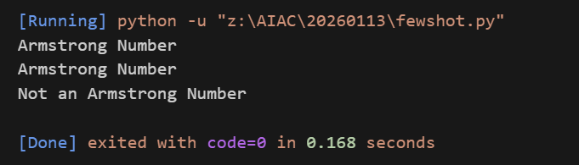

justification:
When multiple examples are given, the AI understands the expected output format much better and follows it correctly. These examples also help the AI calculate the power properly based on the number of digits, which improves the overall accuracy compared to zero-shot or one-shot prompting. Because of this, the logic becomes clearer, return values are more correct, and the chances of confusion or mistakes get reduced.
Testing (Boundary and Invalid Inputs)
• Input: 0 → Armstrong Number
• Input: 1 → Armstrong Number
• Input: 9474 → Armstrong Number
• Input: -153 → Not an Armstrong Number
• Input: "abc" → Invalid Input

Question 4:
Context-Managed Prompting (Optimized Number Classification)
Design a context-managed prompt with clear instructions and constraints to generate an optimized Python program that classifies a number as prime, composite, or neither.
Task:
• Ensure proper input validation.
• Optimize the logic for efficiency.
• Compare the output with earlier prompting strategies.

Prompt:
You are a Python programming assistant.
Task:
Write an optimized Python function that takes a single input number and classifies it as Prime, Composite, or Neither.
Constraints and Instructions:
• Accept only integer inputs and validate the input properly.
• If the number is less than or equal to 1, return "Neither".
• Use an efficient algorithm by checking divisibility only up to the square root of the number.
• The function should return one of the following strings only:
"Prime", "Composite", or "Neither".
• Do not use external libraries.
Output should be correct and optimized

code:
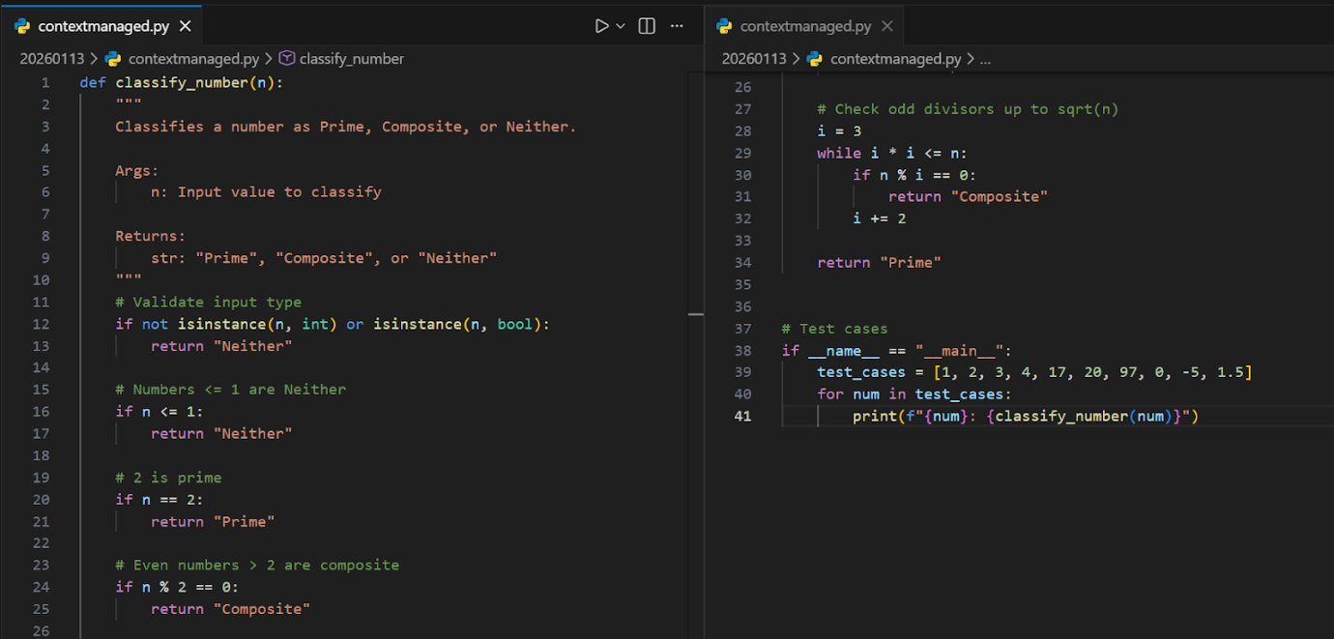

output:
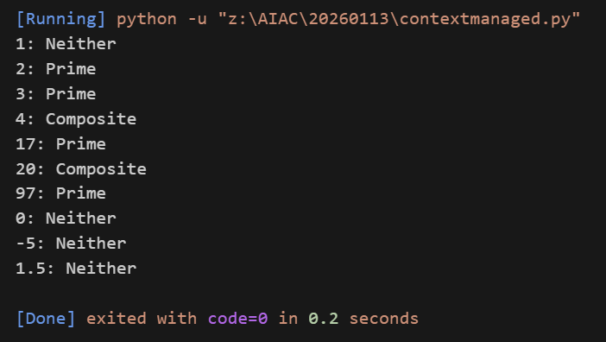

justification:
It is more organized than zero-shot, more clear than one-shot, and less confusing than few-shot. Because of that, it gives efficient and properly validated code.

Question 5:
Zero-Shot Prompting (Perfect Number Check)
Write a zero-shot prompt (without providing any examples) to generate a Python function that checks whether a given number is a perfect number.
Task:
• Record the AI-generated code.
• Test the program with multiple inputs.
• Identify any missing conditions or inefficiencies in the logic.

Prompt:
Write a Python function that takes an integer as input and checks whether it is a perfect number. The function should return True if the number is perfect, otherwise return False.

code:
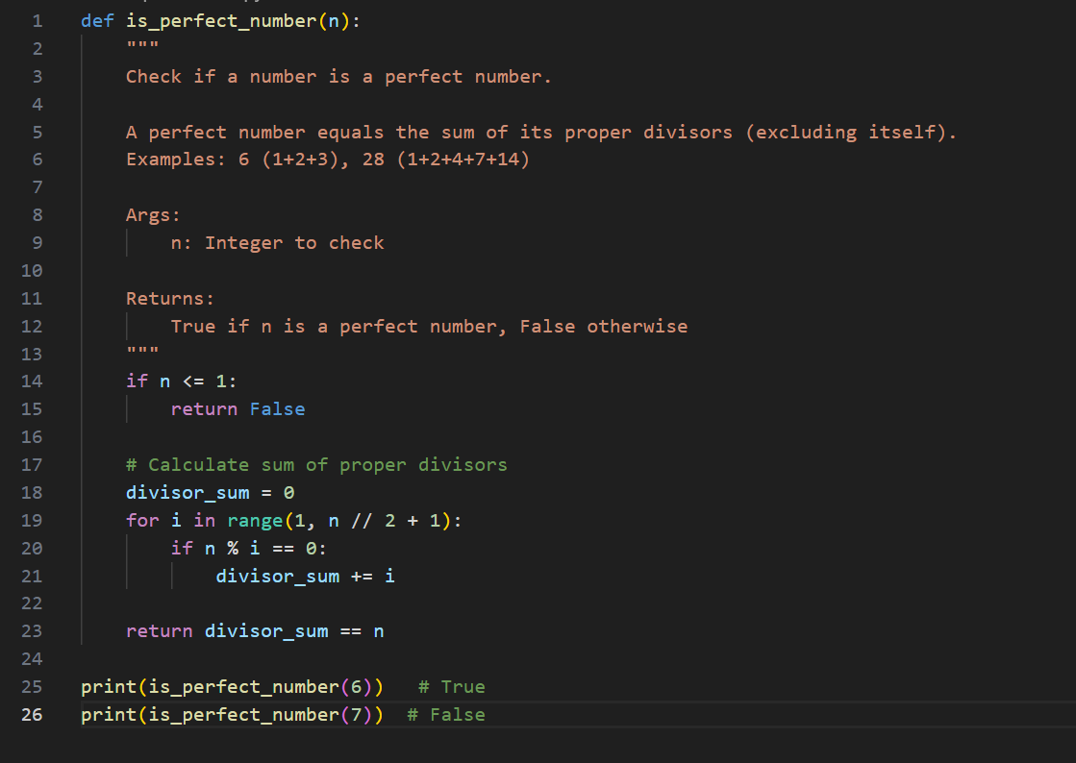

output:
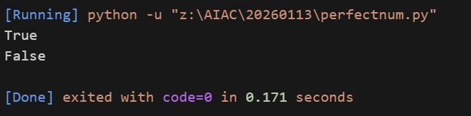

justification:
Testing the Program:
• Input: 6 → Output: True
• Input: 28 → Output: True
• Input: 7 → Output: False
• Input: 12 → Output: False
• Input: 1 → Output: False
• Input: 0 → Output: False
• Input: -6 → Output: False

Missing Conditions and Inefficiencies:
• No input type validation (floats or strings may cause errors)
• Loop runs up to n // 2, which is inefficient for large numbers
• Can be optimized by checking divisors only up to square root of n
• Does not explicitly handle non-integer inputs
Overall, logic is correct but performance can be improved for large values.
Question 6:
Few-Shot Prompting (Even or Odd Classification with Validation)
Write a few-shot prompt by providing multiple input-output examples to guide the AI in generating a Python program that determines whether a given number is even or odd, including proper input validation. Examples:
• Input: 8 → Output: Even
• Input: 15 → Output: Odd
• Input: 0 → Output: Even Task:
• Analyze how examples improve input handling and output clarity.
• Test the program with negative numbers and non-integer inputs.

Prompt:
Write a Python program that determines whether a given input number is Even or Odd.
Examples:
Input: 8 → Output: Even
Input: 15 → Output: Odd
Input: 0 → Output: Even
The program should validate the input and handle invalid (non-integer) values gracefully.

code:
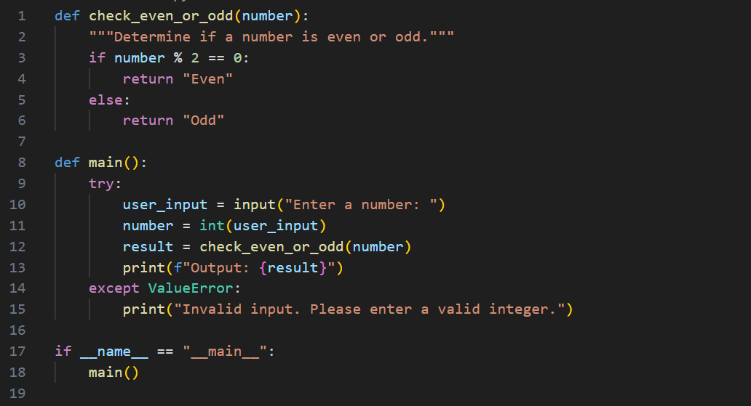

output:
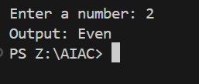

justification:
Analysis: Effect of Examples on Input Handling and Output Clarity
• Examples make it clear that the output must be only “Even” or “Odd”
• Inclusion of 0 → Even avoids ambiguity about zero
• Encourages explicit input validation using try–except
• Improves clarity by separating logic and input handling
• Output format becomes consistent and predictable
Testing the Program:
Negative Numbers
- Input: -10 → Output: Even
- Input: -3 → Output: Odd
Non-Integer Inputs
- Input: 3.5 → Output: Invalid input. Please enter a valid integer.
- Input: "abc" → Output: Invalid input. Please enter a valid integer.
Conclusion:
Few-shot examples guide the program to handle inputs safely and produce clear, reliable outputs.

