AI Assisted Coding

ASSIGNMENT 4.1
Name: PALAKURTHI LALITH PRAKASH
HT No: 2303A52012
Batch: 31
Lab 4: Advanced Prompt Engineering – Zero-shot, One-shot, and Few-shot Techniques, Chain of Thoughts, Prompt Chaining, Directional stimulus prompting
Lab Objectives
• To explore and apply different levels of prompt examples in AI-assisted code generation.
• To understand how zero-shot, one-shot, and few-shot prompting affect AI output quality.
• To evaluate the impact of context richness and example quantity on AI performance.
Q1. Zero-Shot Prompting (Basic Lab Task)
Task:
Write a Python function that classifies a given text as Spam or Not
Spam using zero-shot prompting.
Steps:
1. Construct a prompt without any examples.
2. Clearly specify the output labels.
3. Display only the predicted label.
Input:
"Congratulations! You have won a free lottery ticket."
Expected Output:
Spam

Prompt:
write a py program to detect weather the message is spam message or genune message if it is spam message print spam else not spam

code:
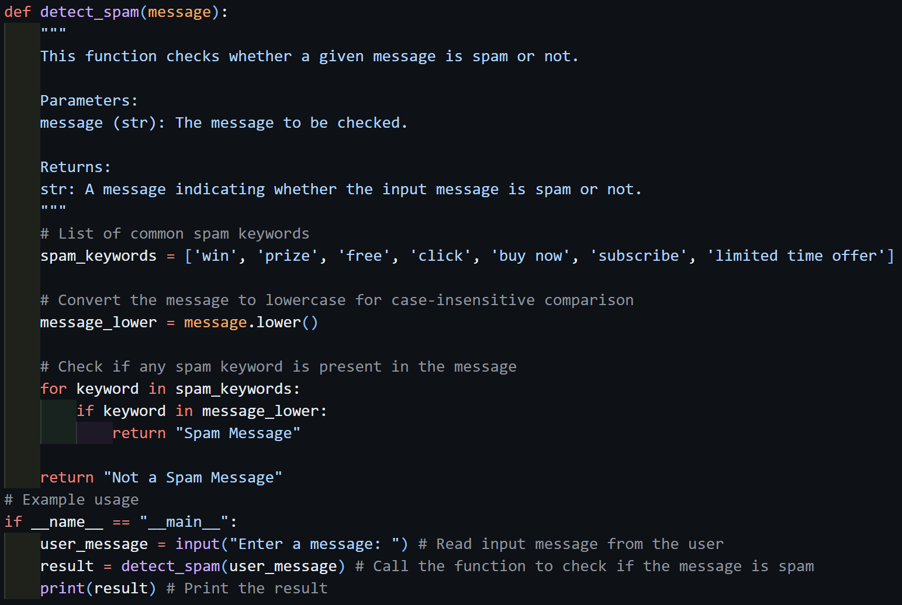

output:

Q2. One-Shot Prompting (Emotion detection)
Task:
Write a Python program that detects the emotion of a sentence
using one-shot prompting.
Emotions: [‘happy', 'sad', 'angry', 'excited', 'nervous', ’neutral’]
Steps:
1. Provide one labeled example inside the prompt.
2. Take a sentence as input.
3. Print the predicted emotion

Prompt:
Write a Python program that detects the emotion of a sentence like 'happy', 'sad', 'angry', 'excited', 'nervous', 'neutral' like "iam very happy today" it should return happy

code:
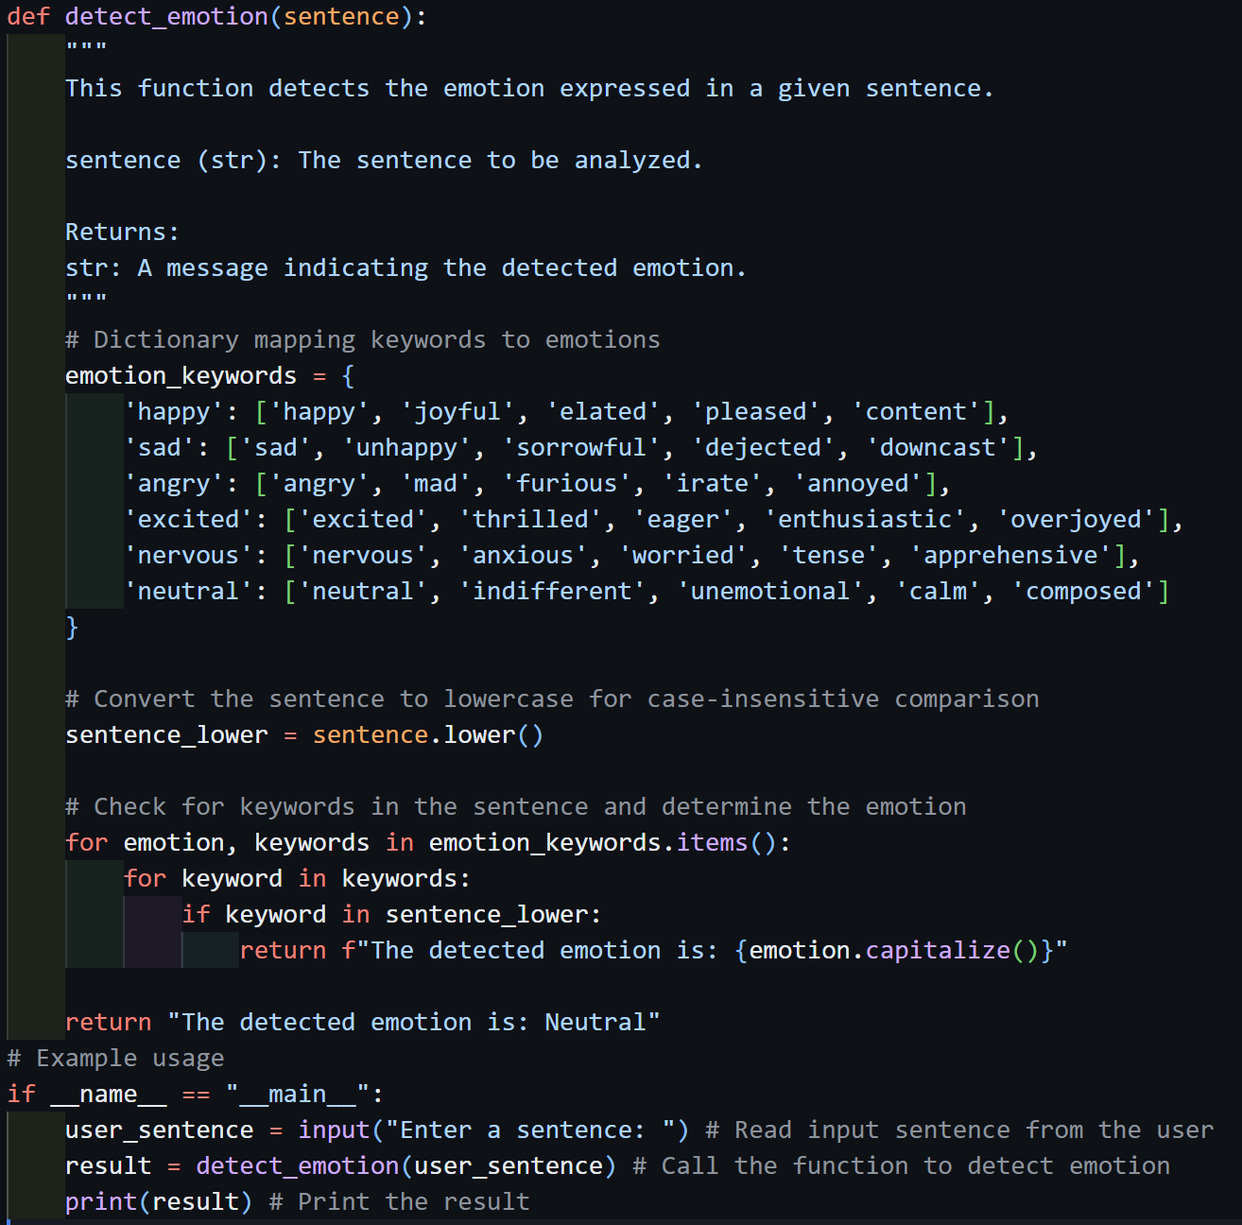

output:
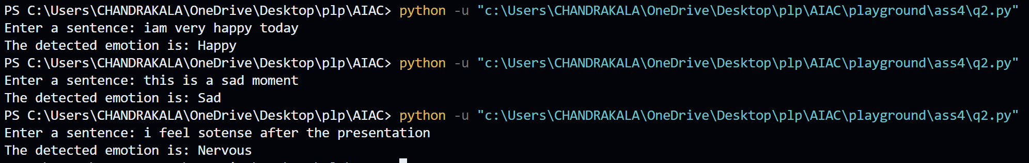

Q3. Few-Shot Prompting (Student Grading Based on Marks)
Task:
Write a Python program that predicts a student’s grade based on
marks using few-shot prompting.
Grades:
['A', 'B', 'C', 'D', 'F']
Grading Criteria (to be inferred from examples):
• 90–100 → A
• 80–89 → B
• 70–79 → C
• 60–69 → D
• Below 60 → F

Prompt:
Write a Python program that predicts a student’s grade based on marks obtained in their exam
like when they get marks in between
90-100 it should return A ,
80-89 it should return B ,
70-79 it should return C ,
60-69 it should return D ,
below 60 F

code:
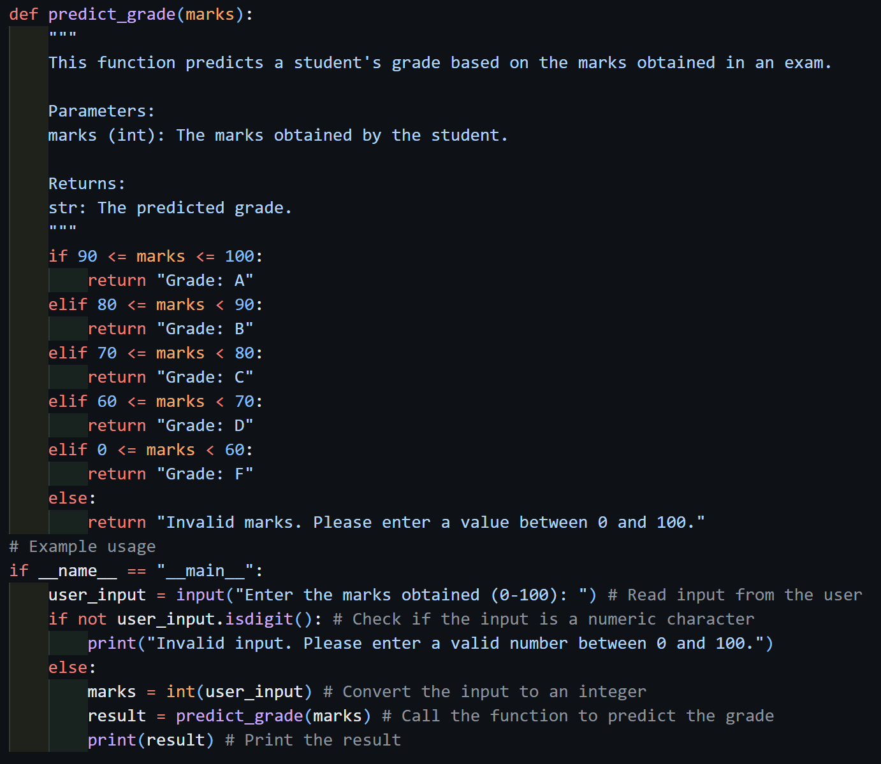

output:
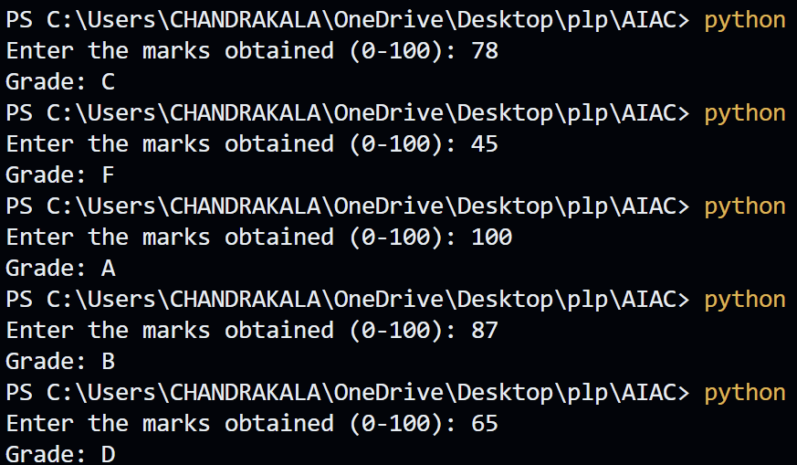
Q4. Multi-Shot Prompting (Indian Zodiac Sign Prediction using Month Name)
Task:
Write a Python program that predicts a person’s Indian Zodiac sign
(Rashi) based on the month of birth (month name) using multi-shot
prompting.
Indian Zodiac Order (Simplified Month-Based Model): The Indian
Zodiac cycle starts in March with Mesha and follows this order:
March → Mesha
April → Vrishabha
May → Mithuna
June → Karka
July → Simha
August → Kanya
September → Tula
October → Vrischika
November → Dhanu
December → Makara
January → Kumbha
February → Meena

Prompt:
Write a Python program that predicts a person’s Indian Zodiac sign
(Rashi) based on the month of birth (month name)
Indian Zodiac Order (Simplified Month-Based Model): The Indian
Zodiac cycle starts in March with Mesha
when a person is born in 15th march it should return Mesha
when a person is born in 14th april it should return Vrishabha
when a person is born in 20th may it should return Mithuna
when a person is born in 10th june it should return Karka
when a person is born in 5th july it should return Simha
when a person is born in 25th august it should return Kanya
when a person is born in 30th september it should return Tula
when a person is born in 18th october it should return Vrischika
when a person is born in 22nd november it should return Dhanu
when a person is born in 15th december it should return Makara
when a person is born in 10th january it should return Kumbha
when a person is born in 28th february it should return Meena

code:
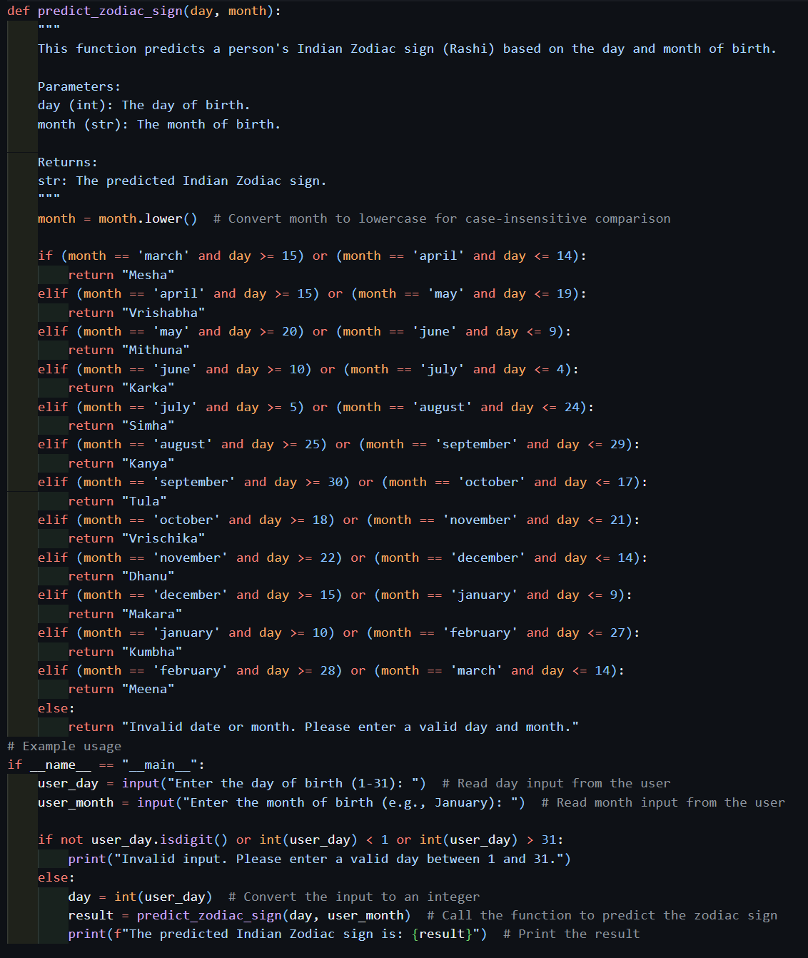

output:
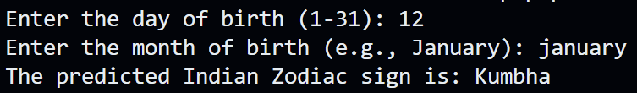
Q5. Result Analysis Based on Marks
Task: Write a Python program that determines whether a student
Passes or Fails based on marks using Chain-of-Thought (CoT)
prompting.
Result Categories:
['Pass', 'Fail']

Prompt:
write a python program to find wheather the studnet is pased or failed
1. take the input from the user as marks
2. the range of enterd marks should be in between 0-100
3. if marks are not in the range print invalid input
4. if in range check whether the marks are greater than or equal to 40
5. if yes print passed else print failed
6. cheack for the non numeric character and print invalid input

code:
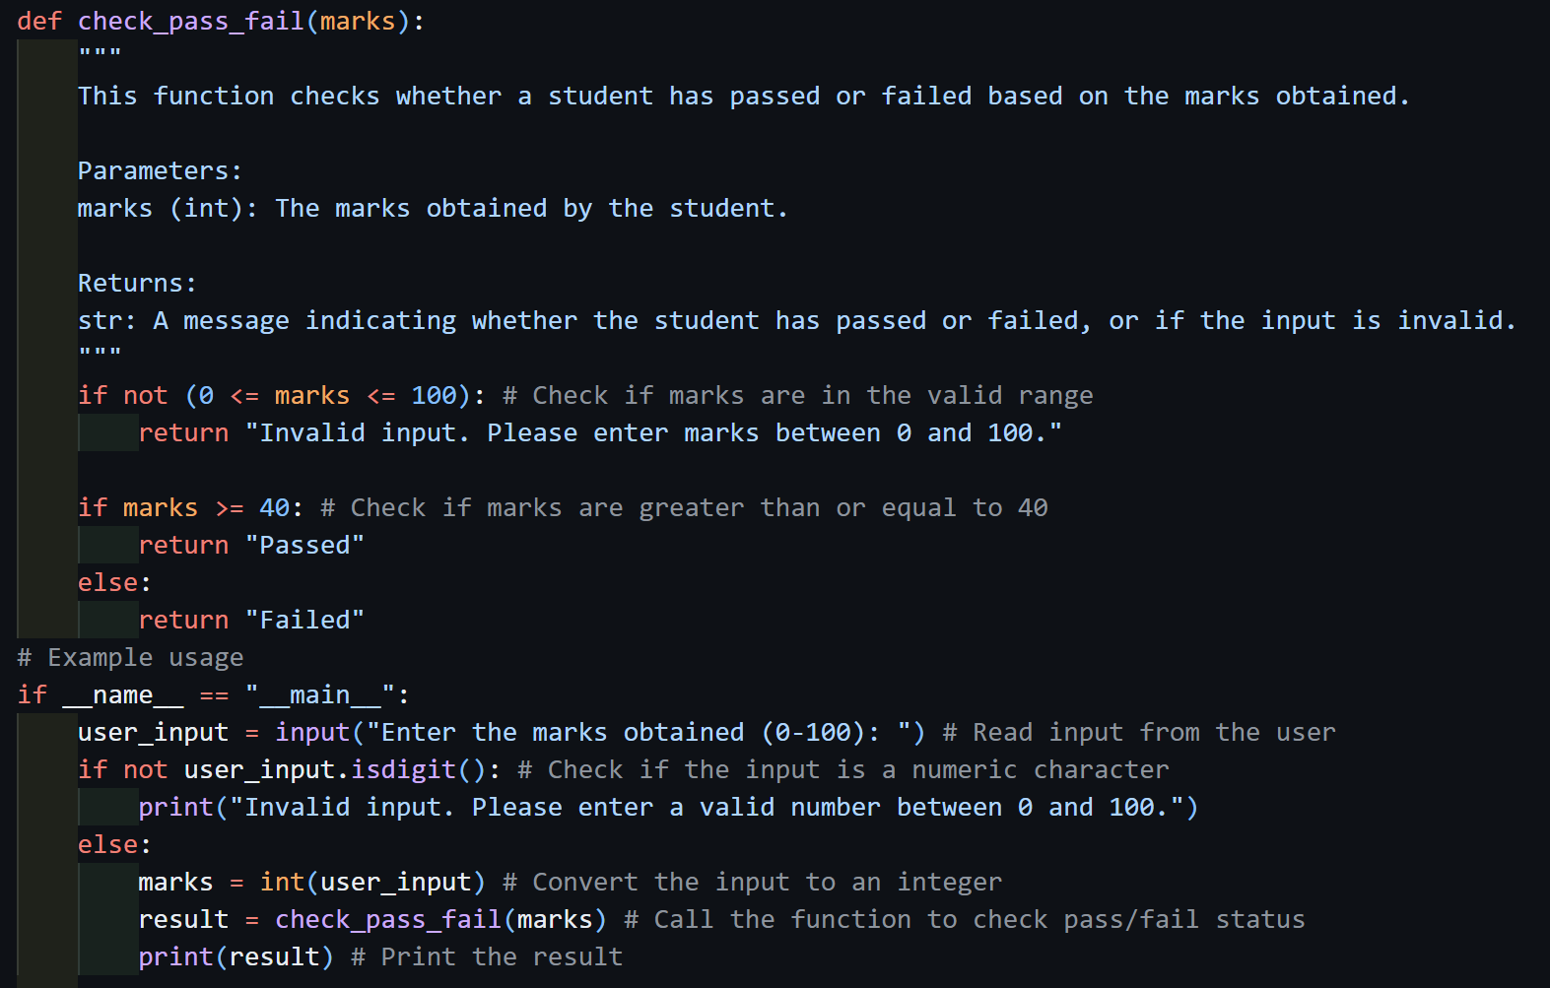

output:
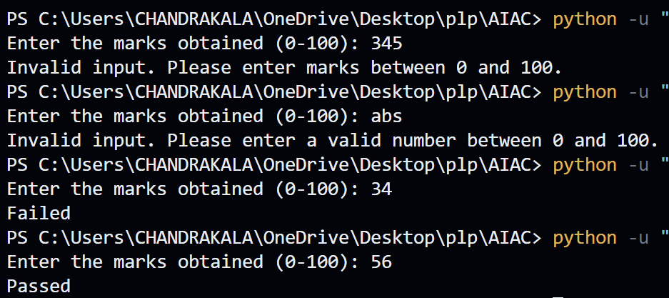
Q6 Voting Eligibility Check (Chain-of-Thought Prompting)
Task: Write a Python program that determines whether a person is eligible to vote using Chain-of-Thought (CoT) prompting

Prompt:
1. take age of the person as input
2. if age is less than 0 or greater than 120 print invalid input
3. if age is more than or equal to 18 print eligible to vote
4. if age is less than 18 print not eligible to vote
5. check for non numeric character and print invalid input

code:
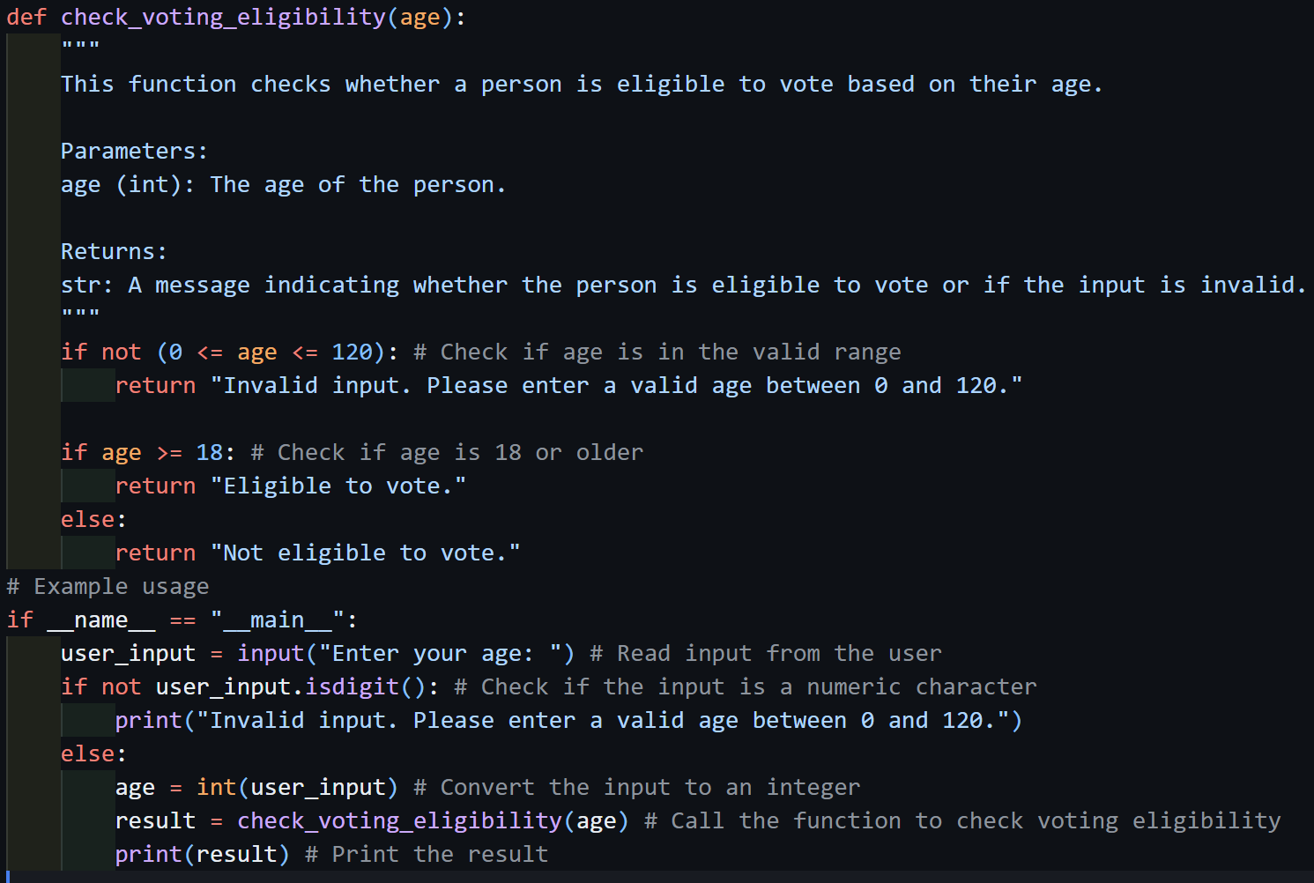

output:
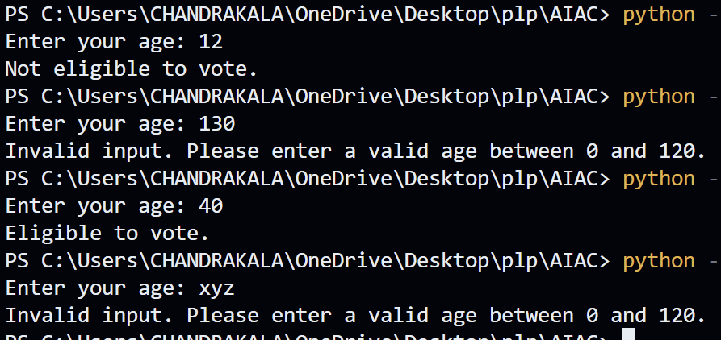
Q7 Prompt Chaining (String Processing – Palindrome Names)
Task: Write a Python program that uses the prompt chaining technique to identify palindrome names from a list of student names.

Prompt:
1. generate a list of studnts names
2. travers the list and make another list with reversed names
3. compare both lists if the original name and reversed name are same then print the name and -> palindrome
4. if not same print the name and -> not a palindrome

code:
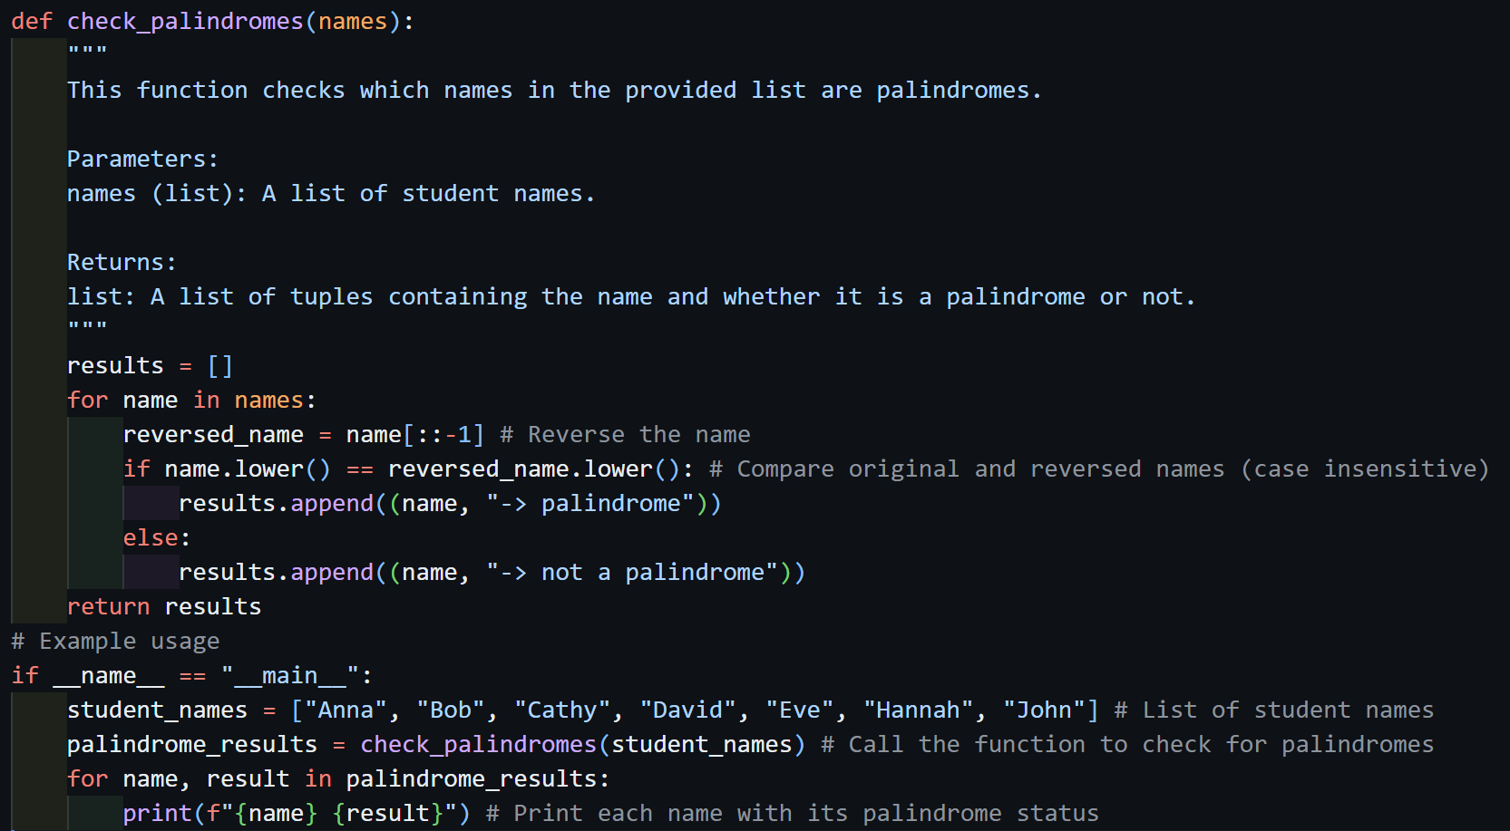

output:
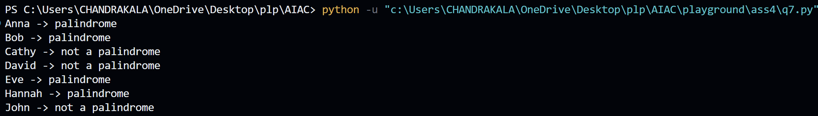
Q8 Prompt Chaining (String Processing – Word Length Analysis)
Task: Write a Python program that uses prompt chaining to analyze a list of words. In the first prompt, generate a list of words. In the second prompt, traverse the list and calculate the length of each word. In the third prompt, use the output of the previous step to determine whether each word is Short (length less than 5) or Long (length greater than or equal to 5), and display the result for each word

Prompt:
1. generate a list of words
2. traverse the list and calculate the length of each word and store it in a new list
3. analize the new list and return the short if the word length is less than 5 else return long
4. print results

code:
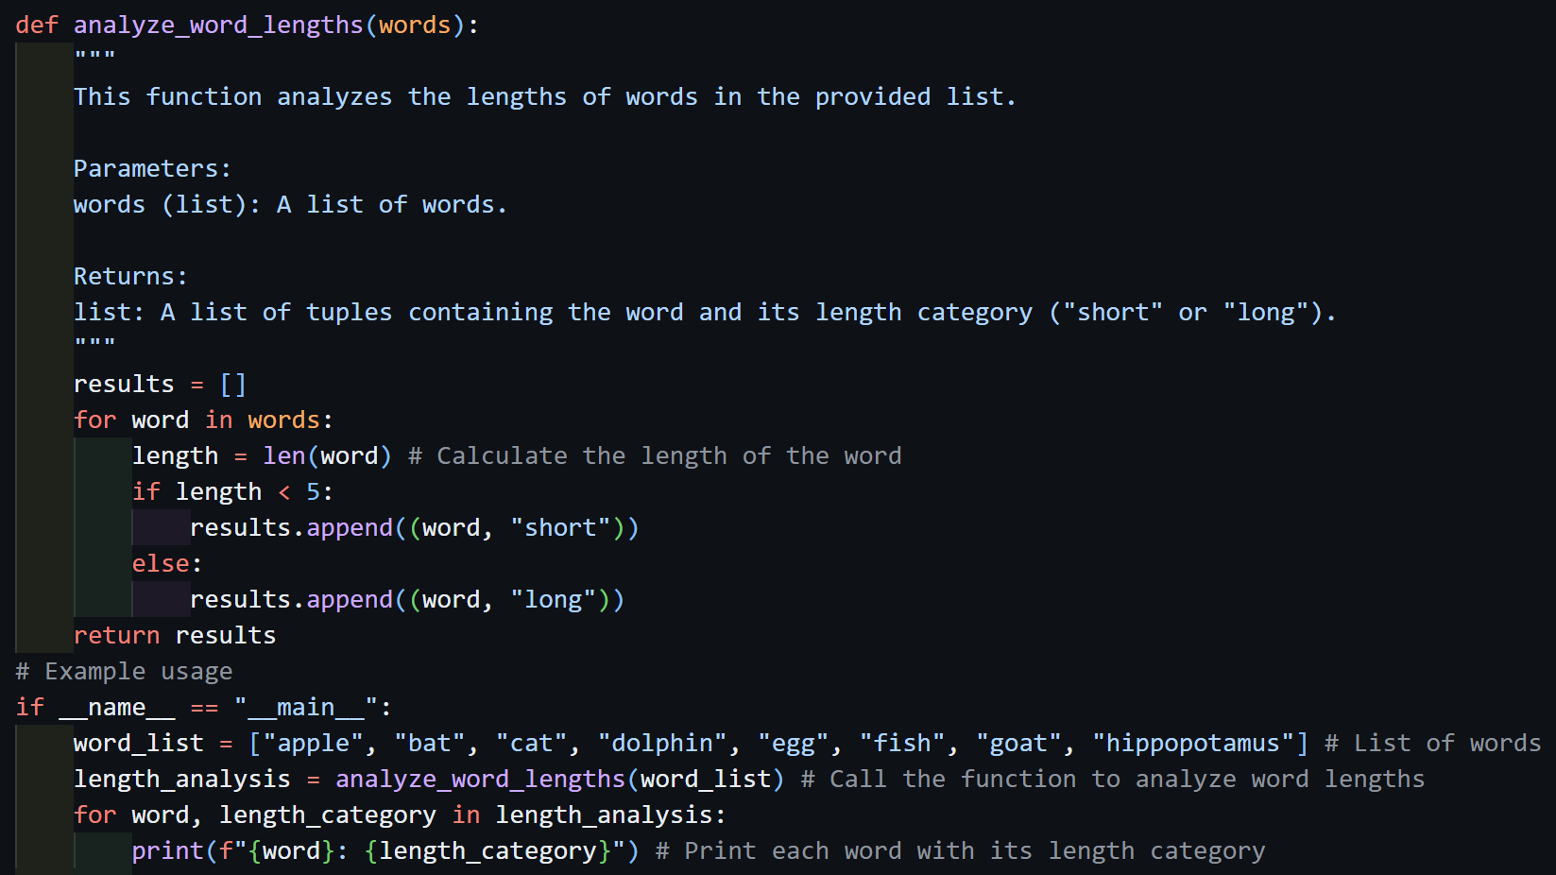

output:
