ASSIGNMENT-1
P.Manoj
2303A52043
Batch-44
Task 1: AI-Generated Logic Without Modularization (Prime Number Check Without Functions)
Scenario : You are developing a basic validation script for a numerical learning application
Prompt : generate prime numbers without using any function definitions
Code :
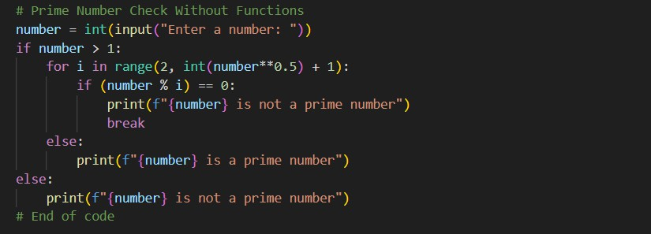
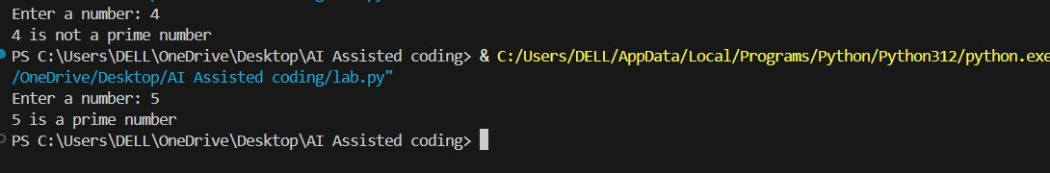

Report: This code checks whether a given number is a prime number or not without using functions.

Task-2 :
Efficiency & Logic Optimization (Cleanup)
Scenario: The script must handle larger input values efficiently.

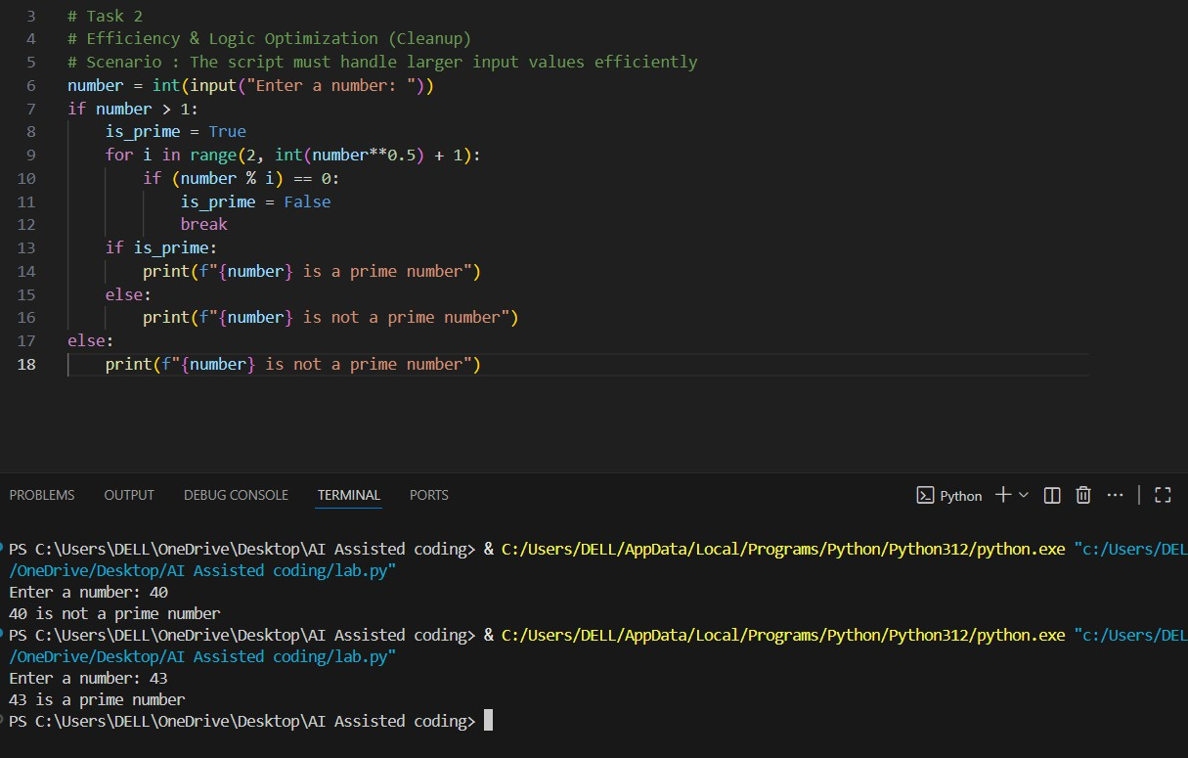
Report: In this task, I optimized the prime number checking algorithm to improve its efficiency for larger input values.
Task-3:
Modular Design Using AI Assistance (Prime Number Check Using Functions) Scenario: The prime-checking logic will be reused across multiple modules Code :
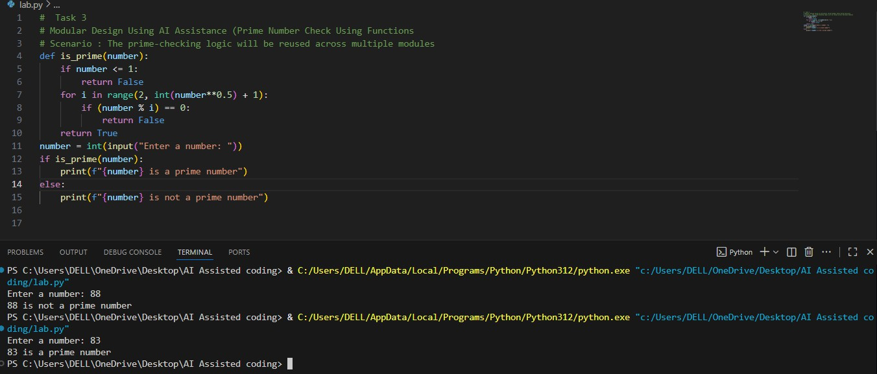

Report : The code defines a function `is_prime` that checks if a given number is prime. It first checks if the number is less than or equal to 1, in which case it returns False.
Task 4:
Comparative Analysis –With vs Without Functions
Scenario : You are participating in a technical review discussion #Without Function Code
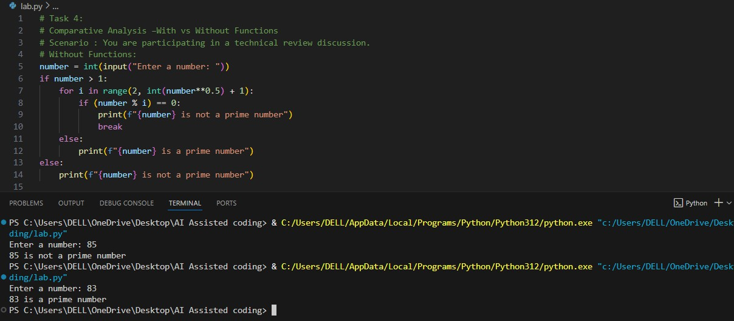
# With Function Code
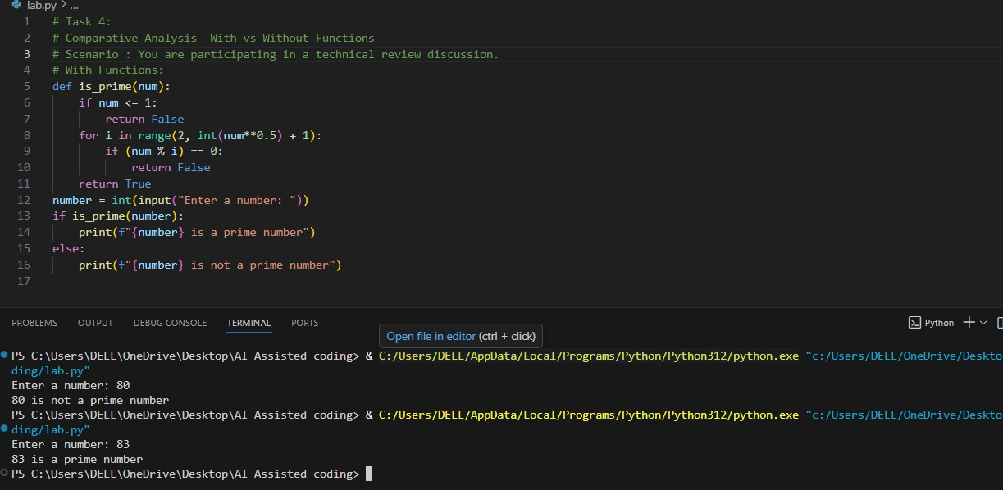

Report : In the first approach without functions, the code is straightforward but lacks modularity. It is harder to reuse the prime-checking logic in other parts of the

program or in different programs. In the second approach with functions, the prime- checking logic is encapsulated within the is_prime function. This makes the code
more modular, reusable, and easier to read.
Task-5:
AI-Generated Iterative vs Recursive Fibonacci Approaches (Different Algorithmic Approaches to Prime Checking)
Scenario : Your mentor wants to evaluate how AI handles alternative logical Strategies

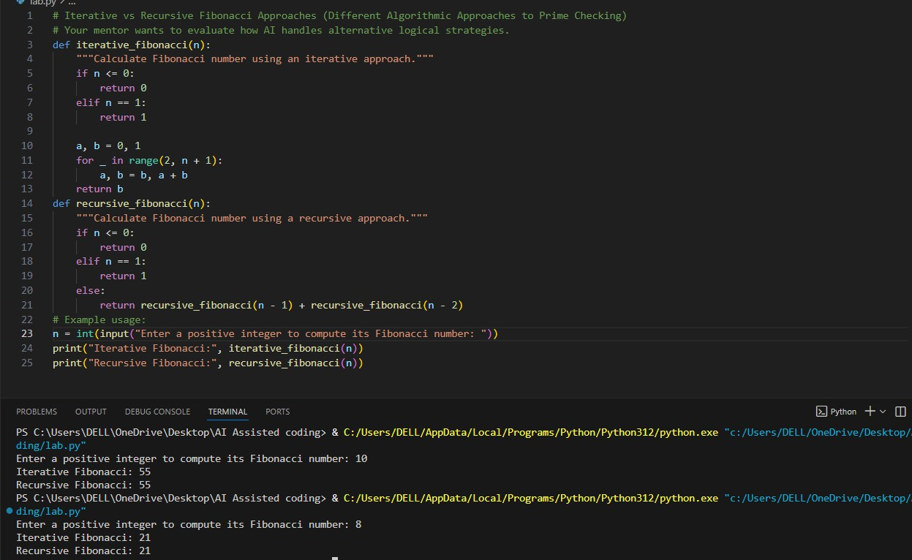
Code :

Report : In this code, we implement two different approaches to calculate the Fibonacci number for a given positive integer n: an iterative approach and a recursive approach. The iterative approach uses a loop to compute the Fibonacci number, which is generally more efficient in terms of time and space complexity. It runs in O(n) time and O(1) space. The recursive approach, on the other hand,
calls itself to compute the Fibonacci number. While this method is more straightforward and easier to understand, it has an exponential time complexity of O(2^n) due to the repeated calculations of the same Fibonacci numbers, making it inefficient for larger values of n.

