Assignment-3.3
keerthisree
2303A52046
b-32
Task 1: AI-Generated Logic for Reading Consumer Details
Scenario
An electricity billing system must collect accurate consumer data.
Task Description
Use an AI tool (GitHub Copilot / Gemini) to generate a Python program that:
- Reads:
  - Previous Units (PU)
  - Current Units (CU)
  - Type of Customer
- Calculates units consumed
- Implements logic directly in the main program (no functions)
Expected Output
- Correct input reading
- Units consumed calculation
- Screenshot showing AI-generated code
- Sample input and output
Prompt:
Code:
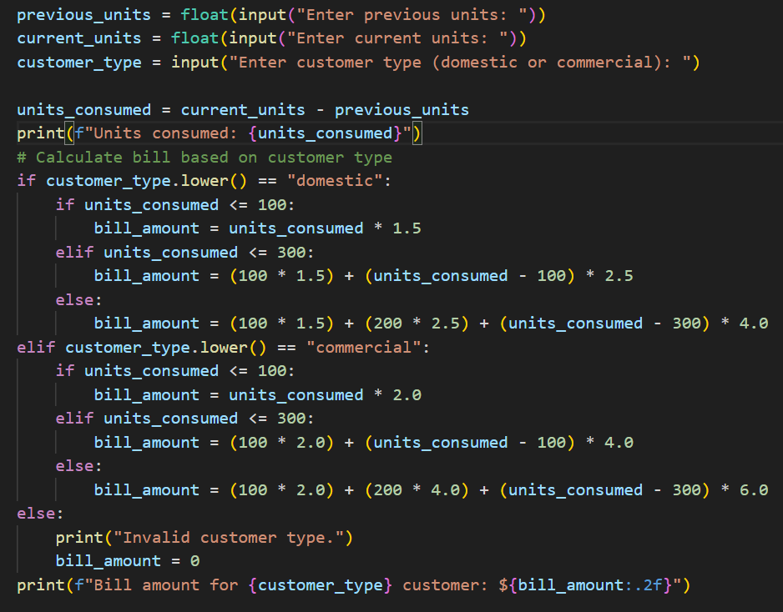
output:
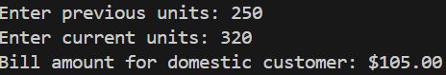
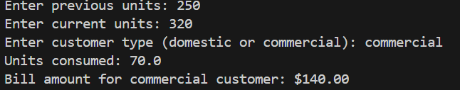
suggestion:
The program collects consumer details such as previous meter reading, current meter reading, and customer type. It processes this data to determine the total electricity units consumed. The entire calculation is written in a straightforward manner within the main program. The results are shown clearly through sample input and output.

Task 2: Energy Charges Calculation Based on Units Consumed
Scenario
Energy charges depend on the number of units consumed and customer type.
Task Description
Review the AI-generated code from Task 1 and extend it to:
- Calculate Energy Charges (EC)
- Use conditional statements based on:
  - Domestic
  - Commercial
  - Industrial consumers
- Improve readability using AI prompts such as:
  - “Simplify energy charge calculation logic”
  - “Optimize conditional statements”
Expected Output
- Correct EC calculation
- Clear conditional logic
- Original and improved versions (optional)
- Sample execution results

Prompt:

Code:
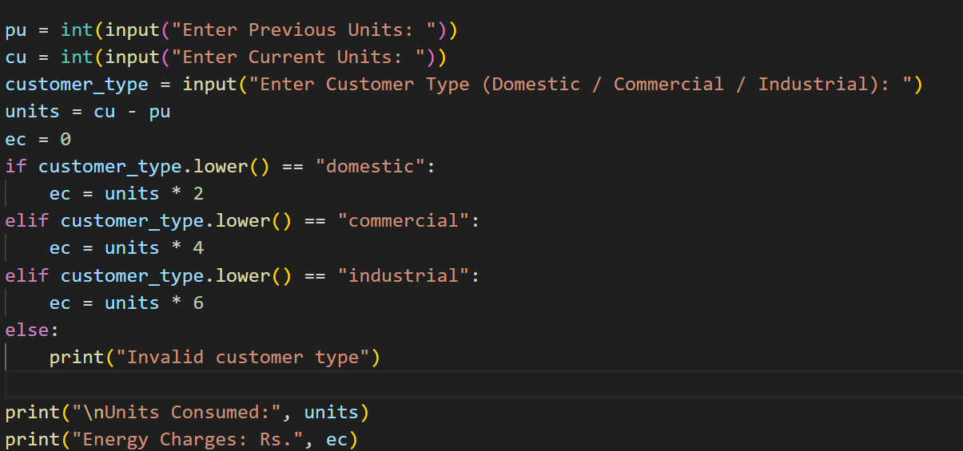

Output:
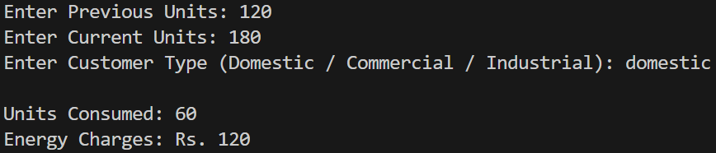

Suggestion:
This task enhances the previous program to calculate energy charges based on units consumed. It uses conditional statements to apply different rates for domestic, commercial, and industrial consumers. AI prompts help simplify and optimize the charge calculation logic. The updated code improves readability and clarity. Sample execution results are included to verify correct energy charge calculation.

Task 3: Modular Design Using AI Assistance (Using Functions)
Scenario
Billing logic must be reusable for multiple consumers.
Task Description
Use AI assistance to generate a Python program that:
- Uses user-defined functions to:
  - Calculate Energy Charges
  - Calculate Fixed Charges
- Returns calculated values
- Includes meaningful comments
Expected Output
- Function-based Python program
- Correct EC and FC values
- Screenshots of AI-assisted function generation
- Test cases with outputs

Prompt:
Code:
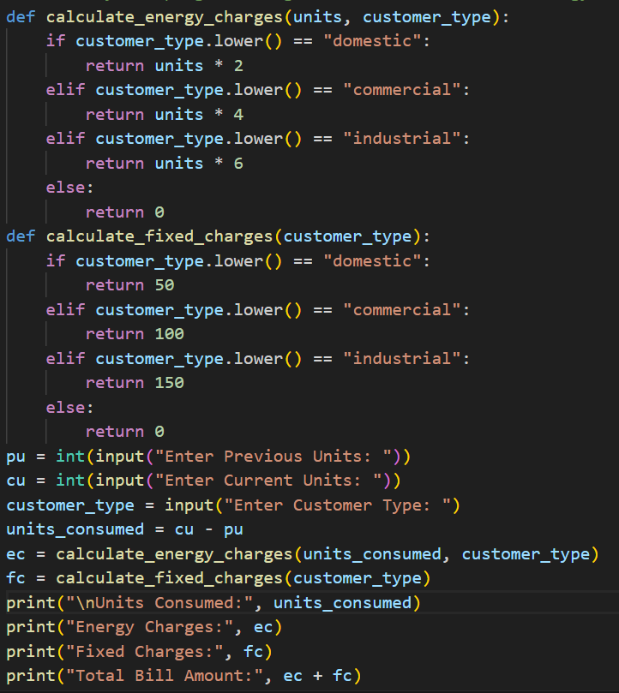

Output:
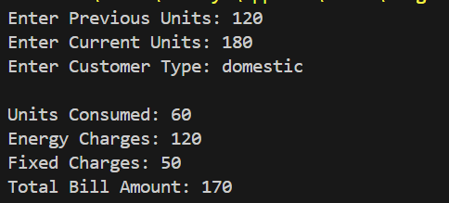
Suggestion:
In this task, AI help is used to convert the billing program into a modular design. Separate user-defined functions are written for calculating energy charges and fixed charges. The functions return their results so they can be reused for multiple consumers. Clear comments are added to improve understanding of the code. Sample test cases and outputs are shown to confirm correct working.
Task 4: Calculation of Additional Charges
Scenario
Electricity bills include multiple additional charges.
Task Description
Extend the program to calculate:
- FC – Fixed Charges
- CC – Customer Charges
- ED – Electricity Duty (percentage of EC)
Use AI prompts like:
- “Add electricity duty calculation”
- “Improve billing accuracy”
Expected Output
- Individual charge values printed
- Correct duty calculation
- Well-structured output
- Verified intermediate results

Prompt:
code:
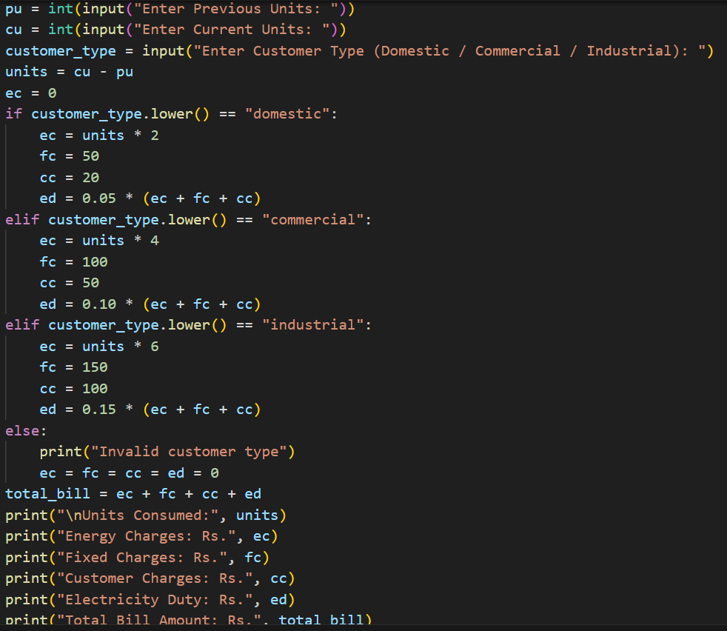
Output:
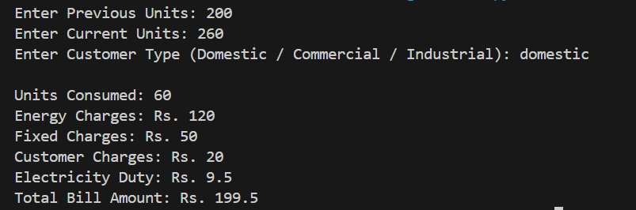
Suggestion:
In this task, the program is enhanced to calculate extra components of the electricity bill. It includes fixed charges, customer charges, and electricity duty calculated as a percentage of energy charges. AI assistance helps ensure accurate and clear billing logic. Each charge is displayed individually for transparency. The final output confirms correct intermediate and total calculations.
Task 5: Final Bill Generation and Output Analysis
Scenario
The final electricity bill must present all values clearly.
Task Description
Develop the final Python application to:
- Calculate total bill:
- Total Bill = EC + FC + CC + ED
- Display:
  - Energy Charges (EC)
  - Fixed Charges (FC)
  - Customer Charges (CC)
  - Electricity Duty (ED)
  - Total Bill Amount
- Analyze the program based on:
  - Accuracy
  - Readability
  - Real-world applicability
Expected Output
- Complete electricity bill output
- Neatly formatted display
- Sample input/output

Prompt:

Code:
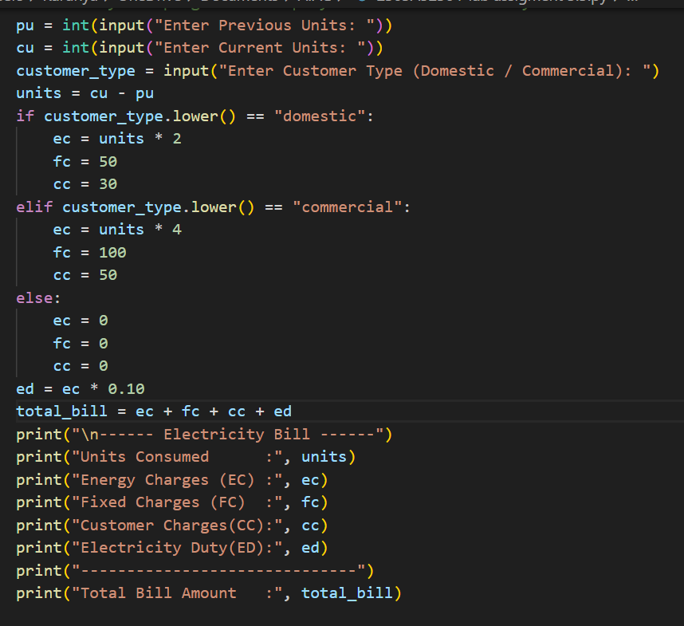
Output:
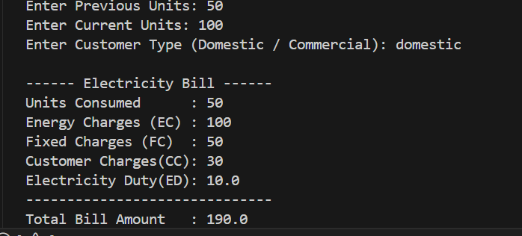

Suggestion:
This electricity billing program works correctly and gives accurate bill amounts based on units consumed.
The code is easy to read and understand because simple logic and clear variables are used.
It can be improved by adding input validation to avoid wrong values.
Slab-wise billing can also be added to match real electricity billing systems.
Overall, the program is useful for basic real-world billing applications.

