Assignment-4
Keerthisree
2303A52046
B-32
Q1. Zero-Shot Prompting (Basic Lab Task)
Task:
Write a Python function that classifies a given text as Spam or Not
Spam using zero-shot prompting.
Steps:
1. Construct a prompt without any examples.
2. Clearly specify the output labels.
3. Display only the predicted label.
Input:
"Congratulations! You have won a free lottery ticket."
Expected Output:
Spam.
Prompt:

Code:
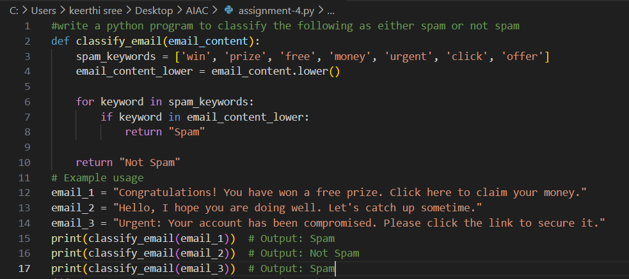
Output:
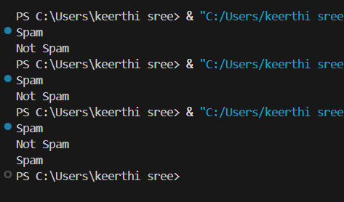
Suggestions:
- Clearly state the task without giving any examples so the model relies on its understanding.
- Explicitly mention the possible output labels: Spam and Not Spam.
- Provide the input text directly and ask for classification in one step.
- Focus on the intent and keywords of the message to decide if it looks like spam.
- Avoid extra explanations and request only the final label as output.
- Keep the prompt concise and unambiguous to get an accurate prediction.

Q2. One-Shot Prompting (Emotion detection)
Task:
Write a Python program that detects the emotion of a sentence
using one-shot prompting.
Emotions: [‘happy', 'sad', 'angry', 'excited', 'nervous', ’neutral’]
Steps:
1. Provide one labeled example inside the prompt.
2. Take a sentence as input.
3. Print the predicted emotion.
Prompt:
Code:
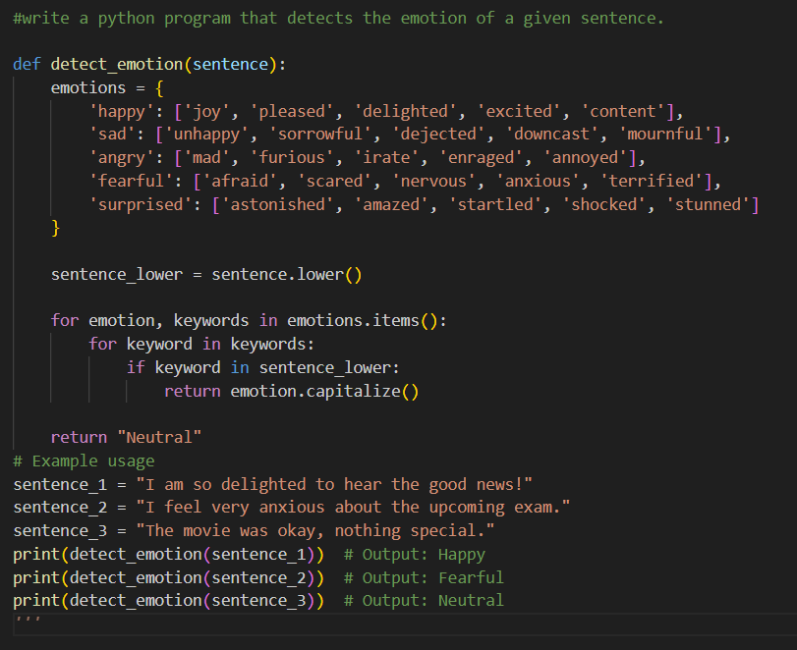
Output:
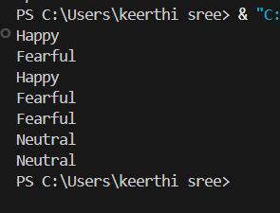
Suggestions:
- Start by giving one clear example that shows a sentence and its correct emotion label.
- Clearly list all possible emotion categories before prediction.
- Take the input sentence in a simple and understandable form.
- Let the model use the single example to understand the emotion pattern.
- Analyze keywords and sentence tone step by step to infer the emotion.
- Print only the predicted emotion to keep the output clean and focused.

Q3. Few-Shot Prompting (Student Grading Based on Marks)
Task:
Write a Python program that predicts a student’s grade based on
marks using few-shot prompting.
Grades:
['A', 'B', 'C', 'D', 'F']
Grading Criteria (to be inferred from examples):
• 90–100 → A
• 80–89 → B
• 70–79 → C
• 60–69 → D
• Below 60 → F
Prompt:
Code:
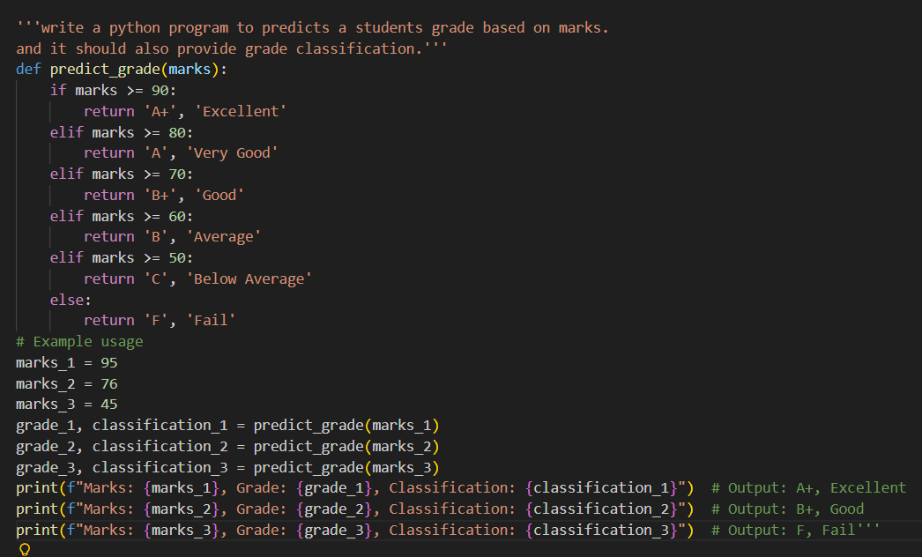
Output:
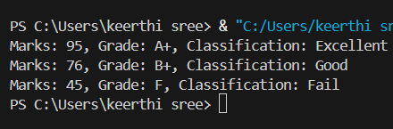
Suggestions:
- Start by showing a few example inputs and outputs so the grading pattern is easy to infer.
- Clearly mention the possible grade labels before applying any logic.
- Take the student’s marks as input and think step by step about where they fall.
- Compare the marks with the inferred grade ranges one condition at a time.
- Assign the correct grade based on the matching range.
- Display only the final predicted grade to keep the output clean and clear.

Q4. Multi-Shot Prompting (Indian Zodiac Sign Prediction using
Month Name)
Task:
Write a Python program that predicts a person’s Indian Zodiac sign
(Rashi) based on the month of birth (month name) using multi-shot
prompting.
Indian Zodiac Order (Simplified Month-Based Model): The Indian
Zodiac cycle starts in March with Mesha and follows this order:
March → Mesha
April → Vrishabha
May → Mithuna
June → Karka
July → Simha
August → Kanya
September → Tula
October → Vrischika
November → Dhanu
December → Makara
January → Kumbha
February → Meena.
Prompt:
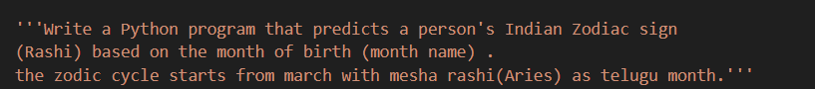
Code:
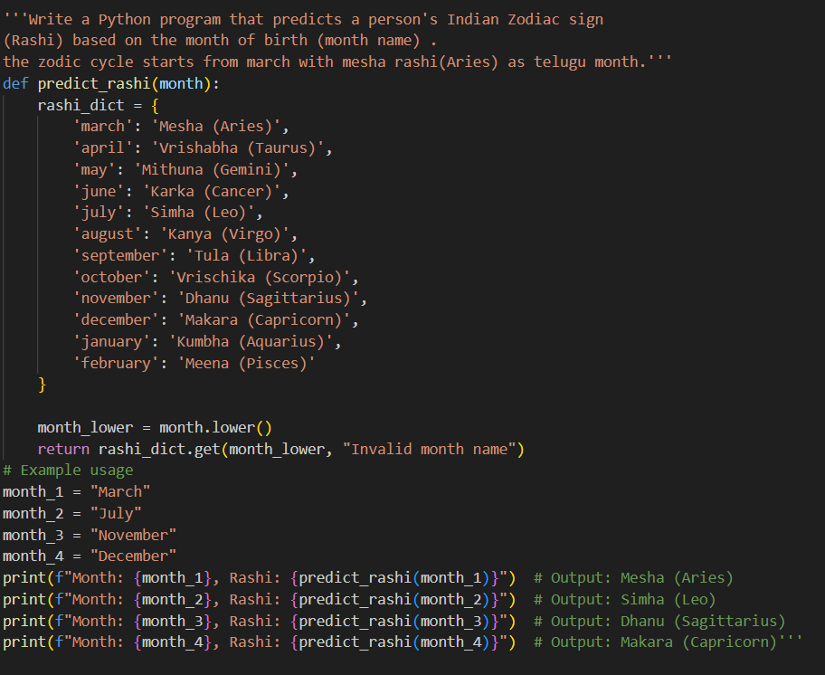
Output:
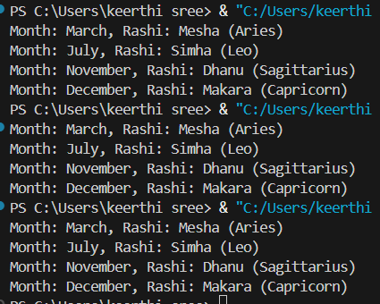
Suggestions:
- Clearly understand the month-to-Rashi mapping before writing the program logic.
- Use multi-shot prompting by showing a few example month–Rashi pairs first.
- Accept the month name as input and handle it in a case-insensitive manner.
- Compare the input month with the predefined zodiac mapping step by step.
- Select and display the correct Indian Zodiac sign based on the month.
- Keep the output clear and readable by displaying only the predicted Rashi.

Q5. Result Analysis Based on Marks
Task: Write a Python program that determines whether a student
Passes or Fails based on marks using Chain-of-Thought (CoT)
prompting.
Result Categories:
['Pass', 'Fail'].
Prompt:
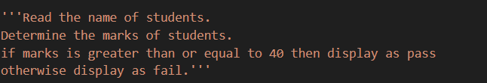
Code:
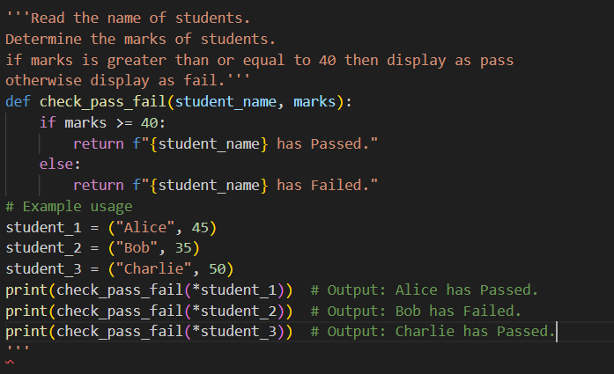
Output:
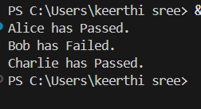
Suggestions:
- Clearly define what conditions lead to Pass or Fail before writing the logic.
- Take the required input (such as marks or score) in a simple and understandable way.
- Think step by step to compare the input value with the passing criteria.
- Use clear conditions to decide whether the result is Pass or Fail.
- Avoid mixing multiple checks at once; keep the logic clean and readable.
- Display only the final result category to make the output easy to understand.

Q6 Voting Eligibility Check (Chain-of-Thought Prompting)
Task: Write a Python program that determines whether a person is
eligible to vote using Chain-of-Thought (CoT) prompting.
Prompt:
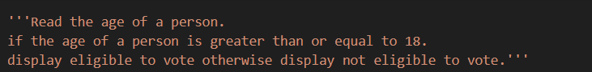
Code:
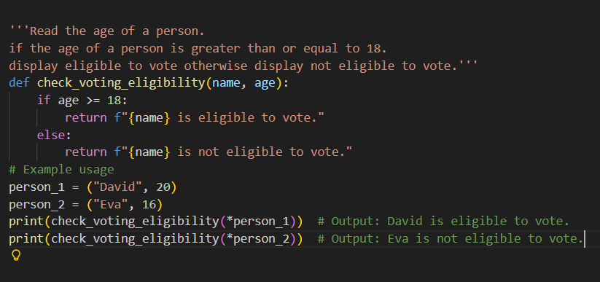
Output:
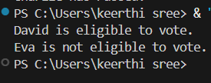
Suggestions:
- Clearly understand the condition for voting eligibility (age must be 18 or above).
- Ask the model to reason step by step instead of giving a direct answer.
- First, take the age as input and think logically about the given value.
- Compare the age with the minimum voting age using a clear condition.
- Explain the reasoning before giving the final eligibility decision. Display a clear output stating whether the person is eligible or not.
Q7 Prompt Chaining (String Processing – Palindrome Names)
Task: Write a Python program that uses the prompt chaining
technique to identify palindrome names from a list of student
names.
Prompt:
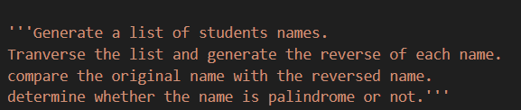
Code:
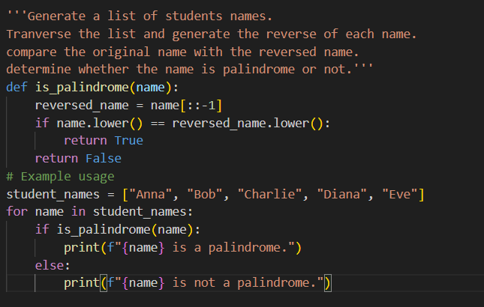
Output:
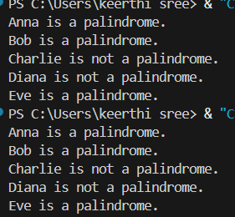
Suggestions:
- Start by generating a clean list of student names to use as input for processing.
- Check each name step by step instead of combining all logic into one prompt.
- Convert names to a common format (like lowercase) to avoid case-sensitivity issues.
- Compare each name with its reverse to identify palindromes correctly.
- Use the result of the palindrome check as input for the final decision display.
- Clearly print whether each student name is a palindrome or not for better readability.

Q8 Prompt Chaining (String Processing – Word Length
Analysis)
Task: Write a Python program that uses prompt chaining to
analyze a list of words. In the first prompt, generate a list of words.
In the second prompt, traverse the list and calculate the length of
each word. In the third prompt, use the output of the previous step
to determine whether each word is Short (length less than 5) or
Long (length greater than or equal to 5), and display the result for
each word
Prompt:
Code:
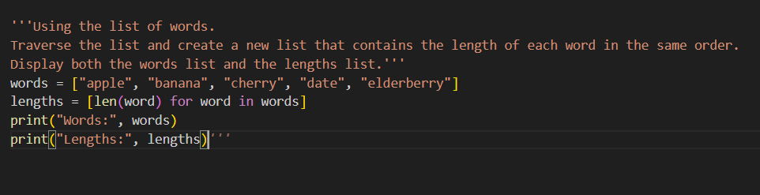
Output:
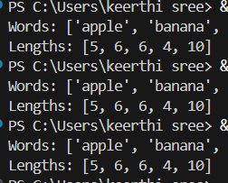
Suggestions:
- Break the problem into small logical steps instead of solving everything at once.
- First, clearly generate a list of meaningful words so the next steps have proper input.
- Use the output of each step as the input for the next step to maintain chaining.
- While traversing the list, focus only on calculating word lengths, not classification yet.
- Apply clear conditions to classify words as Short or Long based on length.
- Display results in a clean and readable format to show proper understanding of processing flow.

