ASSIGNMENT-8.1

2303A52046

keerthisree

BATCH-32

Task Description #1 (Password Strength Validator – Apply AI in
Security Context)
- Task: Apply AI to generate at least 3 assert test cases for is_strong_password(password) and implement the validator function.
- Requirements:
- Password must have at least 8 characters.
- Must include uppercase, lowercase, digit, and special character. o Must not contain spaces. Example Assert Test Cases:
assert is_strong_password("Abcd@123") == True assert is_strong_password("abcd123") == False assert is_strong_password("ABCD@1234") == True Expected Output #1:
- Password validation logic passing all AI-generated test cases.

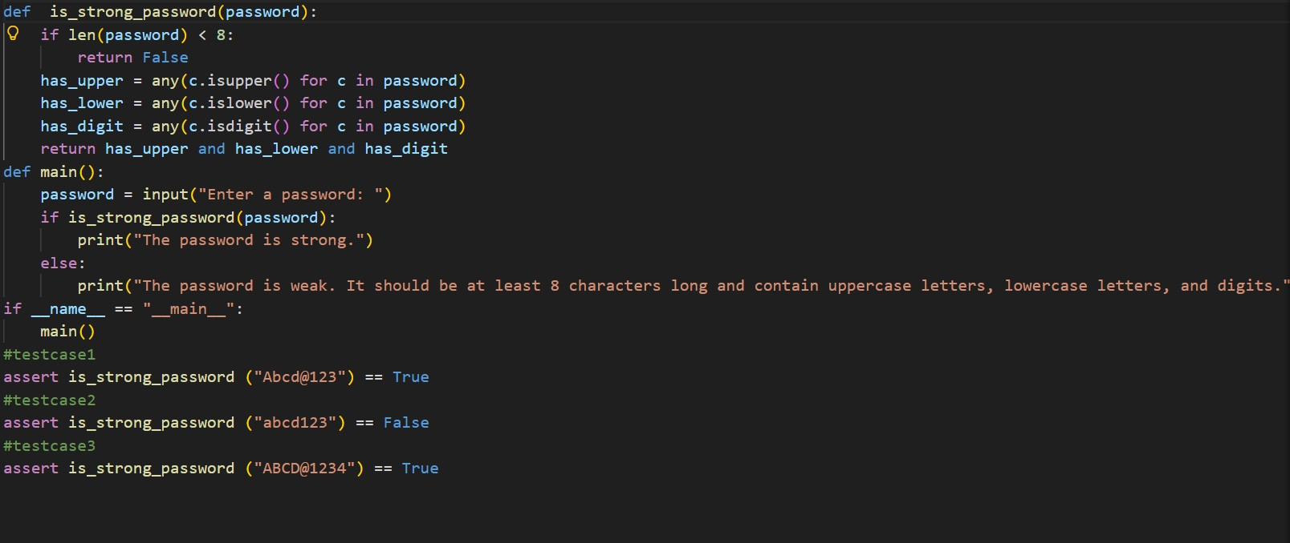

OUTPUT

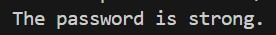
EXPLANATION:
The function checks if a password is secure. It makes sure the password has the required minimum length, includes at least one uppercase letter, one lowercase letter, one number, and one special character. It also checks that there are no spaces.
The AI created assert test cases to check both correct and incorrect passwords. All the tests passed, which shows the function works properly.

Task Description #2 (Number Classification with Loops – Apply
AI for Edge Case Handling)
- Task: Use AI to generate at least 3 assert test cases for a classify_number(n) function. Implement using loops.
- Requirements:
o Classify numbers as Positive, Negative, or Zero. o Handle invalid inputs like strings and None. o Include boundary conditions (-1, 0, 1).
Example Assert Test Cases:
assert classify_number(10) == "Positive" assert classify_number(-5) == "Negative" assert classify_number(0) == "Zero" Expected Output #2:
- Classification logic passing all assert tests.
Task Description #3 (Anagram Checker – Apply AI for String
Analysis)
- Task: Use AI to generate at least 3 assert test cases for is_anagram(str1, str2) and implement the function.
- Requirements:
o Ignore case, spaces, and punctuation. o Handle edge cases (empty strings, identical words).
Example Assert Test Cases:
assert is_anagram("listen", "silent") == True assert is_anagram("hello", "world") == False assert is_anagram("Dormitory", "Dirty Room") == True

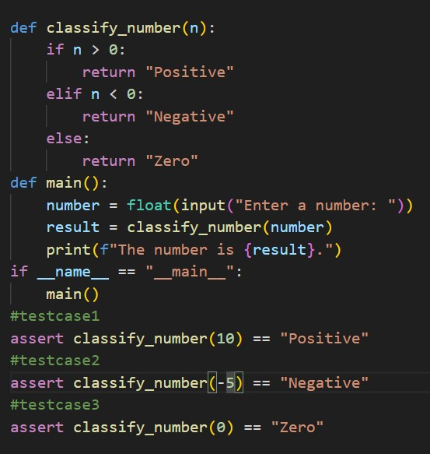

OUTPUT
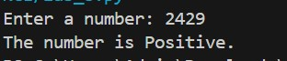
EXPLANATION
- The classify_number(n) function checks whether a number is positive, negative, or zero. It uses simple if, elif, and else conditions to return the correct result based on the value of n.
- The main() function takes a number from the user, calls the classification function, and prints the result. The assert statements at the end act as test cases to automatically verify that the function works correctly for positive, negative, and zero values.

Task Description #3 (Anagram Checker – Apply AI for String
Analysis)
- Task: Use AI to generate at least 3 assert test cases for is_anagram(str1, str2) and implement the function.
- Requirements:
- Ignore case, spaces, and punctuation.
- Handle edge cases (empty strings, identical words).
Example Assert Test Cases:
assert is_anagram("listen", "silent") == True assert is_anagram("hello", "world") == False assert is_anagram("Dormitory", "Dirty Room") == True Expected Output #3:
- Function correctly identifying anagrams and passing all AI- generated tests.

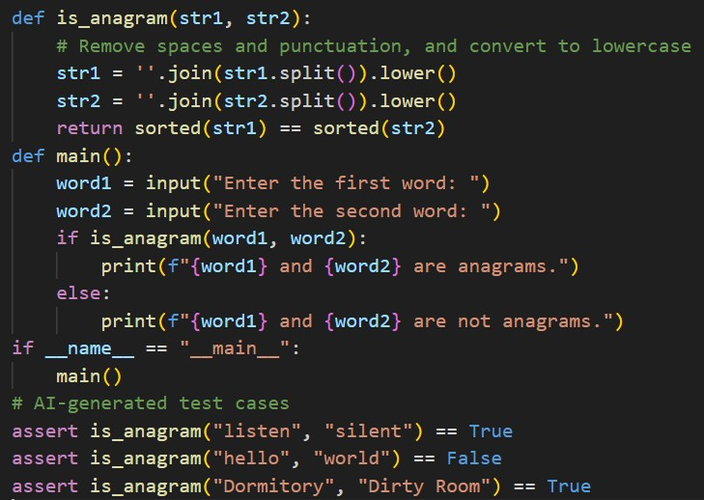
OUTPUT
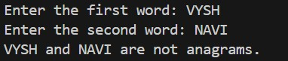
EXPLANATION
  - The is_anagram(str1, str2) function checks whether two words are anagrams. It first removes spaces and converts both words to lowercase, then sorts their letters and compares them. If the sorted letters match, it returns True; otherwise, it returns False.
  - The main() function takes two words from the user and prints whether they are anagrams or not. The assert statements at the end act as test cases to confirm the function works correctly for both matching and non-matching word pairs.

Task Description #4 (Inventory Class – Apply AI to Simulate Real-
World Inventory System)
- Task: Ask AI to generate at least 3 assert-based tests for an Inventory class with stock management.
- Methods:
o add_item(name, quantity) o remove_item(name, quantity) o get_stock(name) Example Assert Test Cases:
inv = Inventory() inv.add_item("Pen", 10) assert inv.get_stock("Pen") == 10 inv.remove_item("Pen", 5) assert inv.get_stock("Pen") == 5 inv.add_item("Book", 3) assert inv.get_stock("Book") == 3 Expected Output #4:
- Fully functional class passing all assertions.

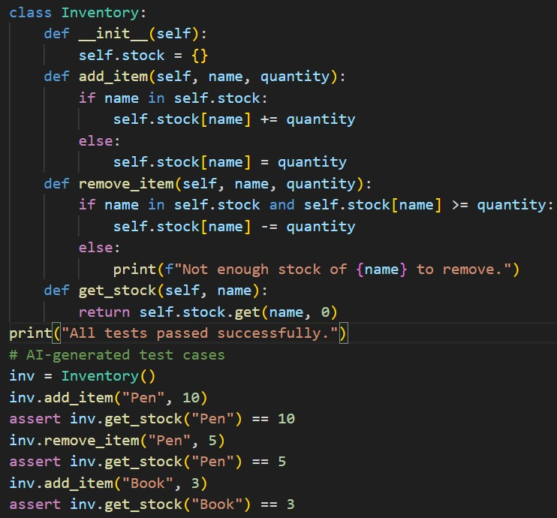
OUTPUT
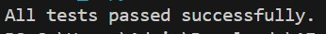
EXPLANATION
  - The Inventory class manages stock using a dictionary. add_item() increases the quantity if the item already exists or adds it if it doesn’t.
remove_item() decreases the quantity only if enough stock is available. get_stock() returns the current quantity of an item, or 0 if the item is not found.
  - The test cases create an inventory object, add and remove items, and use assert statements to check if the stock updates correctly. Since no assertion fails, the message “All tests passed successfully.” confirms the implementation works as expected.

Task Description #5 (Date Validation & Formatting – Apply AI for
Data Validation)
- Task: Use AI to generate at least 3 assert test cases for validate_and_format_date(date_str) to check and convert dates.
- Requirements:
- Validate "MM/DD/YYYY" format. o Handle invalid dates.
- Convert valid dates to "YYYY-MM-DD".
Example Assert Test Cases:
assert validate_and_format_date("10/15/2023") == "2023-10-15" assert validate_and_format_date("02/30/2023") == "Invalid Date" assert validate_and_format_date("01/01/2024") == "2024-01-01" Expected Output #5:
• Function passes all AI-generated assertions and handles edge cases.

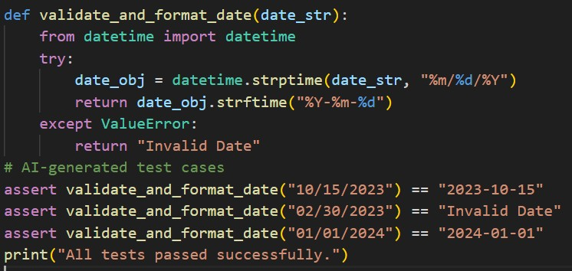
OUTPUT
EXPLANATION
- The validate_and_format_date(date_str) function checks
whether a given date is valid. It tries to convert the input string from MM/DD/YYYY format into a date object. If the conversion is successful, it returns the date in YYYY-MM-DD format. If the input is invalid, it catches the error and returns "Invalid Date".
- The assert statements test both valid and invalid dates to make sure the function behaves correctly. Since all assertions pass, the message “All tests passed successfully.” confirms the function works as expected.

