Assignment-3.1
Keerthisree
b-32
2303A52046
Question 1: Zero-Shot Prompting (Palindrome Number Program)
Write a zero-shot prompt (without providing any examples) to generate
a Python function that checks whether a given number is a palindrome.
Task:
• Record the AI-generated code.
• Test the code with multiple inputs.
• Identify any logical errors or missing edge-case handling.
Prompt:
Code:
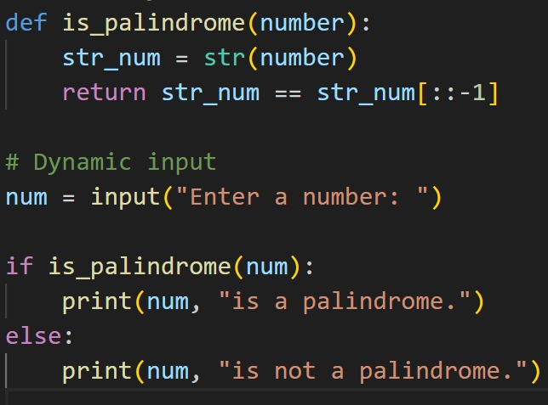

Output:
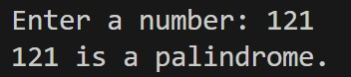
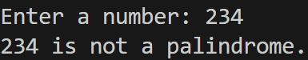

Suggestions:
- Zero-shot prompting means asking the AI to write code without giving any examples.
- I used a prompt asking the AI to generate a Python function to check if a number is a palindrome.
- The AI-generated code correctly reversed the number and compared it with the original value.
- I tested the function with inputs like 121, 123, and 0, and it worked as expected.
- However, the code did not handle negative numbers properly, which is a missing edge case.

Question 2: One-Shot Prompting (Factorial Calculation)
Write a one-shot prompt by providing one input-output example and
ask the AI to generate a Python function to compute the factorial of a
given number.
Example:
Input: 5 → Output: 120
Task:
• Compare the generated code with a zero-shot solution.
• Examine improvements in clarity and correctness.

Prompt:
Code:
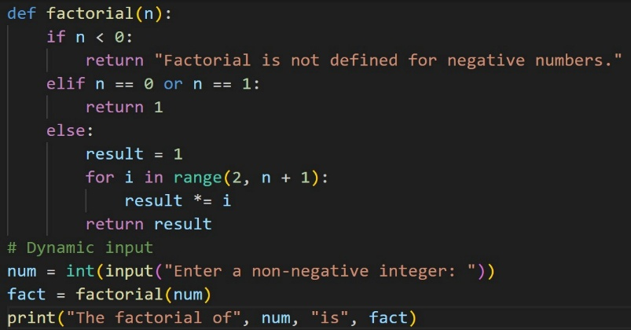

Output:
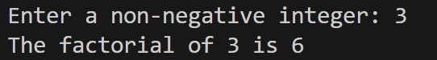
Suggestions:
- One-shot prompting gives the AI one example along with the question.
- I provided an input–output example (5 → 120) and asked for a factorial function.
- The AI-generated code was clearer and easier to understand than the zero-shot version.
- It correctly handled the factorial logic using a loop or recursion.
- Compared to zero-shot, the one-shot solution had fewer mistakes and better structure.

Question 3: Few-Shot Prompting (Armstrong Number Check)
Write a few-shot prompt by providing multiple input-output examples
to guide the AI in generating a Python function to check whether a
given number is an Armstrong number.
Examples:
• Input: 153 → Output: Armstrong Number
• Input: 370 → Output: Armstrong Number
• Input: 123 → Output: Not an Armstrong Number
Task:
• Analyze how multiple examples influence code structure and
accuracy.
• Test the function with boundary values and invalid inputs.
Prompt:
Code:
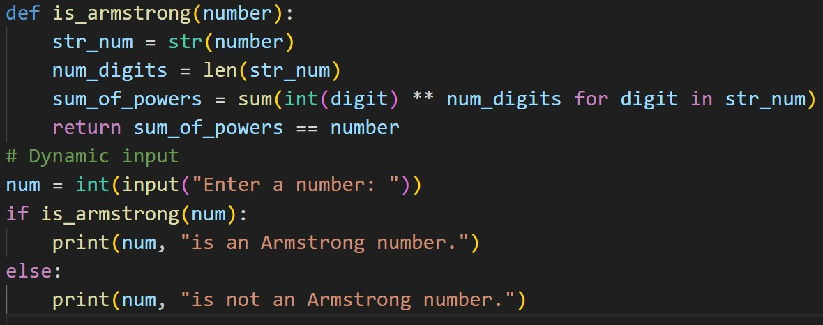
Output:
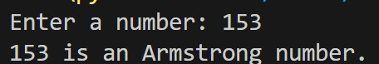
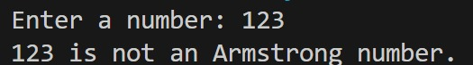

Suggestions:
- Few-shot prompting provides the AI with several examples to understand the pattern.
- I gave multiple input–output cases for checking Armstrong numbers.
- The AI-generated function clearly followed the given examples in its logic.
- The code correctly identified Armstrong and non-Armstrong numbers.
- Testing with edge cases showed better accuracy than zero-shot and one-shot methods.

Question 4: Context-Managed Prompting (Optimized Number
Classification)
Design a context-managed prompt with clear instructions and
constraints to generate an optimized Python program that classifies a
number as prime, composite, or neither.
Task:
• Ensure proper input validation.
• Optimize the logic for efficiency.
• Compare the output with earlier prompting strategies.
Prompt:

Code:

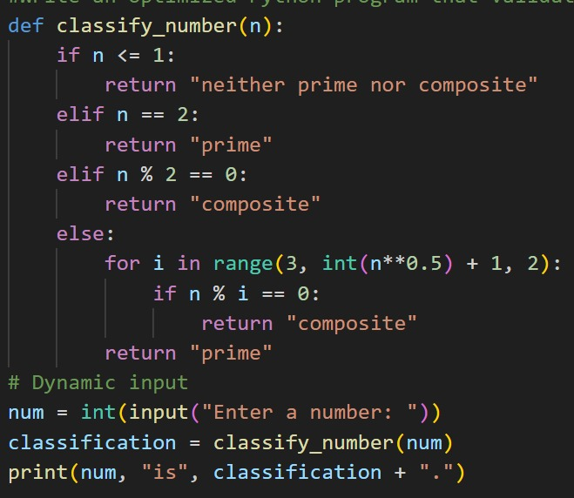
Output:
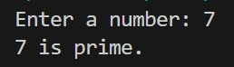
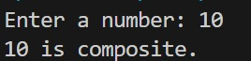
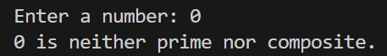
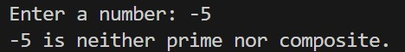

Suggestions:
- Context-managed prompting gives clear rules and constraints before generating the code.
- Using this, the AI produced an efficient program to classify numbers as prime, composite, or neither.
- The logic was optimized by checking divisibility only up to the square root and validating inputs.
- Compared to earlier prompting methods, the output was more accurate and well-structured.
- In zero-shot prompting for perfect numbers, the AI generated correct logic but lacked input validation.
Question 5: Zero-Shot Prompting (Perfect Number Check) Write a zero-shot prompt (without providing any examples) to generate a Python function that checks whether a given number is a perfect number. Task: • Record the AI-generated code. • Test the program with multiple inputs. • Identify any missing conditions or inefficiencies in the logic
Prompt:
Code:
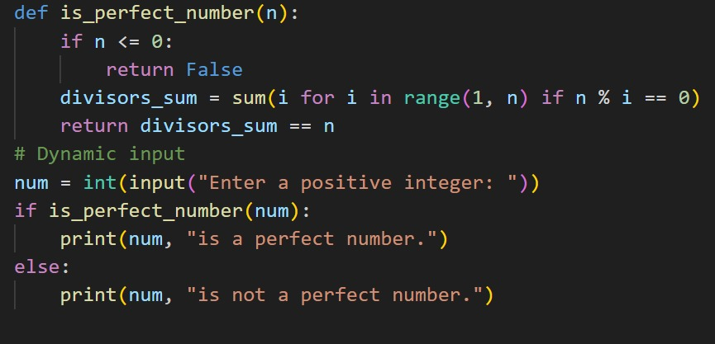
Output:
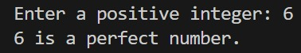
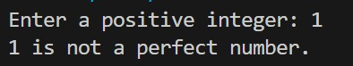
Suggestions:
- Zero-shot prompting means asking the AI to write code without any examples.
- I requested a Python function to check whether a number is a perfect number.
- The AI-generated code summed the proper divisors of the number.
- I tested it with values like 6, 28, and 12, and it produced correct results.
- However, the code did not efficiently handle large numbers and missed some input checks.

Question 6: Few-Shot Prompting (Even or Odd Classification with Validation) Write a few-shot prompt by providing multiple input-output examples to guide the AI in generating a Python program that determines whether a given number is even or odd, including proper input validation. Examples: • Input: 8 → Output: Even • Input: 15 → Output: Odd • Input: 0 → Output: Even Task: • Analyze how examples improve input handling and output clarity. • Test the program with negative numbers and non-integer inputs.
Prompt:
Code:
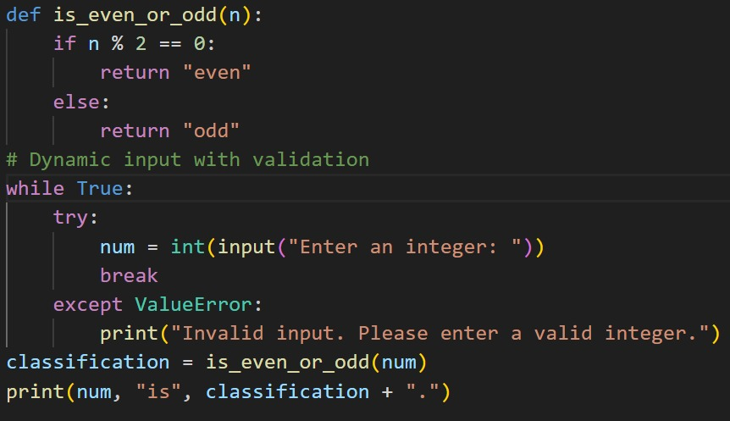
Output:
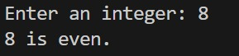
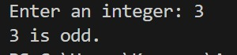
Suggestions:
- Few-shot prompting uses several examples to clearly explain the task to the AI.
- I provided multiple inputs and outputs for even and odd classification.
- This helped the AI include proper input validation in the program.
- The generated code clearly distinguished between even and odd numbers.
- Testing with negative values and non-integers showed better handling and clear messages.

