Task 1 – Refactoring: Eliminating Repetitive Logic
Task: Use AI-assisted coding techniques to restructure a Python program that performs repeated calculations.
Prompt:
#Generate a Python program that refactors a legacy script which repeatedly calculates the area and perimeter of rectangles.
#The program should identify the repeated computations and eliminate redundancy by creating a reusable function that takes
#length and width as parameters and calculates both area and perimeter. The function should include proper docstrings and
#the program should ensure that the output remains the same as the original code while improving readability and maintainability.
Code:
def calculate_rectangle_properties(length, width):
"""
Calculate the area and perimeter of a rectangle.

Parameters:
length (float): The length of the rectangle.
width (float): The width of the rectangle.

Returns:
tuple: A tuple containing the area and perimeter of the rectangle.
"""
area = length * width
perimeter = 2 * (length + width)
return area, perimeter
# List of lengths and widths for multiple rectangles
#inputs are given from the user
rectangles = []
while True:
length = input("Enter the length of the rectangle (or 'q' to quit): ")
if length.lower() == 'q':
break
width = input("Enter the width of the rectangle: ")
try:
length = float(length)
width = float(width)
rectangles.append((length, width))
except ValueError:
print("Please enter valid numbers for length and width.")
# Calculate and print the area and perimeter for each rectangle
for length, width in rectangles:
area, perimeter = calculate_rectangle_properties(length, width)
print(f"Rectangle with length {length} and width {width}:")
print(f"Area: {area}")
print(f"Perimeter: {perimeter}\n")
Output:
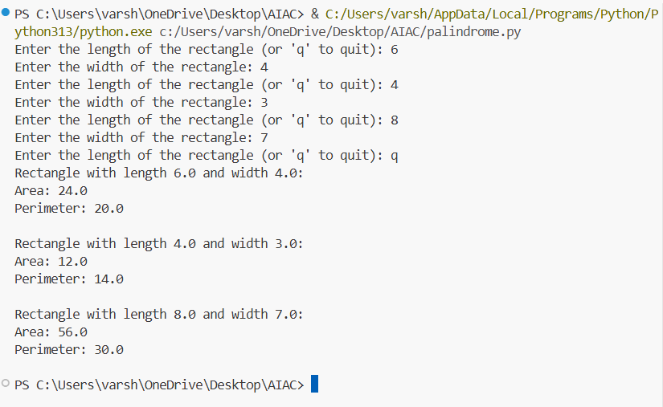
Explanation:
The purpose of this task is to improve the structure of a Python program by removing repetitive code. In many legacy programs, the same calculations are written multiple times using different variable values. This makes the code longer, harder to maintain, and more prone to errors.
In the given program, the calculations for area and perimeter of a rectangle are repeated for different length and width values. Instead of rewriting the same formula multiple times, the logic should be encapsulated into a single reusable function.
Refactoring the code into a function improves code reusability, readability, and maintainability. If the formula ever needs to change in the future, it only needs to be modified in one place instead of several lines across the program.
Additionally, functions should include proper docstrings, which describe the purpose of the function, its parameters, and its return values. This documentation helps other programmers understand the code more easily.
Task 2 – Refactoring: Modularizing Inline Calculations
Task: Use AI to refactor a Python script by extracting repeated inline calculations into reusable functions.
Prompt:
#Generate a Python program that refactors a script where discount and final amount calculations are written repeatedly for
#different purchase amounts. The program should extract the repeated inline calculation into a reusable function that takes
#the amount as input, calculates the 10% discount, and prints the final amount. The code should be modular, readable, and
#include proper documentation so that the same logic can be reused for multiple inputs.
Code:
def calculate_discount_and_final_amount(amount):
"""
Calculate the discount and final amount for a given purchase amount.

Parameters:
amount (float): The original purchase amount.

Returns:
tuple: A tuple containing the discount and the final amount after applying the discount.
"""
discount = amount * 0.10 # Calculate 10% discount
final_amount = amount - discount # Calculate final amount after discount
return discount, final_amount
# List of purchase amounts for which to calculate the discount and final amount
purchase_amounts = []
while True:
user_input = input("Enter the purchase amount (or 'q' to quit): ")
if user_input.lower() == 'q':
break
try:
amount = float(user_input)
purchase_amounts.append(amount)
except ValueError:
print("Please enter a valid number for the purchase amount.")
# Calculate and print the discount and final amount for each purchase amount
for amount in purchase_amounts:
discount, final_amount = calculate_discount_and_final_amount(amount)
print(f"Original Amount: ${amount:.2f}")
print(f"Discount: ${discount:.2f}")
print(f"Final Amount after 10% discount: ${final_amount:.2f}\n")

Output:
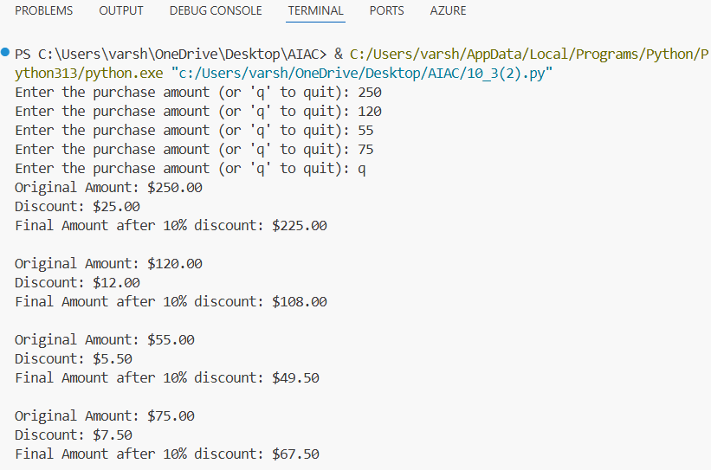
Explanation:
This task focuses on improving the modularity of a Python program by identifying and extracting repeated calculations. In the provided code, the discount and final amount calculations are performed multiple times with different input values.
Writing the same formula repeatedly is inefficient and makes the code harder to modify or debug. To solve this problem, the repeated logic should be placed inside a dedicated reusable function.
By converting the inline calculation into a function, the program becomes more organized, modular, and scalable. The function can accept different input values and return the calculated result without rewriting the same expressions again.
This refactoring technique also improves code readability, because the main program becomes simpler and focuses only on calling the function rather than performing calculations directly.
Task 3 – Refactoring: Improving Loop and Conditional Performance
Task: Apply AI-based suggestions to enhance the performance of Python code that relies on nested loops and repeated conditional checks.
Prompt:
#Generate an optimized Python program that improves the performance of a script which checks whether names in a checklist
#exist in a list of students using nested loops. The program should refactor the code using a more efficient data structure
#or logic for faster lookup while keeping the output the same, printing whether each name is found or not found in the
#student list, and also provide a simple comparison of performance before and after optimization.
Code:
import time
# Original code using nested loops
def check_names_nested_loops(checklist, students):
results = []
for name in checklist:
found = False
for student in students:
if name == student:
found = True
break
results.append((name, "Found" if found else "Not Found"))
return results
# Optimized code using a set for faster lookup
def check_names_optimized(checklist, students):
student_set = set(students) # Convert list to set for O(1) average time complexity
results = []
for name in checklist:
results.append((name, "Found" if name in student_set else "Not Found"))
return results
#inputs are given from the user
checklist = []
students = []
print("Enter names for the checklist (type 'q' to stop):")
while True:
name = input("Checklist name: ")
if name.lower() == 'q':
break
checklist.append(name)
print("Enter names for the student list (type 'q' to stop):")
while True:
name = input("Student name: ")
if name.lower() == 'q':
break
students.append(name)
# Measure performance of the original code
start_time = time.time()
nested_results = check_names_nested_loops(checklist, students)
end_time = time.time()
print("\nResults using nested loops:")
for name, status in nested_results:
print(f"{name}: {status}")
print(f"Time taken with nested loops: {end_time - start_time:.6f} seconds")
# Measure performance of the optimized code
start_time = time.time()
optimized_results = check_names_optimized(checklist, students)
end_time = time.time()
print("\nResults using optimized code:")
for name, status in optimized_results:
print(f"{name}: {status}")
print(f"Time taken with optimized code: {end_time - start_time:.6f} seconds")

Output:
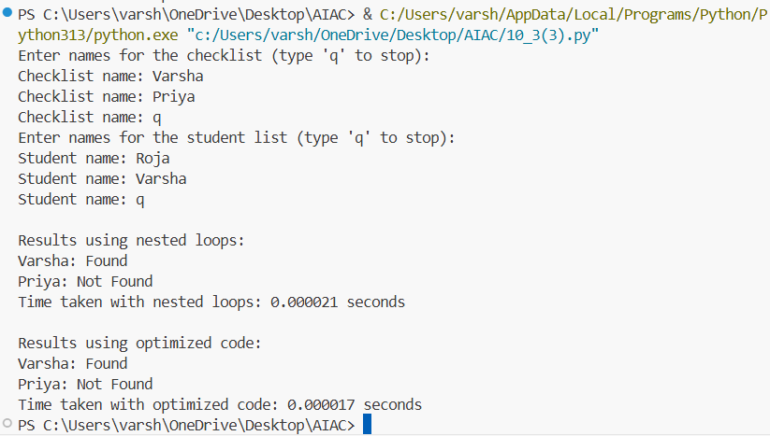
Explanation:
The objective of this task is to optimize a Python program that performs multiple comparisons using nested loops. In the provided code, the program checks whether each name from a checklist exists inside a list of students by iterating through both lists.
This approach results in inefficient performance, especially when the lists become very large, because each element must be compared repeatedly. Nested loops increase the number of operations and slow down the execution time.
To improve performance, AI-assisted refactoring can recommend using more efficient data structures, such as sets. Sets provide faster lookup operations, allowing the program to check whether an element exists in constant time.
By simplifying the logic and reducing the number of comparisons, the program becomes faster, cleaner, and easier to understand while still producing the same output.
Task 4 – Refactoring: Replacing Hardcoded Values with Constants
Task: Utilize AI assistance to improve maintainability by replacing hardcoded numerical values with named constants.
Prompt:
#Generate a Python program that calculates Simple Interest for different principal amounts using the formula
#(Principal × Rate × Time) / 100. The program should refactor the code by replacing hardcoded numeric values
#with descriptive constants such as RATE and TIME defined at the beginning of the program, ensuring the results
#remain unchanged while improving readability and maintainability.
# Define constants for rate and time
Code:
RATE = 5.0 # Annual interest rate in percentage
TIME = 2.0 # Time in years
def calculate_simple_interest(principal):
"""
Calculate the simple interest for a given principal amount.

Parameters:
principal (float): The principal amount.

Returns:
float: The calculated simple interest.
"""
return (principal * RATE * TIME) / 100
# List of principal amounts for which to calculate simple interest
principal_amounts = []
while True:
user_input = input("Enter the principal amount (or 'q' to quit): ")
if user_input.lower() == 'q':
break
try:
principal = float(user_input)
principal_amounts.append(principal)
except ValueError:
print("Please enter a valid number for the principal amount.")
# Calculate and print the simple interest for each principal amount
for principal in principal_amounts:
interest = calculate_simple_interest(principal)
print(f"Principal Amount: ${principal:.2f}")
print(f"Simple Interest at {RATE}% for {TIME} years: ${interest:.2f}\n")

Output:
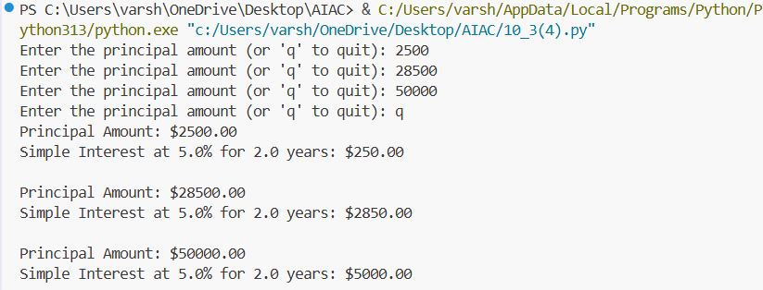
Explanation:
In many legacy programs, numeric values are written directly inside formulas. These are called hardcoded values. While the program may work correctly, this approach reduces readability and makes the code harder to maintain.
In the provided program, the values used in the simple interest formula are written directly inside the calculation. If the interest rate or time period needs to change later, the programmer must search through the code and manually update every occurrence.
To solve this issue, the hardcoded values should be replaced with descriptive constants defined at the beginning of the program. Using constants such as RATE and TIME makes the code more understandable and easier to update.
This refactoring technique improves code clarity, maintainability, and documentation, allowing developers to immediately understand what each value represents.
Task 5 – Refactoring: Enhancing Variable Naming and Code Clarity
Task: Apply AI tools to improve code readability by renaming unclear variables and adding meaningful comments.
Prompt:
#Generate a Python program that improves code readability by refactoring a script that uses unclear variable names
#such as x, y, and z for a simple arithmetic operation. The program should rename variables with meaningful identifiers,
#add clear inline comments explaining the logic, and ensure that the functionality and output of the program remain the same.
# Refactored code with meaningful variable names and inline comments

Code:
def calculate_area_of_rectangle(length, width):
"""
Calculate the area of a rectangle.

Parameters:
length (float): The length of the rectangle.
width (float): The width of the rectangle.

Returns:
float: The area of the rectangle.
"""
# Calculate the area by multiplying length and width
area = length * width
return area
# List of lengths and widths for multiple rectangles
#inputs are given from the user
rectangles = []
while True:
length_input = input("Enter the length of the rectangle (or 'q' to quit): ")
if length_input.lower() == 'q':
break
width_input = input("Enter the width of the rectangle: ")
try:
length = float(length_input)
width = float(width_input)
rectangles.append((length, width))
except ValueError:
print("Please enter valid numbers for length and width.")
# Calculate and print the area for each rectangle
for length, width in rectangles:
area = calculate_area_of_rectangle(length, width)
print(f"Rectangle with length {length} and width {width}:")
print(f"Area: {area}\n")

Output:
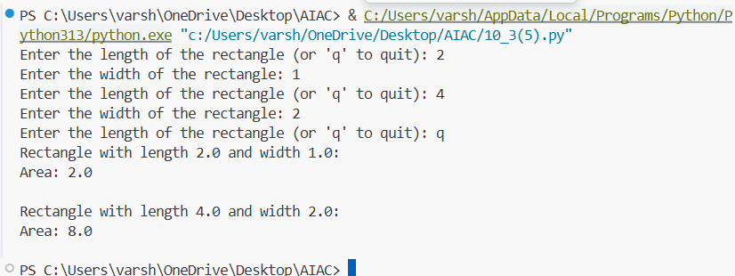
Explanation:
The goal of this task is to enhance code readability by improving variable naming and documentation. In the given code, variables such as x, y, and z are used. Although the program works correctly, these names do not clearly indicate what the variables represent.
Using vague variable names makes it difficult for other programmers to understand the purpose of the code. To improve clarity, variables should be renamed with meaningful and descriptive identifiers that explain their roles within the program.
In addition to better naming, inline comments should be added where necessary to explain the logic of the program. Comments help future developers quickly understand how the code works without needing to analyze every line in detail.
This refactoring step improves code readability, maintainability, and collaboration, ensuring that the program remains easy to understand and modify.

