Task 1 – Portfolio Website Design

• Task: Build a personal portfolio website to showcase your work.
• Requirements:
- Create sections for About Me, Projects, and Contact.
- Use AI to suggest color palettes and typography.
- Create a responsive layout with Grid/Flexbox.
- Add smooth scrolling navigation.
Output Screenshots:

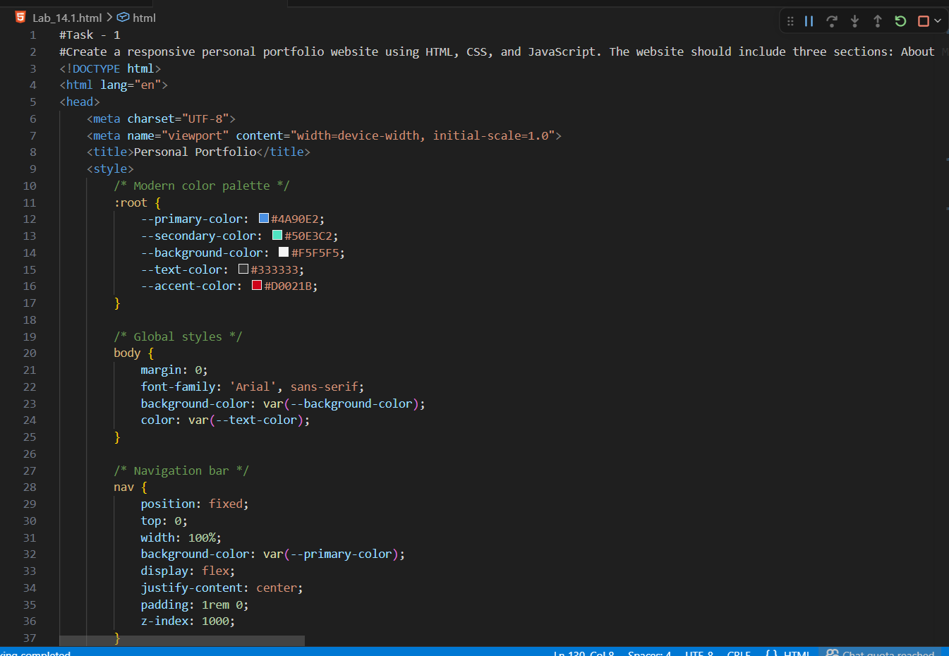
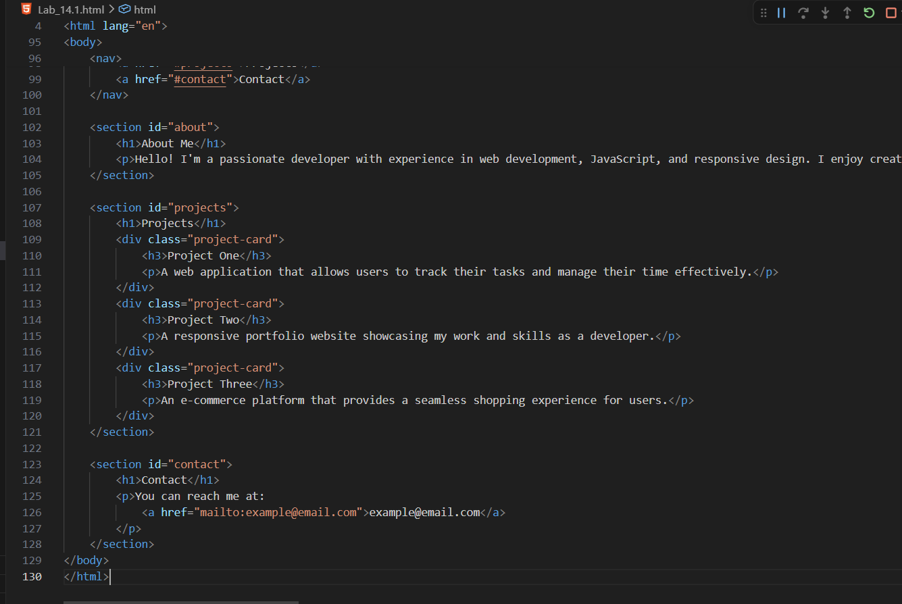

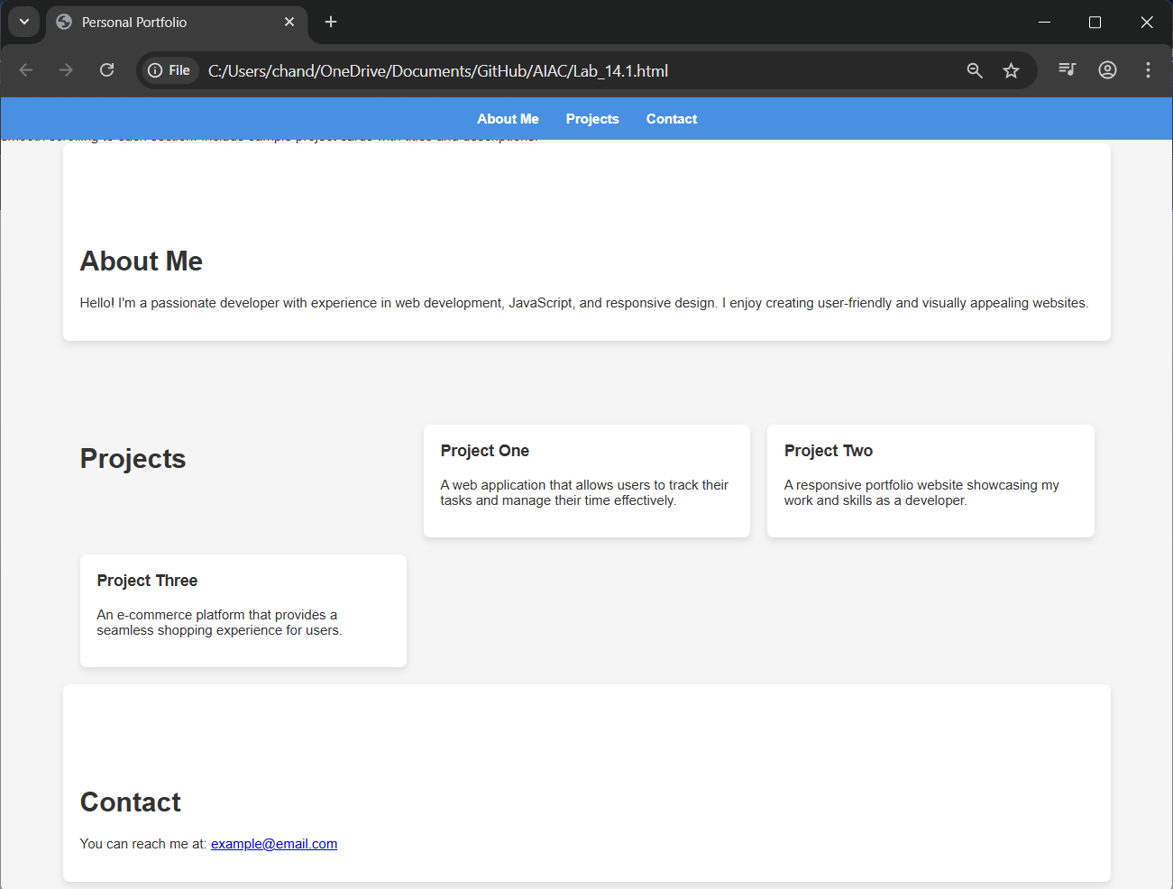

Task 2 – Online Store Product Page

• Task: Design a product display page for an online store.

• Requirements:
- Display product image, title, price, and "Add to Cart" button.
- Style with BEM methodology.
- Make layout responsive.
- Add hover effects and "Add to Cart" alert.

Output Screenshots:

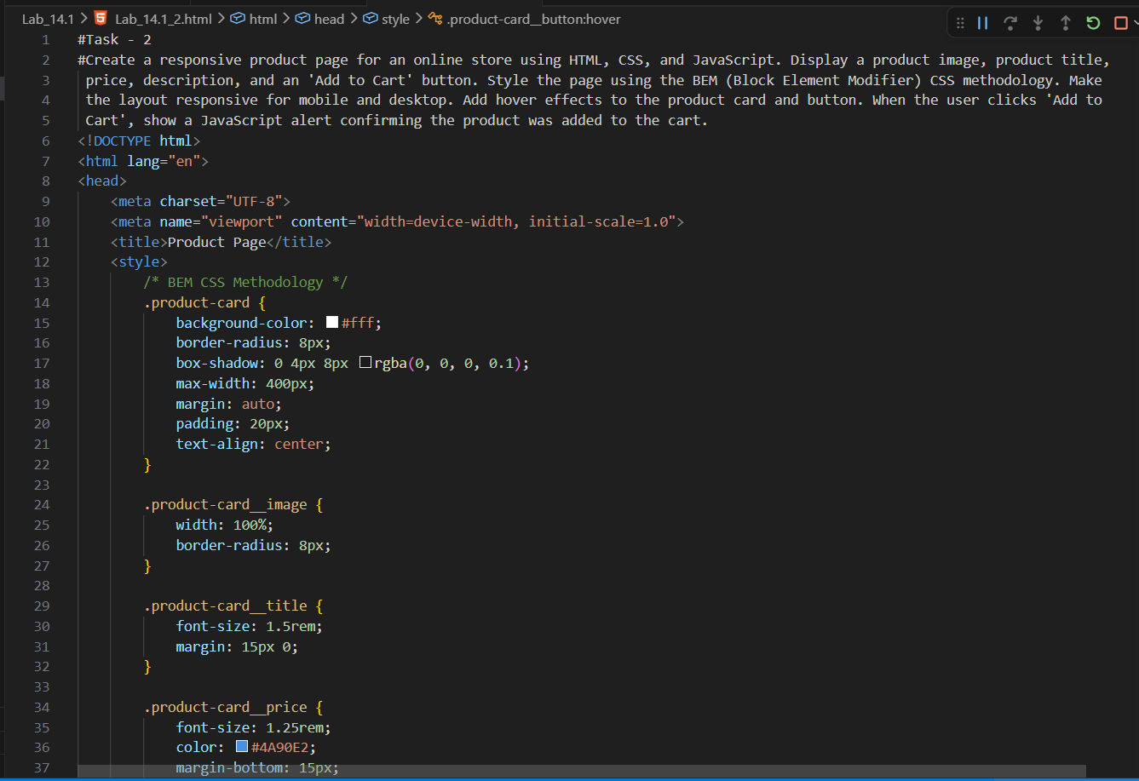
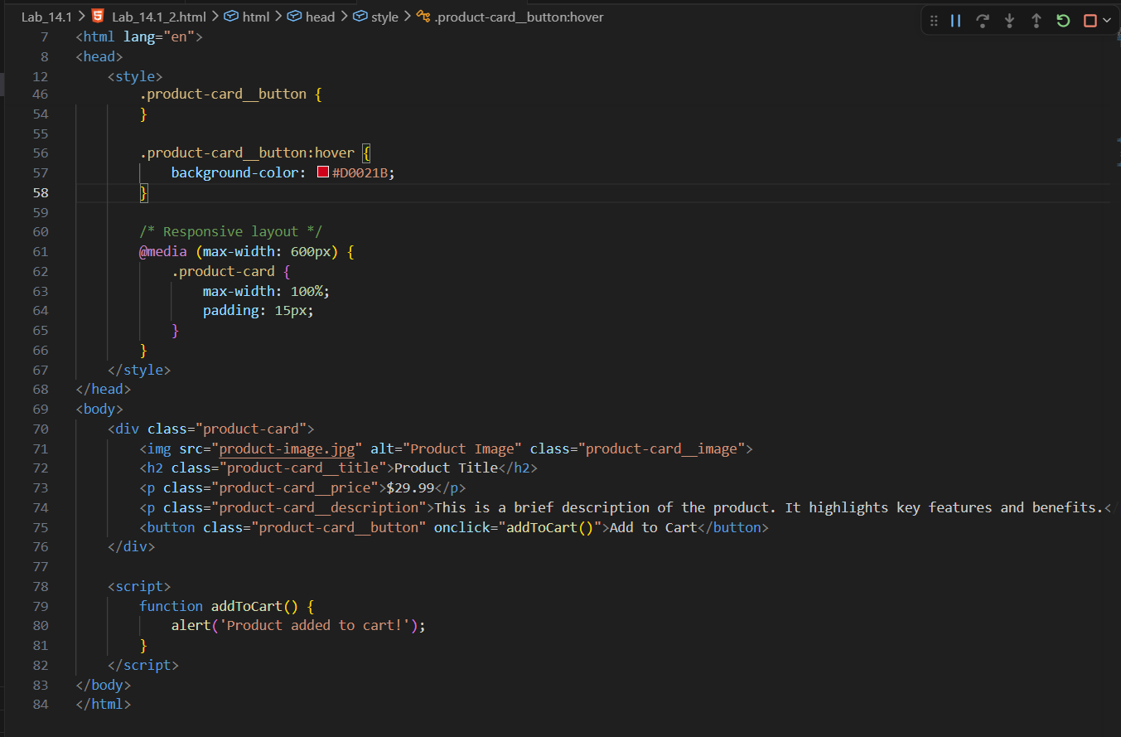
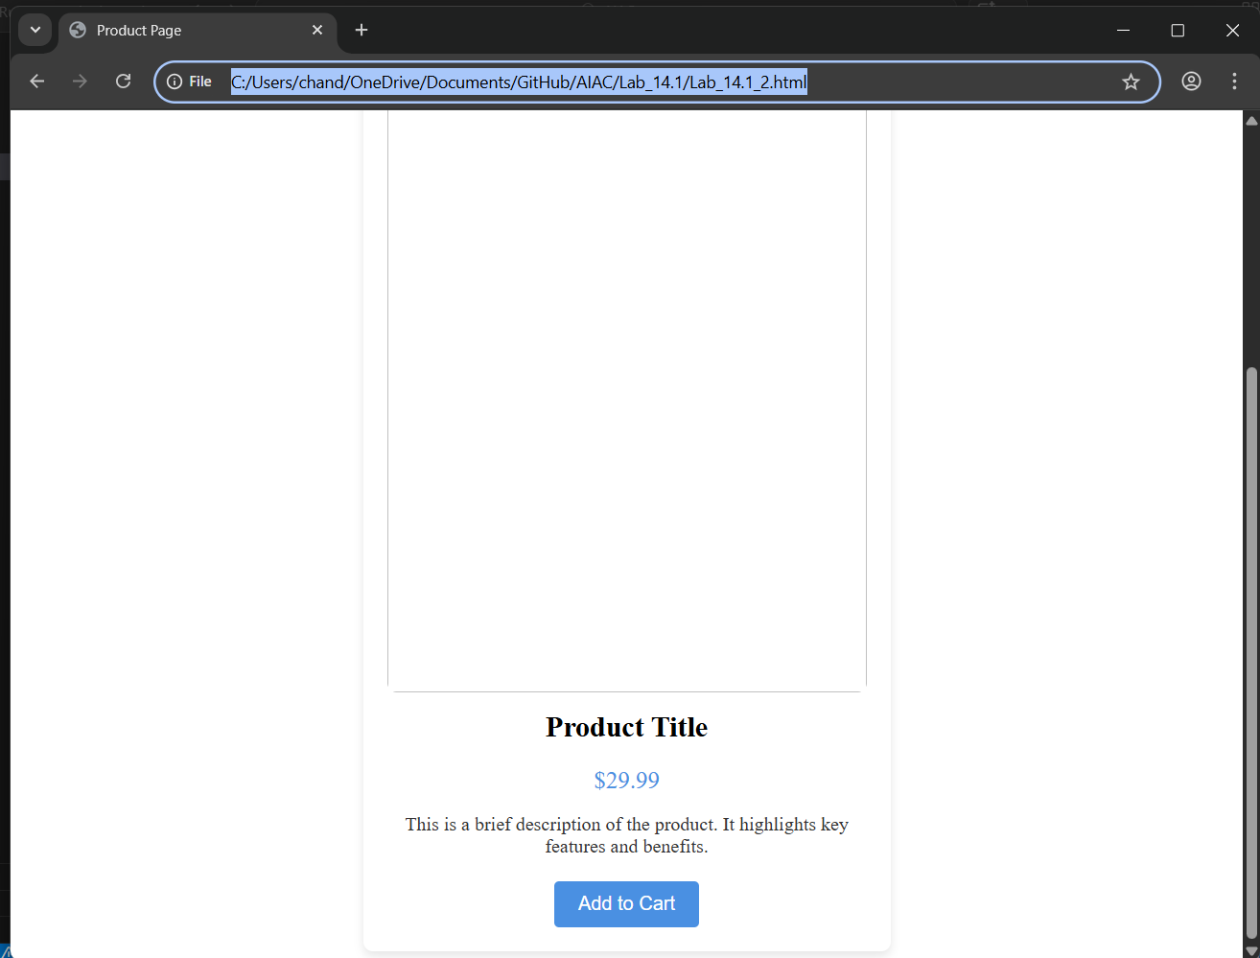

Task 3 – Event Registration Form

• Task: Build an event registration form for a conference.

• Requirements:
- Collect name, email, phone number, and session selection.
- Add form validation with JavaScript.
- Make the form accessible with labels and ARIA.
- Style with a professional look.
Output Screenshots:
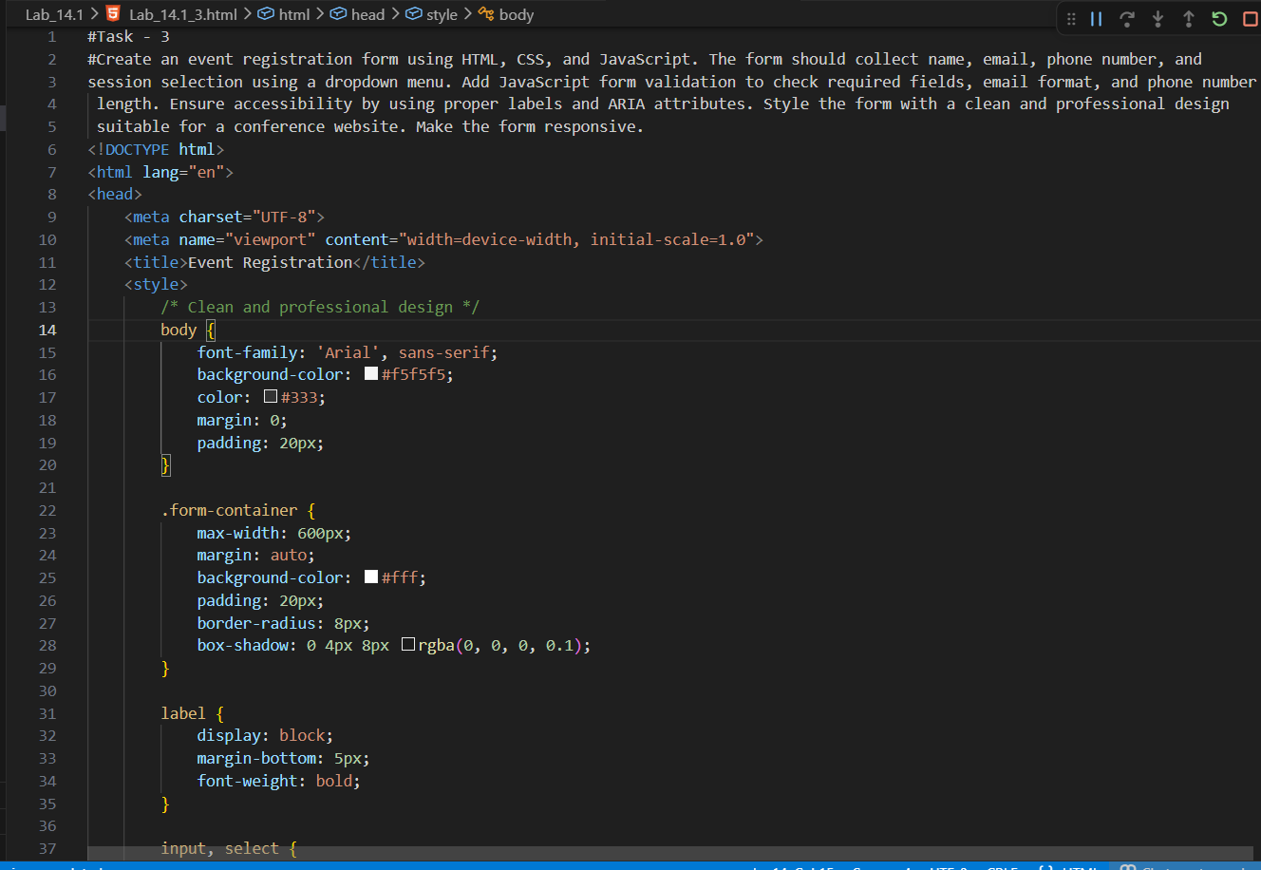
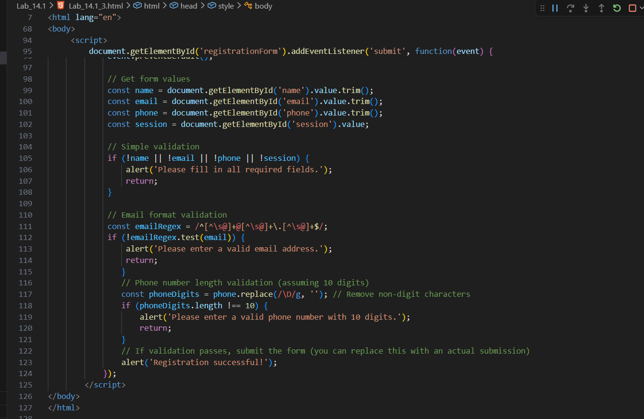
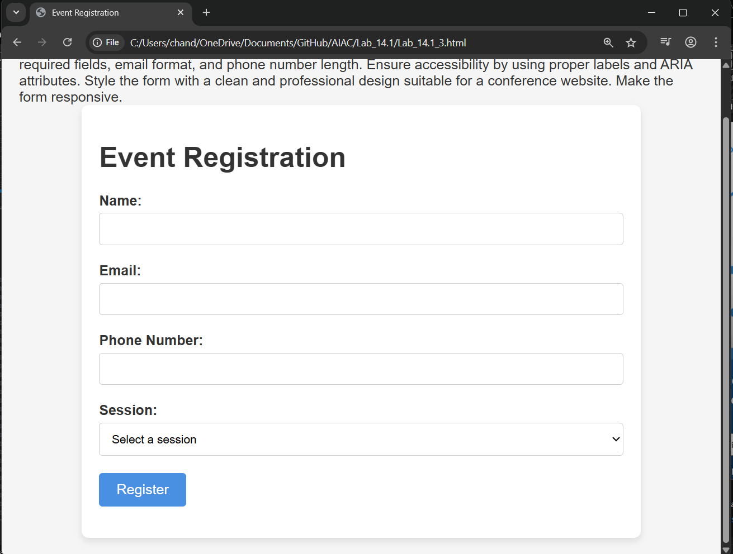

Task 4 – Resume Website

• Task: Build a one-page online resume.

• Requirements:
- Sections: Profile Summary, Skills, Education, Experience.
- Propose professional typography styles.
- Align sections using CSS Grid.
- Add smooth scroll navigation between sections.

Output Screenshots:

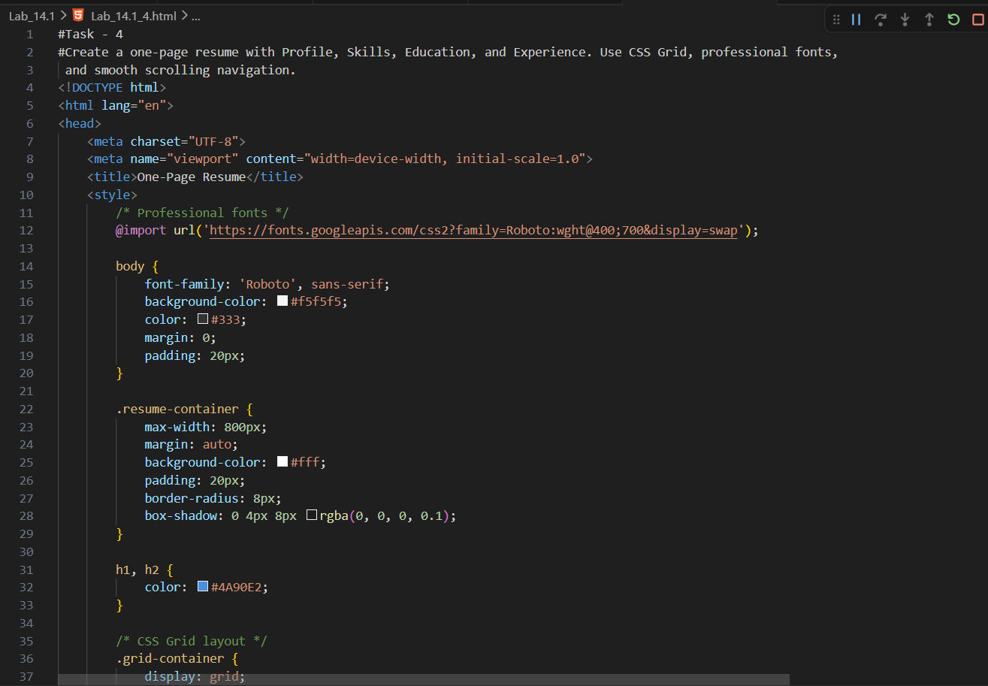
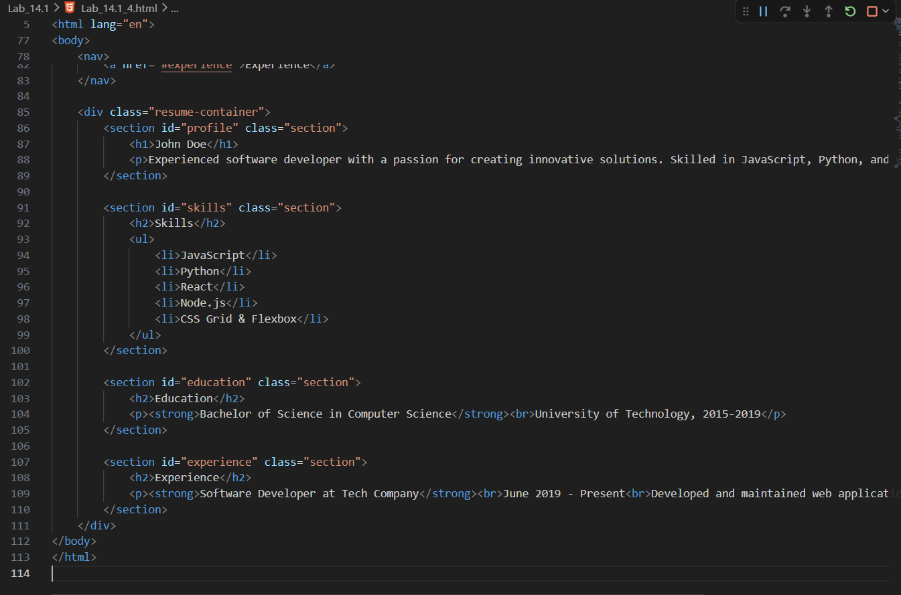
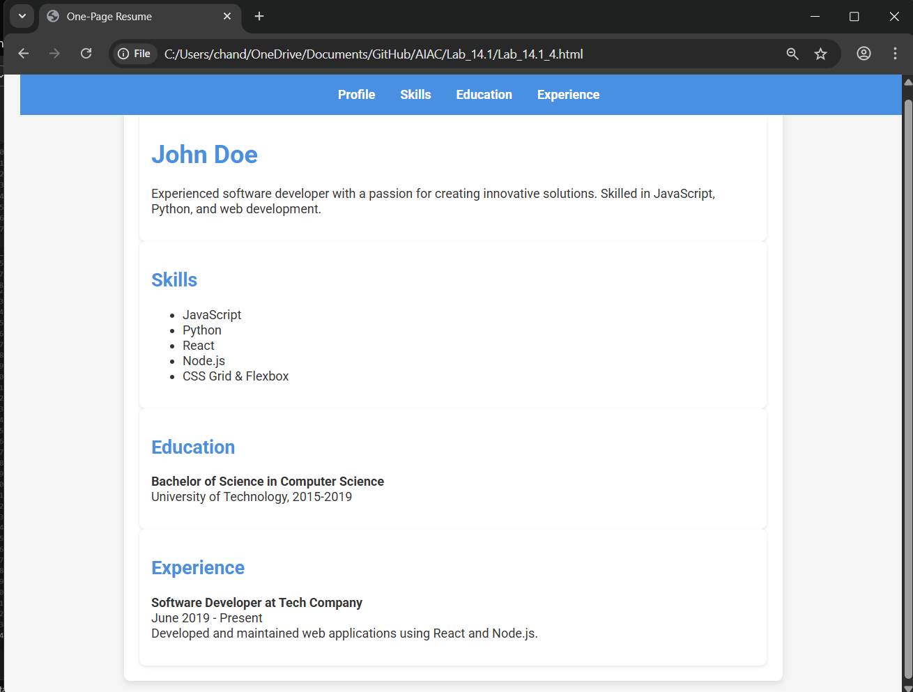

Task 5 – Restaurant Menu Page
• Task: Design a digital menu page for a restaurant.
• Requirements:
- Display menu items with name, description, and price.
- Suggest a food-friendly color palette.
- Design a responsive card-based layout.
- Add hover effects on menu items.

Output Screenshots:

