AIAC TEXT DOCUMENT
TITLE: AI-BASED CAREER GUIDANCE AND SKILL GAP ANALYZER
K. RUCHITHA – 2303A52069
G. NITHYA – 2303A52066

WEBSITE PROMPT:
Create an AI Career Path Predictor UI using HTML, CSS, and JavaScript with a centered card layout.
Include title, subtitle, description, skills input, resume upload input with "or" between them, and a button. Provide the code in separate files: index.html, style.css, and script.js.

Code:

Website view:
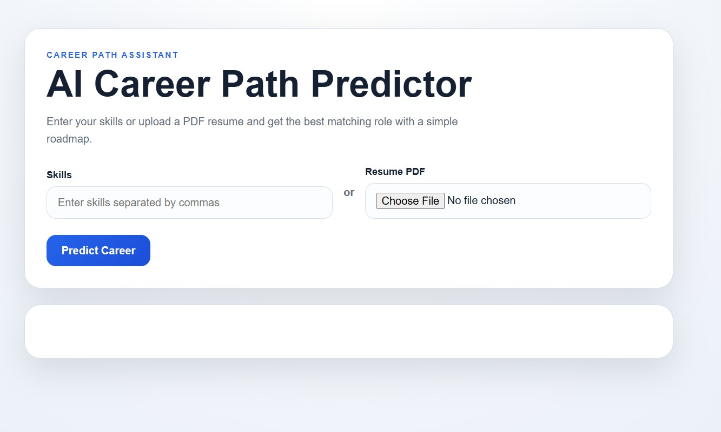

Website gives the result after uploading the resume :

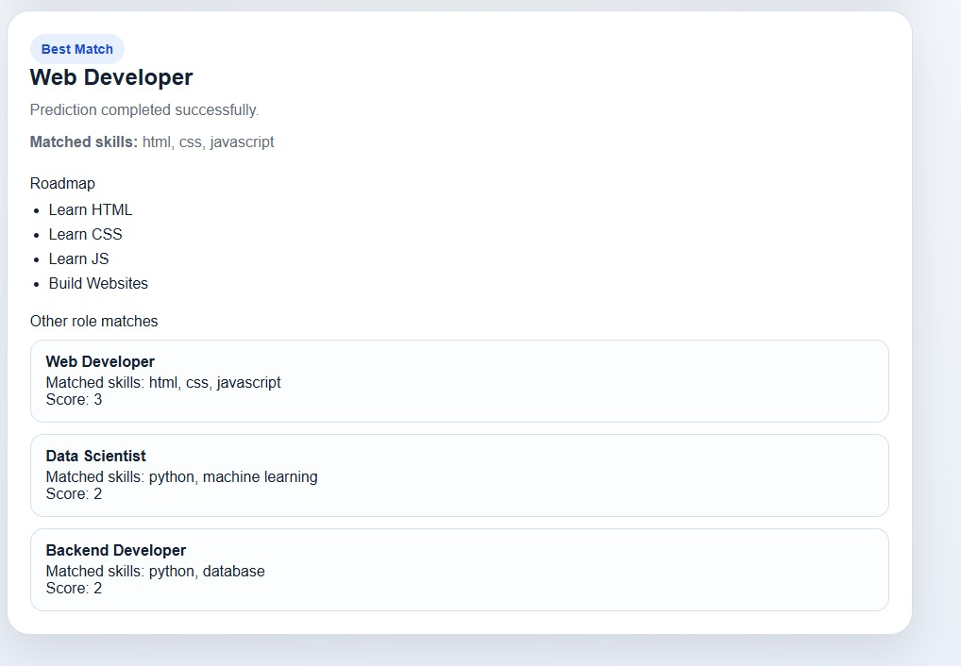

Link:
https://chatgpt.com/share/69e4f9e4-fe98-83e8-b191-08d1ebd70a03

Patent Prompt:
Draft a complete patent-style invention disclosure for an AI-based Career Guidance and Skill Gap Analyser, including title, abstract, detailed description (problem, utility, advantages, best use, working with diagrams), prior art comparison table, technical features, novel elements, implementation/testing details, conception history, disclosure status, non-obviousness justification, and additional comments with drawings/flowcharts."

Tool used link:
For the diagram and for the information:
https://copilot.microsoft.com/shares/AWcGmdaezvkwH6yHwMuaA

