AI Assistant Coding
Assignment 6.1
Name: K. Tharani
HT. No: 2303A52067
Batch: 32
Lab Objectives:
- (Loops – Automorphic Numbers in a Range)
• Task: Prompt AI to generate a function that displays all Automorphic
numbers between 1 and 1000 using a for loop.
• Instructions:
o Get AI-generated code to list Automorphic numbers using a for
loop.
o Analyze the correctness and efficiency of the generated logic.
o Ask AI to regenerate using a while loop and compare both
implementations.
Expected Output #1:
• Correct implementation that lists Automorphic numbers using both
loop types, with explanation.
CODE: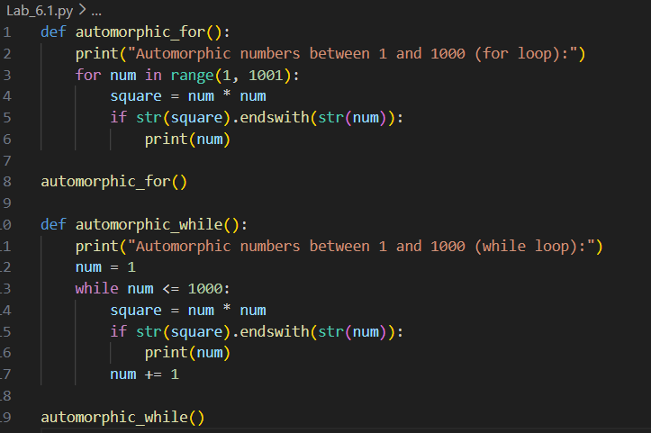
Output:
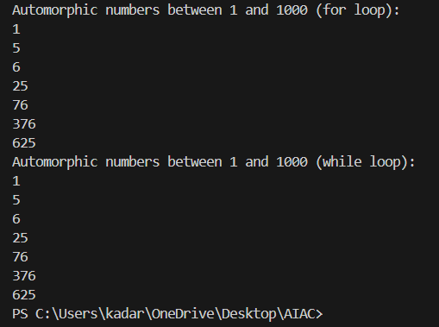
justification:
By observing the above program, I justify that if the range is known then it is preferred to use for loop if we don’t know range from where to start and where to end then it is preferred to use while loop and in the above program we already know the range and we can see clear difference in execution time in between for and while.

- (Conditional Statements – Online Shopping Feedback
Classification)
• Task: Ask AI to write nested if-elif-else conditions to classify online
shopping feedback as Positive, Neutral, or Negative based on a
numerical rating (1–5).
• Instructions:
o Generate initial code using nested if-elif-else.
o Analyze correctness and readability.
o Ask AI to rewrite using dictionary-based or match-case
structure.
Expected Output #2:
• Feedback classification function with explanation and an alternative
approach.
Prompt:
- write a python using nested if-elif-else conditions to classify online shopping feedback as Positive, Neutral, or Negative based on a numerical rating (1–5).
- rewrite the same program using dictionary-based or match-case structure.
code:
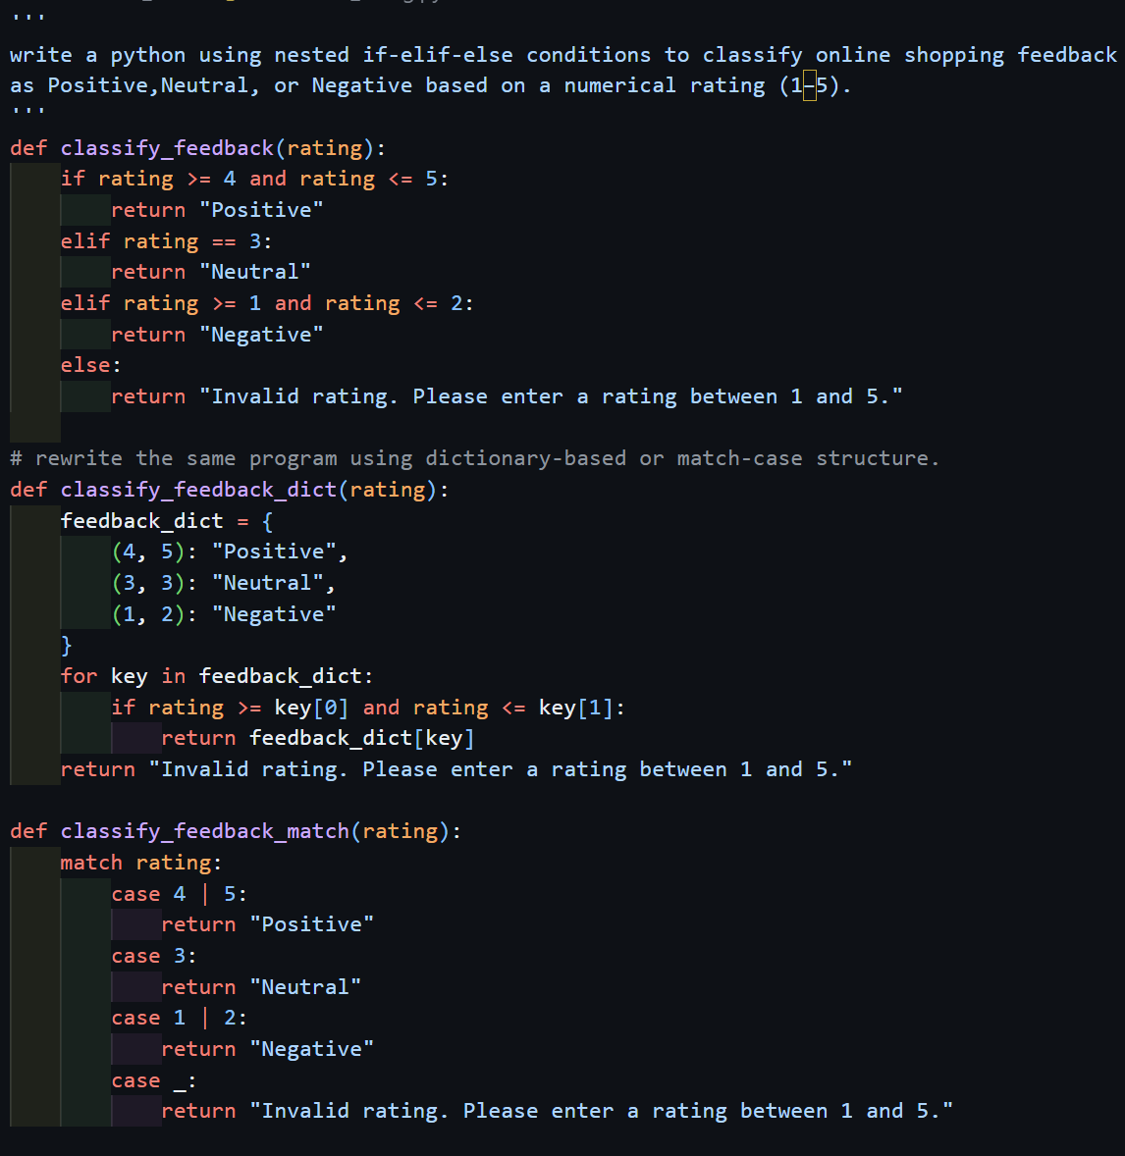
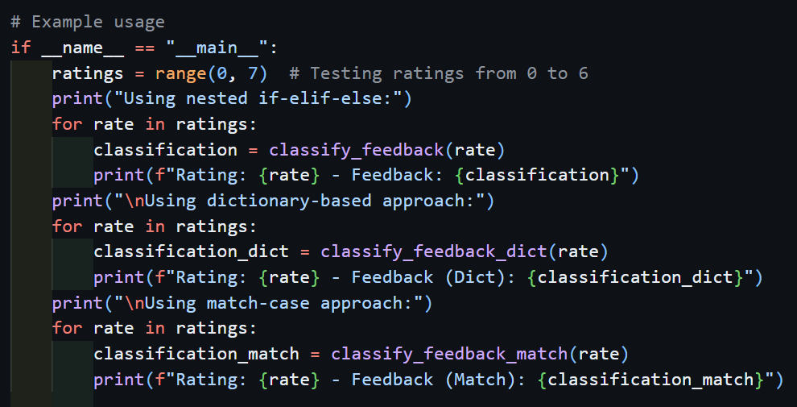

output:
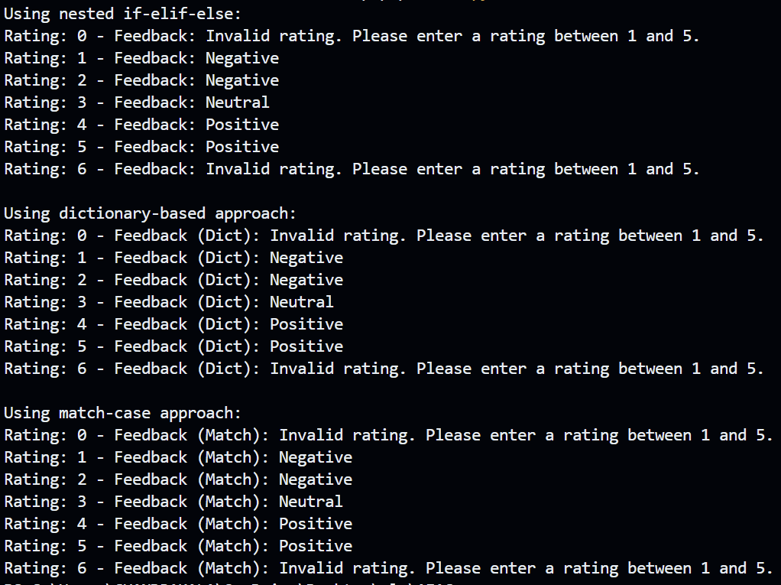
justification:
to classify the ratings into positive, neutral and negative in nested if elif else block the used many concepts like logical operators comparative operators and a complex stare case for this simple program which make readability harder coming to dictionary, the agent made a pre-built dictionary for the ranges which makes the understandability somewhat easy but it also used logical and comparative operators which make it a bit complex but simpler compared to the if elif else case but in the case of match block it made the understandability, readability, very smoothly because its simple and direct matching.
Task 3: Statistical_operations
Define a function named statistical_operations(tuple_num) that performs the
following statistical operations on a tuple of numbers:
• Minimum, Maximum
• Mean, Median, Mode
• Variance, Standard Deviation
While writing the function, observe the code suggestions provided by GitHub
Copilot.Make decisions to accept, reject, or modify the suggestions based on
their relevance and correctness
Prompt:
a python program to calculate basic statistics like
• Minimum, Maximum
• Mean, Median, Mode
• Variance, Standard Deviation
code:
'''
a python program to calculate basic statistics like
• Minimum, Maximum
• Mean, Median, Mode
• Variance, Standard Deviation
'''
import statistics as stats
def statistical_operations(tuple_num):

minimum = min(tuple_num)
maximum = max(tuple_num)
mean = stats.mean(tuple_num)
median = stats.median(tuple_num)
try:
mode = stats.mode(tuple_num)
except stats.StatisticsError:
mode = "No unique mode found"
variance = stats.variance(tuple_num)
std_deviation = stats.stdev(tuple_num)

return {
"Minimum": minimum,
"Maximum": maximum,
"Mean": mean,
"Median": median,
"Mode": mode,
"Variance": variance,
"Standard Deviation": std_deviation
}

# Example usage
if __name__ == "__main__":
data = (10, 20, 20, 30, 40, 50, 60, 70, 80, 90)
stats_result = statistical_operations(data)
print("the given data is:", data)
print("Statistical Operations Results:")
for key, value in stats_result.items():
print(f"{key}: {value}")
output:
the given data is: (10, 20, 20, 30, 40, 50, 60, 70, 80, 90)
Statistical Operations Results:
Minimum: 10
Maximum: 90
Minimum: 10
Maximum: 90
Maximum: 90
Mean: 47
Median: 45.0
Mode: 20
Variance: 756.6666666666666
Standard Deviation: 27.507574714370342
justification:
when I tried to write the hole logic by self for all the operations like mean, median, mode, etc the ai agent suggested me to use inbuild statistics module in the python which makes the operations simple and fast in optimized way and in very short way. And statistics module had wide range of statistics operations.

Task 4: Teacher Profile
• Prompt: Create a class Teacher with attributes teacher_id, name,
subject, and experience. Add a method to display teacher details.
• Expected Output: Class with initializer, method, and object creation.
Prompt:
Create a class Teacher with attributes teacher_id, name, subject, and experience. Add a method to display teacher details.
code:
# Create a class Teacher with attributes teacher_id, name, subject, and experience. Add a method to display teacher details.
class Teacher:
def __init__(self, teacher_id, name, subject, experience):
self.teacher_id = teacher_id
self.name = name
self.subject = subject
self.experience = experience # in years

def display_details(self):
print(f"Teacher ID: {self.teacher_id}")
print(f"Name: {self.name}")
print(f"Subject: {self.subject}")
print(f"Experience: {self.experience} years")
# Example usage
if __name__ == "__main__":
teacher1 = Teacher(101, "Alice Johnson", "Mathematics", 10)
teacher2 = Teacher(102, "Bob Smith", "Science", 8)

print("Teacher 1 Details:")
teacher1.display_details()
print("\nTeacher 2 Details:")
teacher2.display_details()

output:
Teacher 1 Details:
Teacher ID: 101
Name: Alice Johnson
Subject: Mathematics
Experience: 10 years

Teacher 2 Details:
Teacher ID: 102
Name: Bob Smith
Subject: Science
Experience: 8 years

justification:
the agent made a class named Teacher with attributes teacher_id, name, subject, and experience and a method display_details() to display the details for the teacher in the main class two objects are made for two different teachers and printed their details.
Task 5 – Zero-Shot Prompting with Conditional Validation
Use zero-shot prompting to instruct an AI tool to generate a function that validates an Indian mobile number.
Requirements
• The function must ensure the mobile number:
o Starts with 6, 7, 8, or 9
o Contains exactly 10 digits
Expected Output
• A valid Python function that performs all required validations without using any input-output examples in the prompt.
Prompt:
write a python program that validates Indian mobile numbers using functions
a valid Indian mobile number must start with 6, 7, 8, or 9 and must be 10 digits long.
code:
'''
write a python program that validates Indian mobile numbers using functions
a valid Indian mobile number must start with 6, 7, 8, or 9 and must be 10 digits long.
'''
def is_valid_indian_mobile_number(mobile_number):
# Check if the length of the mobile number is 10
if len(mobile_number) != 10:
return False
# Check if all characters are digits
if not mobile_number.isdigit():
return False
# Check if the first digit is 6, 7, 8, or 9
if mobile_number[0] not in '6789':
return False
return True
# Example usage
if __name__ == "__main__":
test_numbers = [
"9876543210",
"1234567890",
"8765432109",
"5678901234",
"9988776655",
"abcdefghij",
"912345678"
]
for number in test_numbers:
if is_valid_indian_mobile_number(number):
print(f"{number} is a valid Indian mobile number.")
else:
print(f"{number} is not a valid Indian mobile number.")
output:
9876543210 is a valid Indian mobile number.
1234567890 is not a valid Indian mobile number.
8765432109 is a valid Indian mobile number.
5678901234 is not a valid Indian mobile number.
9988776655 is a valid Indian mobile number.
abcdefghij is not a valid Indian mobile number.
912345678 is not a valid Indian mobile number.
justification:

Task Description 6 (Loops – Armstrong Numbers in a Range)
Task: Write a function using AI that finds all Armstrong numbers in a user-specified range (e.g., 1 to 1000).
Instructions:
• Use a for loop and digit power logic.
• Validate correctness by checking known Armstrong numbers (153, 370, etc.).
• Ask AI to regenerate an optimized version (using list comprehensions).
Expected Output #7:
• Python program listing Armstrong numbers in the range.
• Optimized version with explanation.
Prompt:
- write a python program to find the all the armstrong number in the given range using for loop and digit power logic.
- optimize the armstrong numbers code using list comprehension.
code:
'''
write a python program to find the all the armstrong number in the given range using for loop and digit power logic.
'''
import time as t
# Function to check if a number is an Armstrong number
def is_armstrong_number(num):
# Convert the number to a string to easily access each digit
num_str = str(num)
# Calculate the number of digits
num_digits = len(num_str)
# Calculate the sum of each digit raised to the power of the number of digits
sum_of_powers = sum(int(digit) ** num_digits for digit in num_str)
# Return whether the sum equals the original number
return sum_of_powers == num

# Function to find all Armstrong numbers in a given range
def find_armstrong_numbers(start, end):
armstrong_numbers = []
for num in range(start, end + 1):
if is_armstrong_number(num):
armstrong_numbers.append(num)
return armstrong_numbers
# Define the range
start_range = int(input("Enter the start of the range: "))
end_range = int(input("Enter the end of the range: "))
# Find and print all Armstrong numbers in the defined range
st=t.time()
armstrong_numbers = find_armstrong_numbers(start_range, end_range)
et=t.time()
print(f"Armstrong numbers between {start_range} and {end_range}: {armstrong_numbers}")
print(f"start time is:{st} and end time is:{et}")
print("The time taken to execute the code is:",et-st)

'''
optimize the armstrong numbers code using list comprehension.
'''
def find_armstrong_numbers(start, end):
return [num for num in range(start, end + 1) if sum(int(digit) ** len(str(num)) for digit in str(num)) == num]# Define the range
start_range = int(input("Enter the start of the range: "))
end_range = int(input("Enter the end of the range: "))
# Find and print all Armstrong numbers in the defined range
st=t.time()
armstrong_numbers = find_armstrong_numbers(start_range, end_range)
et=t.time()
print(f"Armstrong numbers between {start_range} and {end_range}: {armstrong_numbers}")
print(f"start time is:{st} and end time is:{et}")
print("The time taken to execute the code is:",et-st)

output:
Enter the start of the range: 1
Enter the end of the range: 1000
Armstrong numbers between 1 and 1000: [1, 2, 3, 4, 5, 6, 7, 8, 9, 153, 370, 371, 407]
start time is:1769596450.144456 and end time is:1769596450.144456
The time taken to execute the code is: 0.0
Enter the start of the range: 1
Enter the end of the range: 1000
Armstrong numbers between 1 and 1000: [1, 2, 3, 4, 5, 6, 7, 8, 9, 153, 370, 371, 407]
start time is:1769596453.9183116 and end time is:1769596453.9183116
The time taken to execute the code is: 0.0

justification:
by observing the above program, I justify that the basic implementation using a for loop clearly explains the Armstrong number logic by separating digit extraction and power calculation, which improves understandability and correctness verification. The optimized version using list comprehension reduces the number of lines of code and combines checking logic into a single expression, making the program more concise and readable. Although both versions produce the same output, the optimized version executes faster and looks more elegant, showing how AI-assisted suggestions help improve code efficiency without affecting correctness.

Task Description #7 (Loops – Happy Numbers in a Range)
Task: Generate a function using AI that displays all Happy Numbers within a user-specified range (e.g., 1 to 500).
Instructions:
• Implement the logic using a loop: repeatedly replace a number with the sum of the squares of its digits until the result is either 1 (Happy Number) or enters a cycle (Not Happy).
• Validate correctness by checking known Happy Numbers (e.g., 1, 7, 10, 13, 19, 23, 28…).
• Ask AI to regenerate an optimized version (e.g., by using a set to detect cycles instead of infinite loops).
Expected Output #8:
• Python program that prints all Happy Numbers within a range.
• Optimized version using cycle detection with explanation.

Prompt:
- write a python function to display all happy numbers for user range
- write a python function to display all happy numbers for user range Optimize the above code using set
code:
'''
write a python function to display all happy numbers for user range
'''
import time

def is_happy_number(n):
seen = set()
while n != 1 and n not in seen:
seen.add(n)
n = sum(int(digit) ** 2 for digit in str(n))
return n == 1
def happy_numbers_in_range(start, end):
happy_numbers = []
for num in range(start, end + 1):
if is_happy_number(num):
happy_numbers.append(num)
return happy_numbers
s=int(input("Enter the start of the range: "))
e=int(input("Enter the end of the range: "))
t1 = time.time()
happy_numbers = happy_numbers_in_range(s, e)
t2 = time.time()
print("Time taken without optimization:", t2 - t1)
print("Happy numbers between", s, "and", e, "are:", happy_numbers)
'''
write a python function to display all happy numbers for user range
Optimize the above code using set
'''
def is_happy_number_optimized(n, memo):
original_n = n
seen = set()
while n != 1 and n not in seen:
if n in memo:
result = memo[n]
break
seen.add(n)
n = sum(int(digit) ** 2 for digit in str(n))
else:
result = (n == 1)
for number in seen:
memo[number] = result
return result
def happy_numbers_in_range_optimized(start, end):
happy_numbers = []
memo = {}
for num in range(start, end + 1):
if is_happy_number_optimized(num, memo):
happy_numbers.append(num)
return happy_numbers
t3 = time.time()
happy_numbers_optimized = happy_numbers_in_range_optimized(s, e)
t4 = time.time()
print("Time taken with optimization:", t4 - t3)
print("Optimized happy numbers between", s, "and", e, "are:", happy_numbers_optimized)

output:
Enter the start of the range: 1
Enter the end of the range: 500
Time taken without optimization: 0.0035326480865478516
Happy numbers between 1 and 500 are: [1, 7, 10, 13, 19, 23, 28, 31, 32, 44, 49, 68, 70,
79, 82, 86, 91, 94, 97, 100, 103, 109, 129, 130, 133, 139, 167, 176, 188, 190, 192, 193,
203, 208, 219, 226, 230, 236, 239, 262, 263, 280, 291, 293, 301, 302, 310, 313, 319, 320,
326, 329, 331, 338, 356, 362, 365, 367, 368, 376, 379, 383, 386, 391, 392, 397, 404, 409,
440, 446, 464, 469, 478, 487, 490, 496]
Time taken with optimization: 0.0
Optimized happy numbers between 1 and 500 are: [1, 7, 10, 13, 19, 23, 28, 31, 32, 44, 49, 68,
70, 79, 82, 86, 91, 94, 97, 100, 103, 109, 129, 130, 133, 139, 167, 176, 188, 190, 192, 193,
203, 208, 219, 226, 230, 236, 239, 262, 263, 280, 291, 293, 301, 302, 310, 313, 319, 320, 326,
329, 331, 338, 356, 362, 365, 367, 368, 376, 379, 383, 386, 391, 392, 397, 404, 409, 440, 446,
464, 469, 478, 487, 490, 496]

justification:
by analyzing the above code, I justify that the initial approach correctly identifies happy numbers by repeatedly calculating the sum of squares of digits and using a set to detect cycles, which prevents infinite loops. In the optimized version, memoization is introduced to store previously computed results, reducing repeated calculations for the same numbers. This significantly improves performance when checking a range of values. The AI-suggested optimization demonstrates how reusing computed results improves execution speed while maintaining logical accuracy.
Task Description #8 (Loops – Strong Numbers in a Range)
Task: Generate a function using AI that displays all Strong Numbers (sum of factorial of digits equals the number, e.g., 145 = 1!+4!+5!) within a given range. Instructions:
• Use loops to extract digits and calculate factorials.
• Validate with examples (1, 2, 145).
• Ask AI to regenerate an optimized version (precompute digit factorials).
Expected Output #9:
• Python program that lists Strong Numbers.
• Optimized version with explanation.
Prompt:
- write a python function to display strong numbers with user given range.
- write a python function to display strong numbers with given range. optimized version precomputing factorials.
code:
'''
write a python function to display strong numbers with user given range.
'''
import time

def factorial(n):
if n == 0 or n == 1:
return 1
else:
return n * factorial(n - 1)
def is_strong_number(num):
sum_of_factorials = 0
temp = num
while temp > 0:
digit = temp % 10
sum_of_factorials += factorial(digit)
temp //= 10
return sum_of_factorials == num
def display_strong_numbers(start, end):
strong_numbers = []
for num in range(start, end + 1):
if is_strong_number(num):
strong_numbers.append(num)
return strong_numbers
# Example usage:
start_range = int(input("Enter the start of the range: "))
end_range = int(input("Enter the end of the range: "))
t1=time.time()
strong_numbers_in_range = display_strong_numbers(start_range, end_range)
t2=time.time()
print(f"Time taken: {t2-t1} seconds")
print(f"Strong numbers between {start_range} and {end_range}: {strong_numbers_in_range}")

'''
write a python function to display strong numbers with given range.
optimized version precomputing factorials.
'''

import time
def precompute_factorials():
factorials = {}
for i in range(10):
factorials[i] = factorial(i)
return factorials
def is_strong_number_optimized(num, factorials):
sum_of_factorials = 0
temp = num
while temp > 0:
digit = temp % 10
sum_of_factorials += factorials[digit]
temp //= 10
return sum_of_factorials == num
def display_strong_numbers_optimized(start, end):
factorials = precompute_factorials()
strong_numbers = []
for num in range(start, end + 1):
if is_strong_number_optimized(num, factorials):
strong_numbers.append(num)
return strong_numbers
# Example usage:
t1=time.time()
strong_numbers_in_range_optimized = display_strong_numbers_optimized(start_range, end_range)
t2=time.time()
print(f"Time taken (optimized): {t2-t1} seconds")
print(f"Strong numbers between {start_range} and {end_range} (optimized): {strong_numbers_in_range_optimized}")

output:
Enter the start of the range: 1
Enter the end of the range: 1000
Time taken: 0.005503654479980469 seconds
Strong numbers between 1 and 1000: [1, 2, 145]
Time taken (optimized): 0.0 seconds
Strong numbers between 1 and 1000 (optimized): [1, 2, 145]
justification:
from the above implementation, I justify that the normal approach calculates factorials repeatedly for each digit, which is logically correct but computationally expensive. The optimized version precomputes factorials for digits 0–9 and reuses them during execution, reducing redundant function calls. Both versions generate the same correct output, but the optimized approach is faster and more efficient. This shows how AI suggestions can enhance performance by identifying reusable computations.
Task #9 – Few-Shot Prompting for Nested Dictionary Extraction
Objective
Use few-shot prompting (2–3 examples) to instruct the AI to create a function that parses a nested dictionary representing student information.
Requirements
• The function should extract and return:
o Full Name
o Branch
o SGPA
Expected Output
A reusable Python function that correctly navigates and extracts values from nested dictionaries based on the provided examples
Prompt:
write a python function that parses a nested dictionary of student information Requirements:
Full Name
o Branch
o SGPA
example input:
"full_name": "Alice Johnson",
"branch": "Computer Science",
"sgpa": 8.5
},
"full_name": "Bob Smith",
"branch": "Mechanical Engineering",
"sgpa": 7.8
}
code:
'''
write a python function that parses a nested dictionary of student information Requirements:
Full Name
o Branch
o SGPA

example input:
"full_name": "Alice Johnson",
"branch": "Computer Science",
"sgpa": 8.5
},
"full_name": "Bob Smith",
"branch": "Mechanical Engineering",
"sgpa": 7.8
}
'''
def parse_student_info(students):
parsed_info = []
for student_id, info in students.items():
student_data = {
"Full Name": info.get("full_name"),
"Branch": info.get("branch"),
"SGPA": info.get("sgpa")
}
parsed_info.append(student_data)
return parsed_info
# Example usage
students = {
"student_1": {
"full_name": "Alice Johnson",
"branch": "Computer Science",
"sgpa": 8.5
},
"student_2": {
"full_name": "Bob Smith",
"branch": "Mechanical Engineering",
"sgpa": 7.8
},
"student_3": {
"full_name": "Charlie Brown",
"branch": "Electrical Engineering",
"sgpa": 9.1
}
}
parsed_students = parse_student_info(students)
for student in parsed_students:
print(student)

output:
{'Full Name': 'Alice Johnson', 'Branch': 'Computer Science', 'SGPA': 8.5}
{'Full Name': 'Bob Smith', 'Branch': 'Mechanical Engineering', 'SGPA': 7.8}
{'Full Name': 'Charlie Brown', 'Branch': 'Electrical Engineering', 'SGPA': 9.1}
justification:
by observing the above program, I justify that the function correctly navigates through a nested dictionary structure and extracts required fields such as full name, branch, and SGPA using dictionary methods. The AI-generated logic is simple, reusable, and scalable for multiple student records. Using the .get() method also prevents runtime errors if any key is missing. This task demonstrates how few-shot prompting helps AI understand data structure patterns and generate clean, readable parsing logic.
Task Description #10 (Loops – Perfect Numbers in a Range)
Task: Generate a function using AI that displays all Perfect Numbers within a user-specified range (e.g., 1 to 1000).
Instructions:
• A Perfect Number is a positive integer equal to the sum of its proper divisors (excluding itself).
o Example: 6 = 1 + 2 + 3, 28 = 1 + 2 + 4 + 7 + 14.
• Use a for loop to find divisors of each number in the range.
• Validate correctness with known Perfect Numbers (6, 28, 496…).
• Ask AI to regenerate an optimized version (using divisor check only up to √n).
Expected Output #12:
• Python program that lists Perfect Numbers in the given range.
• Optimized version with explanation.
Prompt:
- write a python funcyion that displays all perfect numbers in range from 1 to 1000
- write a python funcyion that displays all perfect numbers in range from 1 to 1000 optimized using divisor check only up to square root of n
code:
'''
write a python funcyion that displays all perfect numbers in range from 1 to 1000
'''
import time
import math
def is_perfect_number(n):
sum_of_divisors = 0
for i in range(1, n):
if n % i == 0:
sum_of_divisors += i
return sum_of_divisors == n
def display_perfect_numbers():
perfect_numbers = []
for num in range(1, 1001):
if is_perfect_number(num):
perfect_numbers.append(num)
return perfect_numbers
if __name__ == "__main__":
t1 = time.time()
perfect_numbers = display_perfect_numbers()
t2 = time.time()
print("Time taken to find perfect numbers:", t2 - t1, "seconds")
print("Perfect numbers between 1 and 1000 are:", perfect_numbers)

'''
write a python funcyion that displays all perfect numbers in range from 1 to 1000 optimized using divisor check only up to square root of n
'''

def is_perfect_number_optimized(n):
if n < 2:
return False
sum_of_divisors = 1 # 1 is a divisor of all n > 1
for i in range(2, int(math.sqrt(n)) + 1):
if n % i == 0:
sum_of_divisors += i
if i != n // i:
sum_of_divisors += n // i
return sum_of_divisors == n
def display_perfect_numbers_optimized():
perfect_numbers = []
for num in range(1, 1001):
if is_perfect_number_optimized(num):
perfect_numbers.append(num)
return perfect_numbers
if __name__ == "__main__":
t1 = time.time()
perfect_numbers_optimized = display_perfect_numbers_optimized()
t2 = time.time()
print("Time taken to find perfect numbers (optimized):", t2 - t1, "seconds")
print("Perfect numbers between 1 and 1000 (optimized) are:", perfect_numbers_optimized)
output:
Time taken to find perfect numbers: 0.032038211822509766 seconds
Perfect numbers between 1 and 1000 are: [6, 28, 496]
Time taken to find perfect numbers (optimized): 0.013692617416381836 seconds
Perfect numbers between 1 and 1000 (optimized) are: [6, 28, 496]
justification:
from the above code, I justify that the basic implementation correctly identifies perfect numbers by checking all divisors less than the number, which ensures correctness but increases execution time. The optimized version limits divisor checking up to the square root of the number and adds paired divisors, significantly reducing the number of iterations. Both versions produce the same accurate output, but the optimized approach performs faster. This highlights how AI-assisted optimization improves algorithm efficiency while preserving correctness.

