AI Assistant Coding
Assignment 6.3
Name: K. RUCHITHA HT. No: 2303A52069 Batch: 32

Q1. Task: Prompt AI to generate a function that displays all Automorphic
numbers between 1 and 1000 using a for loop.
Instructions:
o Get AI-generated code to list Automorphic numbers using a for loop.
o Analyze the correctness and efficiency of the generated logic.
o Ask AI to regenerate using a while loop and compare both implementations
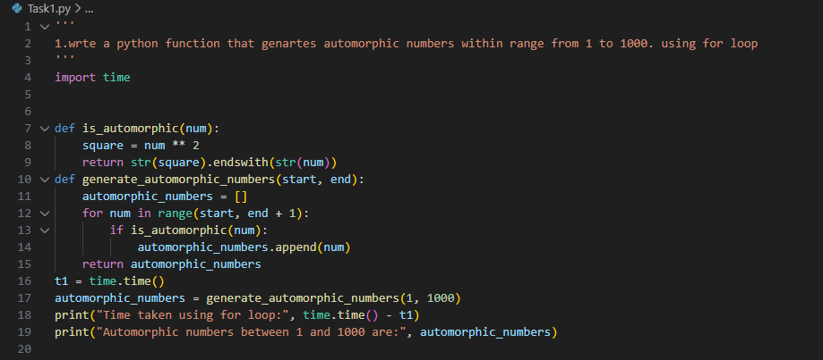
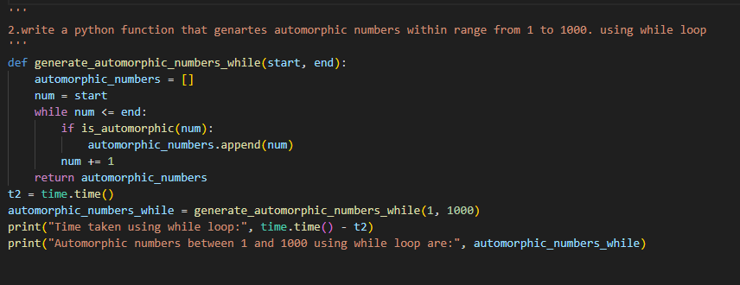
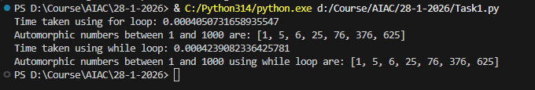
Explanation:
For loop is the best because it takes less time. Use for loop when you know when to stop if not use while loop.

Q2. Task: Ask AI to write nested if-elif-else conditions to classify online
shopping feedback as Positive, Neutral, or Negative based on a
numerical rating (1–5).
• Instructions:
o Generate initial code using nested if-elif-else.
o Analyze correctness and readability.
o Ask AI to rewrite using dictionary-based or match-case
input:
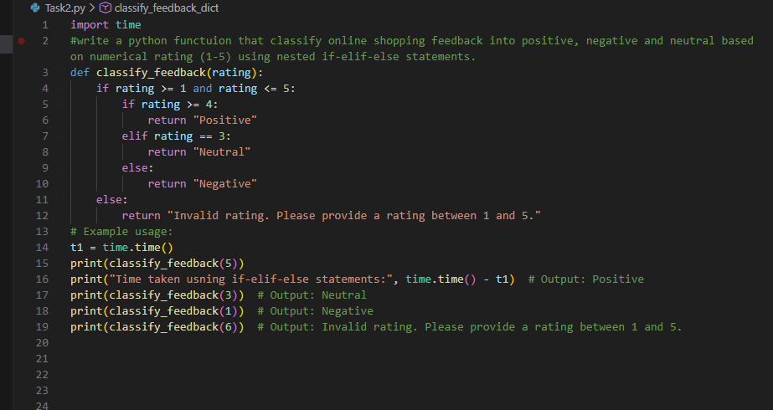
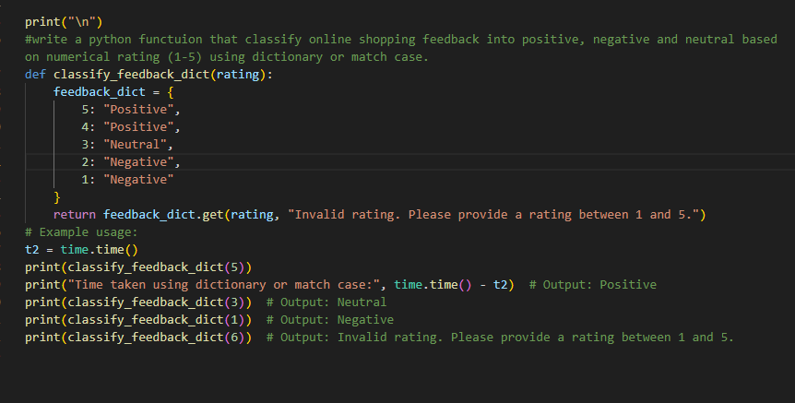
Output:
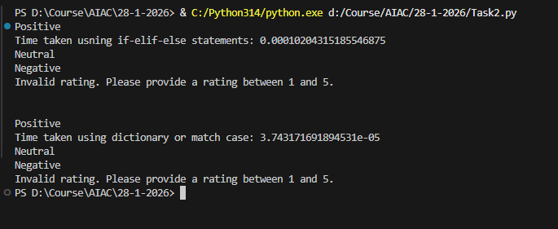
Explanation:
The Condition ensures the correctness of the code. Dictionary improves readability

Q3. Task 3: Statistical_operations
Define a function named statistical_operations(tuple_num) that performs the following statistical operations on a tuple of numbers:
• Minimum, Maximum
• Mean, Median, Mode
• Variance, Standard Deviation
While writing the function, observe the code suggestions provided by GitHub Copilot. Make decisions to accept, reject, or modify the suggestions based on their relevance and correctness
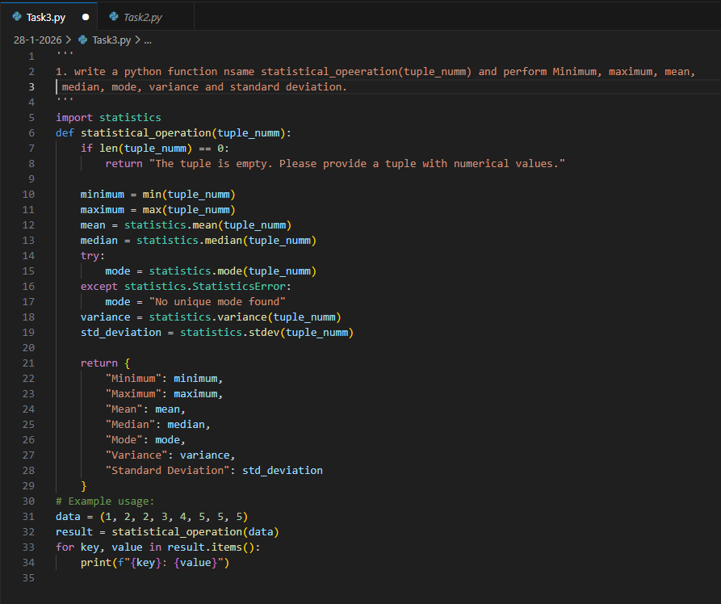
Output:
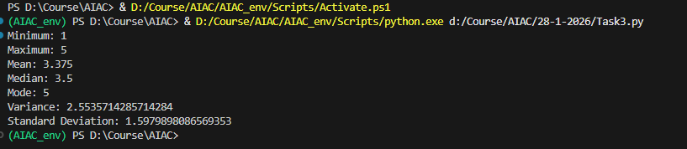

Q4. Task 4: Teacher Profile
• Prompt: Create a class Teacher with attributes teacher_id, name,
subject, and experience. Add a method to display teacher details.
• Expected Output: Class with initializer, method, and object creation.
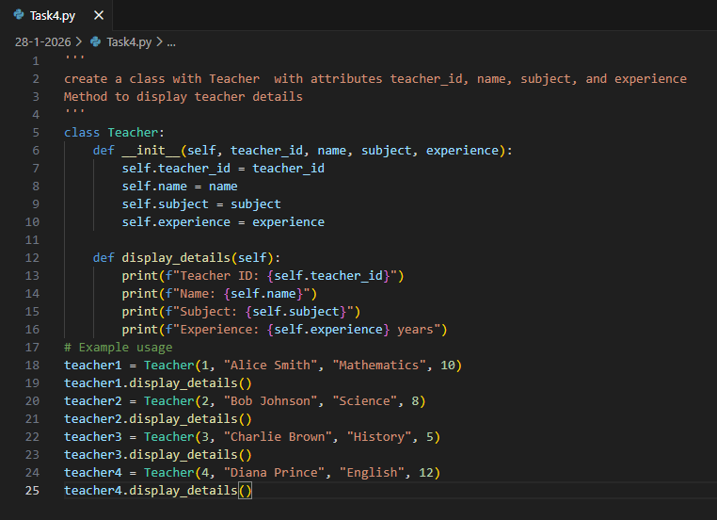
Output:
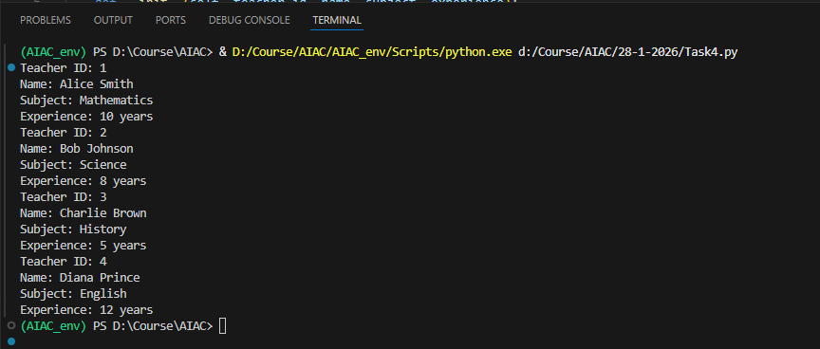

Q5. Task #5 – Zero-Shot Prompting with Conditional Validation
Use zero-shot prompting to instruct an AI tool to generate a function
that validates an Indian mobile number.
Requirements
• The function must ensure the mobile number:
o Starts with 6, 7, 8, or 9
o Contains exactly 10 digits
Expected Output
• A valid Python function that performs all required validations
without using any input-output examples in the prompt
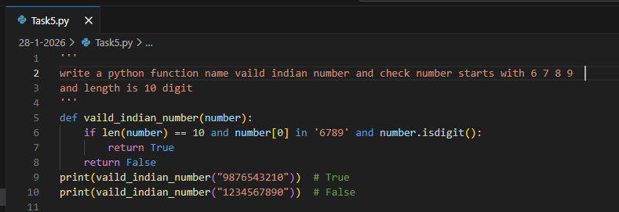
Output:
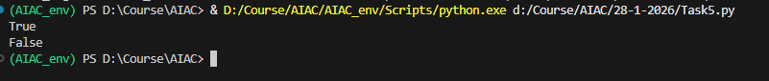

Q6. Task Description #6 (Loops – Armstrong Numbers in a Range)
Task: Write a function using AI that finds all Armstrong numbers in a user-
specified range (e.g., 1 to 1000).
Instructions:
• Use a for loop and digit power logic.
• Validate correctness by checking known Armstrong numbers (153, 370,
etc.).
• Ask AI to regenerate an optimized version (using list comprehensions).
Expected Output #7:
• Python program listing Armstrong numbers in the range.
• Optimized version with explanation
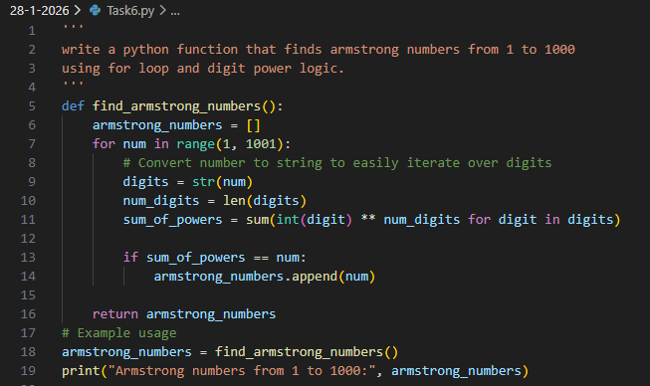
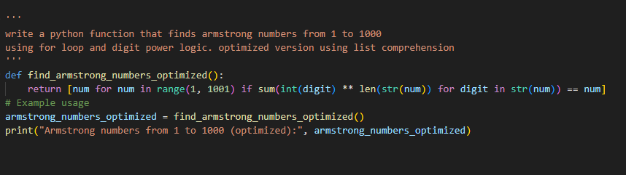
Output:
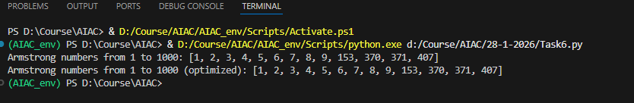
Explanation:
By Using for loop it is easy to understand and debug the code best for beginner. while List comprehension is minimal and hard to debug

Q7. Task Description #7 (Loops – Happy Numbers in a Range)
Task: Generate a function using AI that displays all Happy Numbers within a
user-specified range (e.g., 1 to 500).
Instructions:
• Implement the logic using a loop: repeatedly replace a number with the
sum of the squares of its digits until the result is either 1 (Happy
Number) or enters a cycle (Not Happy).
• Validate correctness by checking known Happy Numbers (e.g., 1, 7, 10,
13, 19, 23, 28…).
• Ask AI to regenerate an optimized version (e.g., by using a set to detect
cycles instead of infinite loops).
Expected Output #8:
• Python program that prints all Happy Numbers within a range.
• Optimized version using cycle detection with explanation.
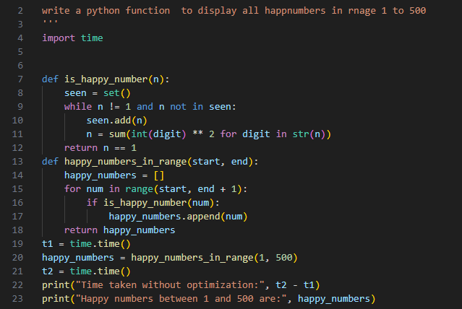
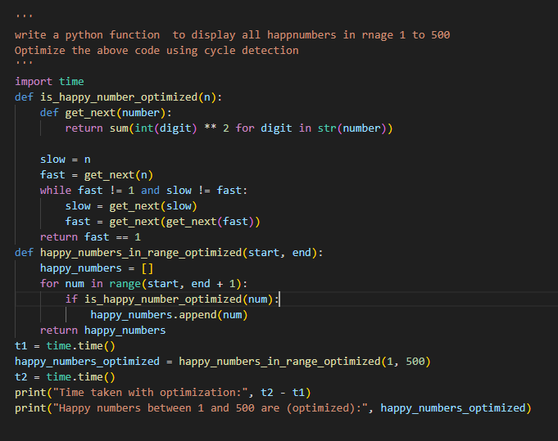
Output:
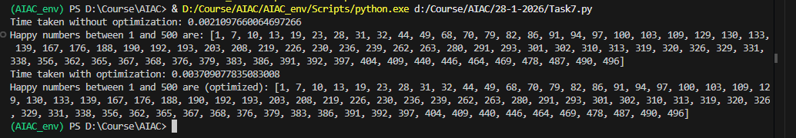
Explanation:
The optimized cycle detection method is the best choice because it reduces memory usage, improves efficiency, and scales better while still producing correct results. The set-based approach is easier for beginners, but the optimized method is more professional and performance-oriented.

Q8. Task Description #8 (Loops – Strong Numbers in a Range)
Task: Generate a function using AI that displays all Strong Numbers (sum of
factorial of digits equals the number, e.g., 145 = 1!+4!+5!) within a given range.
Instructions:
• Use loops to extract digits and calculate factorials.
• Validate with examples (1, 2, 145).
• Ask AI to regenerate an optimized version (precompute digit factorials).
Expected Output #9:
• Python program that lists Strong Numbers.
• Optimized version with explanation.
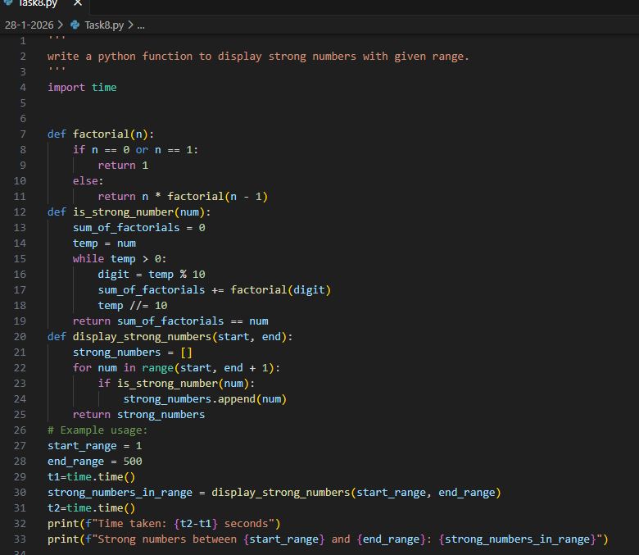
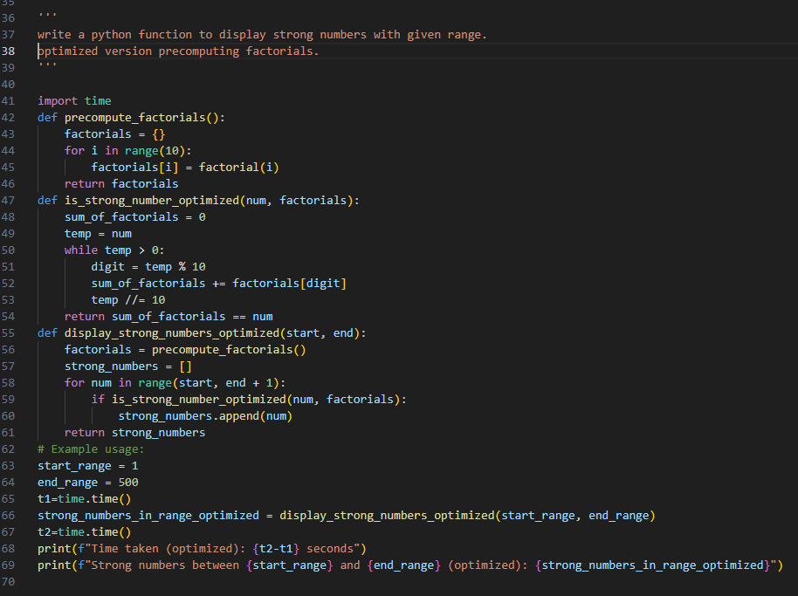
Output:
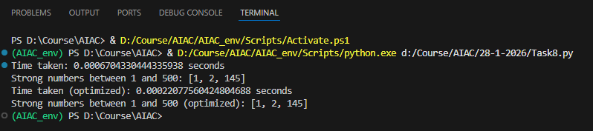
Explanation:
The basic approach identifies strong numbers correctly but recalculates factorials repeatedly, leading to unnecessary computation.
The optimized method precomputes factorials of digits (0–9), reducing repeated calculations and improving efficiency.
Hence, the optimized approach is more suitable for larger ranges due to better performance and scalability.

Q9. Task #9 – Few-Shot Prompting for Nested Dictionary Extraction
Objective
Use few-shot prompting (2–3 examples) to instruct the AI to create a
function that parses a nested dictionary representing student
information.
Requirements
• The function should extract and return:
o Full Name
o Branch
o SGPA
Expected Output
A reusable Python function that correctly navigates and extracts values
from nested dictionaries based on the provided examples
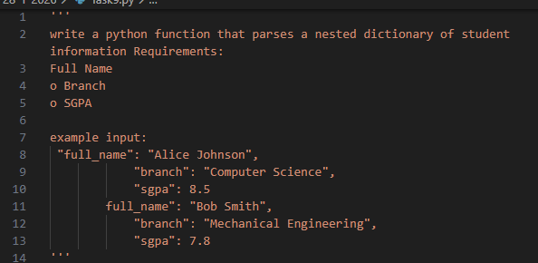
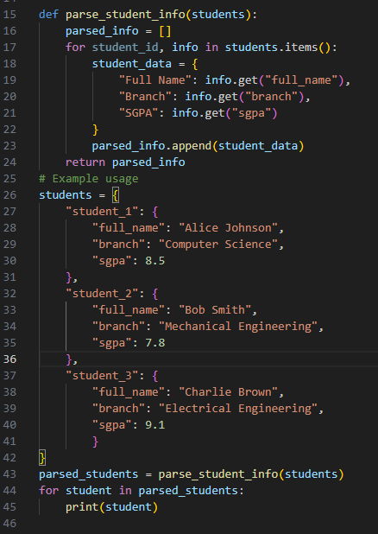
Output:
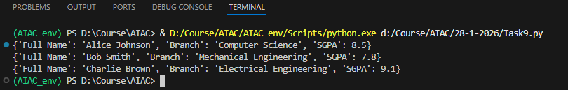

Q10. Task Description #10 (Loops – Perfect Numbers in a Range)
Task: Generate a function using AI that displays all Perfect Numbers within a
user-specified range (e.g., 1 to 1000).
Instructions:
• A Perfect Number is a positive integer equal to the sum of its proper
divisors (excluding itself).
o Example: 6 = 1 + 2 + 3, 28 = 1 + 2 + 4 + 7 + 14.
• Use a for loop to find divisors of each number in the range.
• Validate correctness with known Perfect Numbers (6, 28, 496…).
• Ask AI to regenerate an optimized version (using divisor check only up to
√n)

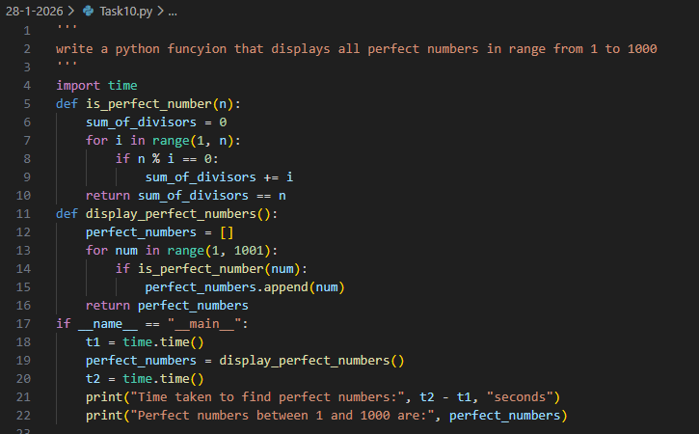
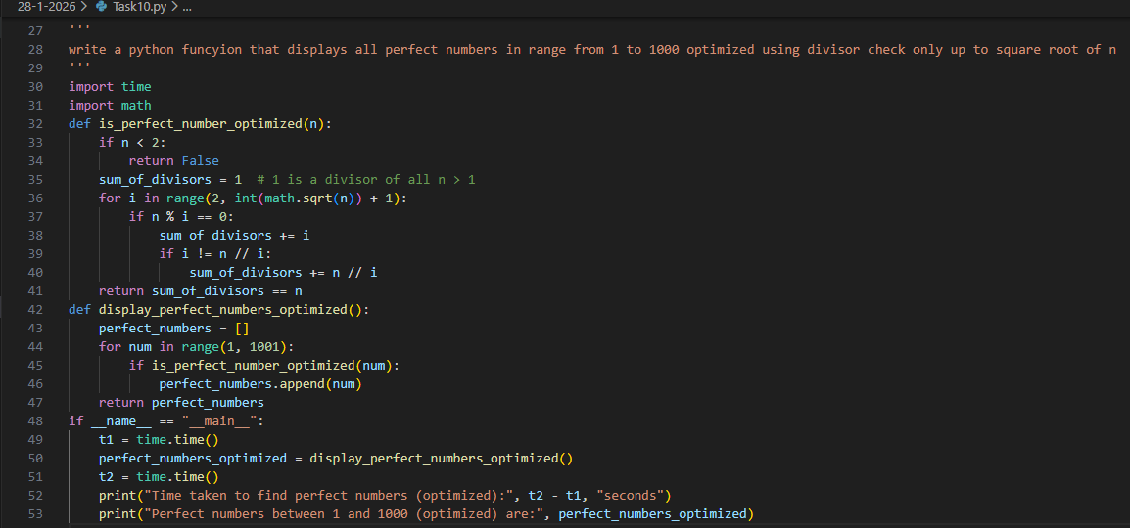

Output:
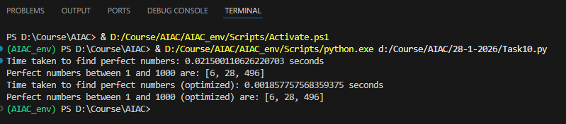

Explanation:
The basic method checks all possible divisors up to the number, resulting in higher time complexity.
The optimized approach checks divisors only up to the square root of the number, significantly improving efficiency while producing the same correct results.

