Humera Nuzhat
2303A52083
Batch 39
AI ASSISTED CODING-9.2 ASSIGNMENT

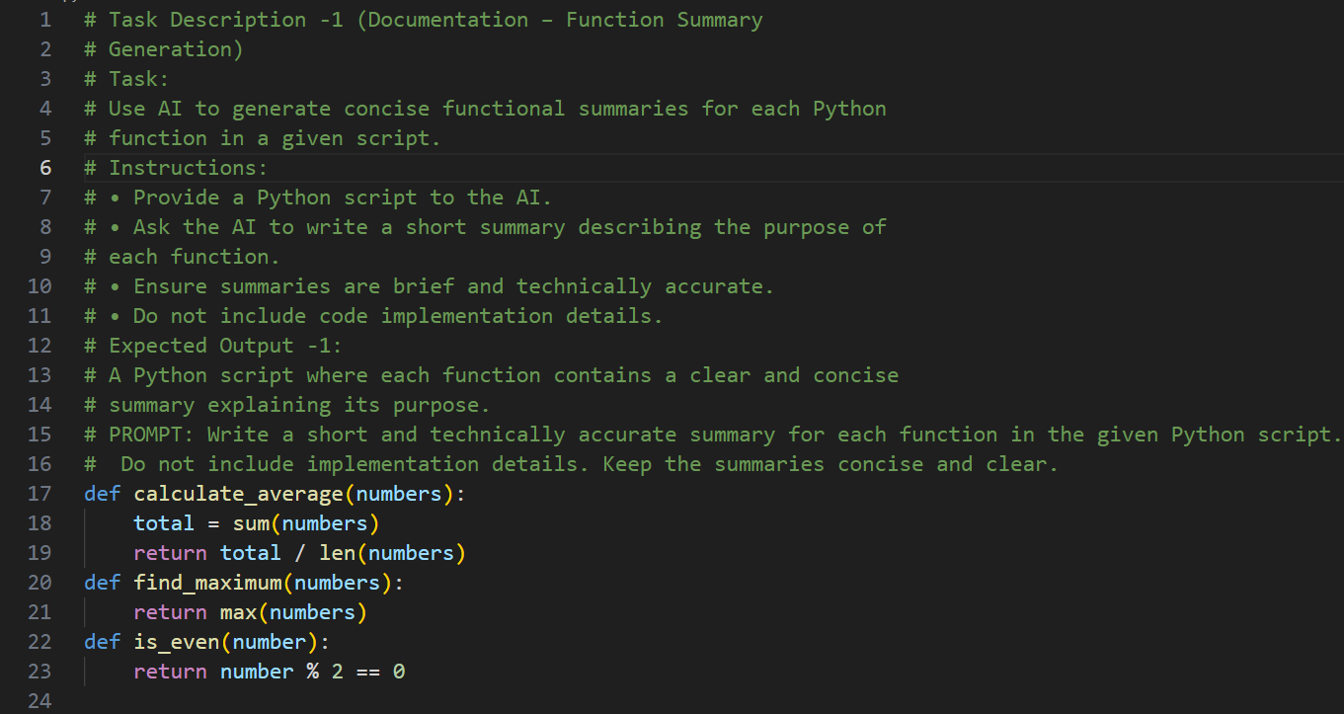

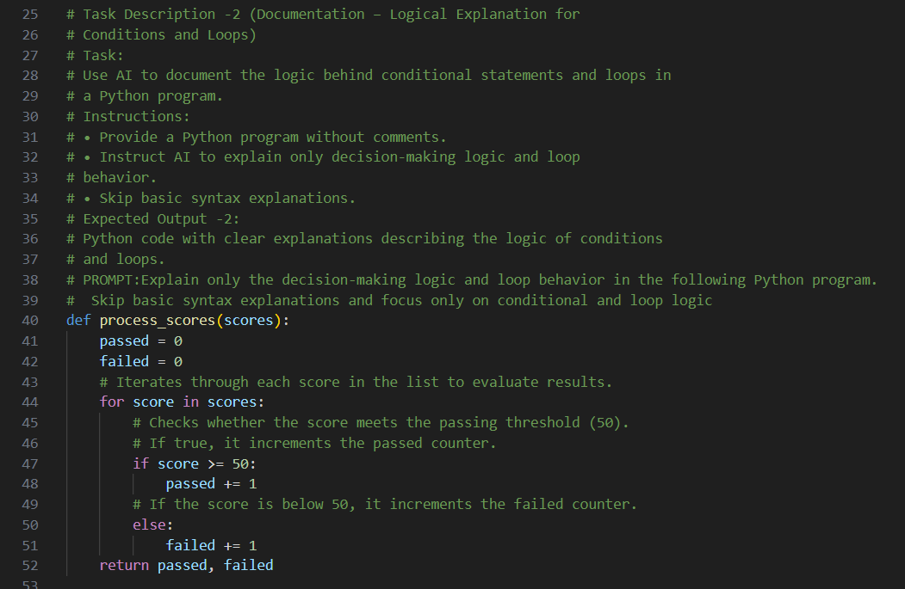

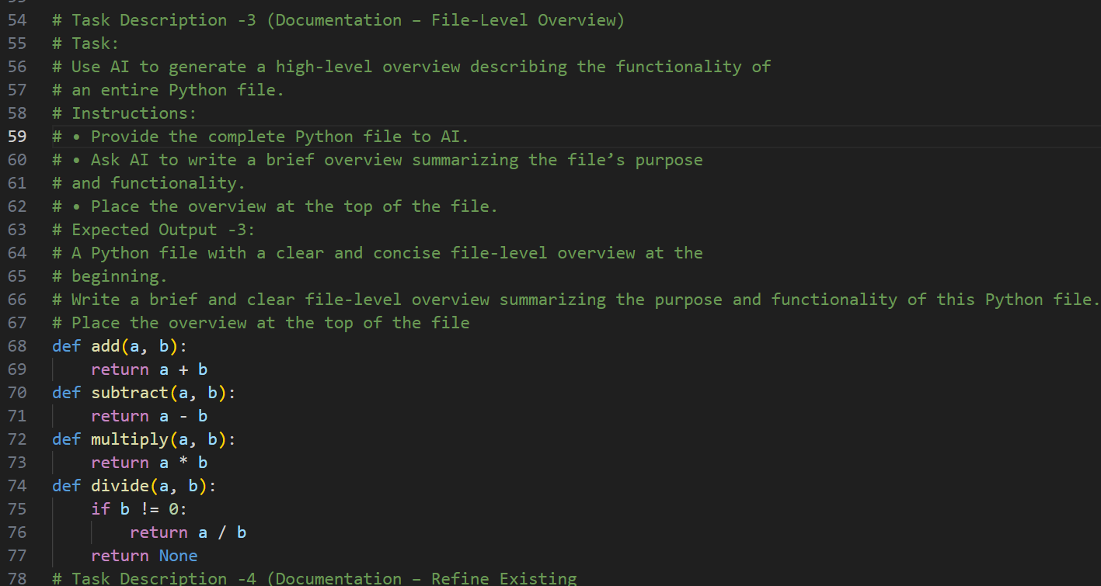

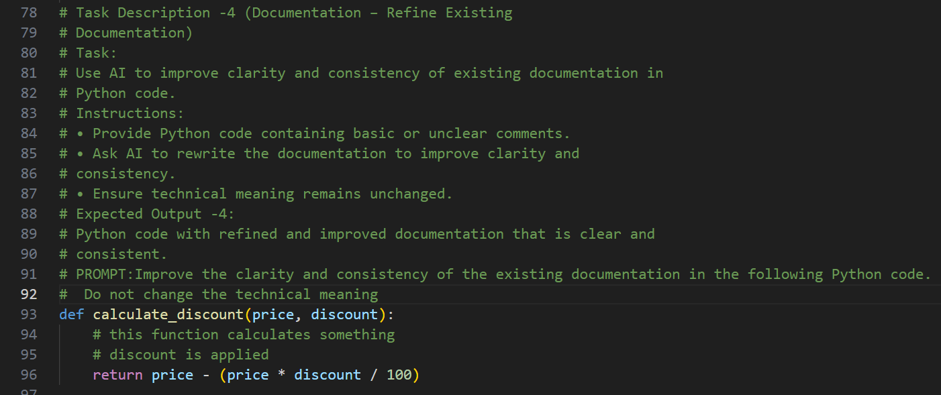

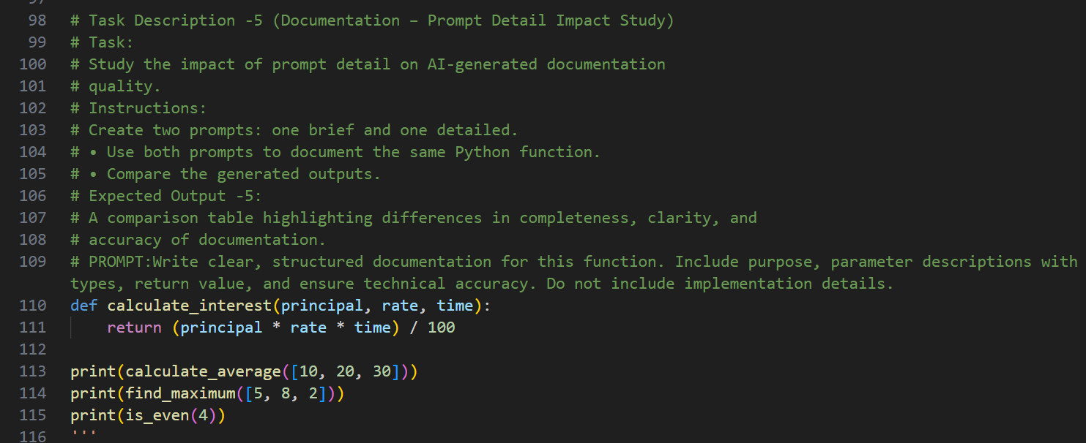

ANALYSIS:

Task 1 – Function Summary Generation
AI effectively generates concise and technically accurate summaries that describe each function’s purpose without exposing implementation details.
This improves code readability and maintainability.

Task 2 – Logical Explanation for Conditions and Loops
AI clearly explains the decision-making logic and loop behavior while avoiding unnecessary syntax details.
This enhances understanding of program flow and conditional execution.

Task 3 – File-Level Overview
AI provides a high-level summary that describes the overall purpose and functionality of the entire file.
This helps readers quickly understand the module before reviewing the code.

Task 4 – Refine Existing Documentation
AI improves clarity, structure, and consistency of comments without changing the technical meaning.
The refined documentation appears more professional and easier to understand.

Task 5 – Prompt Detail Impact Study
Detailed prompts produce more structured, complete, and accurate documentation compared to brief prompts.
This demonstrates that prompt specificity significantly impacts AI output quality

