NAME: HUMERA NUZHAT
2303A52083
BATCH 39

AI ASSISTED CODING-12.2
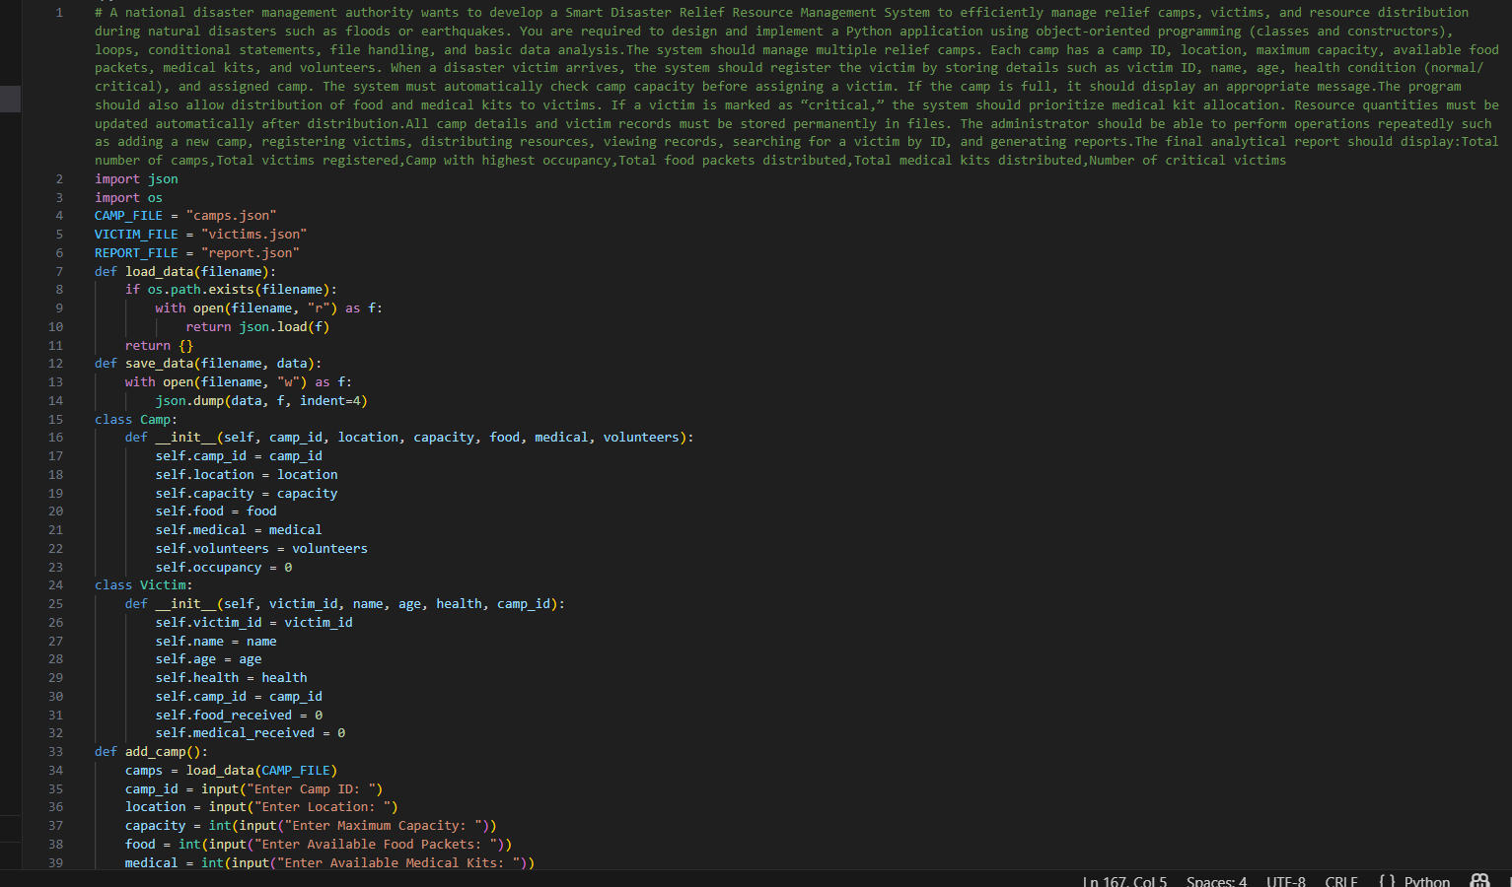

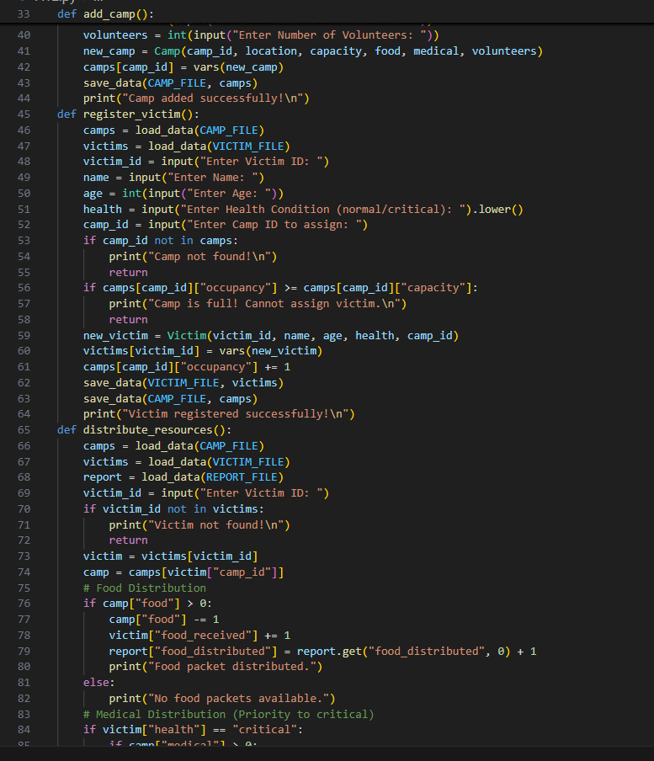

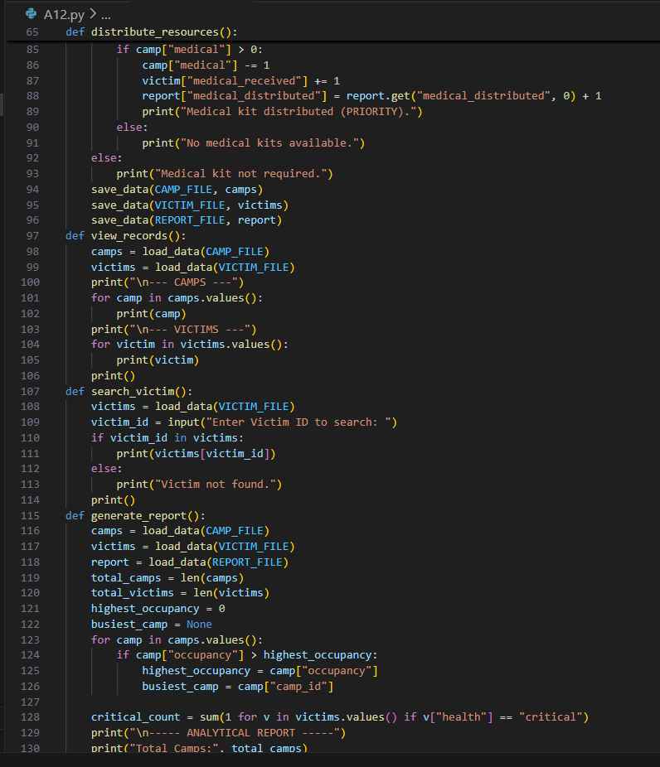

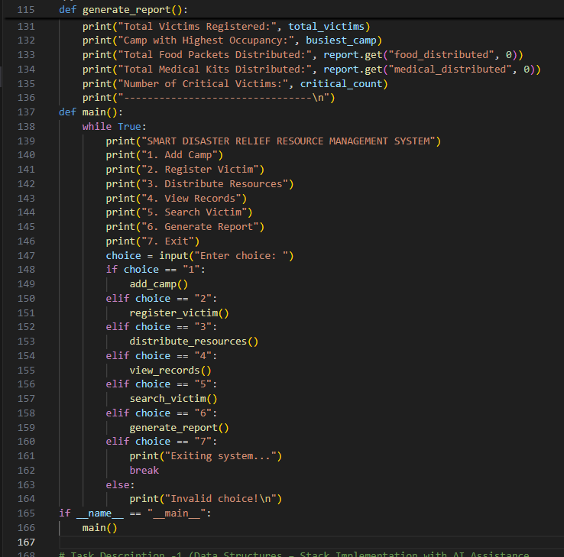

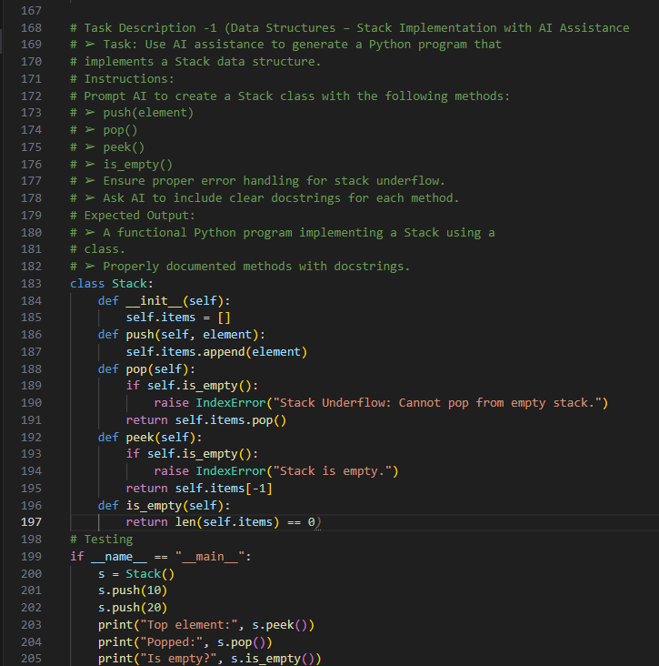

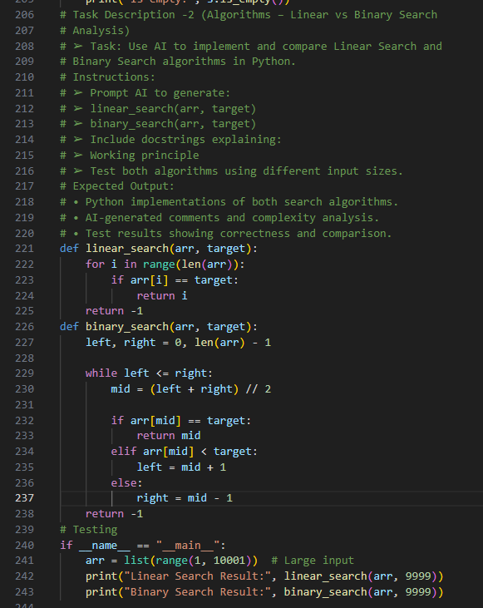

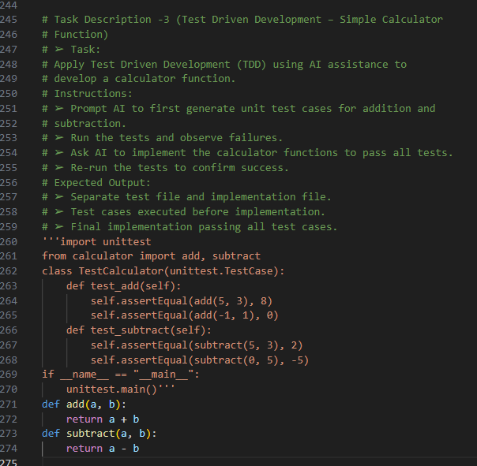

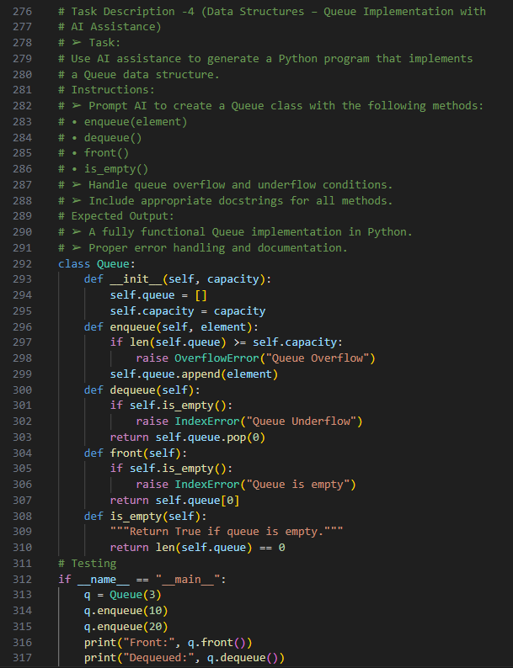
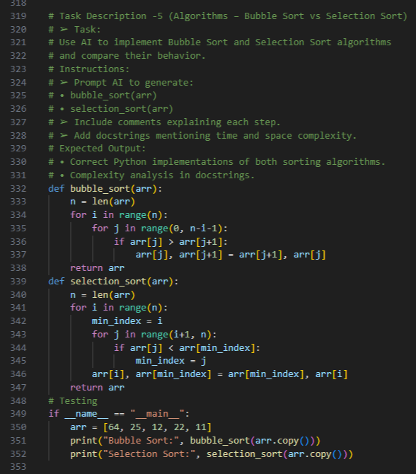

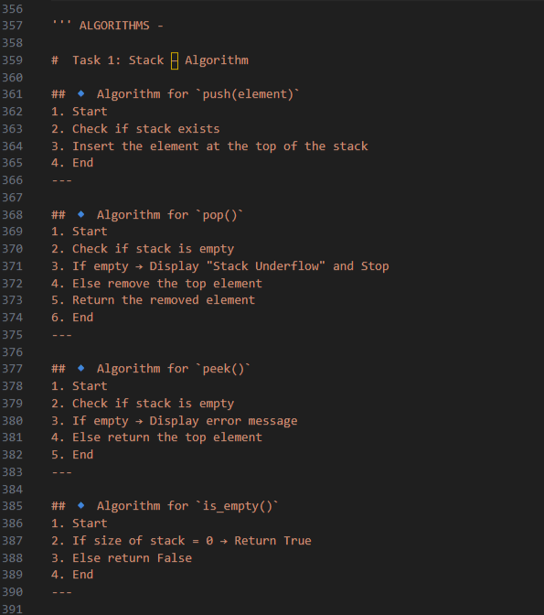

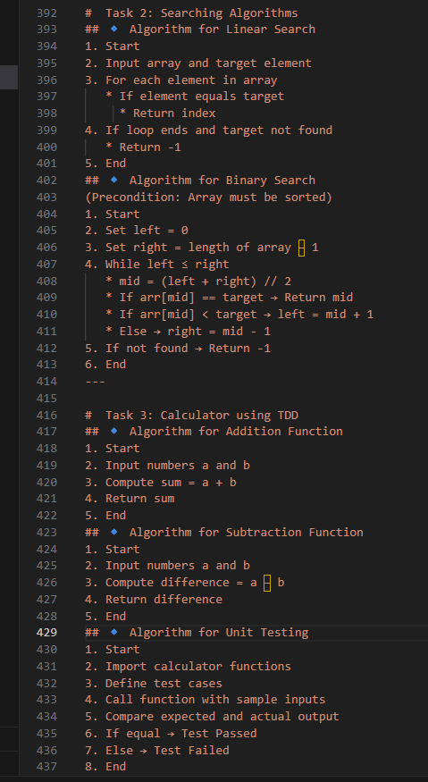
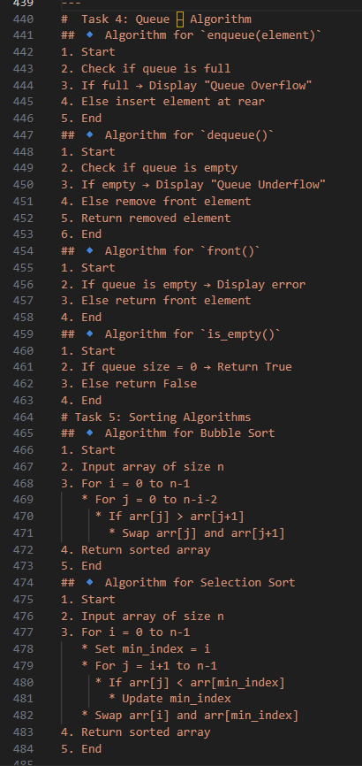

ANALYSIS:

Task 1: Stack Implementation – Analysis
The Stack follows the LIFO (Last In First Out) principle and provides constant time O(1) operations for push, pop, and peek. Proper underflow handling ensures reliability. It is useful in applications like expression evaluation and recursion.

Task 2: Linear vs Binary Search – Analysis
Linear Search works on both sorted and unsorted data but has O(n) time complexity. Binary Search is more efficient with O(log n) time complexity but requires sorted data. Binary Search is preferred for large datasets.

Task 3: Test Driven Development (Calculator) – Analysis
TDD improves code reliability by writing test cases before implementation. It ensures correctness and reduces debugging time. The calculator functions operate in constant time O(1).

Task 4: Queue Implementation – Analysis
The Queue follows the FIFO (First In First Out) principle. Enqueue is O(1), while dequeue is O(n) when using a list. Proper overflow and underflow handling improves robustness.

Task 5: Bubble Sort vs Selection Sort – Analysis
Both algorithms have O(n²) time complexity, making them inefficient for large datasets. Bubble Sort is stable and adaptive, while Selection Sort performs fewer swaps. They are mainly suitable for small datasets.

OUTPUT:

