Task Description #1 (AI-Based Code Completion for Loops)
Task: Use an AI code completion tool to generate a loop-based
program.
Prompt:
“Generate Python code to print all even numbers between 1 and N
using a loop.”
Expected Output:
• AI-generated loop logic.
• Identification of loop type used (for or while).
• Validation with sample inputs
CODE:
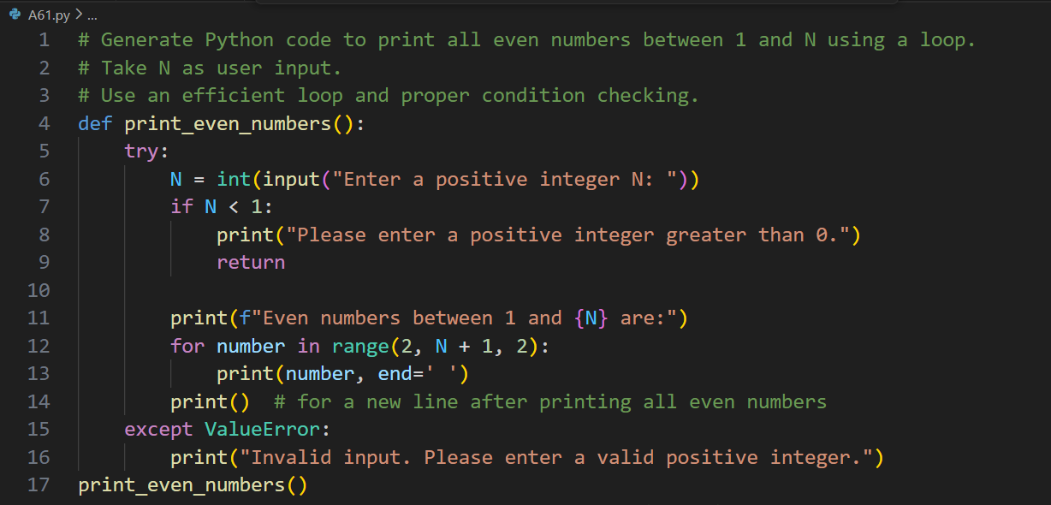
OUTPUT:
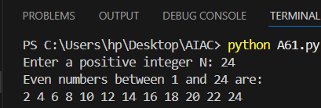
ANALYSIS:

Task 1: Loop – Even Numbers:

The program uses a loop to iterate from 1 to N and applies a conditional check to identify even numbers.
It demonstrates efficient looping logic and basic conditional filtering.

Task Description #2 (AI-Based Code Completion for Loop with

Conditionals)

Task: Use an AI code completion tool to combine loops and

conditionals.

Prompt:

“Generate Python code to count how many numbers in a list are even and odd.”

Expected Output:

• AI-generated code using loop and if condition.

• Correct count validation.

• Explanation of logic flow.

CODE:

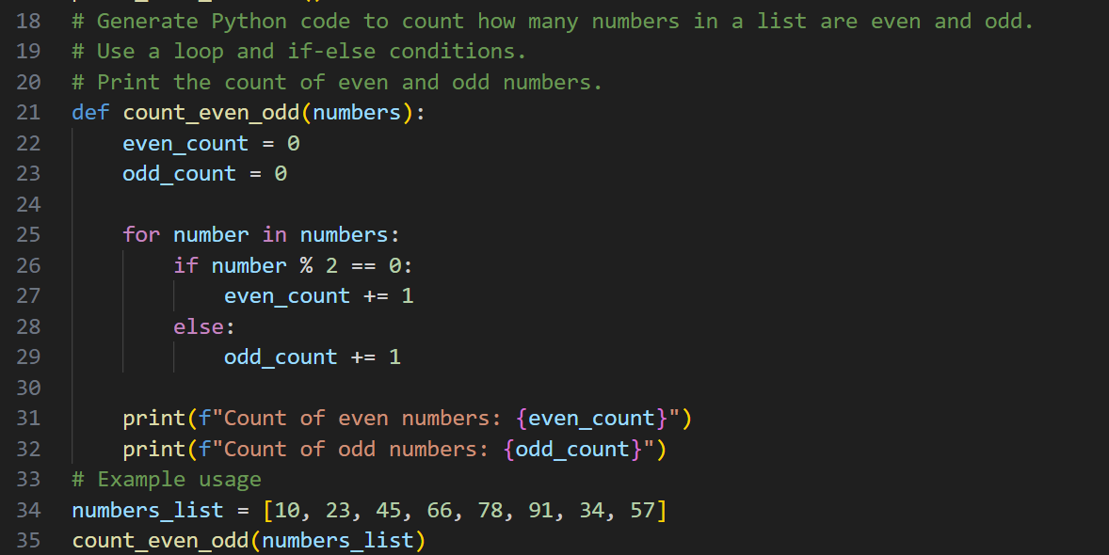

OUTPUT:

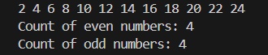
ANALYSIS:

Task 2: Loop with Conditionals (Even & Odd Count)
The code traverses a list using a loop and classifies each element as even or odd using if-else conditions.
It ensures accurate counting and reinforces decision-making within iterative structures.

Task Description #3 (AI-Based Code Completion for Class
Attributes Validation)
Task: Use an AI tool to complete a Python class that validates user
input.
Prompt:
“Generate a Python class User that validates age and email using
conditional statements.”
Expected Output:
• AI-generated class with validation logic.
• Verification of condition handling.
• Test cases for valid and invalid inputs.
CODE: 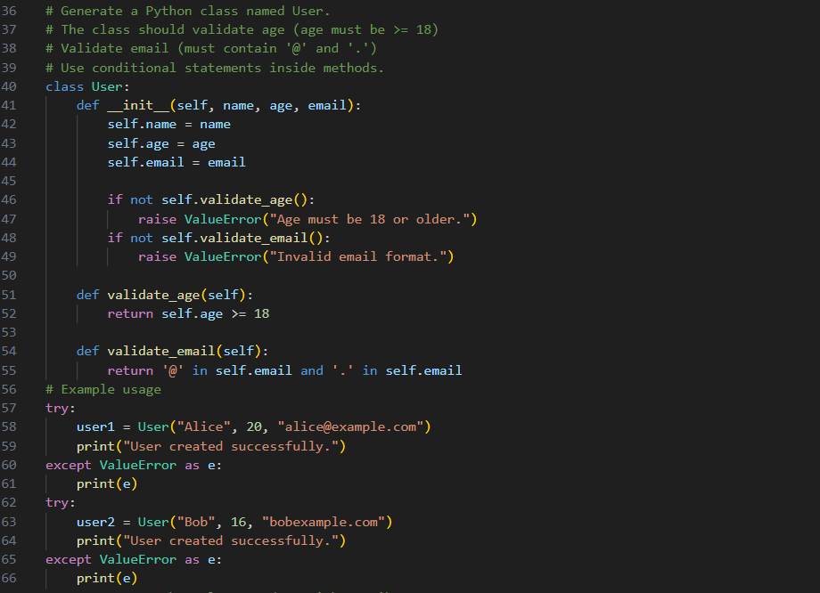
OUTPUT:
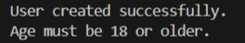
ANALYSIS:

Task 3: Class with Validation (User)
The class uses conditional statements to validate user age and email input.
It improves data integrity by preventing invalid values through logical checks.
Task Description #4 (AI-Based Code Completion for Classes)
Task: Use an AI code completion tool to generate a Python class for
managing student details.
Prompt:
“Generate a Python class Student with attributes (name, roll number, marks) and methods to calculate total and average marks.”
Expected Output:
• AI-generated class code.
• Verification of correctness and completeness of class
structure.
• Minor manual improvements (if needed) with justification.

CODE:
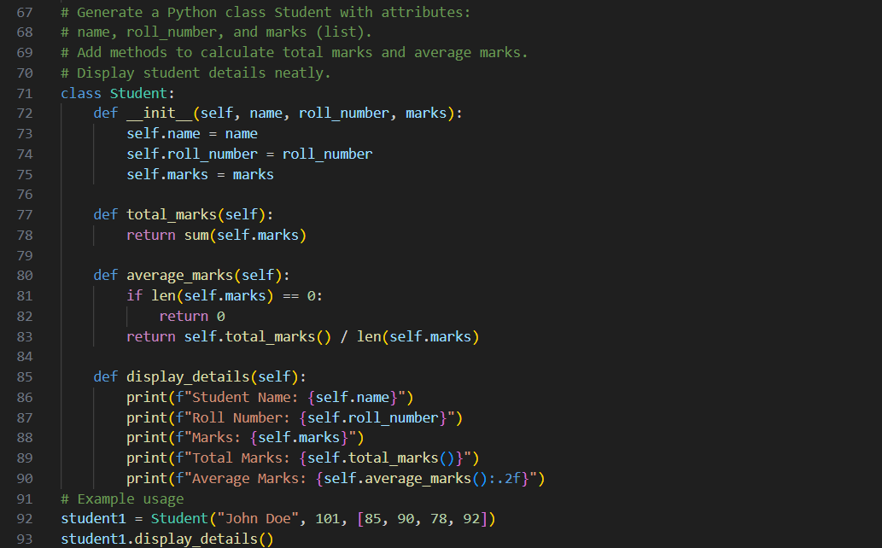
OUTPUT:
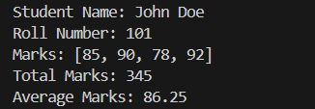
ANALYSIS:

Task 4: Class – Student Details
The student class encapsulates attributes and methods to compute total and average marks.
It demonstrates object-oriented principles such as data encapsulation and method abstraction.

Task Description 5 (AI-Assisted Code Completion Review)
Task: Use an AI tool to generate a complete Python program using
classes, loops, and conditionals together.
Prompt:
“Generate a Python program for a simple bank account system using class, loops, and conditional statements.”
Expected Output:
• Complete AI-generated program.
• Identification of strengths and limitations of AI suggestions.
• Reflection on how AI assisted coding productivity.

CODE:
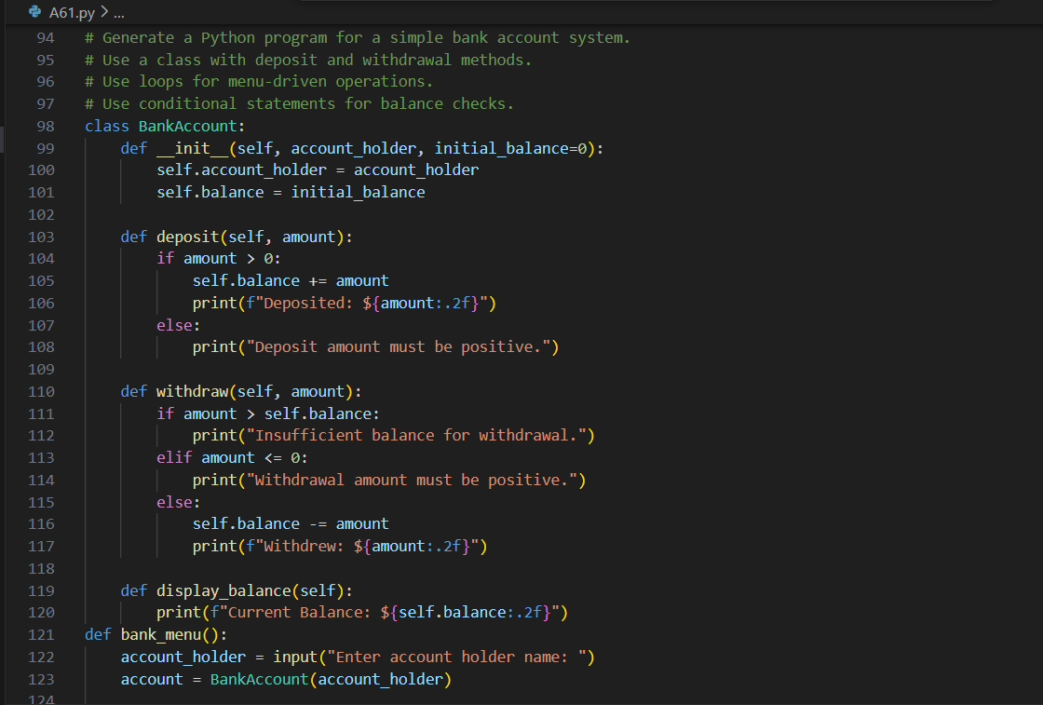
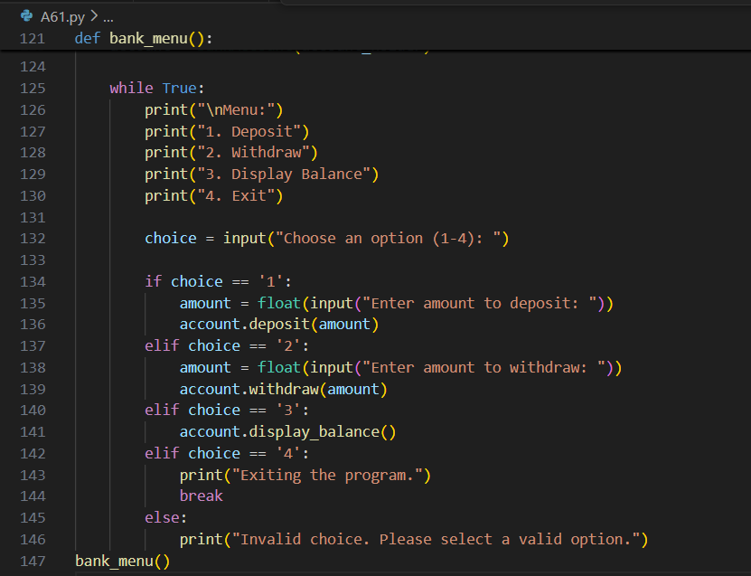

OUTPUT:
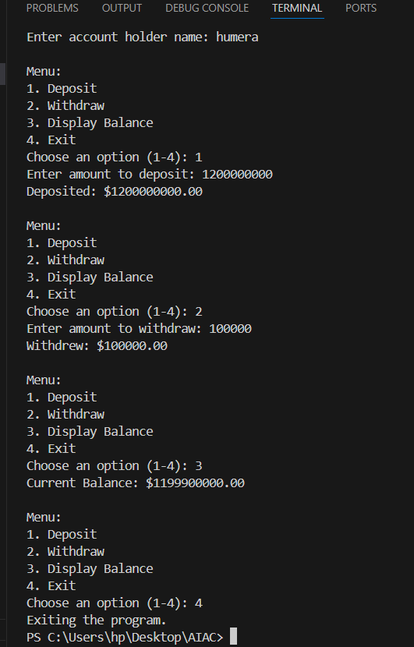

ANALYSIS:

Task 5: Bank Account System (Complete Program)
The program integrates classes, loops, and conditionals to simulate real-world banking operations.
It highlights how AI-assisted code can improve productivity while still requiring logical validation.
NAME: HUMERA NUZHAT
ROLL NO: 2303A52083
BATCH: 39

