AIAC-13.2 ASSIGNMENT
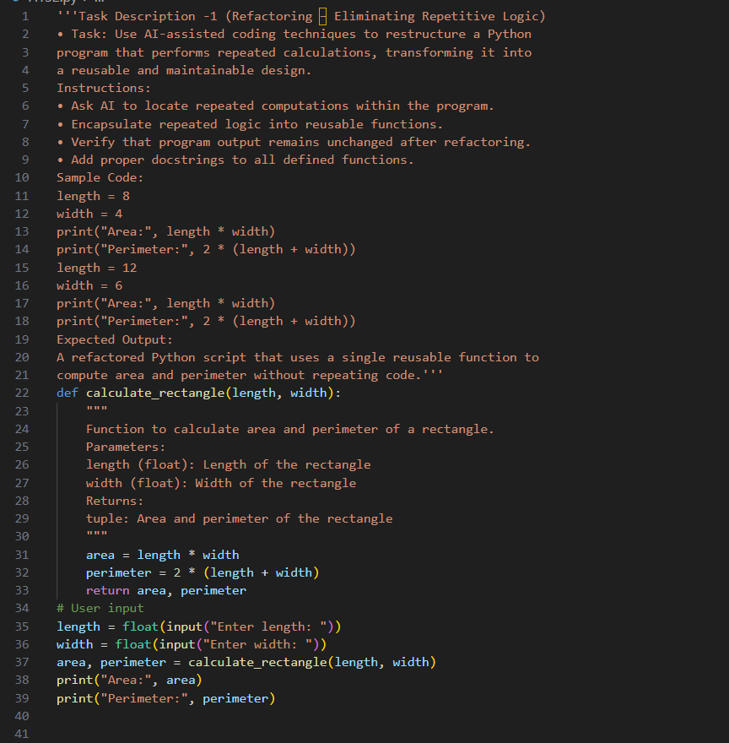

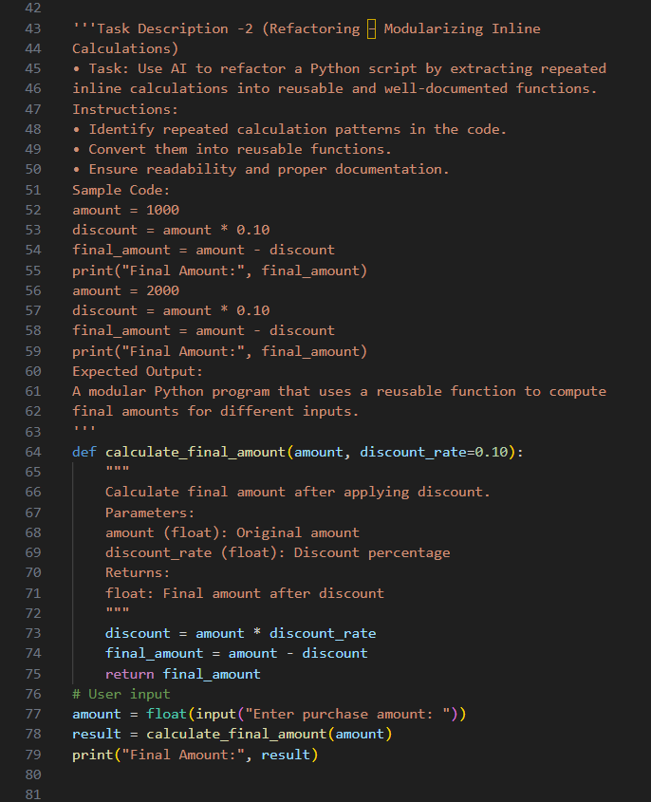

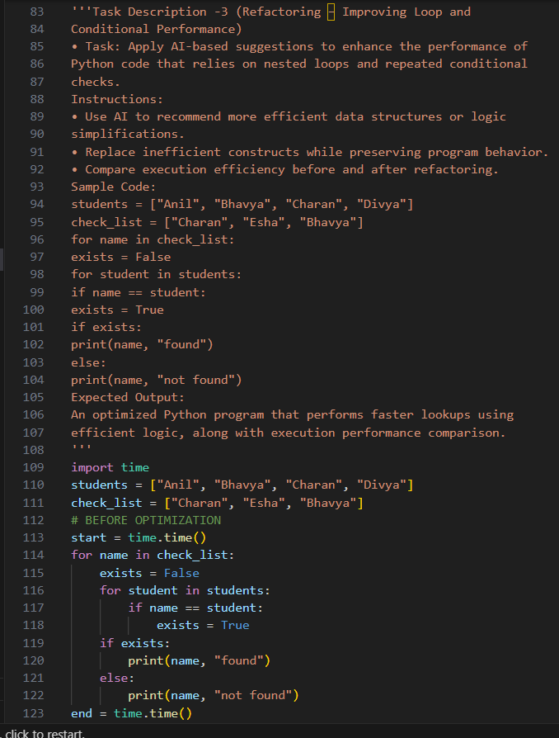
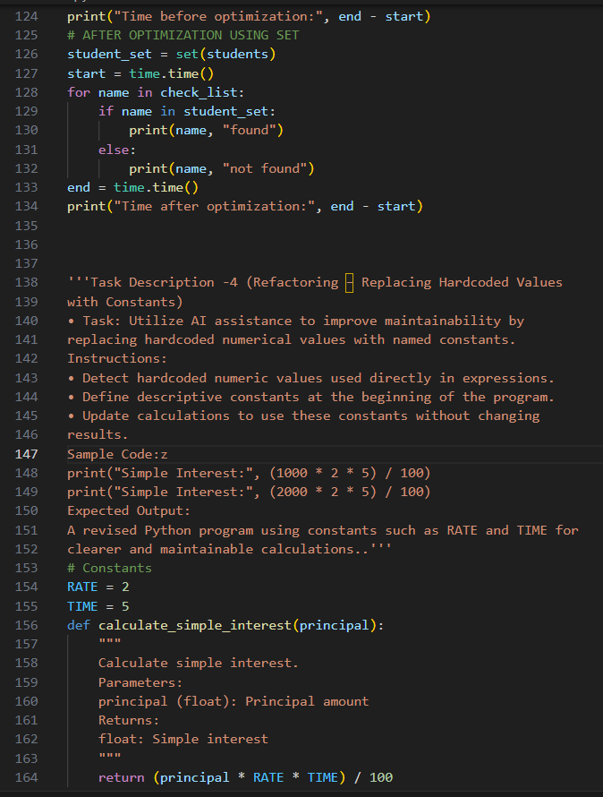
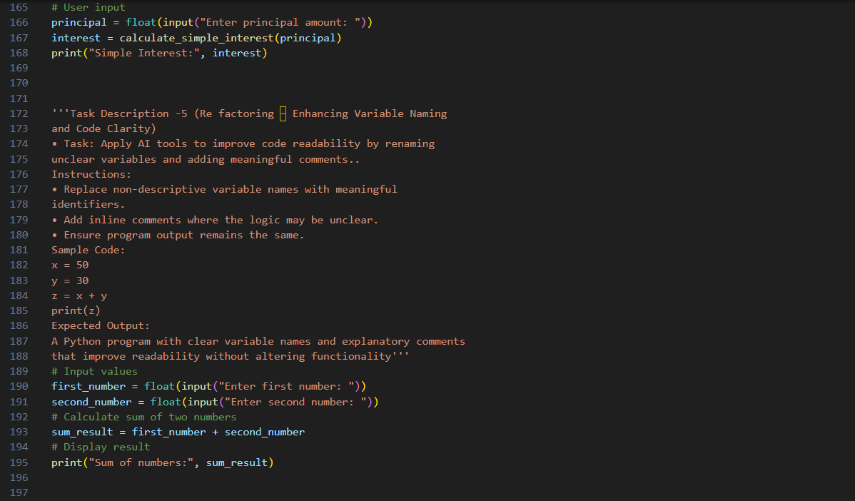
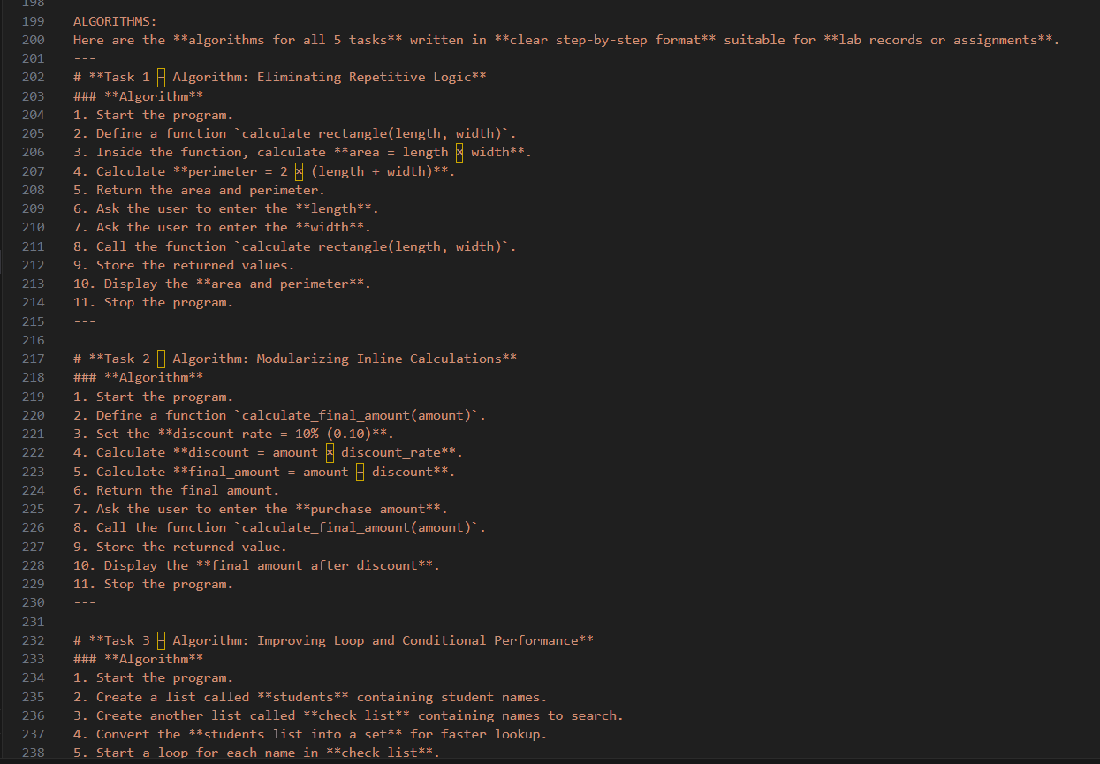
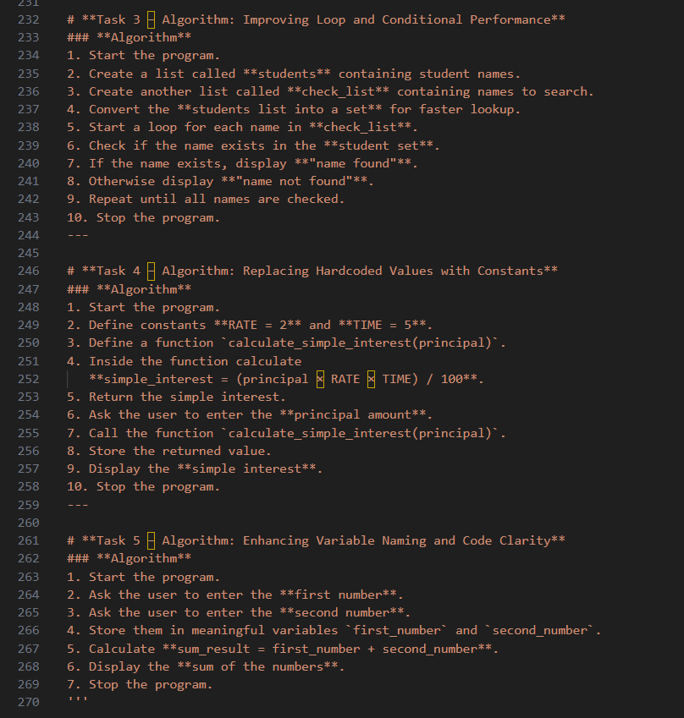

ANALYSIS:
Task 1 – Eliminating Repetitive Logic
The repeated calculations for area and perimeter were refactored into a reusable function to avoid code duplication.
This improves code readability, maintainability, and reusability.
Task 2 – Modularizing Inline Calculations
The repeated discount calculation was extracted into a function to make the code modular and organized.
This allows easy modification of the discount logic without changing multiple parts of the program.
Task 3 – Improving Loop and Conditional Performance
The nested loop used for searching was optimized using a set data structure for faster lookups.
This reduces time complexity and improves program performance.
Task 4 – Replacing Hardcoded Values with Constants
Hardcoded numerical values were replaced with named constants to make the program easier to understand.
This improves maintainability since changes can be made in one place.
Task 5 – Enhancing Variable Naming and Code Clarity
Unclear variable names were replaced with meaningful names and comments were added.
This improves readability and makes the program easier for developers to understand.

OUTPUT:
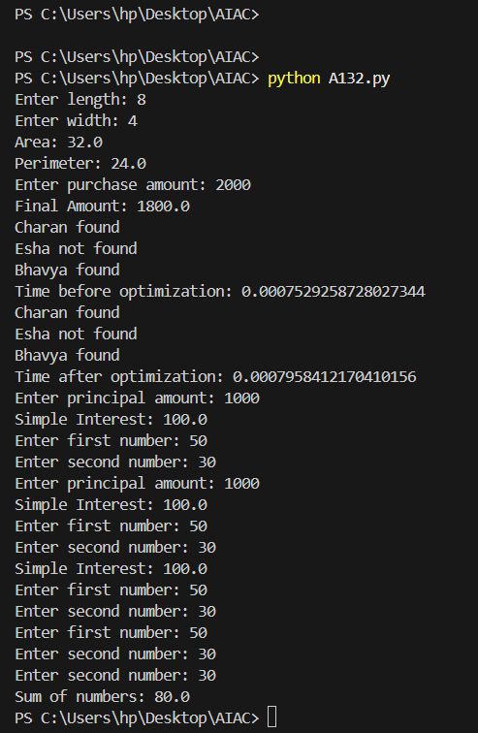

Humera Nuzhat
2303A52083
Batch 39

