Lab 18 – API Integration: Connecting to External Services with Error
Handling
Name: Humera Nuzhat
2303A52083
Batch 39
Task 1 – Weather API Integration
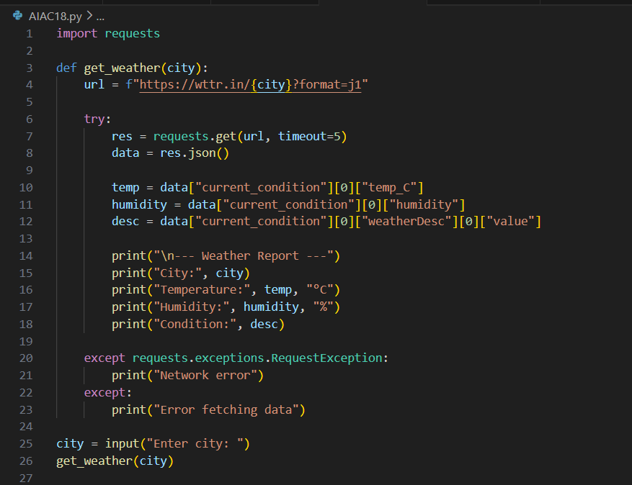

Task 2 – Currency Exchange Rates

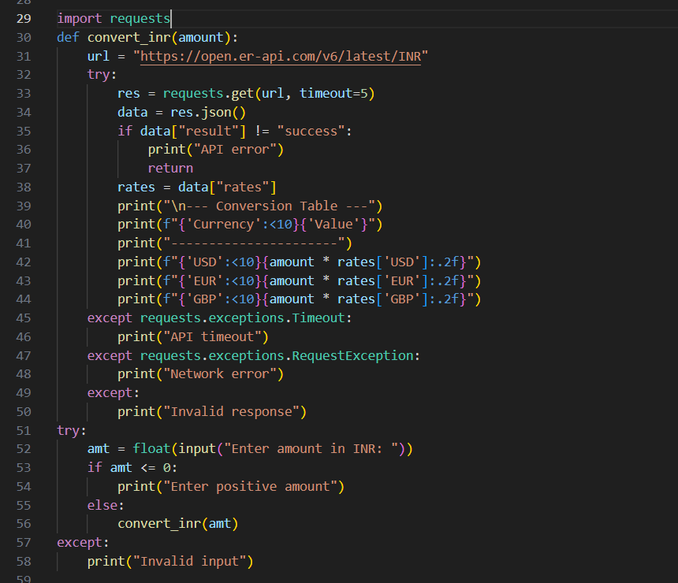

Task 3 – GitHub Repository Info Fetcher
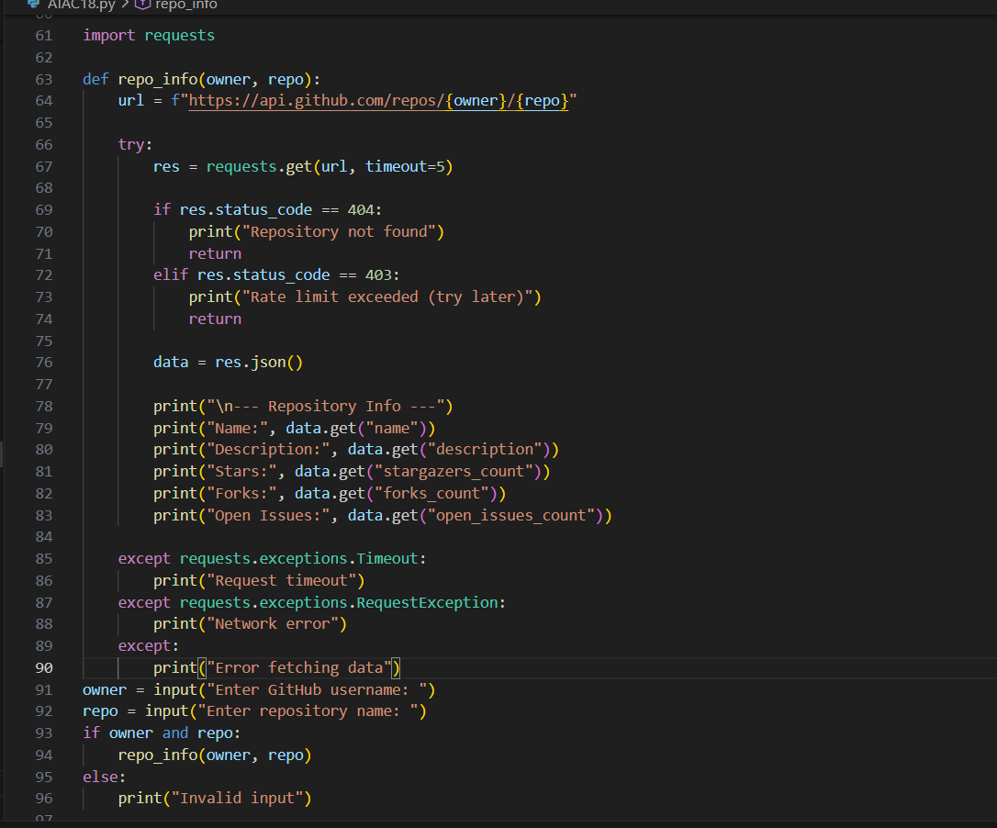

Task 4 – Real-Time Application: News Headlines Aggregator
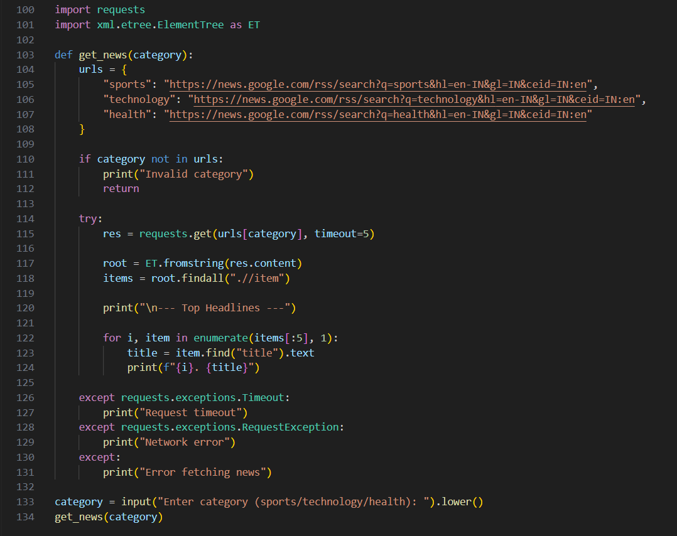

OUTPUT:
