Name: Humera Nuzhat
2303A52083
BATCH 39
AI ASSISTED CODING -14.1
Task 1 – Portfolio Website Design
You are building a personal portfolio website to showcase your
work.
Requirements:
• Create sections for About Me, Projects, and Contact.
• Use AI to:
o Suggest color palettes and typography.
o Create a responsive layout with Grid/Flexbox.
o Add smooth scrolling navigation.
Prompt: "Act as a Senior Frontend Developer. Create a single-page professional portfolio for Humera Nuzhat, a CSE student at SR University specializing in AI/ML.
- Sections: About Me, Projects (Web Dev, Python, DBMS), and Contact.
- Design: Use a 'Midnight Tech' theme with Slate (#0f172a) and Indigo (#6366f1).
- Layout: Use CSS Flexbox for the nav and CSS Grid for the project cards.
- Interactions: Add smooth scrolling and a scroll-reveal effect using JavaScript."
- <!DOCTYPE html>
- <html lang="en">
- <head>
- <meta charset="UTF-8">
- <meta name="viewport" content="width=device-width, initial-scale=1.0">
- <title>Humera Nuzhat | AI & ML Portfolio</title>
- <link href="https://cdn.jsdelivr.net/npm/remixicon@3.5.0/fonts/remixicon.css" rel="stylesheet">

- <style>
- /* --- AI-SUGGESTED TYPOGRAPHY & COLOR PALETTE --- */
- :root {
- --bg-dark: #0f172a; /* Deep Slate */
- --bg-card: #1e293b; /* Lighter Slate for cards */
- --accent-glow: #6366f1; /* Electric Indigo */
- --text-main: #f8fafc; /* Off-white */
- --text-dim: #94a3b8; /* Muted blue-grey */
- --white: #ffffff;
- }

- * {
- margin: 0;
- padding: 0;
- box-sizing: border-box;
- font-family: 'Segoe UI', Roboto, Helvetica, Arial, sans-serif;
- }

- html {
- scroll-behavior: smooth;
- }

- body {
- background-color: var(--bg-dark);
- color: var(--text-main);
- line-height: 1.6;
- }

- /* --- RESPONSIVE LAYOUT (FLEXBOX/GRID) --- */
- .container {
- max-width: 1100px;
- margin: 0 auto;
- padding: 0 2rem;
- }

- section {
- padding: 80px 0;
- }

- .section-title {
- font-size: 2.2rem;
- text-align: center;
- margin-bottom: 3rem;
- color: var(--white);
- }

- .section-title span {
- color: var(--accent-glow);
- }

- /* --- NAVIGATION --- */
- header {
- position: sticky;
- top: 0;
- background: rgba(15, 23, 42, 0.9);
- backdrop-filter: blur(12px);
- z-index: 1000;
- border-bottom: 1px solid rgba(255,255,255,0.05);
- }

- nav {
- display: flex;
- justify-content: space-between;
- align-items: center;
- height: 70px;
- }

- .logo {
- font-size: 1.5rem;
- font-weight: 800;
- letter-spacing: -1px;
- text-decoration: none;
- color: var(--white);
- }

- .logo span { color: var(--accent-glow); }

- .nav-links {
- display: flex;
- list-style: none;
- gap: 2.5rem;
- }

- .nav-links a {
- text-decoration: none;
- color: var(--text-dim);
- font-weight: 500;
- transition: 0.3s;
- }

- .nav-links a:hover {
- color: var(--accent-glow);
- }

- /* --- HERO SECTION --- */
- .hero {
- height: 70vh;
- display: flex;
- flex-direction: column;
- justify-content: center;
- align-items: center;
- text-align: center;
- background: radial-gradient(circle at center, #1e1b4b 0%, #0f172a 100%);
- }

- .hero h1 {
- font-size: 4rem;
- margin-bottom: 10px;
- background: linear-gradient(to right, #fff, #6366f1);
- -webkit-background-clip: text;
- -webkit-text-fill-color: transparent;
- }

- .hero p {
- font-size: 1.2rem;
- color: var(--text-dim);
- max-width: 600px;
- margin-bottom: 30px;
- }

- .btn {
- background: var(--accent-glow);
- color: var(--white);
- padding: 12px 32px;
- border-radius: 8px;
- text-decoration: none;
- font-weight: 600;
- transition: 0.3s;
- display: inline-block;
- }

- .btn:hover {
- transform: translateY(-3px);
- box-shadow: 0 10px 20px rgba(99, 102, 241, 0.3);
- }

- /* --- ABOUT SECTION --- */
- .about-box {
- background: var(--bg-card);
- padding: 40px;
- border-radius: 20px;
- border: 1px solid rgba(255,255,255,0.05);
- }

- .about-box p {
- margin-bottom: 20px;
- font-size: 1.1rem;
- color: var(--text-dim);
- }

- .about-box strong {
- color: var(--white);
- }

- /* --- PROJECTS GRID --- */
- .project-grid {
- display: grid;
- grid-template-columns: repeat(auto-fit, minmax(300px, 1fr));
- gap: 2rem;
- }

- .project-card {
- background: var(--bg-card);
- padding: 30px;
- border-radius: 16px;
- transition: 0.4s;
- border: 1px solid transparent;
- }

- .project-card:hover {
- border-color: var(--accent-glow);
- transform: translateY(-10px);
- }

- .project-card i {
- font-size: 2.5rem;
- color: var(--accent-glow);
- margin-bottom: 15px;
- display: block;
- }

- .project-card h3 {
- margin-bottom: 12px;
- color: var(--white);
- }

- .project-card p {
- font-size: 0.95rem;
- color: var(--text-dim);
- }

- /* --- CONTACT SECTION --- */
- .contact-content {
- display: flex;
- flex-direction: column;
- align-items: center;
- gap: 20px;
- }

- .contact-info {
- display: flex;
- gap: 30px;
- margin-bottom: 20px;
- flex-wrap: wrap;
- justify-content: center;
- }

- .info-item {
- display: flex;
- align-items: center;
- gap: 10px;
- color: var(--text-main);
- font-size: 1.1rem;
- }

- .info-item i { color: var(--accent-glow); font-size: 1.3rem; }

- .social-links {
- display: flex;
- gap: 20px;
- }

- .social-links a {
- color: var(--white);
- font-size: 1.5rem;
- transition: 0.3s;
- }

- .social-links a:hover {
- color: var(--accent-glow);
- transform: scale(1.2);
- }

- /* --- RESPONSIVE DESIGN --- */
- @media (max-width: 768px) {
- .hero h1 { font-size: 2.8rem; }
- .nav-links { display: none; } /* Simplified for lab */
- .project-grid { grid-template-columns: 1fr; }
- }
- </style>
- </head>
- <body>

- <header>
- <div class="container">
- <nav>
- <a href="#" class="logo">Humera<span>.</span></a>
- <ul class="nav-links">
- <li><a href="#home">Home</a></li>
- <li><a href="#about">About</a></li>
- <li><a href="#projects">Projects</a></li>
- <li><a href="#contact">Contact</a></li>
- </ul>
- </nav>
- </div>
- </header>

- <section id="home" class="hero">
- <div class="container">
- <h1>Humera Nuzhat</h1>
- <p>CSE Student | Specializing in AI & Machine Learning | SR University</p>
- <a href="#projects" class="btn">View My Portfolio</a>
- </div>
- </section>

- <section id="about" class="container">
- <h2 class="section-title">About <span>Me</span></h2>
- <div class="about-box">
- <p>
- I am a <strong>Computer Science Engineering student</strong> at <strong>SR University</strong>, specializing in the dynamic fields of <strong>Artificial Intelligence and Machine Learning</strong>.
- </p>
- <p>
- Beyond standard academics, I focus on the intersection of data science and software engineering. I have a keen interest in developing predictive models and high-performance applications that solve real-world problems. My goal is to leverage my technical foundation in DBMS, OS, and C programming to build next-generation intelligent systems.
- </p>
- </div>
- </section>

- <section id="projects" class="container">
- <h2 class="section-title">My <span>Projects</span></h2>
- <div class="project-grid">
- <div class="project-card">
- <i class="ri-html5-line"></i>
- <h3>Smart Task Manager</h3>
- <p>A sleek productivity tool developed using <strong>HTML, CSS, and JS</strong>. Implements local storage and event listeners for a seamless user experience.</p>
- </div>
- <div class="project-card">
- <i class="ri-terminal-box-line"></i>
- <h3>Trend Predictor</h3>
- <p>Utilized <strong>Python</strong> and Scikit-learn to analyze datasets and forecast market trends, focusing on data cleaning and feature engineering.</p>
- </div>
- <div class="project-card">
- <i class="ri-database-2-line"></i>
- <h3>Inventory DBMS</h3>
- <p>A robust backend system built with <strong>C and SQL</strong>. Manages complex stock data with optimized indexing and relational database design.</p>
- </div>
- </div>
- </section>

- <section id="contact" class="container">
- <h2 class="section-title">Contact <span>Me</span></h2>
- <div class="contact-content">
- <div class="contact-info">
- <div class="info-item">
- <i class="ri-phone-fill"></i> +91 87654321
- </div>
- <div class="info-item">
- <i class="ri-mail-fill"></i> 2303a52085@sru.edu.in
- </div>
- </div>
- <div class="social-links">
- <a href="https://linkedin.com/in/humera-nuzhat-fake"><i class="ri-linkedin-box-fill"></i></a>
- <a href="https://github.com/humera-nuzhat-fake"><i class="ri-github-fill"></i></a>
- </div>
- </div>
- </section>

- <script>
- // Smooth scrolling for navigation links
- document.querySelectorAll('.nav-links a, .btn').forEach(anchor => {
- anchor.addEventListener('click', function(e) {
- e.preventDefault();
- const targetId = this.getAttribute('href');
- document.querySelector(targetId).scrollIntoView({
- behavior: 'smooth'
- });
- });
- });
- </script>

- </body>
- </html>

OUTPUT:
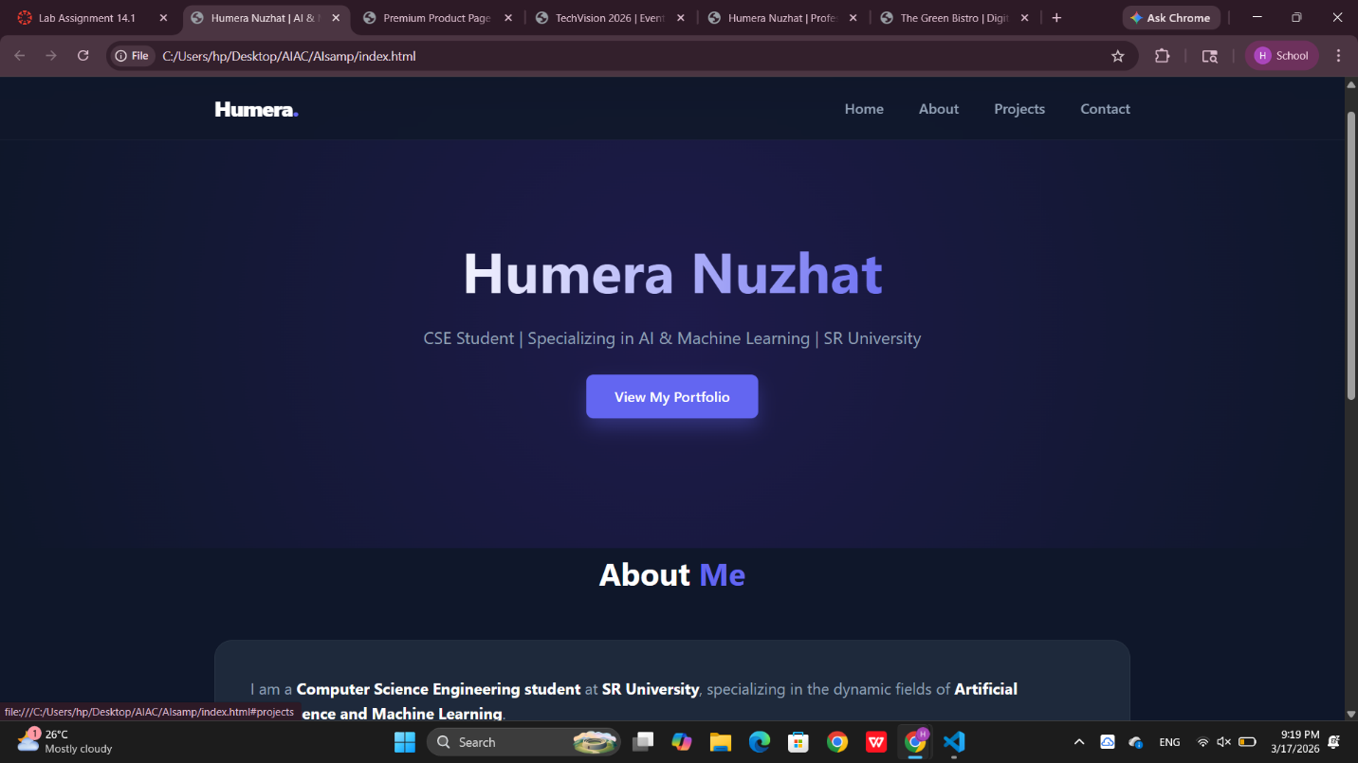
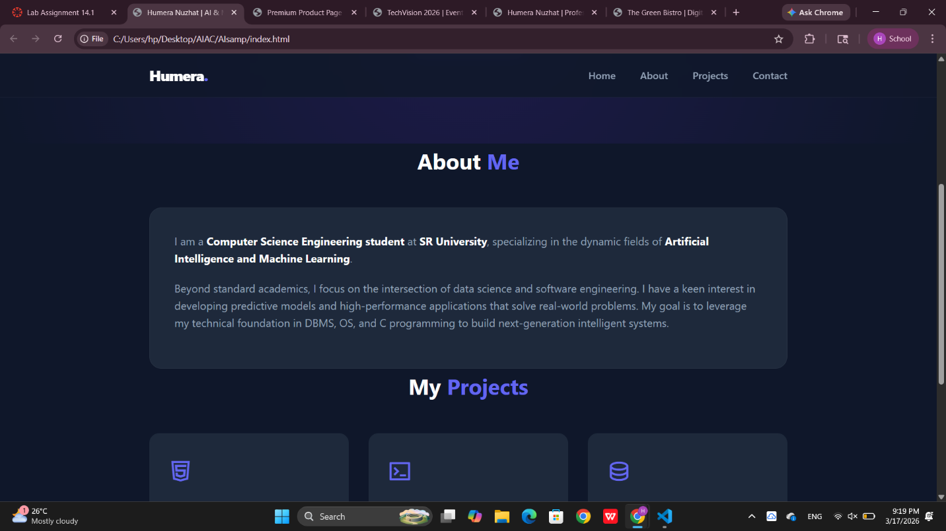
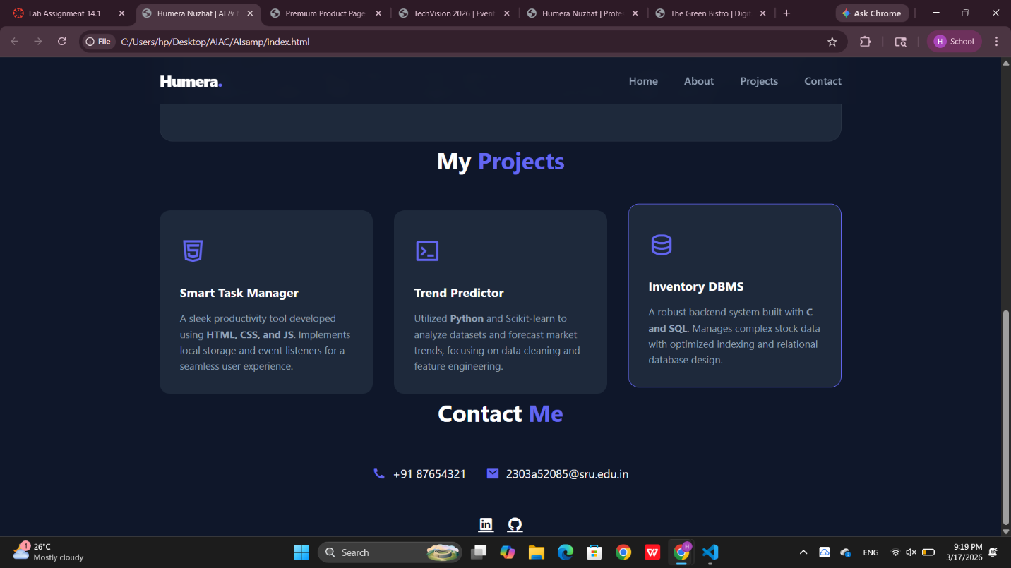
Task 2 – Online Store Product Page
Design a product display page for an online store.
Requirements:
• Display product image, title, price, and "Add to Cart" button.
• Use AI to:
o Style with BEM methodology.
o Make layout responsive.
o Add hover effects and "Add to Cart" alert
Prompt: "Design a premium e-commerce product display page.
- Elements: Include a high-quality product image, title, price, and 'Add to Cart' button.
- Methodology: Use the BEM (Block Element Modifier) naming convention for all CSS classes.
- Responsiveness: Use a media query to stack the image and text vertically on mobile.
- JS: Add an event listener to the button that shows a success alert when clicked.
- Effects: Add a subtle scale-up hover effect on the product image."
- <!DOCTYPE html>
- <html lang="en">
- <head>
- <meta charset="UTF-8">
- <meta name="viewport" content="width=device-width, initial-scale=1.0">
- <title>Premium Product Page | Online Store</title>
- <link href="https://cdn.jsdelivr.net/npm/remixicon@3.5.0/fonts/remixicon.css" rel="stylesheet">

- <style>
- /* --- BEM METHODOLOGY STYLING --- */
- :root {
- --color-primary: #2563eb;
- --color-dark: #1e293b;
- --color-light: #f8fafc;
- --color-accent: #f59e0b;
- --shadow: 0 10px 25px -5px rgba(0, 0, 0, 0.1);
- }

- * {
- margin: 0;
- padding: 0;
- box-sizing: border-box;
- font-family: 'Inter', sans-serif;
- }

- body {
- background-color: #f1f5f9;
- display: flex;
- justify-content: center;
- align-items: center;
- min-height: 100vh;
- padding: 20px;
- }

- /* BLOCK: Product Card */
- .product-card {
- background: white;
- max-width: 900px;
- width: 100%;
- display: flex; /* Flexbox for responsive side-by-side layout */
- border-radius: 20px;
- overflow: hidden;
- box-shadow: var(--shadow);
- transition: transform 0.3s ease;
- }

- /* ELEMENT: Product Card Image Section */
- .product-card__image-wrapper {
- flex: 1;
- background-color: #e2e8f0;
- display: flex;
- justify-content: center;
- align-items: center;
- padding: 40px;
- position: relative;
- }

- .product-card__image {
- max-width: 100%;
- height: auto;
- object-fit: contain;
- transition: transform 0.5s ease;
- }

- /* MODIFIER: Hover effect on image */
- .product-card:hover .product-card__image {
- transform: scale(1.1) rotate(-2deg);
- }

- /* ELEMENT: Content Section */
- .product-card__content {
- flex: 1;
- padding: 50px;
- display: flex;
- flex-direction: column;
- justify-content: center;
- }

- .product-card__category {
- text-transform: uppercase;
- font-size: 0.8rem;
- font-weight: 700;
- color: var(--color-primary);
- letter-spacing: 1px;
- margin-bottom: 10px;
- }

- .product-card__title {
- font-size: 2.5rem;
- color: var(--color-dark);
- line-height: 1.1;
- margin-bottom: 15px;
- }

- .product-card__description {
- color: #64748b;
- margin-bottom: 25px;
- font-size: 1rem;
- }

- .product-card__price-tag {
- font-size: 1.8rem;
- font-weight: 800;
- color: var(--color-dark);
- margin-bottom: 30px;
- }

- /* ELEMENT: Button */
- .product-card__button {
- background-color: var(--color-dark);
- color: white;
- border: none;
- padding: 16px 32px;
- border-radius: 12px;
- font-size: 1.1rem;
- font-weight: 600;
- cursor: pointer;
- display: flex;
- align-items: center;
- justify-content: center;
- gap: 10px;
- transition: all 0.3s ease;
- }

- /* MODIFIER: Button Hover */
- .product-card__button:hover {
- background-color: var(--color-primary);
- box-shadow: 0 10px 15px -3px rgba(37, 99, 235, 0.4);
- transform: translateY(-2px);
- }

- .product-card__button:active {
- transform: translateY(0);
- }

- /* --- RESPONSIVE LAYOUT --- */
- @media (max-width: 768px) {
- .product-card {
- flex-direction: column; /* Stack image on top of text on mobile */
- }

- .product-card__content {
- padding: 30px;
- }

- .product-card__title {
- font-size: 1.8rem;
- }
- }
- </style>
- </head>
- <body>

- <main class="product-card">

- <div class="product-card__image-wrapper">
- <img src="https://images.unsplash.com/photo-1505740420928-5e560c06d30e?auto=format&fit=crop&w=600&q=80"
- alt="Premium Headphones"
- class="product-card__image">
- </div>

- <div class="product-card__content">
- <span class="product-card__category">Audio Tech</span>
- <h1 class="product-card__title">Sonic Pro Wireless</h1>
- <p class="product-card__description">
- Experience studio-quality sound with active noise cancellation and 40-hour battery life. Designed for comfort, built for performance.
- </p>
- <div class="product-card__price-tag">$299.00</div>

- <button class="product-card__button" id="addToCartBtn">
- <i class="ri-shopping-cart-line"></i> Add to Cart
- </button>
- </div>
- </main>

- <script>
- // JS Requirement: Add to Cart Alert
- const cartBtn = document.getElementById('addToCartBtn');

- cartBtn.addEventListener('click', () => {
- // Visual feedback on the button
- cartBtn.innerHTML = '<i class="ri-check-line"></i> Added!';
- cartBtn.style.backgroundColor = '#10b981'; // Success Green

- // Professional Alert
- setTimeout(() => {
- alert('Success! Sonic Pro Wireless has been added to your cart.');
- // Reset button
- cartBtn.innerHTML = '<i class="ri-shopping-cart-line"></i> Add to Cart';
- cartBtn.style.backgroundColor = '';
- }, 500);
- });
- </script>

- </body>
- </html>

OUTPUT:
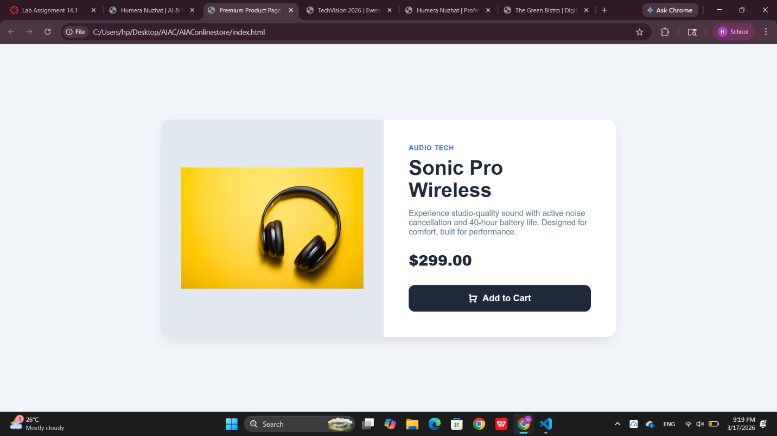
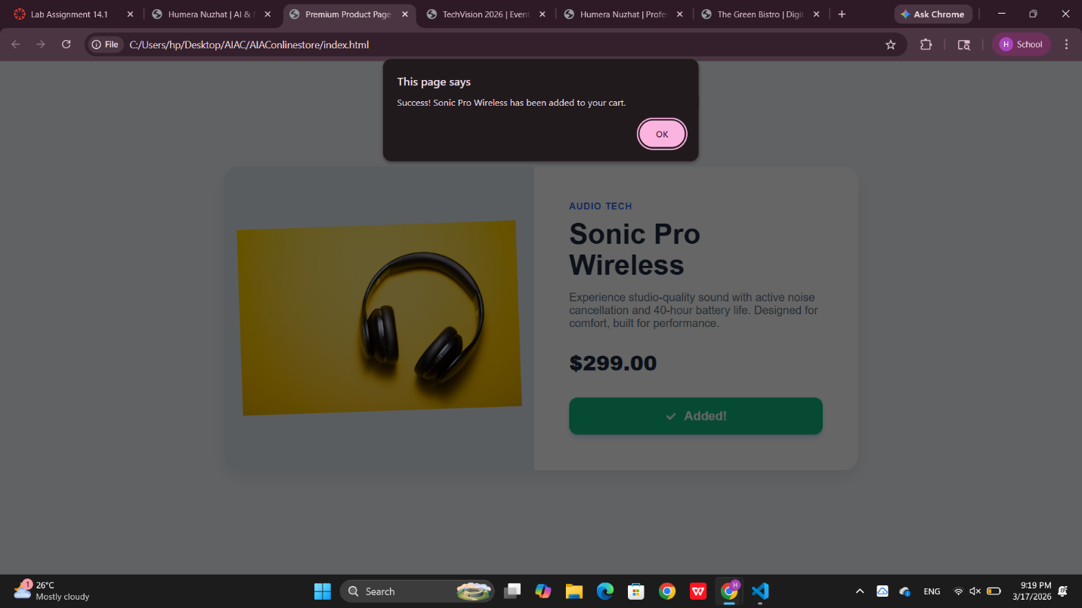
Task 3 – Event Registration Form
Build an event registration form for a conference.
Requirements:
• Collect name, email, phone number, and session selection.
• Use AI to:
o Add form validation with JavaScript.
o Make the form accessible with labels and ARIA.
o Style with a professional look
Prompt: "Build a professional event registration form for a tech conference.
- Fields: Full Name, Email, Phone Number, and a dropdown for Session Selection.
- Accessibility: Ensure the form is accessible by using proper <label> tags and ARIA attributes (aria-required, aria-live, aria-describedby).
- Validation: Write a JavaScript function to validate that the email is in the correct format and the phone number is 10 digits before allowing submission.
- Style: Use a clean, corporate look with clear error messages in red."
- <!DOCTYPE html>
- <html lang="en">
- <head>
- <meta charset="UTF-8">
- <meta name="viewport" content="width=device-width, initial-scale=1.0">
- <title>TechVision 2026 | Event Registration</title>
- <style>
- /* --- PROFESSIONAL THEME --- */
- :root {
- --primary-blue: #1e40af;
- --error-red: #dc2626;
- --success-green: #16a34a;
- --input-border: #cbd5e1;
- --bg-light: #f8fafc;
- }

- * {
- box-sizing: border-box;
- margin: 0;
- padding: 0;
- font-family: 'Segoe UI', system-ui, sans-serif;
- }

- body {
- background-color: var(--bg-light);
- display: flex;
- justify-content: center;
- align-items: center;
- min-height: 100vh;
- padding: 20px;
- }

- .form-container {
- background: white;
- padding: 40px;
- border-radius: 12px;
- box-shadow: 0 10px 25px rgba(0,0,0,0.05);
- max-width: 500px;
- width: 100%;
- }

- header {
- text-align: center;
- margin-bottom: 30px;
- }

- header h1 {
- color: #0f172a;
- font-size: 1.8rem;
- margin-bottom: 8px;
- }

- header p {
- color: #64748b;
- font-size: 0.9rem;
- }

- /* --- ACCESSIBLE FORM ELEMENTS --- */
- .form-group {
- margin-bottom: 20px;
- position: relative;
- }

- label {
- display: block;
- margin-bottom: 8px;
- font-weight: 600;
- color: #334155;
- font-size: 0.9rem;
- }

- input, select {
- width: 100%;
- padding: 12px;
- border: 1px solid var(--input-border);
- border-radius: 6px;
- font-size: 1rem;
- transition: all 0.3s ease;
- background-color: white;
- }

- input:focus, select:focus {
- outline: none;
- border-color: var(--primary-blue);
- box-shadow: 0 0 0 3px rgba(30, 64, 175, 0.1);
- }

- /* Error States */
- .form-group.error input {
- border-color: var(--error-red);
- }

- .error-message {
- color: var(--error-red);
- font-size: 0.8rem;
- margin-top: 5px;
- display: none; /* Hidden by default */
- }

- .form-group.error .error-message {
- display: block;
- }

- .submit-btn {
- width: 100%;
- background-color: var(--primary-blue);
- color: white;
- padding: 14px;
- border: none;
- border-radius: 6px;
- font-size: 1rem;
- font-weight: 600;
- cursor: pointer;
- transition: background 0.3s;
- margin-top: 10px;
- }

- .submit-btn:hover {
- background-color: #1e3a8a;
- }

- .submit-btn:disabled {
- background-color: #94a3b8;
- cursor: not-allowed;
- }
- </style>
- </head>
- <body>

- <div class="form-container">
- <header>
- <h1>Conference Registration</h1>
- <p>Secure your spot for TechVision 2026</p>
- </header>

- <form id="registrationForm" novalidate aria-label="Event Registration Form">

- <div class="form-group" id="nameGroup">
- <label for="fullName">Full Name</label>
- <input type="text" id="fullName" name="fullName"
- placeholder="e.g. Humera Nuzhat"
- aria-required="true"
- aria-describedby="nameError">
- <span class="error-message" id="nameError" aria-live="polite">Please enter your full name.</span>
- </div>

- <div class="form-group" id="emailGroup">
- <label for="email">Email Address</label>
- <input type="email" id="email" name="email"
- placeholder="name@example.com"
- aria-required="true"
- aria-describedby="emailError">
- <span class="error-message" id="emailError" aria-live="polite">Please enter a valid email address.</span>
- </div>

- <div class="form-group" id="phoneGroup">
- <label for="phone">Phone Number</label>
- <input type="tel" id="phone" name="phone"
- placeholder="+91 0000000000"
- aria-required="true"
- aria-describedby="phoneError">
- <span class="error-message" id="phoneError" aria-live="polite">Please enter a 10-digit phone number.</span>
- </div>

- <div class="form-group" id="sessionGroup">
- <label for="session">Select a Session</label>
- <select id="session" name="session" aria-required="true" aria-describedby="sessionError">
- <option value="">-- Choose a session --</option>
- <option value="ai-ml">Artificial Intelligence & ML</option>
- <option value="web-tech">Advanced Web Technologies</option>
- <option value="cloud">Cloud Computing & Dev Ops</option>
- </select>
- <span class="error-message" id="sessionError" aria-live="polite">Please select a session to attend.</span>
- </div>

- <button type="submit" class="submit-btn">Register Now</button>
- </form>
- </div>

- <script>
- const form = document.getElementById('registrationForm');

- form.addEventListener('submit', (e) => {
- e.preventDefault();
- let isValid = true;

- // Reset previous errors
- document.querySelectorAll('.form-group').forEach(group => group.classList.remove('error'));

- // 1. Name Validation
- const nameInput = document.getElementById('fullName');
- if (nameInput.value.trim().length < 2) {
- showError('nameGroup');
- isValid = false;
- }

- // 2. Email Validation (Regex)
- const emailInput = document.getElementById('email');
- const emailPattern = /^[^\s@]+@[^\s@]+\.[^\s@]+$/;
- if (!emailPattern.test(emailInput.value)) {
- showError('emailGroup');
- isValid = false;
- }

- // 3. Phone Validation (Simple 10 digit)
- const phoneInput = document.getElementById('phone');
- if (phoneInput.value.trim().length < 10) {
- showError('phoneGroup');
- isValid = false;
- }

- // 4. Session Validation
- const sessionInput = document.getElementById('session');
- if (sessionInput.value === "") {
- showError('sessionGroup');
- isValid = false;
- }

- if (isValid) {
- alert('Success! Registration submitted for ' + nameInput.value);
- form.reset();
- }
- });

- function showError(groupId) {
- document.getElementById(groupId).classList.add('error');
- }
- </script>
- </body>
- </html>
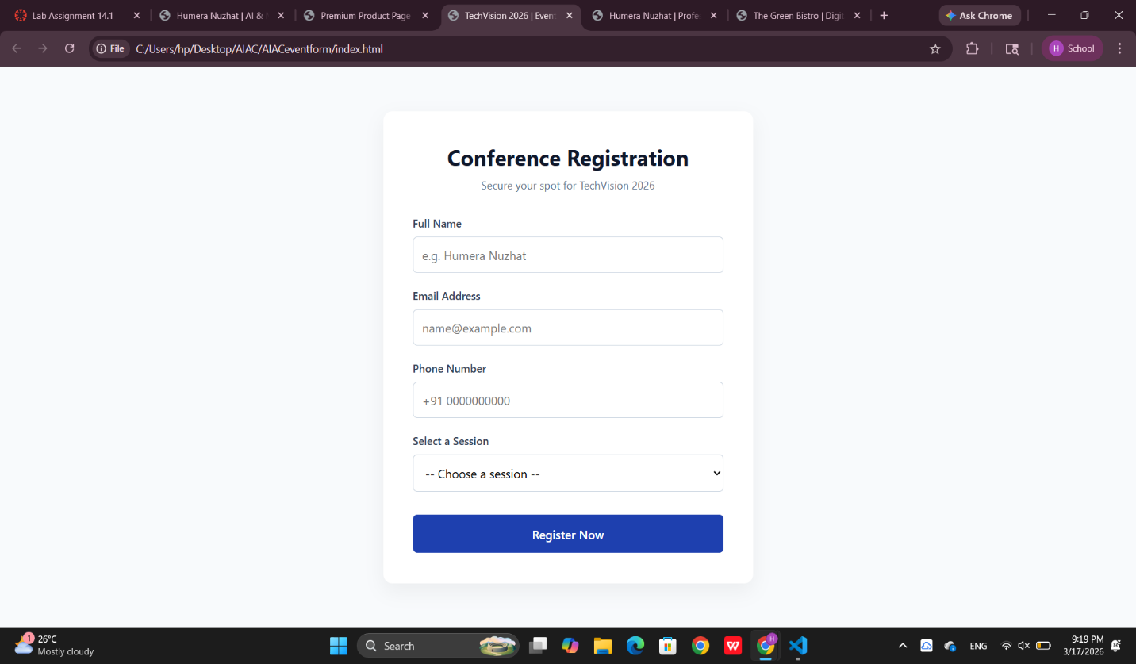
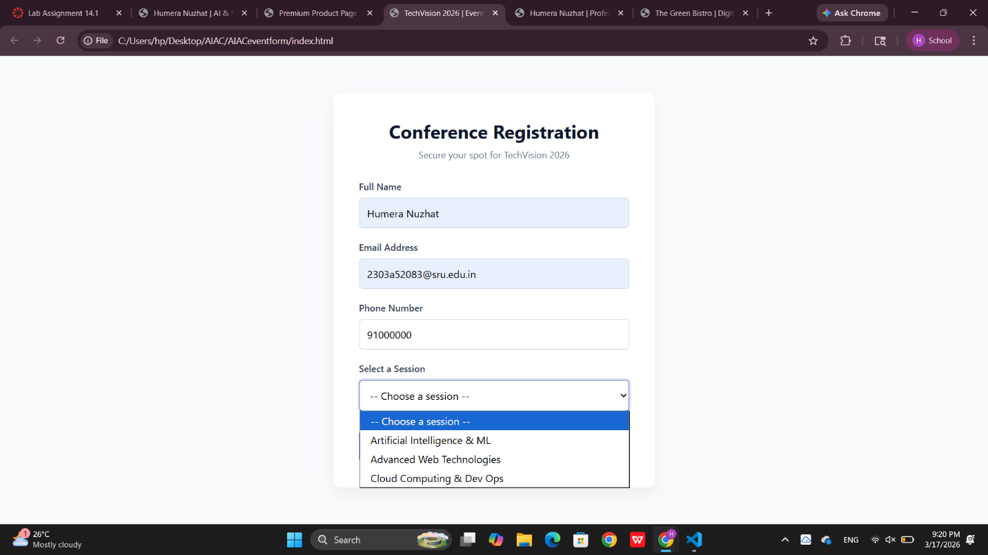
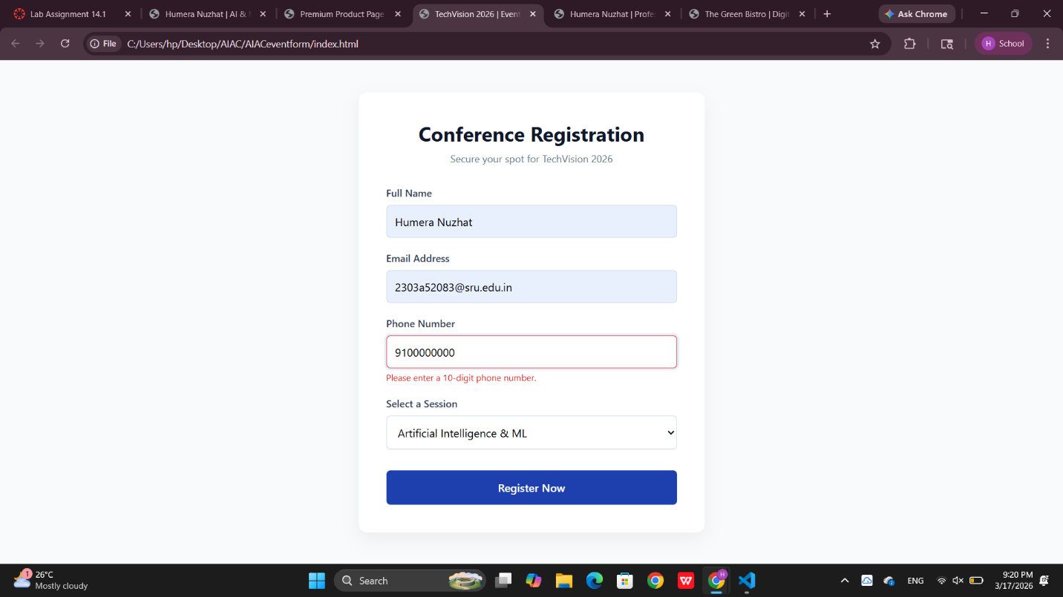
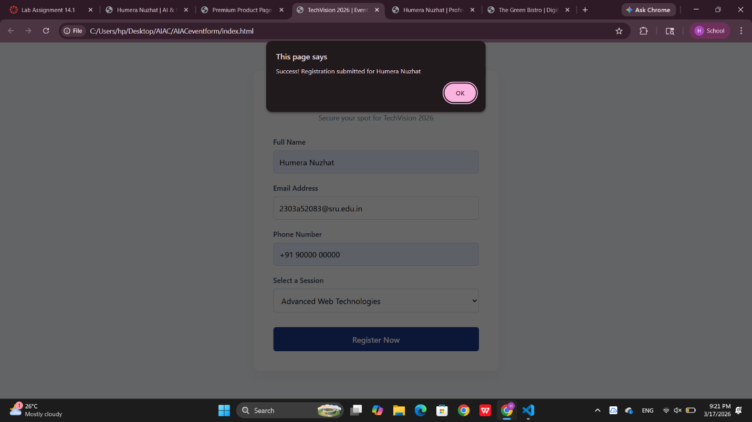
Task 4 – Resume Website
Build a one-page online resume.
Requirements:
• Sections: Profile Summary, Skills, Education, Experience.
• Use AI to:
o Propose professional typography styles.
o Align sections using CSS Grid.
o Add smooth scroll navigation between sections.
Prompt: "Generate a one-page online resume using a sophisticated 'Executive' layout.
- Typography: Suggest a pairing of 'Playfair Display' for headings and 'Inter' for body text.
- Layout: Use CSS Grid to create a two-column layout (Sidebar for Skills/Education, Main for Summary/Experience).
- Navigation: Create a sticky header with links that use smooth-scroll to jump to specific sections.
- Responsive: Ensure the grid collapses to a single column on screens smaller than 768px."
- <!DOCTYPE html>
- <html lang="en">
- <head>
- <meta charset="UTF-8">
- <meta name="viewport" content="width=device-width, initial-scale=1.0">
- <title>Humera Nuzhat | Professional Resume</title>

- <link href="https://fonts.googleapis.com/css2?family=Inter:wght@300;400;600&family=Playfair+Display:wght@700&display=swap" rel="stylesheet">
- <link href="https://cdn.jsdelivr.net/npm/remixicon@3.5.0/fonts/remixicon.css" rel="stylesheet">

- <style>
- :root {
- --primary: #1e293b; /* Slate 800 */
- --accent: #0f172a; /* Slate 900 */
- --text: #334155; /* Slate 600 */
- --light-bg: #f8fafc;
- --border: #e2e8f0;
- }

- * {
- margin: 0;
- padding: 0;
- box-sizing: border-box;
- }

- html {
- scroll-behavior: smooth;
- }

- body {
- font-family: 'Inter', sans-serif;
- color: var(--text);
- background-color: #ffffff;
- line-height: 1.7;
- }

- /* --- STICKY NAVIGATION --- */
- .resume-nav {
- position: sticky;
- top: 0;
- background: white;
- border-bottom: 1px solid var(--border);
- z-index: 100;
- padding: 1rem 0;
- }

- .nav-container {
- max-width: 1000px;
- margin: 0 auto;
- display: flex;
- justify-content: center;
- gap: 2rem;
- }

- .nav-container a {
- text-decoration: none;
- color: var(--primary);
- font-weight: 600;
- font-size: 0.9rem;
- text-transform: uppercase;
- letter-spacing: 1px;
- transition: 0.3s;
- }

- .nav-container a:hover {
- color: #6366f1;
- }

- /* --- CSS GRID MAIN LAYOUT --- */
- .resume-wrapper {
- max-width: 1000px;
- margin: 40px auto;
- display: grid;
- grid-template-columns: 1fr 2fr; /* Sidebar 1 part, Content 2 parts */
- gap: 60px;
- padding: 0 20px;
- }

- h1, h2, h3 {
- font-family: 'Playfair Display', serif;
- color: var(--accent);
- }

- .profile-header {
- grid-column: 1 / -1; /* Header spans full width */
- text-align: center;
- padding-bottom: 40px;
- border-bottom: 2px solid var(--primary);
- margin-bottom: 40px;
- }

- .profile-header h1 { font-size: 3.5rem; margin-bottom: 10px; }

- /* --- SECTIONS --- */
- .section-title {
- font-size: 1.5rem;
- margin-bottom: 20px;
- display: flex;
- align-items: center;
- gap: 10px;
- border-bottom: 1px solid var(--border);
- padding-bottom: 5px;
- }

- .sidebar-section {
- margin-bottom: 40px;
- }

- .skills-list {
- list-style: none;
- }

- .skills-list li {
- background: var(--light-bg);
- margin-bottom: 8px;
- padding: 8px 15px;
- border-radius: 4px;
- font-size: 0.9rem;
- border-left: 3px solid var(--primary);
- }

- .experience-item, .education-item {
- margin-bottom: 30px;
- }

- .date {
- font-size: 0.85rem;
- font-weight: 600;
- color: #6366f1;
- }

- .job-title {
- font-size: 1.2rem;
- font-weight: 700;
- color: var(--accent);
- }

- /* --- RESPONSIVE --- */
- @media (max-width: 768px) {
- .resume-wrapper {
- grid-template-columns: 1fr; /* Stack into 1 column */
- }
- .profile-header h1 { font-size: 2.5rem; }
- .nav-container { gap: 1rem; flex-wrap: wrap; }
- }
- </style>
- </head>
- <body>

- <nav class="resume-nav">
- <div class="nav-container">
- <a href="#summary">Profile</a>
- <a href="#skills">Skills</a>
- <a href="#education">Education</a>
- <a href="#experience">Experience</a>
- </div>
- </nav>

- <div class="resume-wrapper">
- <header class="profile-header">
- <h1>Humera Nuzhat</h1>
- <p>Artificial Intelligence & Machine Learning Student</p>
- </header>

- <aside class="sidebar">
- <section id="skills" class="sidebar-section">
- <h2 class="section-title"><i class="ri-tools-fill"></i> Skills</h2>
- <ul class="skills-list">
- <li>Python & C Programming</li>
- <li>Machine Learning Algorithms</li>
- <li>Database Management (SQL)</li>
- <li>Frontend (HTML/CSS/JS)</li>
- <li>Data Visualization</li>
- </ul>
- </section>

- <section id="education" class="sidebar-section">
- <h2 class="section-title"><i class="ri-book-open-fill"></i> Education</h2>
- <div class="education-item">
- <p class="date">2023 - Present</p>
- <p class="job-title">B.Tech in CSE (AI & ML)</p>
- <p>SR University</p>
- </div>
- </section>
- </aside>

- <main class="content">
- <section id="summary" class="sidebar-section">
- <h2 class="section-title"><i class="ri-user-4-fill"></i> Profile Summary</h2>
- <p>
- Ambitious Computer Science student at SR University with a specialized focus on AI/ML.
- Proven ability to develop responsive web applications and backend systems. Passionate
- about using data-driven insights to solve complex technical challenges.
- </p>
- </section>

- <section id="experience" class="sidebar-section">
- <h2 class="section-title"><i class="ri-briefcase-4-fill"></i> Experience</h2>

- <div class="experience-item">
- <p class="date">Summer 2025</p>
- <p class="job-title">Web Development Intern</p>
- <p><em>Tech Solutions Inc.</em></p>
- <p>Collaborated on developing responsive UI components for client dashboards using modern CSS frameworks and JavaScript.</p>
- </div>

- <div class="experience-item">
- <p class="date">2024 - 2025</p>
- <p class="job-title">Machine Learning Project Lead</p>
- <p><em>Academic Research Group</em></p>
- <p>Directed a team of 4 in building a predictive model for local weather patterns using Python and historical datasets.</p>
- </div>
- </main>
- </main>
- </div>

- <script>
- // Smooth scrolling is handled via CSS "scroll-behavior: smooth"
- // This JS ensures the URL updates without a jump
- document.querySelectorAll('.nav-container a').forEach(link => {
- link.addEventListener('click', (e) => {
- console.log('Navigating to section...');
- });
- });
- </script>
- </body>
- </html>

OUTPUT:
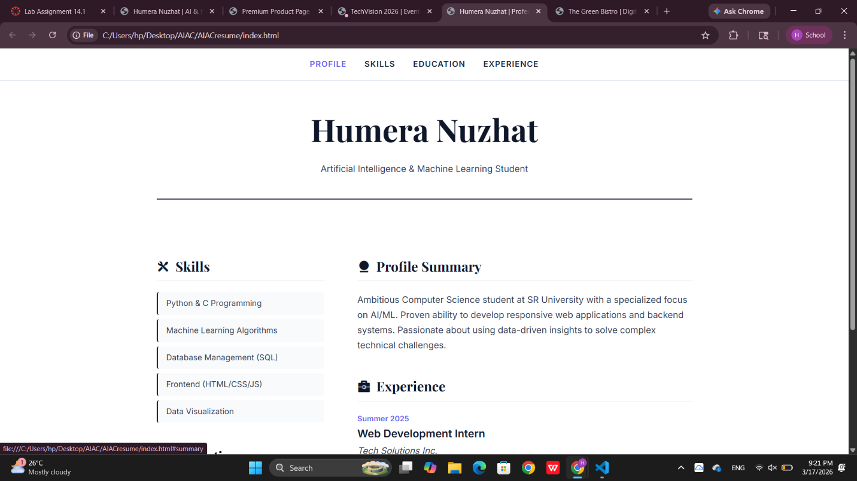
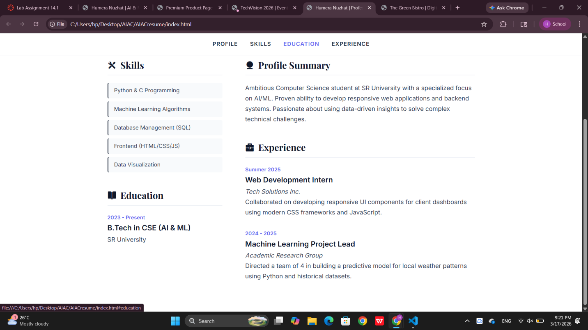
Task 5 – Restaurant Menu Page
Design a digital menu page for a restaurant.
Requirements:
• Display menu items with name, description, and price.
• Use AI to:
o Suggest a food-friendly color palette.
o Design a responsive card-based layout.
o Add hover effects on menu items.
Prompt: "Design a digital menu for 'The Green Bistro' restaurant.
- Palette: Suggest a food-friendly color palette using forest greens, creams, and terracotta oranges.
- Layout: Create a responsive card-based layout using CSS Grid auto-fit.
- Content: Each card must show a food image, name, description, and price.
- Hover: Add a 'lift' animation and shadow increase when a user hovers over a menu card.
- Font: Use a high-end Serif font for the menu titles."
- <!DOCTYPE html>
- <html lang="en">
- <head>
- <meta charset="UTF-8">
- <meta name="viewport" content="width=device-width, initial-scale=1.0">
- <title>The Green Bistro | Digital Menu</title>
- <link href="https://cdn.jsdelivr.net/npm/remixicon@3.5.0/fonts/remixicon.css" rel="stylesheet">
- <link href="https://fonts.googleapis.com/css2?family=Cormorant+Garamond:wght@600;700&family=Poppins:wght@300;400;500&display=swap" rel="stylesheet">

- <style>
- /* --- FOOD-FRIENDLY COLOR PALETTE --- */
- :root {
- --primary-green: #2d4a22; /* Forest green (Freshness) */
- --warm-cream: #fdfaf5; /* Soft background */
- --accent-orange: #d97706; /* Terracotta (Appetite) */
- --text-dark: #1a1a1a;
- --text-muted: #6b7280;
- }

- * {
- margin: 0;
- padding: 0;
- box-sizing: border-box;
- }

- body {
- font-family: 'Poppins', sans-serif;
- background-color: var(--warm-cream);
- color: var(--text-dark);
- line-height: 1.6;
- }

- header {
- text-align: center;
- padding: 60px 20px;
- background-color: var(--primary-green);
- color: white;
- clip-path: polygon(0 0, 100% 0, 100% 85%, 0% 100%);
- }

- header h1 {
- font-family: 'Cormorant Garamond', serif;
- font-size: 3.5rem;
- margin-bottom: 10px;
- }

- .container {
- max-width: 1100px;
- margin: 40px auto;
- padding: 0 20px;
- }

- /* --- RESPONSIVE CARD LAYOUT --- */
- .menu-grid {
- display: grid;
- grid-template-columns: repeat(auto-fit, minmax(300px, 1fr));
- gap: 30px;
- margin-top: 40px;
- }

- .menu-item {
- background: white;
- border-radius: 15px;
- overflow: hidden;
- box-shadow: 0 4px 15px rgba(0,0,0,0.05);
- transition: all 0.4s cubic-bezier(0.175, 0.885, 0.32, 1.275);
- cursor: pointer;
- border: 1px solid #f1f1f1;
- }

- /* --- HOVER EFFECTS --- */
- .menu-item:hover {
- transform: translateY(-10px);
- box-shadow: 0 15px 30px rgba(45, 74, 34, 0.15);
- border-color: var(--primary-green);
- }

- .menu-item__img {
- width: 100%;
- height: 200px;
- object-fit: cover;
- transition: transform 0.5s ease;
- }

- .menu-item:hover .menu-item__img {
- transform: scale(1.1);
- }

- .menu-item__content {
- padding: 25px;
- }

- .menu-item__header {
- display: flex;
- justify-content: space-between;
- align-items: center;
- margin-bottom: 10px;
- }

- .menu-item__title {
- font-family: 'Cormorant Garamond', serif;
- font-size: 1.5rem;
- font-weight: 700;
- color: var(--primary-green);
- }

- .menu-item__price {
- font-weight: 600;
- color: var(--accent-orange);
- font-size: 1.2rem;
- }

- .menu-item__desc {
- font-size: 0.9rem;
- color: var(--text-muted);
- margin-bottom: 15px;
- }

- .menu-item__tag {
- display: inline-block;
- background: #f3f4f6;
- padding: 4px 12px;
- border-radius: 20px;
- font-size: 0.75rem;
- font-weight: 500;
- color: var(--primary-green);
- }

- /* Responsive adjustments */
- @media (max-width: 600px) {
- header h1 { font-size: 2.5rem; }
- .menu-grid { grid-template-columns: 1fr; }
- }
- </style>
- </head>
- <body>

- <header>
- <h1>The Green Bistro</h1>
- <p>Organic. Seasonal. Authentic.</p>
- </header>

- <main class="container">
- <div class="menu-grid">

- <article class="menu-item">
- <img src="https://images.unsplash.com/photo-1546069901-ba9599a7e63c?auto=format&fit=crop&w=500&q=80" alt="Avocado Bowl" class="menu-item__img">
- <div class="menu-item__content">
- <div class="menu-item__header">
- <h3 class="menu-item__title">Avocado Zen Bowl</h3>
- <span class="menu-item__price">$14.50</span>
- </div>
- <p class="menu-item__desc">Fresh organic avocado, quinoa, cherry tomatoes, and a light lemon-tahini dressing.</p>
- <span class="menu-item__tag"><i class="ri-leaf-line"></i> Vegan</span>
- </div>
- </article>

- <article class="menu-item">
- <img src="https://images.unsplash.com/photo-1565299624946-b28f40a0ae38?auto=format&fit=crop&w=500&q=80" alt="Special Pizza" class="menu-item__img">
- <div class="menu-item__content">
- <div class="menu-item__header">
- <h3 class="menu-item__title">Wild Mushroom Pizza</h3>
- <span class="menu-item__price">$18.00</span>
- </div>
- <p class="menu-item__desc">Hand-stretched dough, truffle oil, sautéed wild mushrooms, and fresh mozzarella.</p>
- <span class="menu-item__tag"><i class="ri-fire-line"></i> Chef's Choice</span>
- </div>
- </article>

- <article class="menu-item">
- <img src="https://images.unsplash.com/photo-1512621776951-a57141f2eefd?auto=format&fit=crop&w=500&q=80" alt="Greek Salad" class="menu-item__img">
- <div class="menu-item__content">
- <div class="menu-item__header">
- <h3 class="menu-item__title">Aegean Greek Salad</h3>
- <span class="menu-item__price">$12.00</span>
- </div>
- <p class="menu-item__desc">Classic Mediterranean salad with kalamata olives, feta cheese, and extra virgin olive oil.</p>
- <span class="menu-item__tag"><i class="ri-seedling-line"></i> Gluten Free</span>
- </div>
- </article>

- </div>
- </main>

- <script>
- // Optional JS for a simple "Click to Order" feature
- document.querySelectorAll('.menu-item').forEach(item => {
- item.addEventListener('click', () => {
- const title = item.querySelector('.menu-item__title').innerText;
- alert(`Added ${title} to your order!`);
- });
- });
- </script>

- </body>
- </html>

OUTPUT:
