School of Computer Science and Artificial Intelligence

Lab Assignment -4.2

Program :B. Tech (CSE)
Specialization :AIML
Course Title : AI ASSISTED CODING
Course Code : 23CS002PC304
Semester : VI
Academic Session : 2025-2026
Name of Student : KOPPULA REETHI LAKSHMI
Enrollment No. : 2303A52097
Batch No. : 33

TASK 1
Task Description-1
• Zero-shot: Prompt AI with only the instruction. Write a Python function to determine
whether a given number is prime
Expected Output-1
• A basic Python function to check if a number is prime, demonstrating correct logical
conditions without relying on examples or additional context
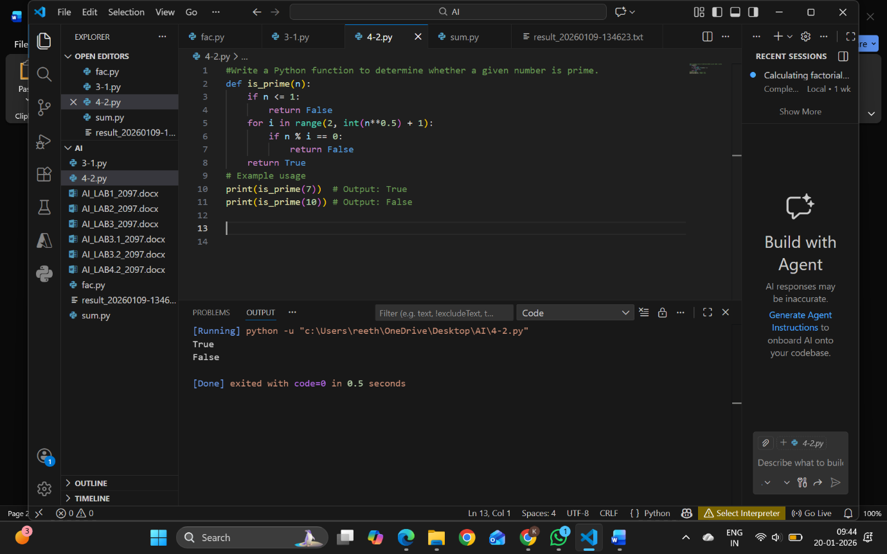
Explanation
This function checks:
- Numbers ≤ 1 are not prime
- Divisibility from 2 to √n
- If no divisor is found, the number is prime

TASK 2
Task Description-2
• One-shot: Provide one example: Input: [1, 2, 3, 4], Output: 10 to help AI generate a
function that calculates the sum of elements in a list.
Expected Output-2
• A correct conversion function guided by the single example.
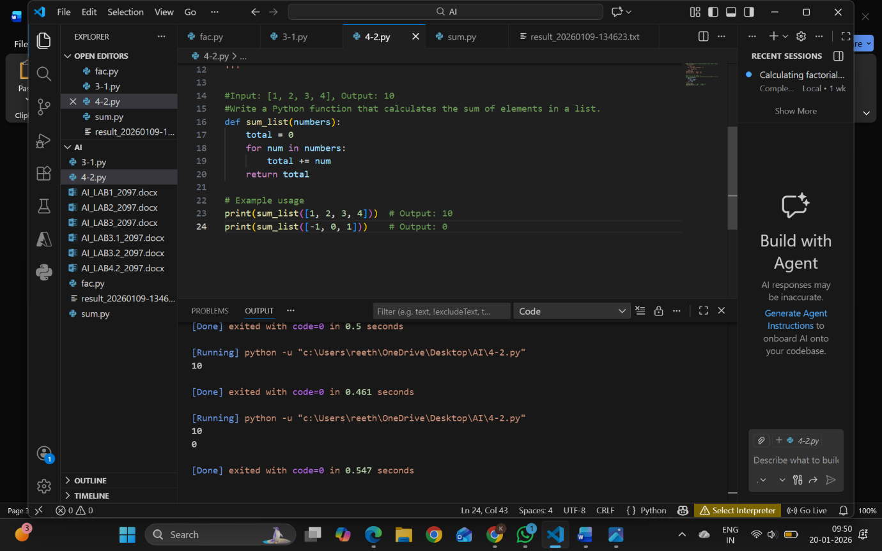
Explanation
The example clearly shows that:
- The function must add all elements
- Loop-based summation is used instead of built-in sum()
TASK 3
Task Description-3
• Few-shot: Give 2–3 examples to create a function that extracts digits from an
alphanumeric string.
Expected Output-3
• Accurate function that returns only the digits from alphanumeric string.
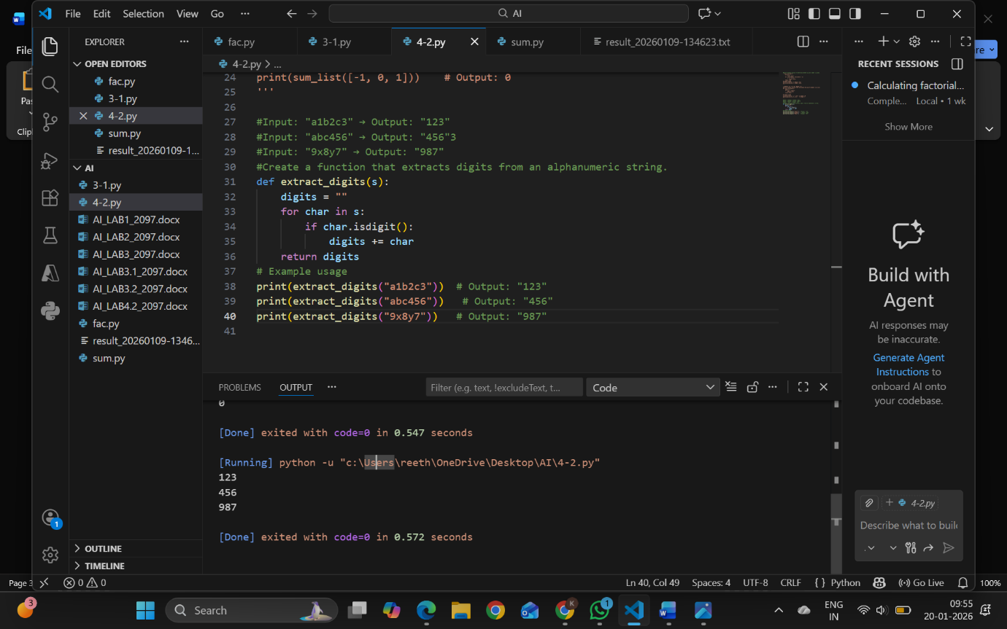

Explanation
Multiple examples helped the AI understand:
- Only digits must be extracted
- Order must be preserved

TASK 4

Task Description-4
• Compare zero-shot vs few-shot prompting for generating a function that counts the
number of vowels in a string.
Expected Output-4
• Output comparison + student explanation on how examples helped the model.

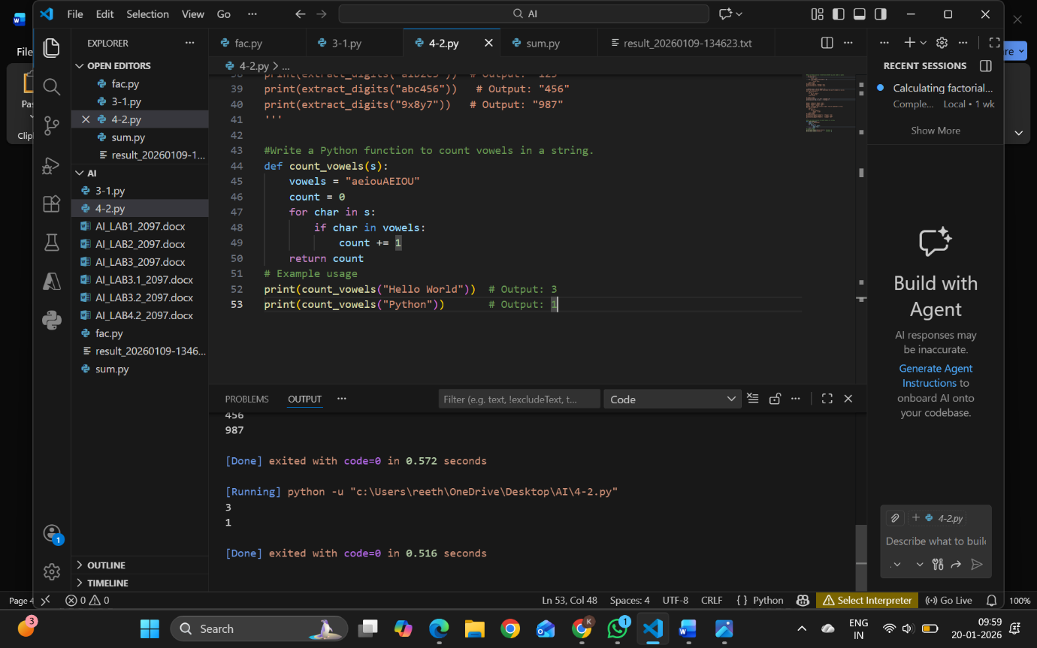
Explanation
Few-shot prompting produces:
- Cleaner code
- Better handling of edge cases
- More optimized logic
Examples help the AI understand expected behavior clearly.

TASK 5

Task Description-5
• Use few-shot prompting with 3 sample inputs to generate a function that determines
the minimum of three numbers without using the built-in min() function.
Expected Output-5
• A function that handles all cases with correct logic based on example patterns.
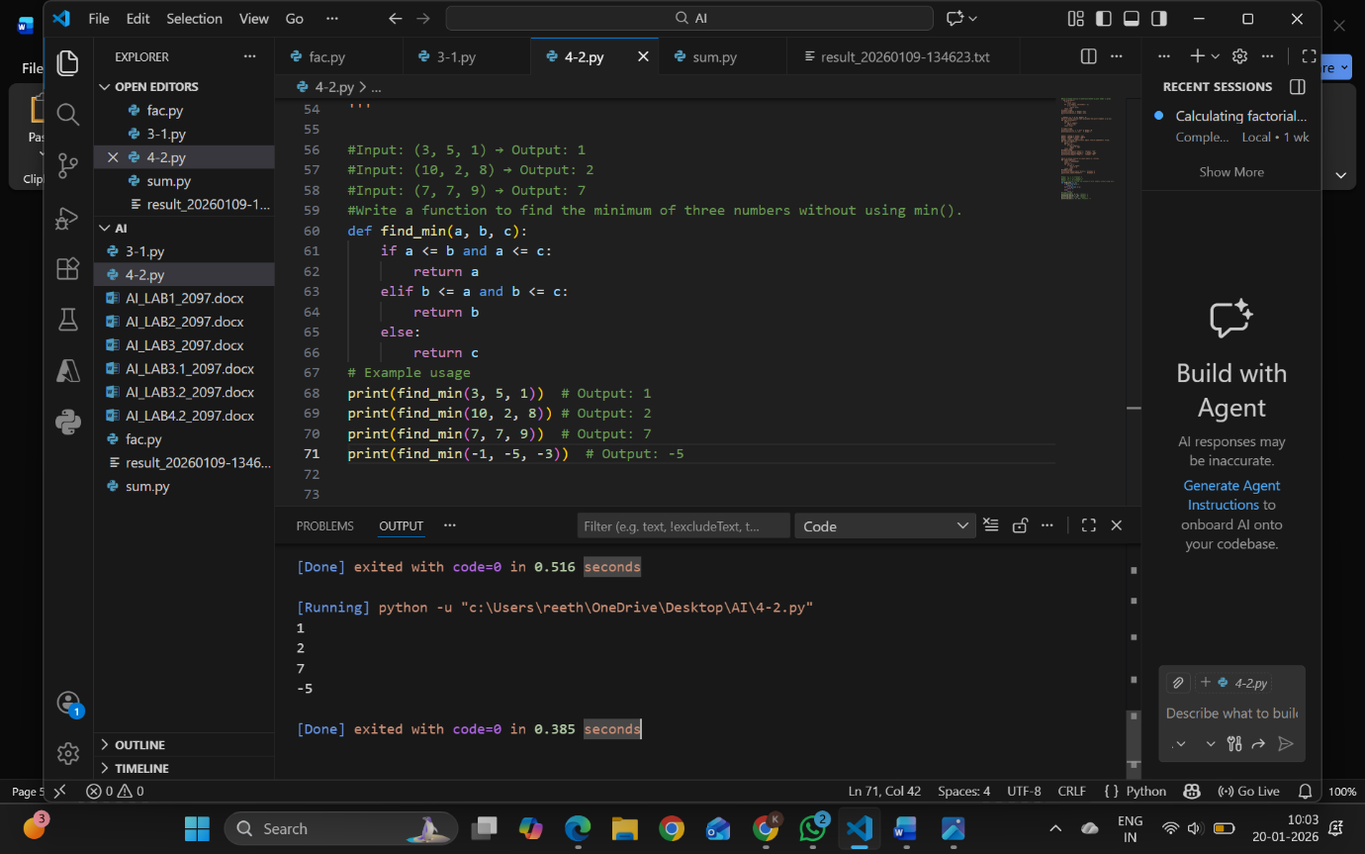
Explanation
Few-shot examples guide:
- Conditional logic
- Handling equal values
- Avoiding built-in functions

