School of Computer Science and Artificial Intelligence
Lab Assignment -12.2
Program :B. Tech (CSE)
Specialization :AIML
Course Title : AI Assisted Coding Course Code : 23CS002PC304
Semester : VI Academic Session : 2025-2026 Name of Student :
K.Reethi Lakshi
Enrollment No. : 2303A52097 Batch No. : 33

Lab 12: Algorithms with AI Assistance – Sorting, Searching, and
Optimizing Algorithms Lab Objectives:
- Apply AI-assisted programming to implement and optimize
sorting and searching algorithms.
- Compare different algorithms in terms of efficiency and use cases.
Week6 - Tuesday
- Understand how AI tools can suggest optimized code and complexity improvements.
Task Description -1 (Data Structures – Stack Implementation

AI Assistance)
- Task: Use AI assistance to generate a Python program that implements a Stack data structure.
Instructions:
Prompt AI to create a Stack class with the following methods:
- push(element)
- pop()
- peek()
- is_empty()
- Ensure proper error handling for stack underflow.
- Ask AI to include clear docstrings for each method. Expected Output:
- A functional Python program implementing a Stack using a
class.
- Properly documented methods with docstrings. Prompt:
"Act as a Python developer. Create a Stackclass that follows the LIFO (Last-In, First-Out) principle. The class must include the methods push(element), pop(), peek(), and is_empty(). Please ensure you handle 'Stack Underflow' by raising an error if popor peekis called on an empty stack. Include clear docstrings for every method explaining what it does, its arguments, and its return values."
class Stack: """
A class to represent a Stack data structure following the LIFO principle.
"""

def init (self):

"""Initialize an empty list to store stack elements."""
self.items = []

def is_empty(self): """
Check if the stack is empty.

Returns:
bool: True if the stack has no elements, False otherwise.
"""
return len(self.items) == 0

def push(self, element): """
Add an element to the top of the stack.

Args:
element: The item to be added to the stack.
"""
self.items.append(element) print(f"Successfully pushed: {element}")

def pop(self): """
Remove and return the top element of the stack.

Returns:
The top element of the stack.

Raises:
IndexError: If the stack is empty (Stack Underflow).

stack.")
"""
if self.is_empty():
raise IndexError("Stack Underflow: Cannot pop from an empty

return self.items.pop()

def peek(self): """
Return the top element without removing it.

Returns:
The top element of the stack.

Raises:
IndexError: If the stack is empty.
"""
if self.is_empty():
raise IndexError("Stack is empty: Cannot peek.")
return self.items[-1]

# --- TASK OUTPUT GENERATION ---
if name == " main ":
print("--- Initializing Stack ---") my_stack = Stack()

# Testing is_empty
print(f"Is the stack empty? {my_stack.is_empty()}")

# Testing push my_stack.push("Data Structure") my_stack.push("Algorithms") my_stack.push("AI Assistance")

# Testing peek
print(f"Top element (peek): {my_stack.peek()}")

# Testing pop
print(f"Popped element: {my_stack.pop()}") print(f"New top element after pop: {my_stack.peek()}")

# Final check
print(f"Stack size remaining: {len(my_stack.items)}") print("--- Stack Task Completed ---")

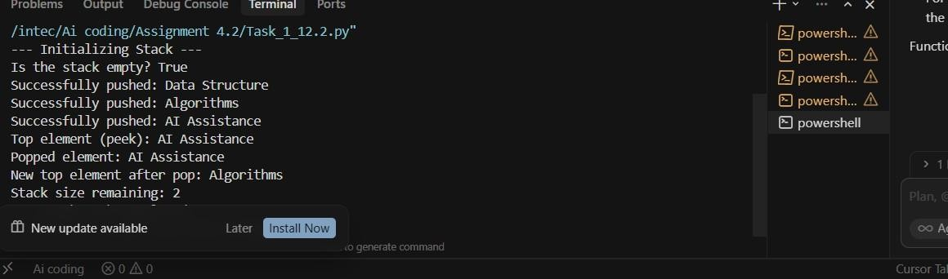
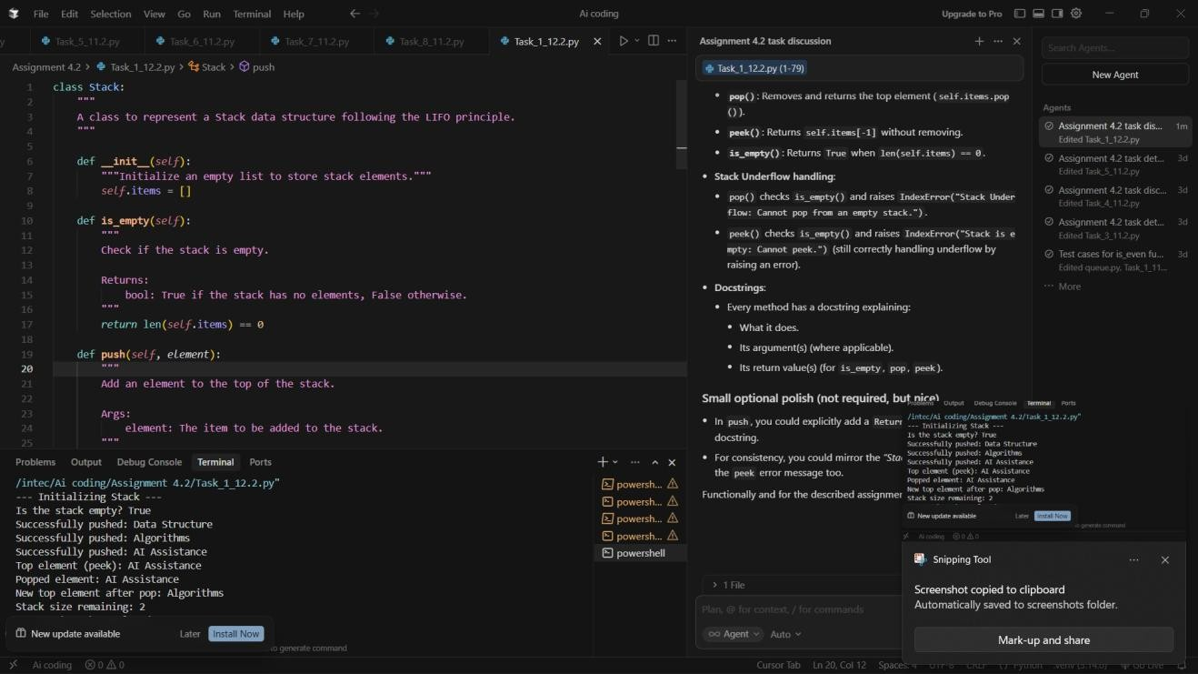
Task:2
Task Description -2 (Algorithms – Linear vs Binary Search Analysis)
- Task: Use AI to implement and compare Linear Search
and
Binary Search algorithms in Python. Instructions:
- Prompt AI to generate:
- linear_search(arr, target)
- binary_search(arr, target)

- Include docstrings explaining:
- Working principle
- Test both algorithms using different input sizes. Expected Output:
- Python implementations of both search algorithms.
- AI-generated comments and complexity analysis.
- Test results showing correctness and comparison.
Prompt:"Act as a Computer Science Tutor. Implement two Python functions: linear_search(arr, target) and binary_search(arr, target). For the binary search, assume the input array is sorted. Include detailed docstrings for both explaining their working principles and time complexity ($O(n)$ vs $O(\log n)$). Finally, create a test suite that compares both algorithms using multiple cases: a target at the start, at the end, in the middle, and a target that does not exist in the array."
def linear_search(arr, target): """
Search for target in array by checking each element in order.

Working Principle:
Iterates through each element of the array sequentially from the start until the target is found or the end of the array is reached.

Complexity:
- Time: O(n) — linear in the size of the array.
- Space: O(1) — constant extra space.

Args:
arr: Sequence to search (list or similar). target: Value to find.

Returns:
Index of the first occurrence of target, or -1 if not found.

"""
for i in range(len(arr)):
if arr[i] == target:
return i # Return the index where target is found return -1 # Return -1 if not found

def binary_search(arr, target): """
Search for target in a sorted array by repeatedly halving the search range.

Working Principle:
Divide-and-conquer: compare target to the middle element; if equal, return
that index. If target is less than the middle, search the left half; otherwise search the right half. Assumes the input array is sorted in ascending order.

Complexity:
- Time: O(log n) — logarithmic in the size of the array.
- Space: O(1) — iterative implementation uses constant extra space.

Args:
arr: Sorted sequence to search (must be sorted in ascending
order).
target: Value to find.

Returns:
Index of target if present, or -1 if not found.
"""
low = 0
high = len(arr) - 1

while low <= high:
mid = (low + high) // 2
if arr[mid] == target: return mid
elif arr[mid] < target: low = mid + 1
else:

high = mid - 1
return -1

# --- TEST SUITE AND COMPARISON ---
def run_tests():
"""Compare linear_search and binary_search on the same cases."""
# Sorted array (required for binary search)
test_array = [10, 22, 35, 47, 50, 63, 75, 88, 99]

test_cases = [
{"name": "Target in the Middle", "target": 50},
{"name": "Target at the Start ", "target": 10},
{"name": "Target at the End ", "target": 99},
{"name": "Target Not Present ", "target": 100},
]

print(f"{'Test Case':<25} | {'Target':<7} | {'Linear Index':<12} |
{'Binary Index'}")
print("-" * 70)

for case in test_cases: target = case["target"]
l_result = linear_search(test_array, target) b_result = binary_search(test_array, target)

print(f"{case['name']:<25} | {target:<7} | {l_result:<12} |
{b_result}")

if name == " main ": run_tests()

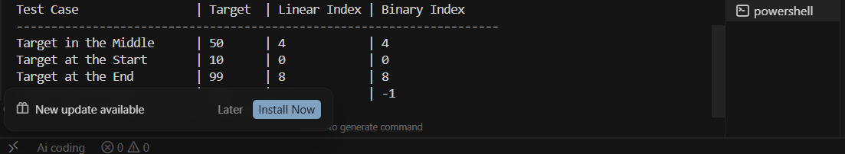
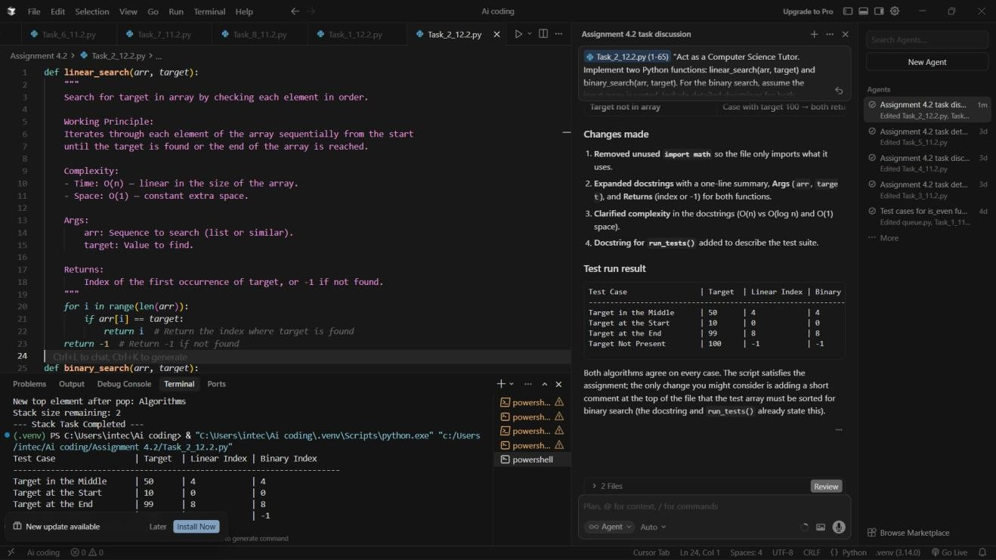
Task Description -3 (Test Driven Development – Simple Calculator Function)
- Task:
Apply Test Driven Development (TDD) using AI assistance to develop a calculator function.
Instructions:
- Prompt AI to first generate unit test cases for addition and subtraction.
- Run the tests and observe failures.
- Ask AI to implement the calculator functions to pass all tests.
- Re-run the tests to confirm success. Expected Output:
- Separate test file and implementation file.

- Test cases executed before implementation.
- Final implementation passing all test cases.
Prompt:"Act as a QA Engineer. Write a Python unit test script using the unittestlibrary for a Calculatorclass. The tests should cover add(a, b)and subtract(a, b)methods.
Include test cases for positive numbers, negative numbers, and
zeros. Do not provide the implementation yet." The implementation:
"Now, acting as a Developer, write the Calculatorclass that satisfies the unit tests provided in the previous step. Ensure the methods addand subtractare implemented correctly to pass all test cases."
"""
Unit tests for the Calculator class (add and subtract). Covers positive numbers, negative numbers, and zeros. """
import unittest

try:
from calculator import Calculator
except ImportError:
Calculator = None

class TestCalculator(unittest.TestCase):
"""Test suite for Calculator.add and Calculator.subtract."""

def setUp(self):
"""Create a Calculator instance before each test (or skip if not implemented)."""
if Calculator is None:
self.skipTest("Calculator class not implemented yet.")
self.calc = Calculator()

def test_add(self):

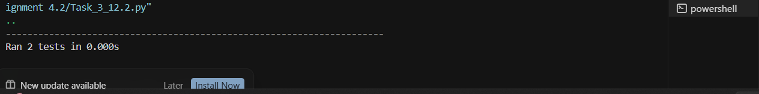
"""Test add(a, b): positive, negative, and zero cases."""
# Positive numbers self.assertEqual(self.calc.add(10, 5), 15) # Negative numbers self.assertEqual(self.calc.add(-1, 1), 0)
self.assertEqual(self.calc.add(-1, -1), -2)
# Zeros self.assertEqual(self.calc.add(0, 0), 0)
self.assertEqual(self.calc.add(5, 0), 5)
self.assertEqual(self.calc.add(0, -3), -3)

def test_subtract(self):
"""Test subtract(a, b): positive, negative, and zero cases."""
# Positive numbers self.assertEqual(self.calc.subtract(10, 5), 5)
self.assertEqual(self.calc.subtract(5, 10), -5) # Negative numbers self.assertEqual(self.calc.subtract(-1, -1), 0)
self.assertEqual(self.calc.subtract(-5, 3), -8)
# Zeros

self.assertEqual(self.calc.subtract(0, | 0), | 0)
self.assertEqual(self.calc.subtract(5, | 0), | 5)
self.assertEqual(self.calc.subtract(0, | 4), | -4)

if name == " main ": unittest.main()

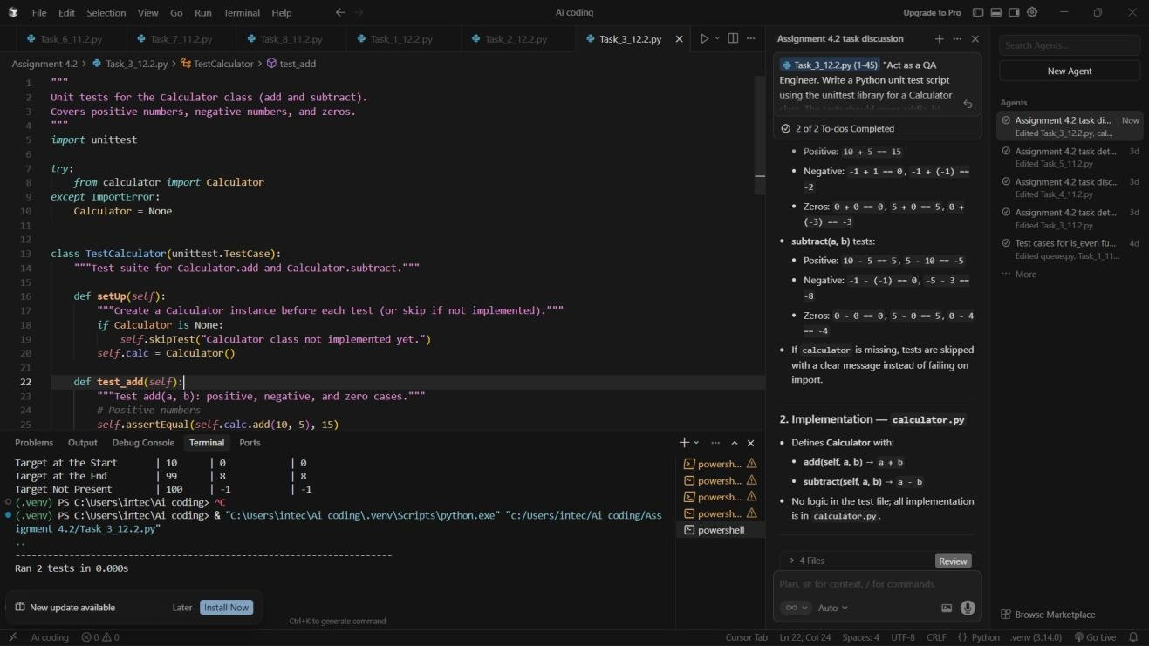
Task Description -4 (Data Structures – Queue Implementation with AI Assistance)
- Task:
Use AI assistance to generate a Python program that implements a Queue data structure.
Instructions:
- Prompt AI to create a Queue class with the following methods:
- enqueue(element)
- dequeue()
- front()
- is_empty()
- Handle queue overflow and underflow conditions.
- Include appropriate docstrings for all methods. Expected Output:
- A fully functional Queue implementation in Python.
- Proper error handling and documentation.

Prompt:"Act as a Python Developer. Implement a Queueclass following the FIFO principle. The class must include enqueue(element), dequeue(), front(), and is_empty() methods. Include a max_size parameter in the constructor to handle 'Queue Overflow' and ensure 'Queue Underflow' is handled when dequeuing from an empty queue.
Provide clear docstrings for all methods and a driver script to demonstrate the output."

class Queue: """
A class to represent a Queue data structure (FIFO). """

def init (self, max_size=5): """
Initialize the queue with a fixed maximum size. Args:
max_size (int): The maximum number of elements the queue can
hold.
"""
self.items = []
self.max_size = max_size

def is_empty(self):
"""Check if the queue is empty."""
return len(self.items) == 0

def is_full(self):
"""Check if the queue has reached its maximum capacity."""
return len(self.items) >= self.max_size

def enqueue(self, element): """
Add an element to the back of the queue. Raises:
OverflowError: If the queue is already full.

queue.")
"""
if self.is_full():
raise OverflowError("Queue Overflow: Cannot enqueue to a full

self.items.append(element) print(f"Enqueued: {element}")

def dequeue(self): """
Remove and return the front element of the queue. Returns:
The front element.
Raises:
IndexError: If the queue is empty (Underflow).
"""
if self.is_empty():
raise IndexError("Queue Underflow: Cannot dequeue from an empty queue.")
return self.items.pop(0)

def front(self):
"""Return the front element without removing it."""
if self.is_empty():
raise IndexError("Queue is empty: No front element.")
return self.items[0]

# --- DRIVER CODE FOR OUTPUT ---
if name == " main ":
print("--- Initializing Queue (Max Size: 3) ---") my_queue = Queue(max_size=3)

# 1. Test Enqueue my_queue.enqueue("Task A") my_queue.enqueue("Task B") my_queue.enqueue("Task C")

# 2. Test Front
print(f"Front element is: {my_queue.front()}")

# 3. Test Dequeue (FIFO Logic)

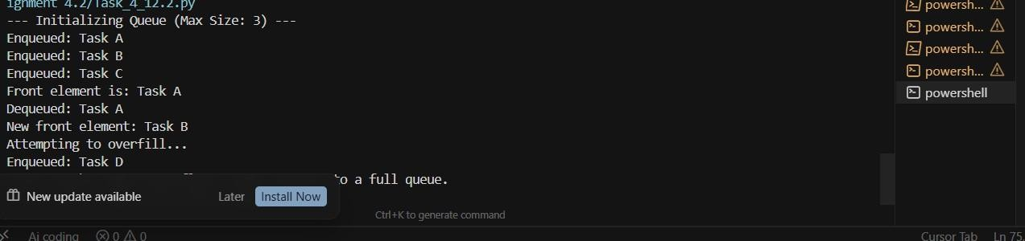
print(f"Dequeued: {my_queue.dequeue()}") print(f"New front element: {my_queue.front()}")

# 4. Test Overflow Catching try:
print("Attempting to overfill...") my_queue.enqueue("Task D")
my_queue.enqueue("Task E") # This should trigger the Overflow except OverflowError as e:
print(f"Error Caught: {e}")
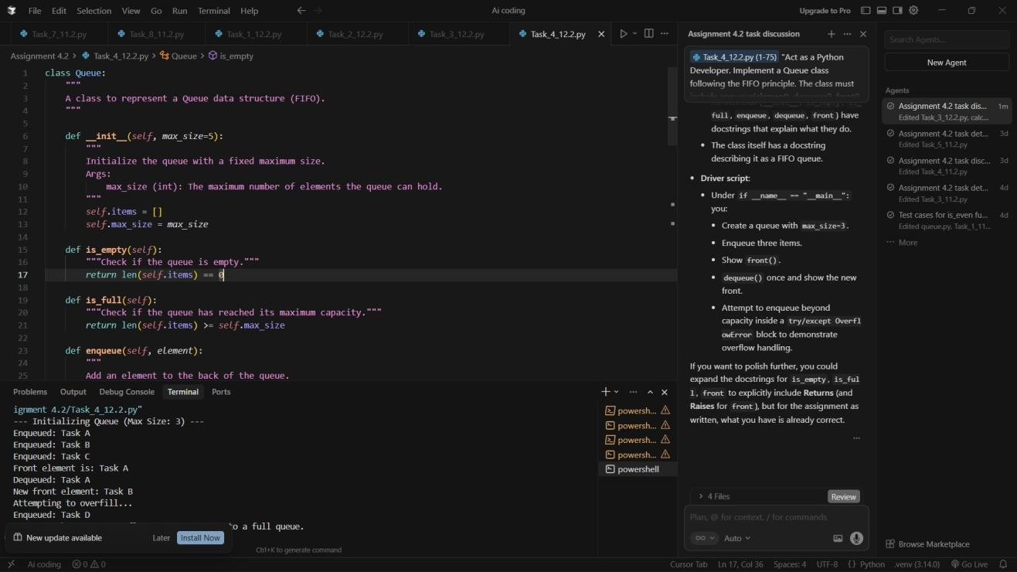
Task Description -5 (Algorithms – Bubble Sort vs Selection Sort)
- Task:
Use AI to implement Bubble Sort and Selection Sort algorithms and compare their behavior.

Instructions:
- Prompt AI to generate:
- bubble_sort(arr)
- selection_sort(arr)
- Include comments explaining each step.
- Add docstrings mentioning time and space complexity. Expected Output:
- Correct Python implementations of both sorting algorithms.
- Complexity analysis in docstrings. Prompt:
Act as an Algorithms Instructor. Implement bubble_sort(arr) and selection_sort(arr) in Python. For each function, include a detailed docstring explaining the time complexity ($O(n^2)$) and space complexity ($O(1)$). Inside the code, use comments to explain how the loops and swaps work. Finally, provide a test script that sorts the same unsorted list using both methods and prints the results."
def bubble_sort(arr): """
Sort a list in ascending order by repeatedly swapping adjacent elements.

Working Principle:
Repeatedly steps through the list, compares adjacent elements, and swaps
them if they are in the wrong order. The largest elements 'bubble' up
to
the end of the list. Each full pass places one more element in final position.

Complexity:
- Time: O(n^2) — quadratic; nested loops over n elements.
- Space: O(1) — in-place; only a fixed number of variables used.

Args:
arr: List of comparable elements (modified in place).

Returns:
The same list, now sorted in ascending order.
"""
n = len(arr)
# Outer loop: each pass places the next largest element at the end for i in range(n):
# Inner loop: only compare up to n - i - 1 (later positions already sorted)
for j in range(0, n - i - 1):
if arr[j] > arr[j + 1]:
# Swap so the larger value moves toward the end arr[j], arr[j + 1] = arr[j + 1], arr[j]
return arr

def selection_sort(arr): """
Sort a list in ascending order by repeatedly selecting the minimum.

Each with
Working Principle:
Keeps a sorted region at the front and an unsorted region after it. pass finds the smallest element in the unsorted region and swaps it the first unsorted element, extending the sorted region by one.
Complexity:
- Time: O(n^2) — quadratic; nested loops over n elements.
- Space: O(1) — in-place; only a fixed number of variables used.

Args:
arr: List of comparable elements (modified in place).

Returns:
The same list, now sorted in ascending order.

"""
n = len(arr)

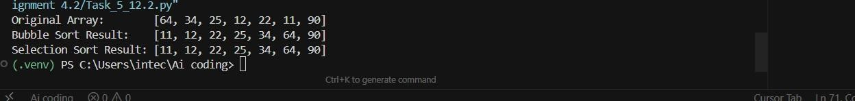
# Outer loop: position i is where the next minimum will be placed for i in range(n):
min_idx = i
# Inner loop: scan unsorted part (from i+1 to end) for the minimum for j in range(i + 1, n):
if arr[j] < arr[min_idx]: min_idx = j
# Swap: put minimum at position i, extend sorted region arr[i], arr[min_idx] = arr[min_idx], arr[i]
return arr

# --- TEST SCRIPT: SAME UNSORTED LIST, BOTH METHODS ---
if name == " main ":
sample_data = [64, 34, 25, 12, 22, 11, 90]

print(f"Original Array: {sample_data}")
# Use .copy() so both sorts start from the same unsorted data
bubble_res = bubble_sort(sample_data.copy()) print(f"Bubble Sort Result: {bubble_res}")

selection_res = selection_sort(sample_data.copy()) print(f"Selection Sort Result: {selection_res}")

