LAB_ASSIGNMENT_2
NAME: KOPPULA REETHI LAKSHMI
HALLTICKET NUMBER: 2303A52097
BATCH 33 (AIML)
Task 1

Refactoring Odd / Even Logic
Step1 :Original code:

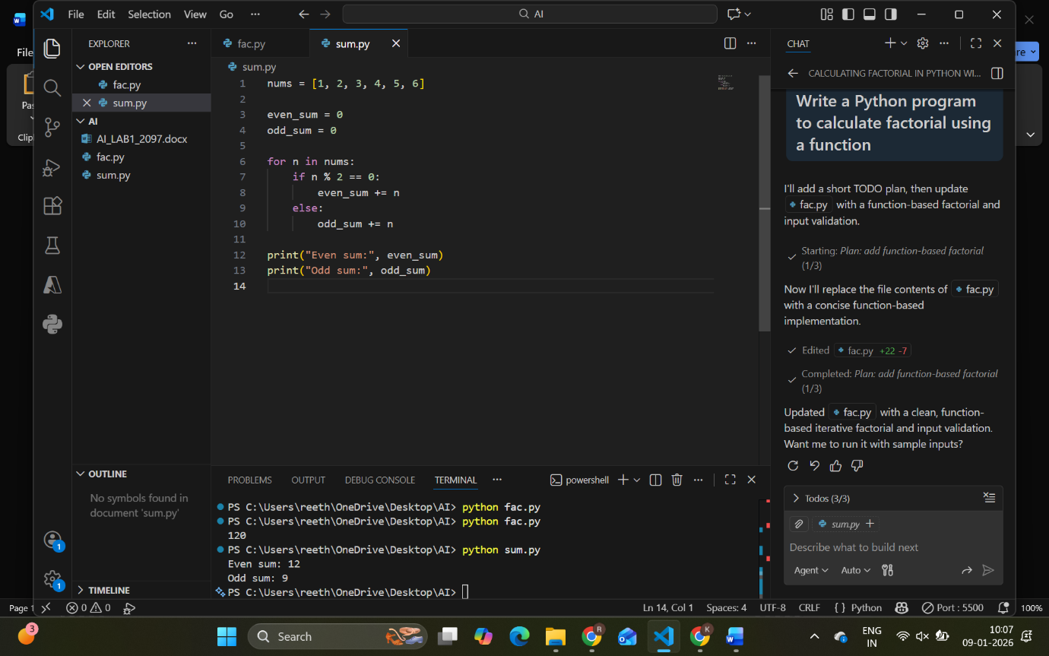

Step 2: Refactor Using AI
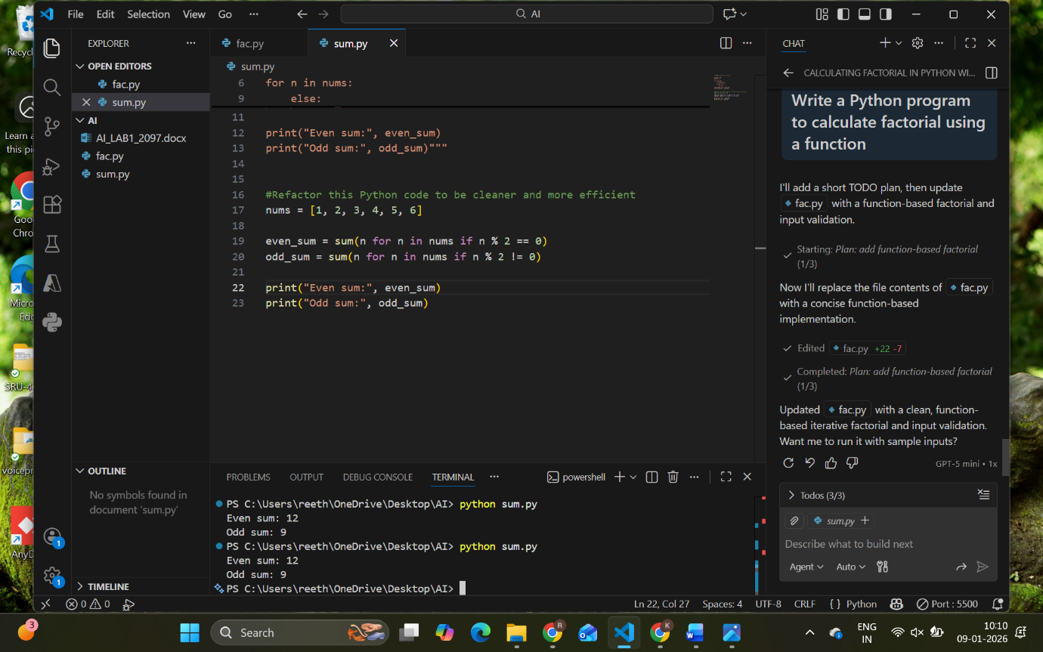
TASK 2
Area Calculation Explanation
Step 1: Write Area Function
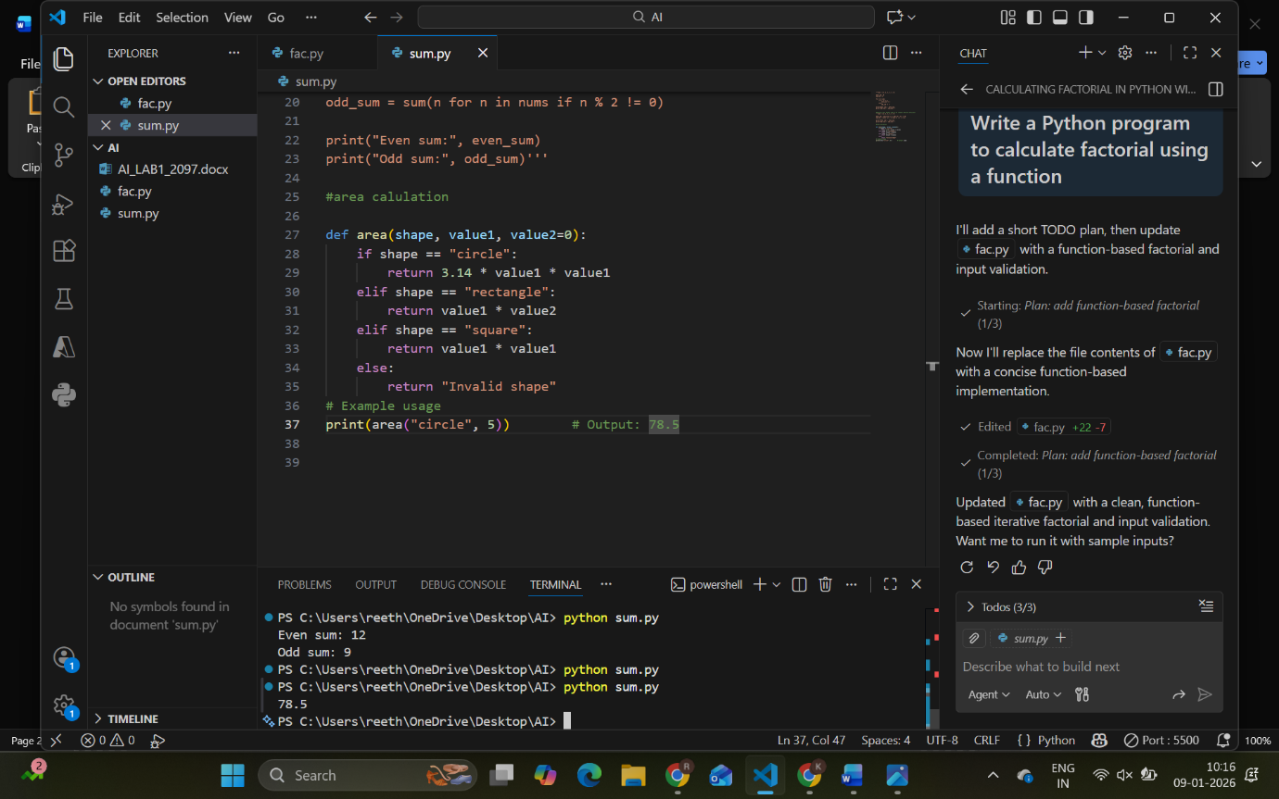
Step 2: Ask Gemini to Explain
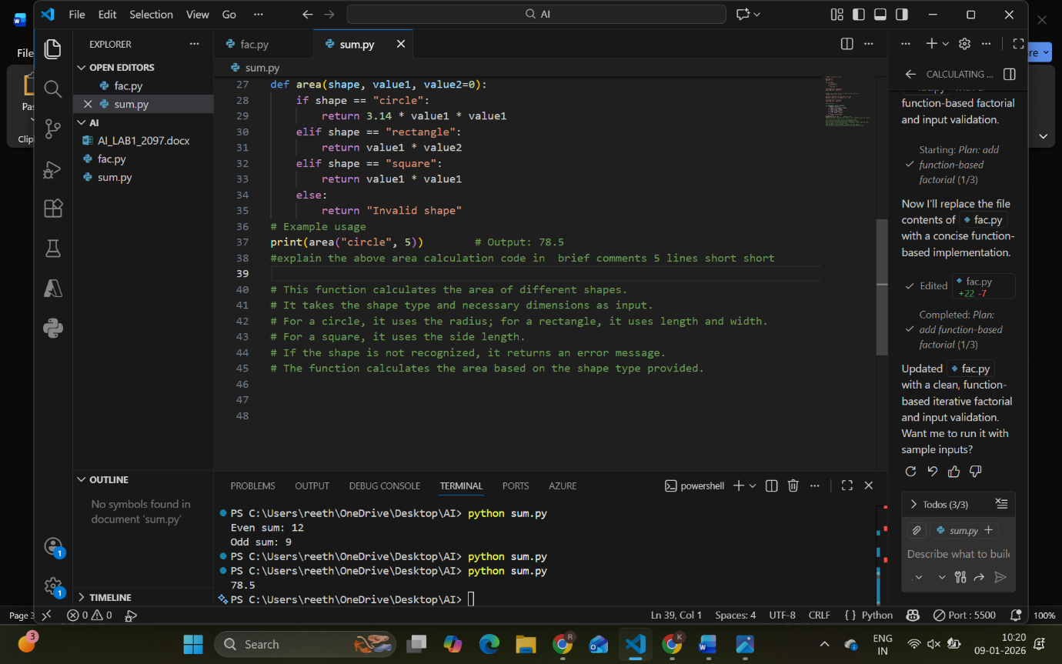

TASK 3
Prompt Sensitivity Experiment
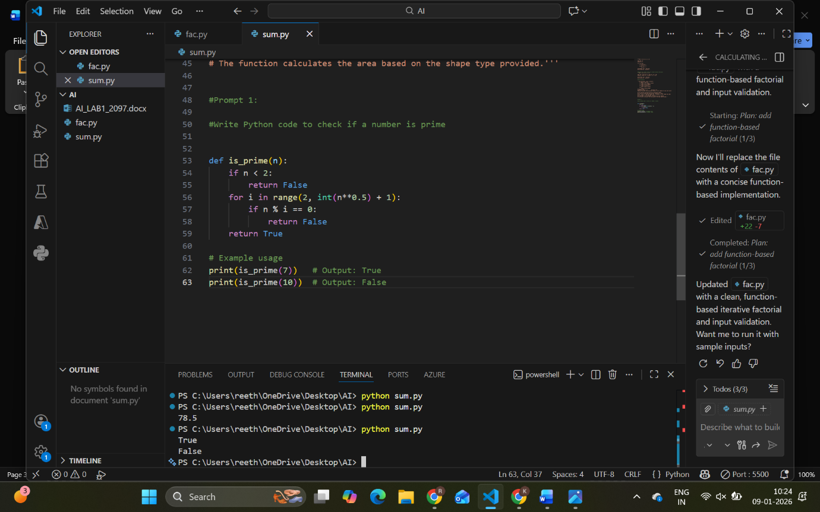
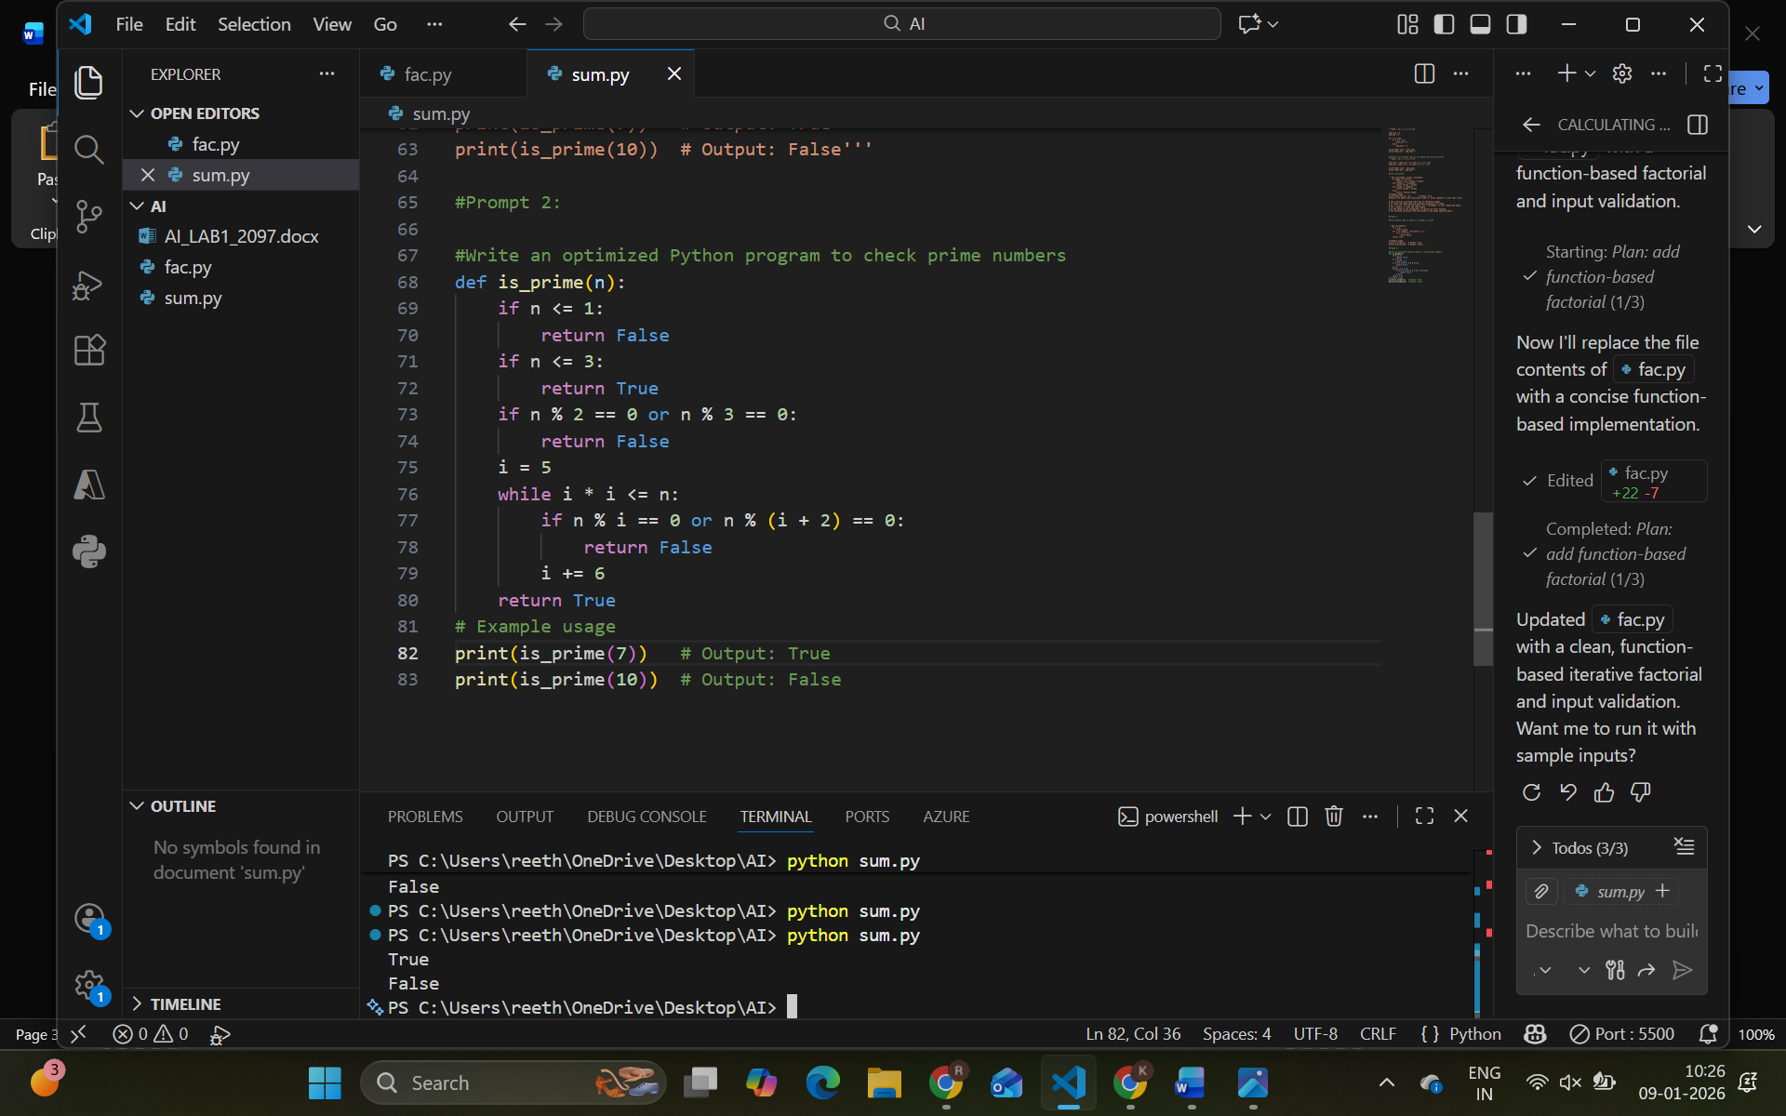

TASK 4
Tool Comparison Reflection – VS Code GitHub Copilot
GitHub Copilot integrated with VS Code provides real-time AI assistance while writing code. It suggests code automatically as the developer types, which helps in faster coding and reduces syntax errors. Copilot is especially useful for writing repetitive code, functions, and boilerplate logic. It understands the context of the program and provides relevant suggestions, improving productivity. However, it gives limited explanations compared to tools like Gemini and requires the developer to review suggestions carefully. Overall, GitHub Copilot is a powerful tool for experienced developers working inside VS Code.

