School of Computer Science and Artificial Intelligence

Lab Assignment -6.5

Program :B. Tech (CSE)
Specialization :AIML
Course Title : AI Assisted Coding
Course Code : 23CS002PC304
Semester : VI
Academic Session : 2025-2026
Name of Student : K.Reethi lakshmi
Enrollment No. : 2303A52097
Batch No. : 33

Task Description #1 (AI-Based Code Completion for Conditional
Eligibility Check)
Task: Use an AI tool to generate eligibility logic.
Prompt:
“Generate Python code to check voting eligibility based on age and
citizenship.”
Expected Output:
• AI-generated conditional logic.
give me code in python
• Correct eligibility decisions.
• Explanation of conditions.
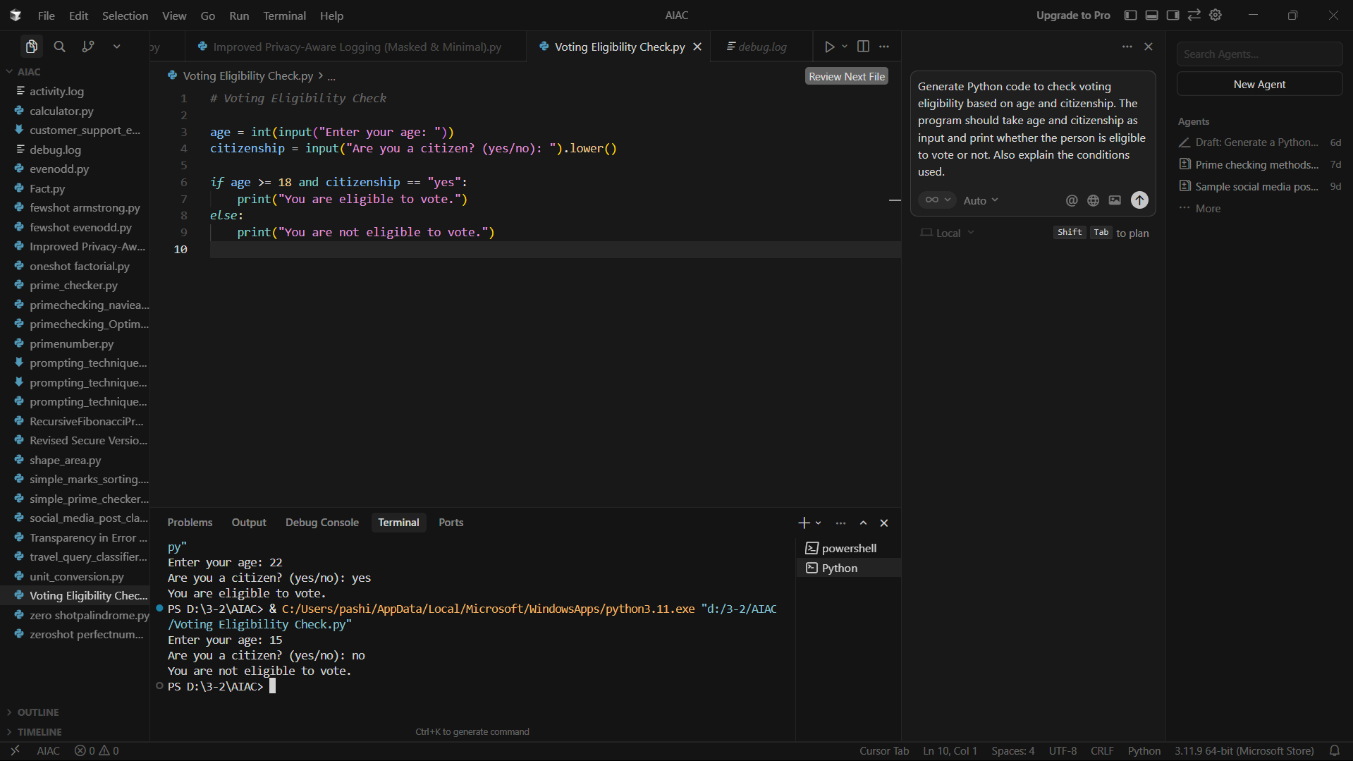
Step-by-Step Explanation of Conditions
Step 1: Take input
- age → user’s age (integer)
- citizenship → whether the user is a citizen (yes or no)
Step 2: Apply conditions
The condition used is:
age >= 18 and citizenship == "yes"
- age >= 18 → Voting is allowed only if the person is 18 years or older
- citizenship == "yes" → Person must be a citizen of the country
Step 3: Decision
- If both conditions are true, the person can vote
- If any condition is false, the person cannot vote

Task Description #2(AI-Based Code Completion for Loop-Based
String Processing)
Task: Use an AI tool to process strings using loops.
Prompt:
“Generate Python code to count vowels and consonants in a string
using a loop.”
Expected Output:
• AI-generated string processing logic.
• Correct counts.
• Output verification.
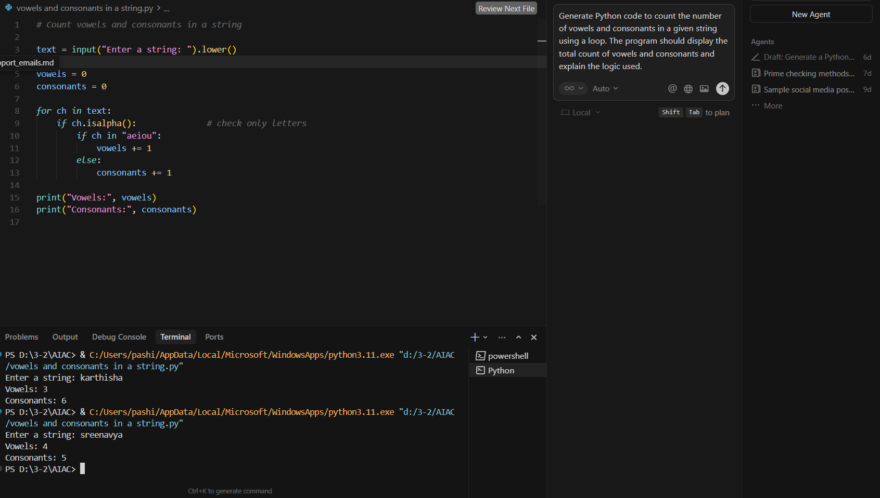
Step-by-Step Explanation (String Processing Logic)
Step 1: Take input
- Read a string from the user
- Convert it to lowercase to avoid case issues (A and a)
Step 2: Initialize counters
- vowels = 0
- consonants = 0
Step 3: Loop through the string
for ch in text:
- Each character is checked one by one
Step 4: Apply conditions
- ch.isalpha() → ensures only letters are counted
- If character is in "aeiou" → vowel
- Otherwise → consonant
Step 5: Print results
- Display total number of vowels
- Display total number of consonants

Task Description #3 (AI-Assisted Code Completion Reflection
Task)
Task: Use an AI tool to generate a complete program using classes,
loops, and conditionals.
Prompt:
“Generate a Python program for a library management system
using classes, loops, and conditional statements.”
Expected Output:
• Complete AI-generated program.
• Review of AI suggestions quality.
• Short reflection on AI-assisted coding experience.
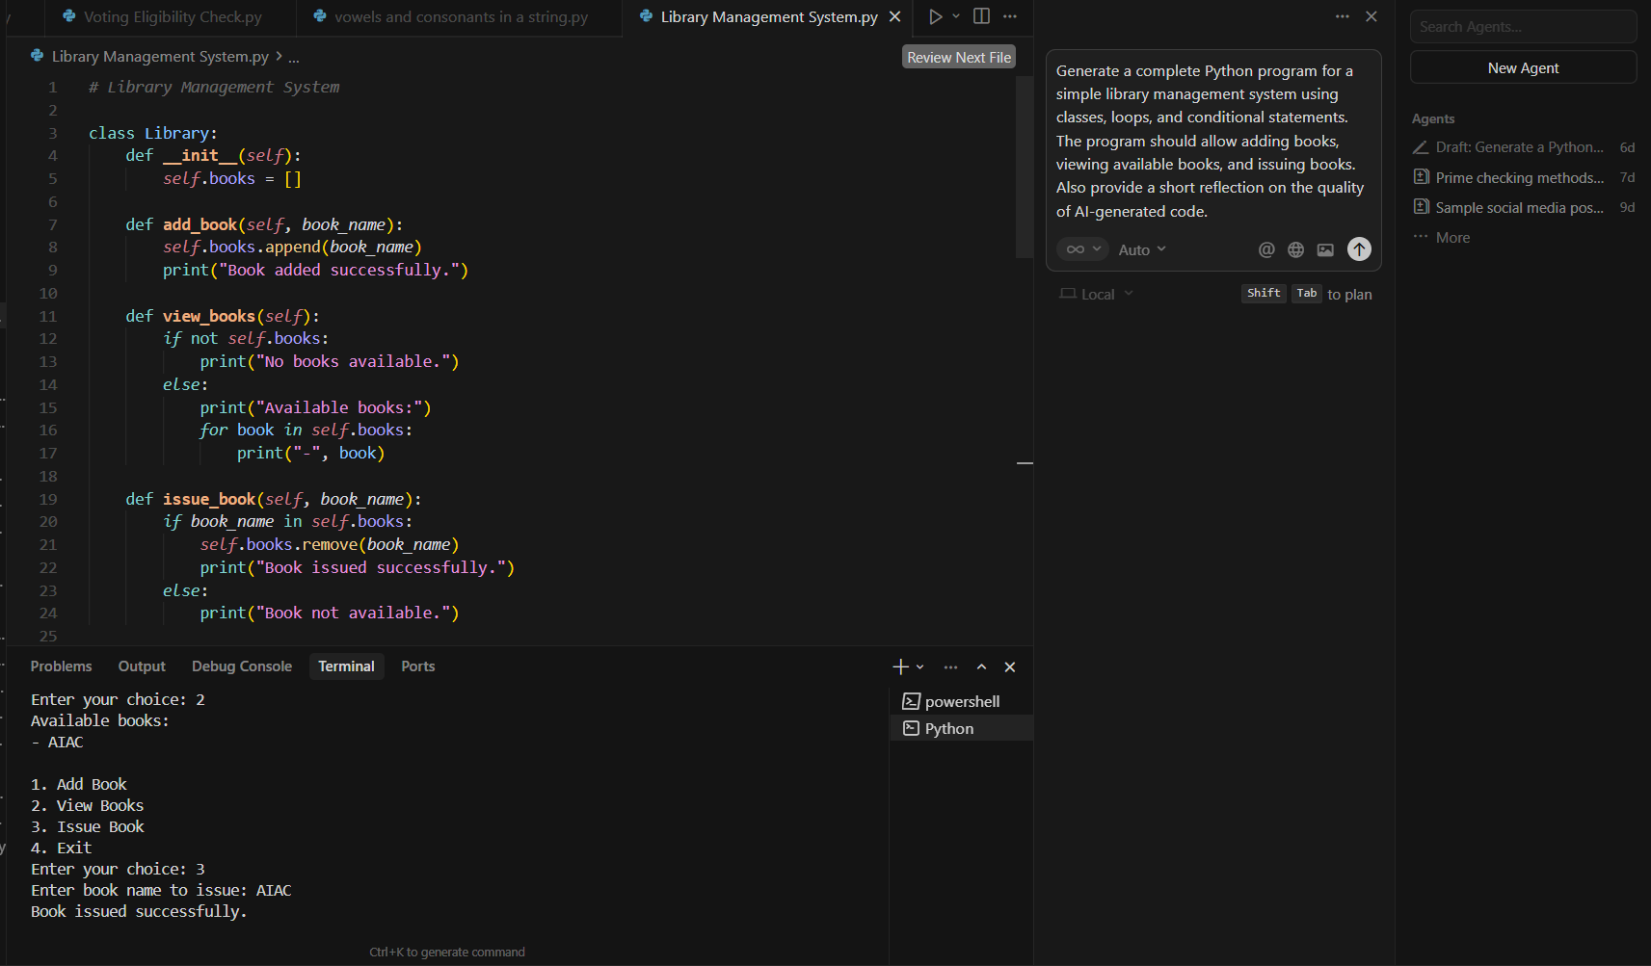
Explanation of Program Components
Classes
- Library class stores and manages book data
- Uses a list books to store book names
Loops
- while True loop keeps the menu running until the user exits
- for loop displays available books
Conditionals
- if–elif–else used to:
  - Handle user menu choices
  - Check book availability before issuing
Review of AI Suggestions Quality
- The AI-generated code is structured and readable
- Proper use of object-oriented programming
- Logical flow using loops and conditionals
- Easy to understand and modify
- Suitable for beginner-level implementation

Task Description #4 (AI-Assisted Code Completion for Class-
Based Attendance System)
Task: Use an AI tool to generate an attendance management class.
Prompt: “Generate a Python class to mark and display student
attendance using loops.”
Expected Output:
• AI-generated attendance logic.
• Correct display of attendance.
• Test cases.
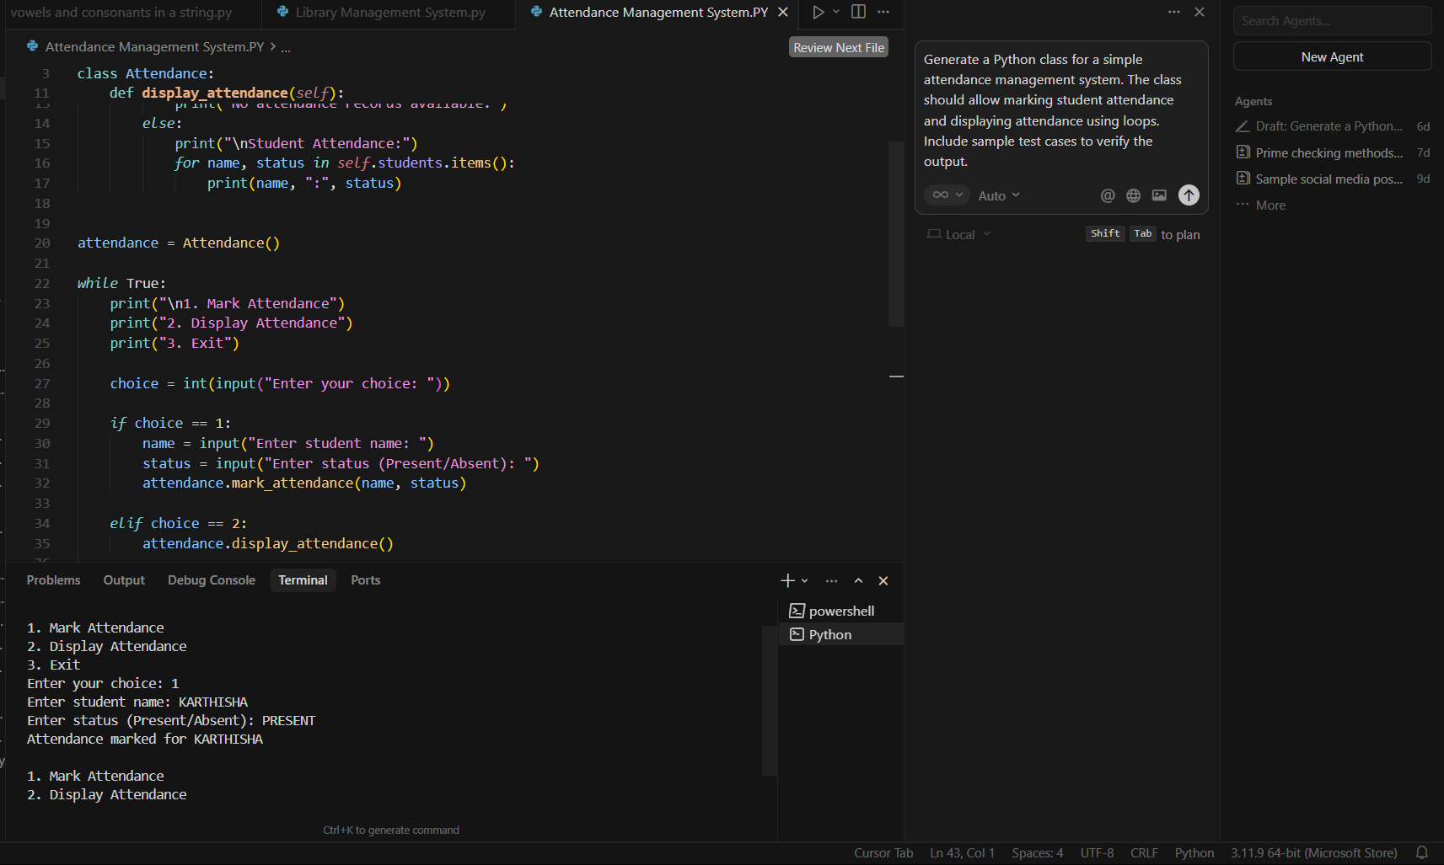
Explanation of Attendance Logic
Step 1: Class Creation
- Attendance class is created
- Uses a dictionary students
  - Key → student name
  - Value → attendance status (Present/Absent)
Step 2: Mark Attendance
- mark_attendance() method
- Stores or updates student attendance
Step 3: Display Attendance
- display_attendance() method
- Uses a for loop to print all records
Step 4: Loop & Conditionals
- while loop keeps menu running
- if–elif–else handles user choices

Task Description #5 (AI-Based Code Completion for Conditional
Menu Navigation)
Task: Use an AI tool to complete a navigation menu.
Prompt: “Generate a Python program using loops and conditionals
to simulate an ATM menu.”
Expected Output:
• AI-generated menu logic.
• Correct option handling.
• Output verification.
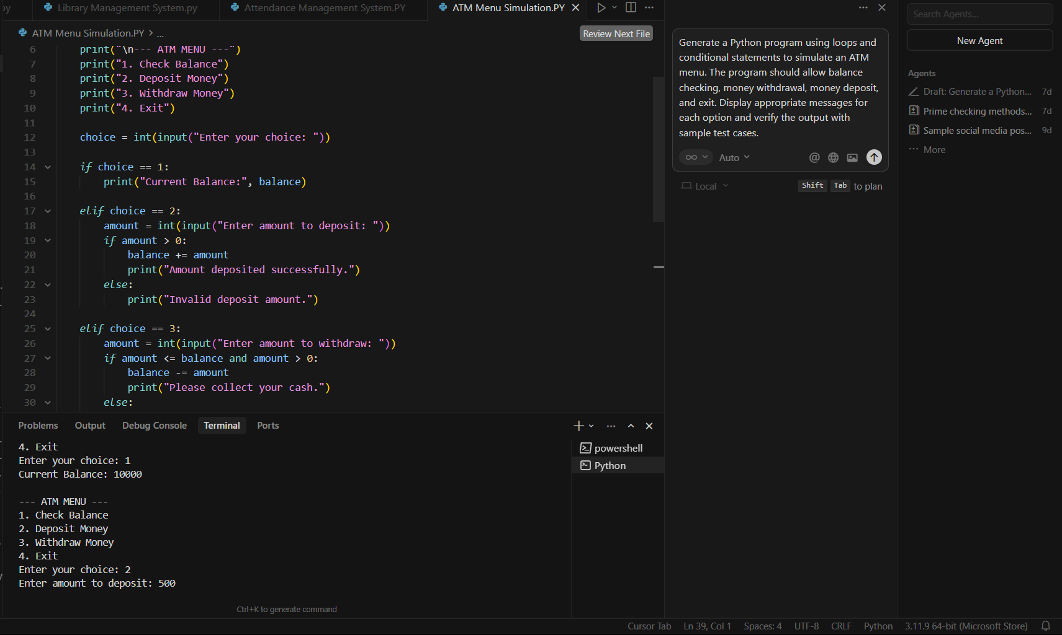
Explanation of Menu Logic
Step 1: Initialize balance
- balance = 10000 sets the starting amount
Step 2: Loop for menu
- while True keeps the ATM menu running
- Menu repeats until user chooses Exit
Step 3: Conditional handling
- if choice == 1 → Check balance
- elif choice == 2 → Deposit money
- elif choice == 3 → Withdraw money
- elif choice == 4 → Exit program
- else → Invalid option

