School of Computer Science and Artificial Intelligence

Lab Assignment # 7.2

Program : B. Tech (CSE)
Specialization :AIML
Course Title : AI Assisted Coding
Course Code : 23CS002PC304
Semester : VI
Academic Session : 2025-2026
Name of Student : K . Reethi Lakshmi
Enrollment No. : 2303A52097
Batch No. : 33
Date :03/02/26

Task 1 – Runtime Error Due to Invalid Input Type
Buggy Code:
num = input("Enter a number: ")
result = num + 10
print(result)
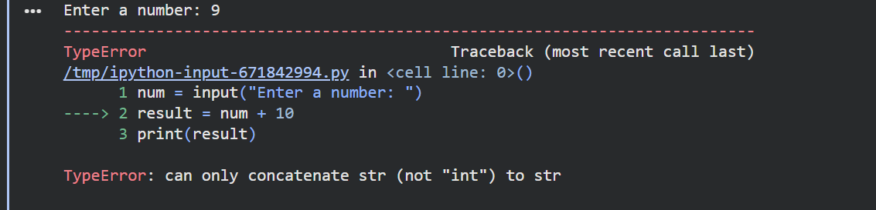
AI Explanation:
The program attempts to perform arithmetic on a string value. The input must be converted to an integer or float before calculations.
Corrected Code:
num = int(input("Enter a number: "))
result = num + 10
print(result)
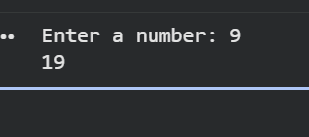
Conclusion:
AI identified the runtime error and resolved it by converting user input into a numeric type.

Task 2 – Incorrect Function Return Value:
Buggy Code:
def square(n):
result = n * n
print(square(4))
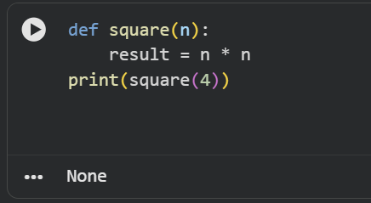
AI Explanation:
Without a return statement, the computed value cannot be accessed outside the function.

Corrected Code:
def square(n):
result = n * n
return result

Conclusion:
AI detected the missing return statement and corrected the function behavior.
Task 3 – IndexError in List Traversal
Buggy Code:
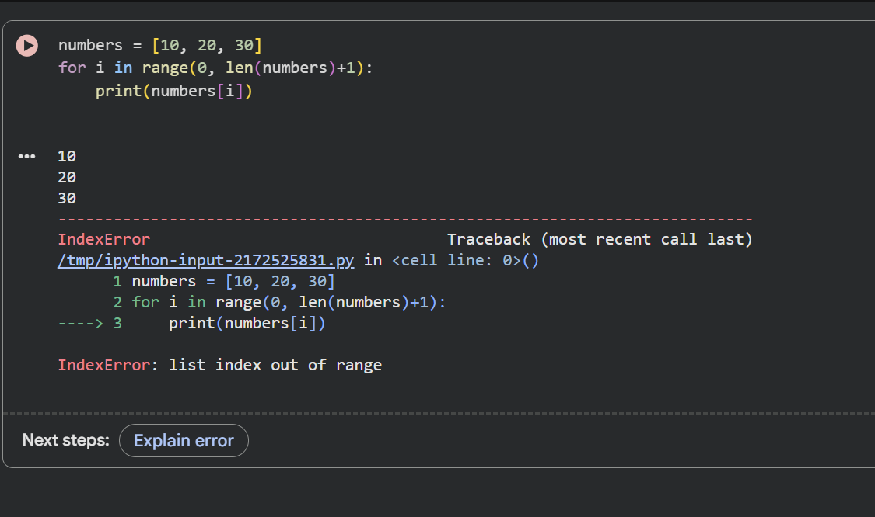
AI Explaination:
Python list indices range from 0 to len(list) - 1. The loop condition must be corrected.
Corrected Code:
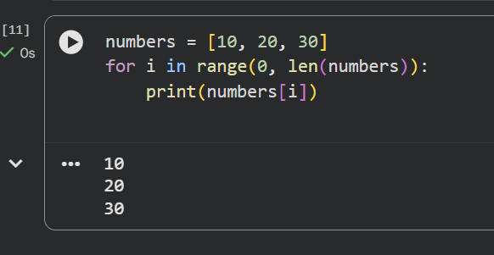

Conclusion:
AI corrected the loop boundary to prevent out-of-range access.

Task 4 – Uninitialized Variable Usage
Buggy Code:
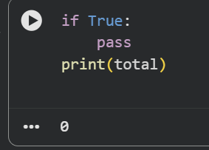
AI Explanation:
Variables must be initialized before usage, even if logic blocks are present.
Corrected Code:
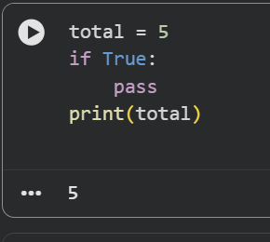
Conclusion:
AI detected the uninitialized variable and ensured safe initialization.
Task 5 – Logical Error in Student Grading System
Buggy Code:
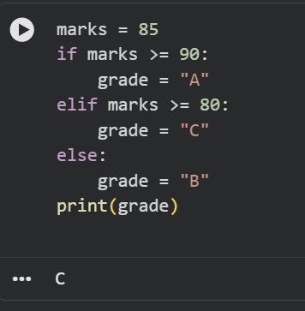
AI Explanation:
Grading conditions must follow descending or correct logical ranges.

Corrected Code:
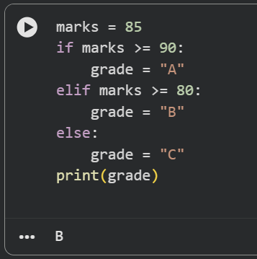

Conclusion:
AI corrected the logical flow to ensure accurate grade assignment.

