LAB_ASSIGNMENT_3.1
NAME: KOPPULA REETHI LAKSHMI
HALLTICKET NUMBER: 2303A52097
BATCH 33 (AIML)
QUESTION 1
Zero-Shot Prompting
Palindrome Number Program
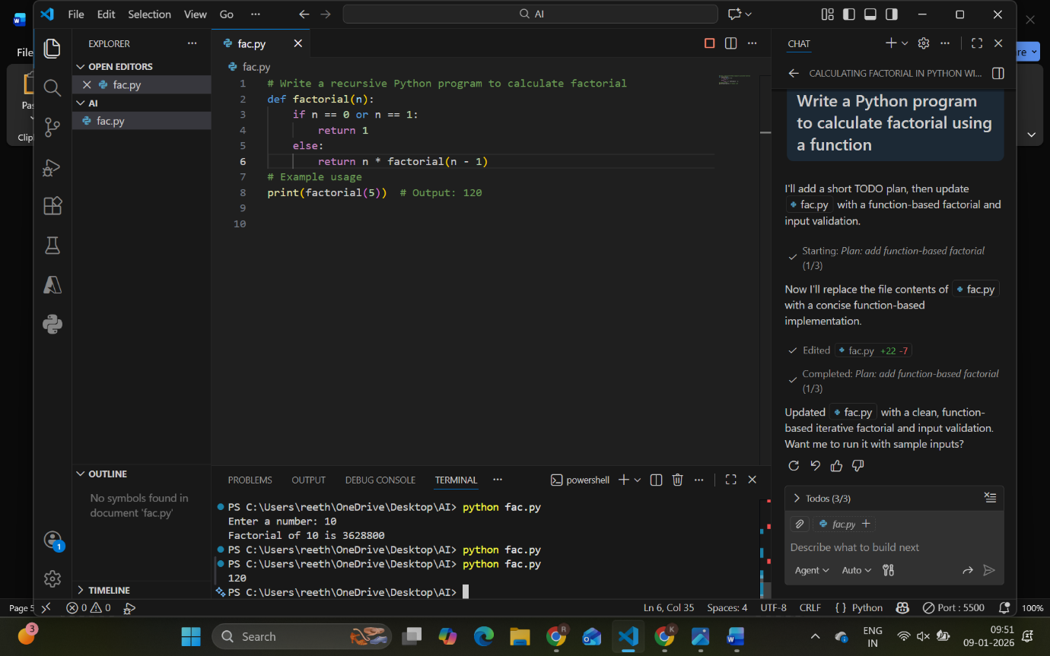
Identify Issues
- Negative numbers are not handled clearly
- Input validation is missing
- Works only for integers

QUESTION 2
One-Shot Prompting
Factorial Calculation
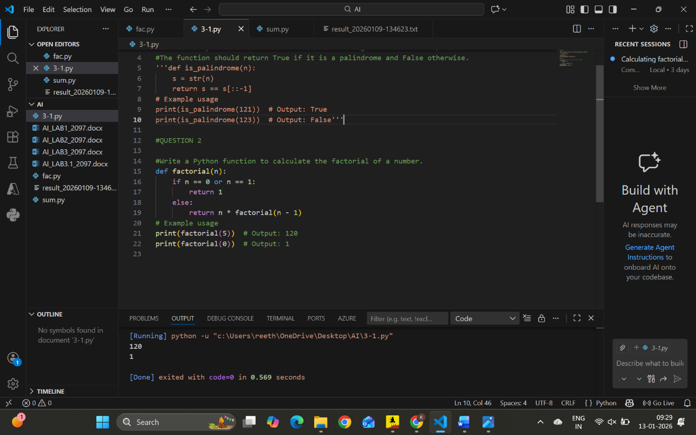
Compare with Zero-Shot
- One-shot gives clearer logic
- Includes validation for negative numbers
- Code readability is improved

QUESTION 3
Few-Shot Prompting
Armstrong Number Check

Analysis
- Multiple examples improved accuracy
- Code handles different digit lengths
- Non-integer input not handled

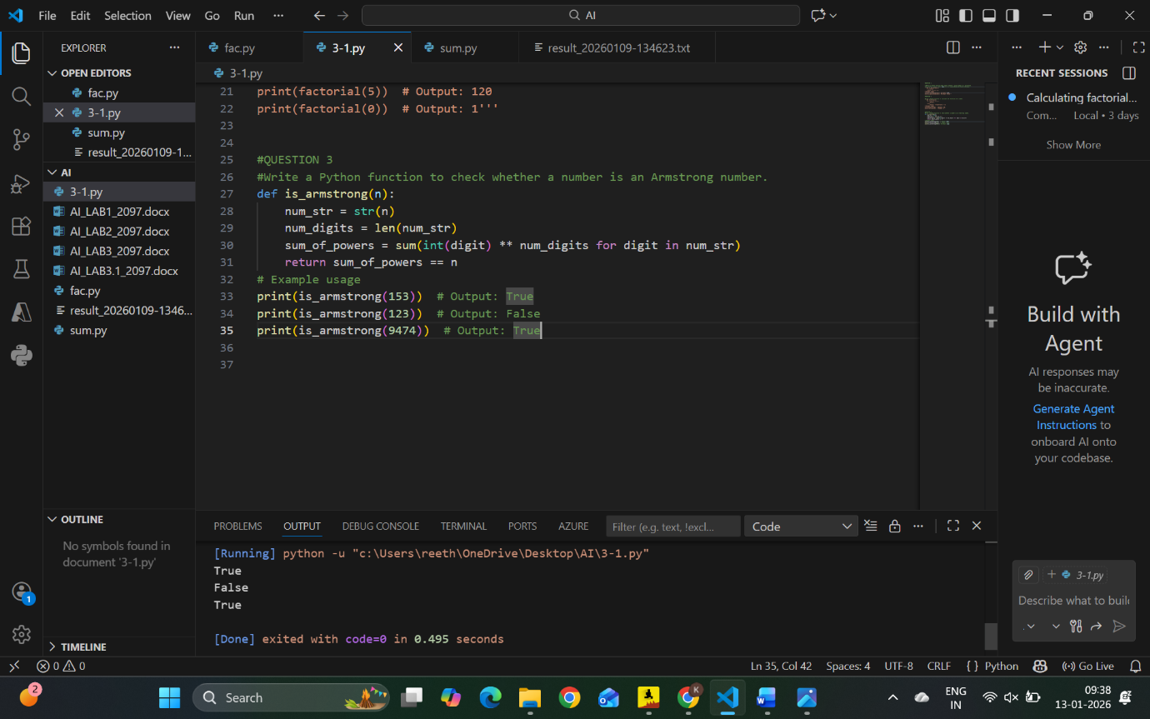

QUESTION 4 (OPTIONAL)
Context-Managed Prompting
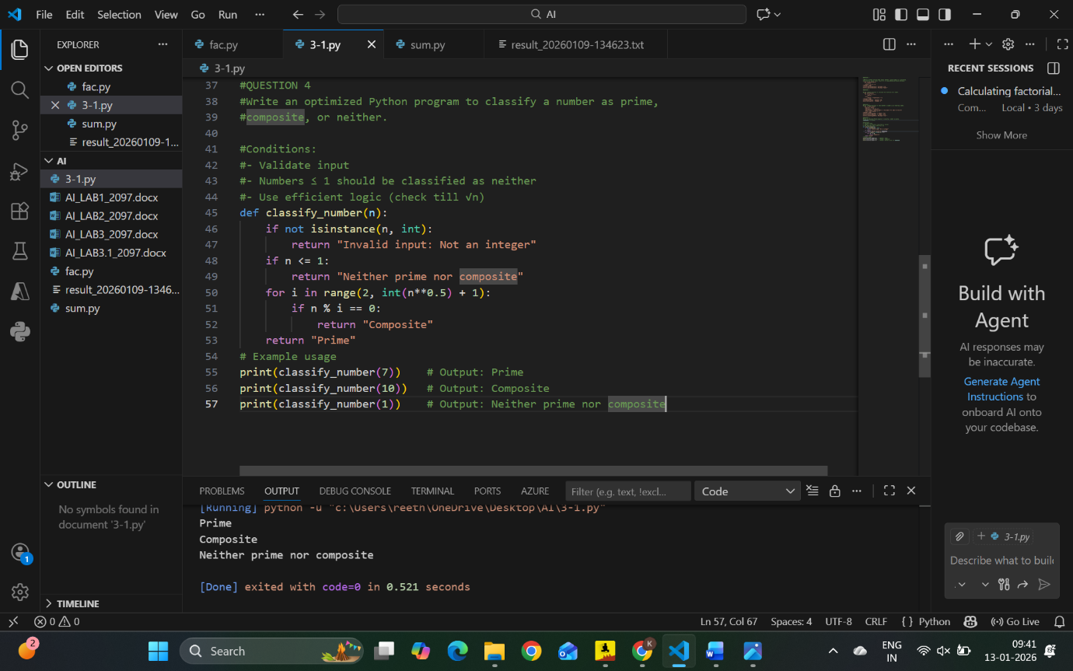

QUESTION 5
Zero-Shot Prompting
Perfect Number
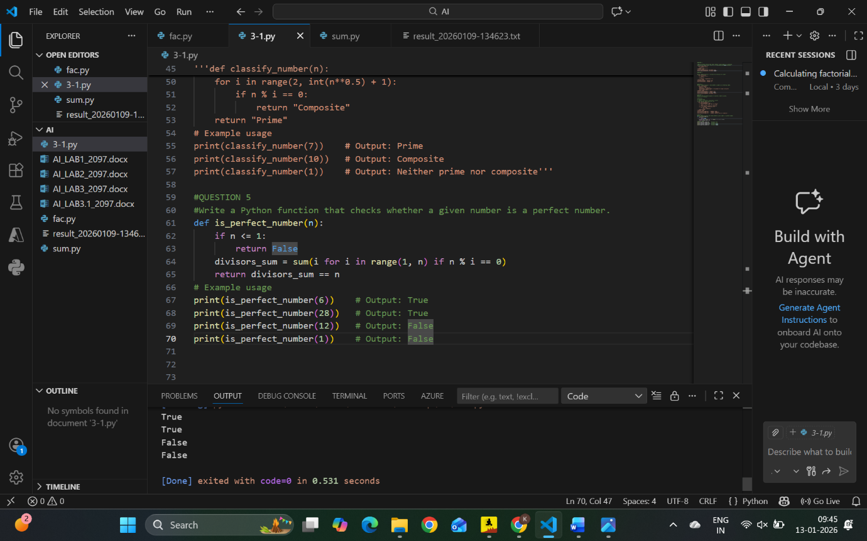
Observations
- May not handle negative numbers
- Efficiency issues for large numbers

QUESTION 6
Few-Shot Prompting
Even or Odd with Validation

Analysis
- Few-shot improves validation
- Output clarity is better
- Handles edge cases

