LAB_ASSIGNMENT_3.1
NAME: KOPPULA REETHI LAKSHMI
HALLTICKET NUMBER: 2303A52097
BATCH 33 (AIML)
Task 0
● Install and configure GitHub Copilot in VS Code. Take screenshots of
each step.
Expected Output
● Install and configure GitHub Copilot in VS Code. Take screenshots of
each step.
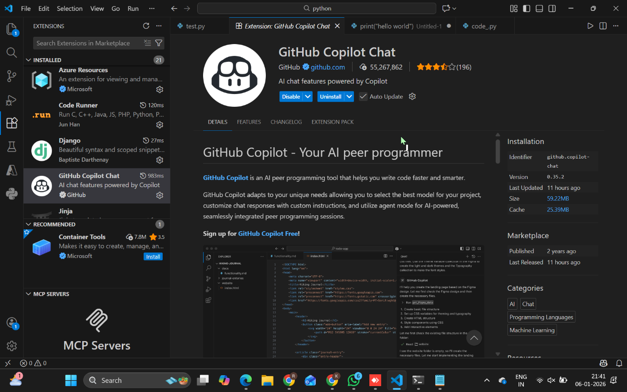

Task 1
AI-Generated Logic Without Modularization (Factorial without Functions)

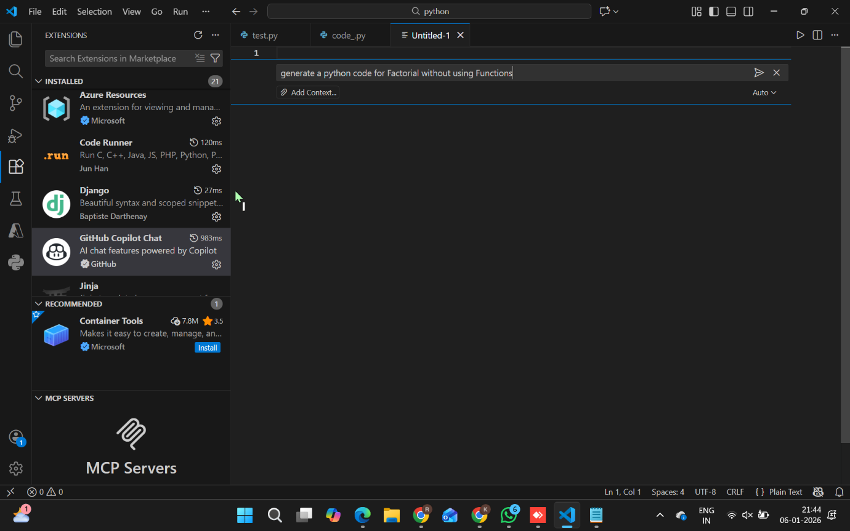

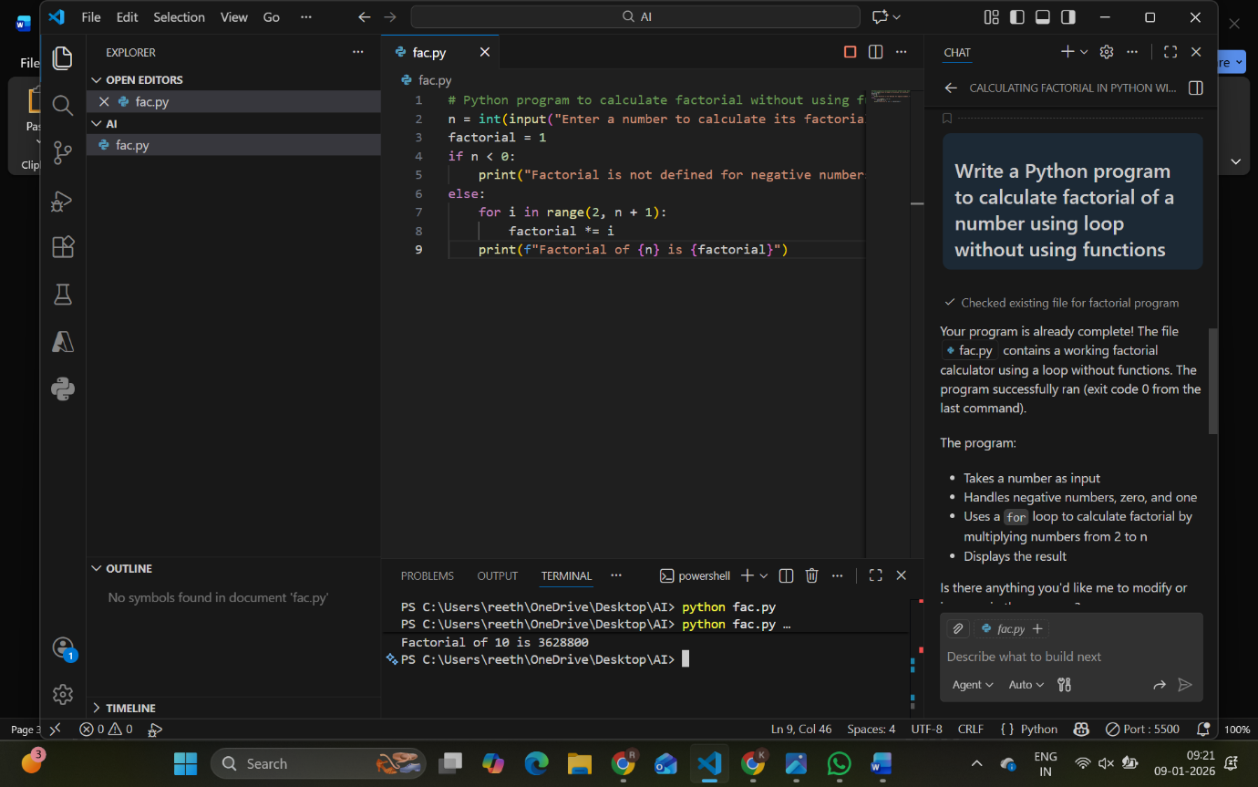

TASK 2
Optimize the AI Code

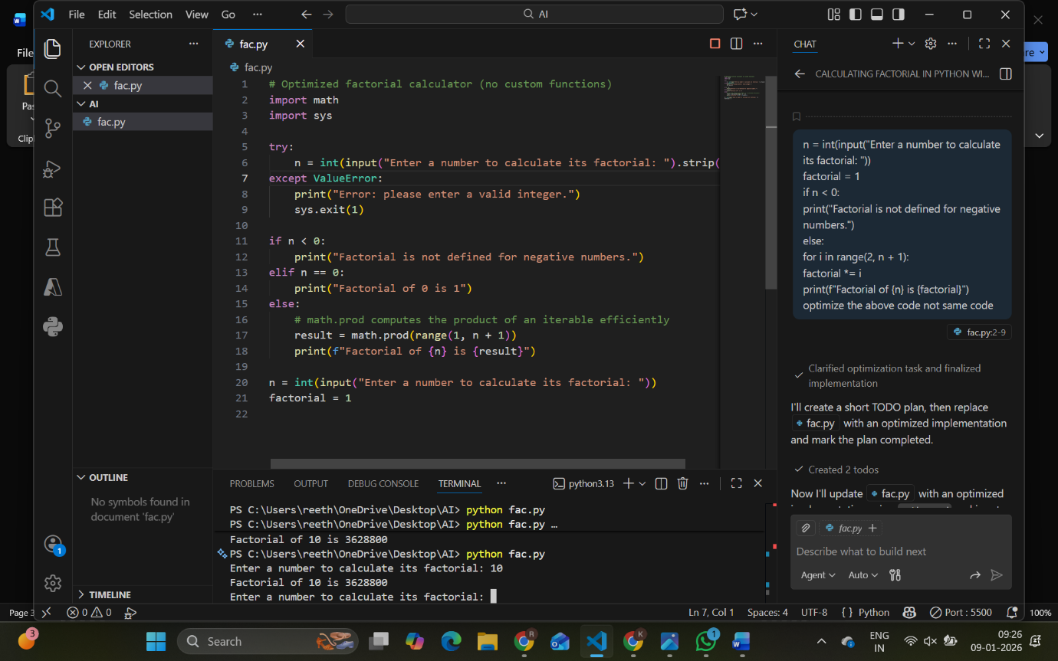

TASK 3

Factorial WITH Functions (Modular Design)

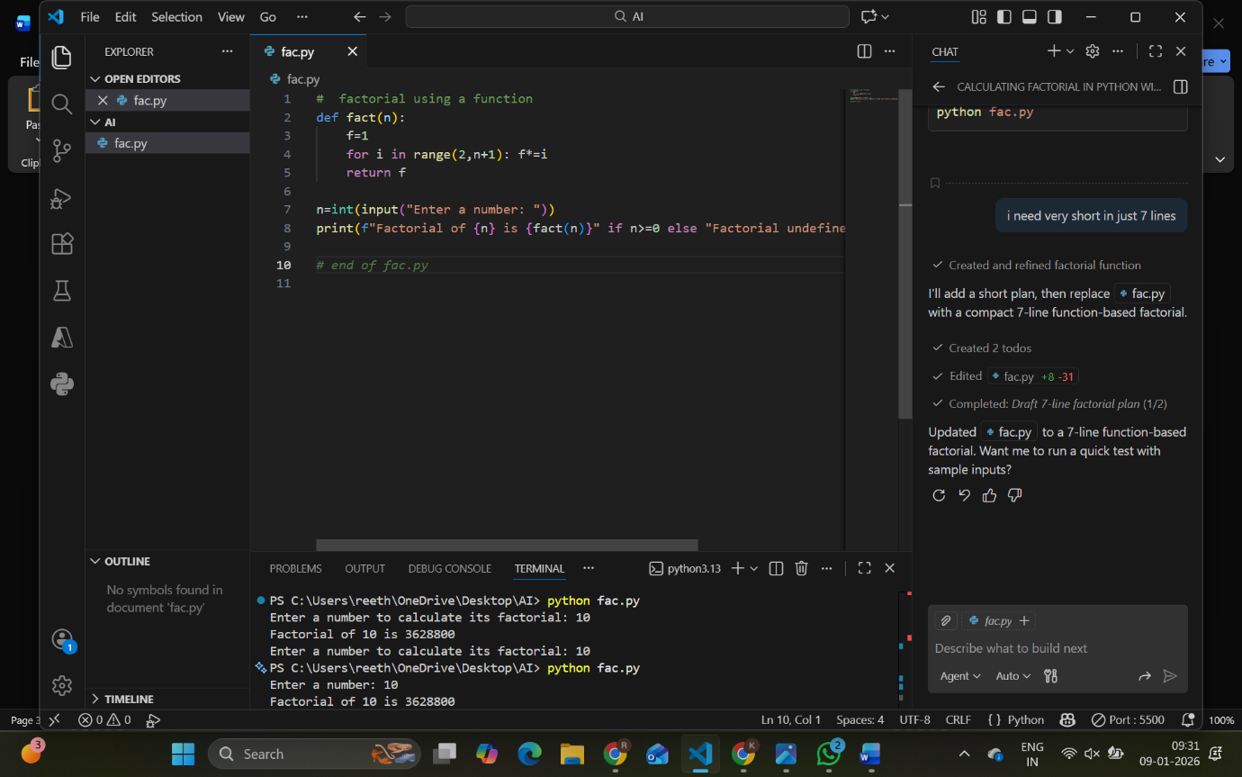

TASK 4
Comparison (Without vs With Functions)
Criteria | Without Function | With Function
Logic clarity | Low | High
Reusability | No | Yes
Debugging | Difficult | Easy
Large projects | Not suitable | Suitable
AI dependency risk | High | Lower

TASK 5
Iterative vs Recursive
