School of Computer Science and Artificial Intelligence

Lab Assignment # 11.5

Program : B. Tech (CSE)
Specialization :AIML
Course Title : AI Assisted Coding
Course Code : 23CS002PC304
Semester : VI
Academic Session : 2025-2026
Name of Student : KOPPULA REETHI LASKHMI
Enrollment No. : 2303A52097
Batch No. : 33
Date :20/02/26

Lab 11 – Data Structures with AI: Implementing Fundamental Structures
Task 1 – Stack Implementation
Prompt:
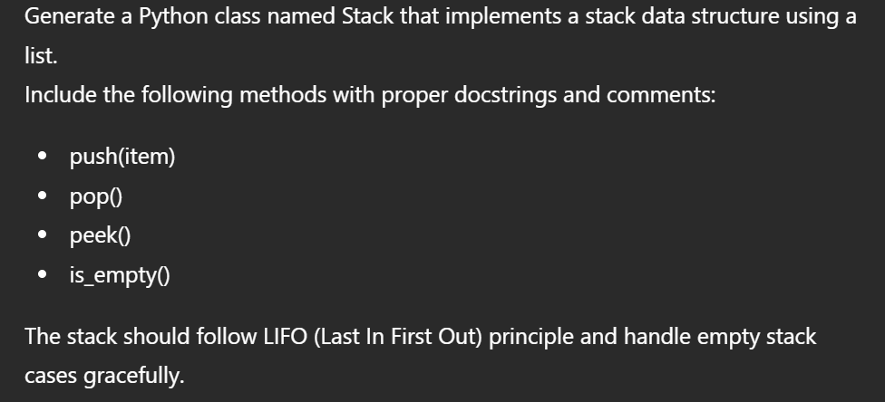
Code:
class Stack:
"""A simple implementation of a Stack data structure using a Python list."""

def __init__(self):
"""Initializes an empty Stack."""
self._items = [] # Internal list to store stack elements

def push(self, item):
"""Adds an item to the top of the stack (LIFO).

Args:
item: The item to be added to the stack.
"""
self._items.append(item)

def pop(self):
"""Removes and returns the item from the top of the stack.

Returns:
The item removed from the top of the stack.

Raises:
IndexError: If the stack is empty when pop is called.
"""
if self.is_empty():
raise IndexError("Cannot pop from an empty stack")
return self._items.pop() # list's pop() removes and returns the last item

def peek(self):
"""Returns the item from the top of the stack without removing it.

Returns:
The item at the top of the stack.

Raises:
IndexError: If the stack is empty when peek is called.
"""
if self.is_empty():
raise IndexError("Cannot peek into an empty stack")
return self._items[-1] # Return the last item without removing it

def is_empty(self):
"""Checks if the stack is empty.

Returns:
True if the stack is empty, False otherwise.
"""
return len(self._items) == 0

def __len__(self):
"""Returns the number of items in the stack."""
return len(self._items)

def __str__(self):
"""Returns a string representation of the stack."""
return f"Stack: {self._items}"

# Example usage:
my_stack = Stack()
print(f"Is stack empty? {my_stack.is_empty()}") # True

my_stack.push(10)
my_stack.push(20)
my_stack.push(30)
print(f"Stack after pushes: {my_stack}") # Stack: [10, 20, 30]
print(f"Top item (peek): {my_stack.peek()}") # 30
print(f"Stack after peek: {my_stack}") # Stack: [10, 20, 30]

popped_item = my_stack.pop()
print(f"Popped item: {popped_item}") # 30
print(f"Stack after pop: {my_stack}") # Stack: [10, 20]

print(f"Is stack empty? {my_stack.is_empty()}") # False

my_stack.pop()
my_stack.pop()
print(f"Stack after more pops: {my_stack}") # Stack: []
print(f"Is stack empty? {my_stack.is_empty()}") # True

# Demonstrating error handling for empty stack
try:
my_stack.pop()
except IndexError as e:
print(f"Error: {e}") # Error: Cannot pop from an empty stack

try:
my_stack.peek()
except IndexError as e:
print(f"Error: {e}") # Error: Cannot peek into an empty stack

Output:
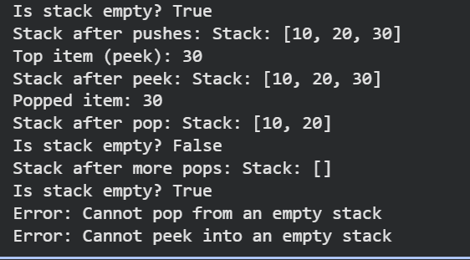
Task 2 – Queue Implementation
Prompt:
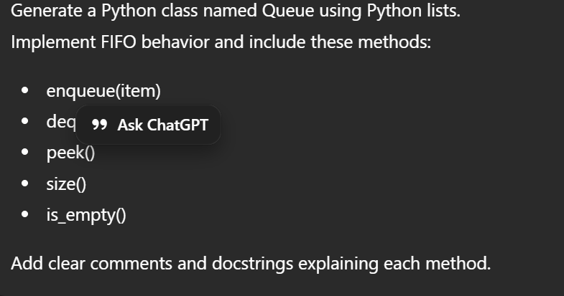
Code:
class Queue:
"""A simple implementation of a Queue data structure using a Python list."""

def __init__(self):
"""Initializes an empty Queue."""
self._items = [] # Internal list to store queue elements

def enqueue(self, item):
"""Adds an item to the rear of the queue (FIFO).

Args:
item: The item to be added to the queue.
"""
self._items.append(item)

def dequeue(self):
"""Removes and returns the item from the front of the queue.

Returns:
The item removed from the front of the queue.

Raises:
IndexError: If the queue is empty when dequeue is called.
"""
if self.is_empty():
raise IndexError("Cannot dequeue from an empty queue")
return self._items.pop(0) # list's pop(0) removes and returns the first item

def peek(self):
"""Returns the item from the front of the queue without removing it.

Returns:
The item at the front of the queue.

Raises:
IndexError: If the queue is empty when peek is called.
"""
if self.is_empty():
raise IndexError("Cannot peek into an empty queue")
return self._items[0] # Return the first item without removing it

def is_empty(self):
"""Checks if the queue is empty.

Returns:
True if the queue is empty, False otherwise.
"""
return len(self._items) == 0

def size(self):
"""Returns the number of items in the queue."""
return len(self._items)

def __str__(self):
"""Returns a string representation of the queue."""
return f"Queue: {self._items}"

# Example usage:
my_queue = Queue()
print(f"Is queue empty? {my_queue.is_empty()}") # True
print(f"Queue size: {my_queue.size()}") # 0

my_queue.enqueue(10)
my_queue.enqueue(20)
my_queue.enqueue(30)
print(f"Queue after enqueues: {my_queue}") # Queue: [10, 20, 30]
print(f"Front item (peek): {my_queue.peek()}") # 10
print(f"Queue after peek: {my_queue}") # Queue: [10, 20, 30]
print(f"Queue size: {my_queue.size()}") # 3

dequeued_item = my_queue.dequeue()
print(f"Dequeued item: {dequeued_item}") # 10
print(f"Queue after dequeue: {my_queue}") # Queue: [20, 30]
print(f"Queue size: {my_queue.size()}") # 2

print(f"Is queue empty? {my_queue.is_empty()}") # False

my_queue.dequeue()
my_queue.dequeue()
print(f"Queue after more dequeues: {my_queue}") # Queue: []
print(f"Is queue empty? {my_queue.is_empty()}") # True
print(f"Queue size: {my_queue.size()}") # 0

# Demonstrating error handling for empty queue
try:
my_queue.dequeue()
except IndexError as e:
print(f"Error: {e}") # Error: Cannot dequeue from an empty queue

try:
my_queue.peek()
except IndexError as e:
print(f"Error: {e}") # Error: Cannot peek into an empty queue
Output:
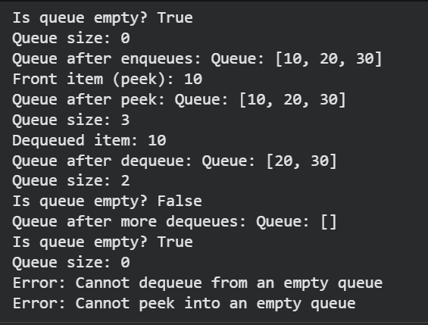
Task 3 – Singly Linked List
Prompt:
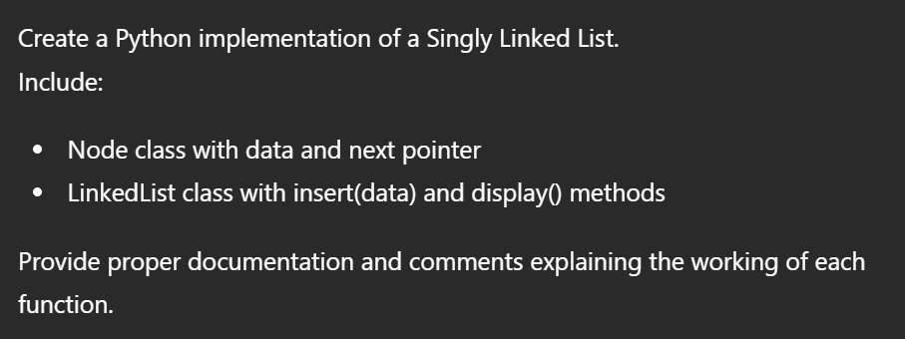
Code:
class Node:
"""Represents a node in a singly linked list."""

def __init__(self, data):
"""Initializes a new node with data and sets the next pointer to None.

Args:
data: The data to be stored in the node.
"""
self.data = data
self.next = None # Pointer to the next node, initially None

class LinkedList:
"""Implements a singly linked list data structure."""

def __init__(self):
"""Initializes an empty linked list with the head pointer set to None."""
self.head = None # The head of the list, initially None

def insert(self, data):
"""Inserts a new node with the given data at the end of the linked list.

If the list is empty, the new node becomes the head.

Args:
data: The data to be inserted into the new node.
"""
new_node = Node(data)
if self.head is None:
self.head = new_node # If list is empty, new node is the head
else:
current = self.head
while current.next:
current = current.next # Traverse to the last node
current.next = new_node # Link the new node to the end

def display(self):
"""Prints the data of all nodes in the linked list from head to tail."""
elements = []
current = self.head
while current:
elements.append(current.data)
current = current.next
print("Linked List: " + " -> ".join(map(str, elements)))

# Example Usage:
my_list = LinkedList()
print("Inserting elements:")
my_list.insert(10)
my_list.insert(20)
my_list.insert(30)
my_list.display()

my_list.insert(40)
my_list.display()

empty_list = LinkedList()
print("Displaying an empty list:")
empty_list.display()
Output:
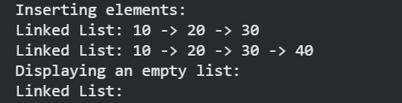

Task 4 – Hash Table
Prompt:
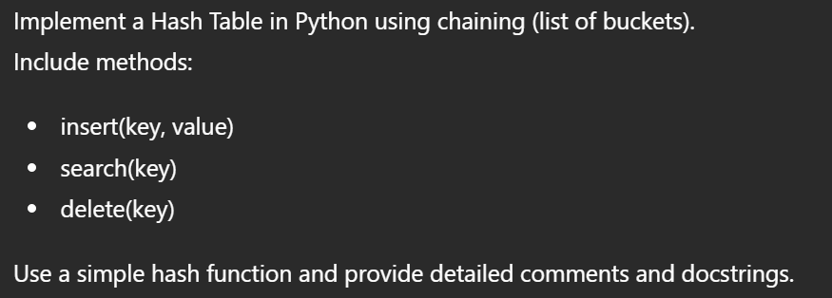
Code:
class HashTable:
"""A simple Hash Table implementation using chaining for collision resolution."""

def __init__(self, size=10):
"""Initializes the Hash Table with a given size.

Args:
size (int): The number of buckets in the hash table.
"""
self.size = size
self.table = [[] for _ in range(self.size)] # Initialize with empty buckets (lists)

def _hash(self, key):
"""A simple hash function that returns an index for the given key.

Args:
key: The key to be hashed.

Returns:
int: The index within the hash table's buckets.
"""
return hash(key) % self.size

def insert(self, key, value):
"""Inserts a key-value pair into the hash table.

If the key already exists, its value is updated.

Args:
key: The key to be inserted.
value: The value associated with the key.
"""
index = self._hash(key)
bucket = self.table[index]

# Check if the key already exists in the bucket
for i, (k, v) in enumerate(bucket):
if k == key:
bucket[i] = (key, value) # Update existing key's value
print(f"Updated key '{key}' at index {index} with new value '{value}'.")
return

# If key does not exist, add the new key-value pair
bucket.append((key, value))
print(f"Inserted ('{key}', '{value}') at index {index}.")

def search(self, key):
"""Searches for a key in the hash table and returns its associated value.

Args:
key: The key to search for.

Returns:
any: The value associated with the key, or None if the key is not found.
"""
index = self._hash(key)
bucket = self.table[index]

for k, v in bucket:
if k == key:
print(f"Found key '{key}' with value '{v}' at index {index}.")
return v
print(f"Key '{key}' not found in hash table.")
return None

def delete(self, key):
"""Deletes a key-value pair from the hash table.

Args:
key: The key to be deleted.

Returns:
bool: True if the key was deleted, False if not found.
"""
index = self._hash(key)
bucket = self.table[index]

for i, (k, v) in enumerate(bucket):
if k == key:
del bucket[i] # Remove the item from the bucket
print(f"Deleted key '{key}' from index {index}.")
return True
print(f"Key '{key}' not found for deletion.")
return False

def display(self):
"""Prints the current state of the hash table."""
print("\n--- Hash Table Contents ---")
for i, bucket in enumerate(self.table):
print(f"Bucket {i}: {bucket}")
print("---------------------------")

# Example Usage:
ht = HashTable(size=5)
ht.display()

print("\n--- Inserting elements ---")
ht.insert("apple", 10)
ht.insert("banana", 20)
ht.insert("cherry", 30)
ht.insert("date", 40)
ht.insert("elderberry", 50)
ht.insert("fig", 60) # This might cause a collision depending on hash function
ht.display()

print("\n--- Searching for elements ---")
ht.search("banana")
ht.search("cherry")
ht.search("grape") # Not found

print("\n--- Updating an element ---")
ht.insert("apple", 100) # Update existing key
ht.display()

print("\n--- Deleting elements ---")
ht.delete("date")
ht.delete("banana")
ht.delete("kiwi") # Not found
ht.display()

print("\n--- Final search after deletion ---")
ht.search("banana") # Should not be found
ht.search("apple") # Should be found
Output:
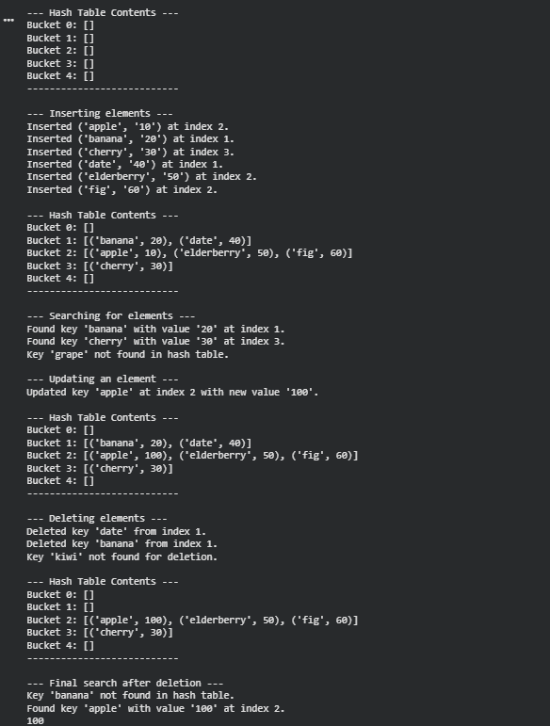

Task 5 – Graph Representation
Prompt:
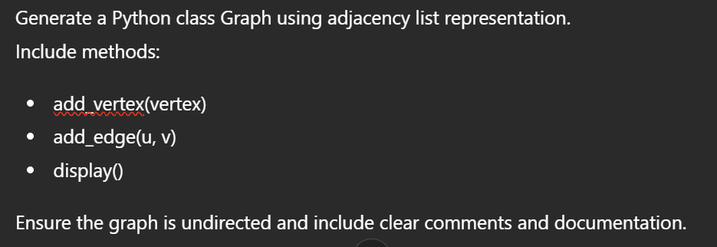
Code:
class Graph:
"""A simple undirected Graph implementation using an adjacency list."""

def __init__(self):
"""Initializes an empty graph with no vertices or edges."""
self.adj_list = {}

def add_vertex(self, vertex):
"""Adds a vertex to the graph if it doesn't already exist.

Args:
vertex: The vertex to be added.
"""
if vertex not in self.adj_list:
self.adj_list[vertex] = []
print(f"Added vertex: {vertex}")
else:
print(f"Vertex {vertex} already exists.")

def add_edge(self, u, v):
"""Adds an undirected edge between two vertices u and v.

If u or v do not exist, they are added to the graph first.

Args:
u: The first vertex of the edge.
v: The second vertex of the edge.
"""
# Ensure both vertices exist in the graph
if u not in self.adj_list:
self.add_vertex(u)
if v not in self.adj_list:
self.add_vertex(v)

# Add edge (u, v) and (v, u) for an undirected graph
if v not in self.adj_list[u]:
self.adj_list[u].append(v)
print(f"Added edge: {u} -- {v}")
else:
print(f"Edge {u} -- {v} already exists.")

if u not in self.adj_list[v]: # Ensure the reverse edge is also added
self.adj_list[v].append(u)

def display(self):
"""Prints the adjacency list representation of the graph."""
print("\n--- Graph Adjacency List ---")
if not self.adj_list:
print("Graph is empty.")
return

for vertex, neighbors in self.adj_list.items():
print(f"{vertex}: {neighbors}")
print("---------------------------")

# Example Usage:
g = Graph()
g.display()

print("\n--- Adding vertices ---")
g.add_vertex('A')
g.add_vertex('B')
g.add_vertex('C')
g.add_vertex('A') # Try adding existing vertex
g.display()

print("\n--- Adding edges ---")
g.add_edge('A', 'B')
g.add_edge('B', 'C')
g.add_edge('C', 'A')
g.add_edge('D', 'A') # D will be added automatically
g.add_edge('A', 'B') # Try adding existing edge
g.display()

print("\n--- Graph with isolated vertex ---")
g.add_vertex('E')
g.display()
Output:
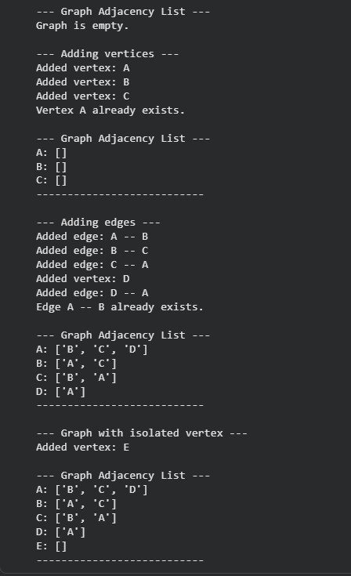
Task 6 – Smart Hospital Management System
Prompt:
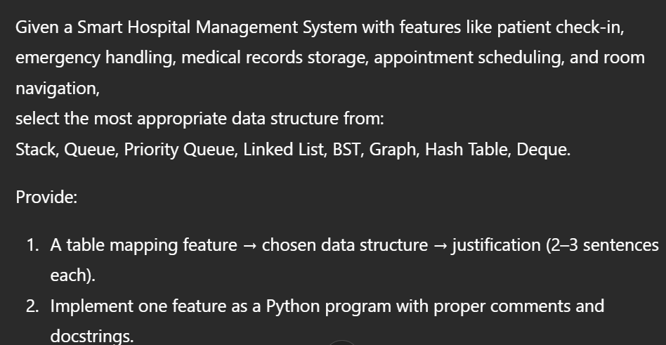
Code:
class EmergencyHandling:
"""Manages emergency patient handling using a priority queue.

Patients are added with a priority, and the system can handle the next
highest priority patient or check the current queue status.
Higher priority numbers indicate a more critical patient.
"""

def __init__(self):
"""Initializes an empty emergency handling queue."""
# Stores patients as tuples: (priority, patient_name)
# Higher numbers mean higher priority
self._patients = []
print("Emergency Handling System Initialized.")

def add_patient(self, patient_name, priority):
"""Adds a new patient to the emergency queue with a specified priority.

Args:
patient_name (str): The name of the patient.
priority (int): The priority level of the patient. Higher numbers
indicate higher criticality (e.g., 5 > 1).
"""
if not isinstance(priority, int) or priority < 0:
print(f"Warning: Invalid priority '{priority}' for patient '{patient_name}'. Priority must be a non-negative integer.")
return
self._patients.append((priority, patient_name))
print(f"Added patient '{patient_name}' with priority {priority}.")

def handle_next_patient(self):
"""Identifies, removes, and returns the patient with the highest priority.

If the queue is empty, an IndexError is raised.

Returns:
str: The name of the patient with the highest priority.

Raises:
IndexError: If the emergency queue is empty.
"""
if not self._patients:
raise IndexError("No patients in the queue to handle.")

# Find the patient with the highest priority
highest_priority = -1
patient_to_handle_index = -1

for i, (priority, patient_name) in enumerate(self._patients):
if priority > highest_priority:
highest_priority = priority
patient_to_handle_index = i
# If priorities are equal, the patient who arrived earlier (lower index) is handled first
# This is implicitly handled by iterating from start to end and only updating if > highest_priority

# Remove and return the patient
# pop() returns the item at the specified index
handled_patient = self._patients.pop(patient_to_handle_index)
print(f"Handling patient '{handled_patient[1]}' with priority {handled_patient[0]}.")
return handled_patient[1]

def check_status(self):
"""Returns a list of patients in the queue, ordered by priority (highest first).

Returns:
list: A list of patient names, or a message if the queue is empty.
"""
if not self._patients:
return "No patients currently in the queue."

# Sort patients by priority in descending order (highest priority first)
# If priorities are equal, their original insertion order (stable sort) is maintained.
sorted_patients = sorted(self._patients, key=lambda x: x[0], reverse=True)

status_list = [patient_name for priority, patient_name in sorted_patients]
print("Current queue status (highest priority first):")
for patient in status_list:
print(f"- {patient}")
return status_list

# Example Usage:
print("\n--- Initializing Emergency Handling System ---")
emergency_queue = EmergencyHandling()

print("\n--- Adding Patients ---")
emergency_queue.add_patient("Alice", 3)
emergency_queue.add_patient("Bob", 5) # Bob is more critical
emergency_queue.add_patient("Charlie", 2)
emergency_queue.add_patient("David", 5) # David has same priority as Bob
emergency_queue.add_patient("Eve", 1)

print("\n--- Checking Status ---")
emergency_queue.check_status()

print("\n--- Handling Patients ---")
try:
emergency_queue.handle_next_patient() # Should be Bob (priority 5)
emergency_queue.check_status()
emergency_queue.handle_next_patient() # Should be David (priority 5, arrived after Bob)
emergency_queue.check_status()
emergency_queue.handle_next_patient() # Should be Alice (priority 3)
emergency_queue.check_status()
except IndexError as e:
print(f"Error: {e}")

print("\n--- Adding more patients and handling ---")
emergency_queue.add_patient("Frank", 4)
emergency_queue.add_patient("Grace", 3)
emergency_queue.check_status()
emergency_queue.handle_next_patient() # Should be Frank (priority 4)
emergency_queue.handle_next_patient() # Should be Grace (priority 3)
emergency_queue.handle_next_patient() # Should be Charlie (priority 2)
emergency_queue.handle_next_patient() # Should be Eve (priority 1)

print("\n--- Checking status after all patients handled ---")
print(emergency_queue.check_status())

print("\n--- Attempting to handle patient from empty queue ---")
try:
emergency_queue.handle_next_patient()
except IndexError as e:
print(f"Error: {e}")

Output:
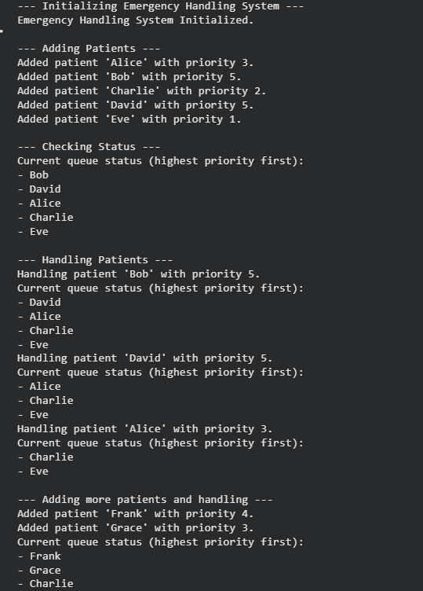
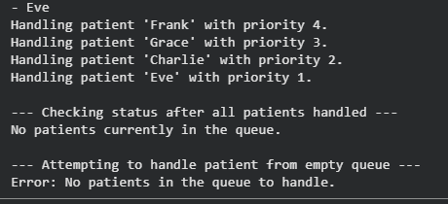
Task 7 – Smart City Traffic Control System
Prompt:
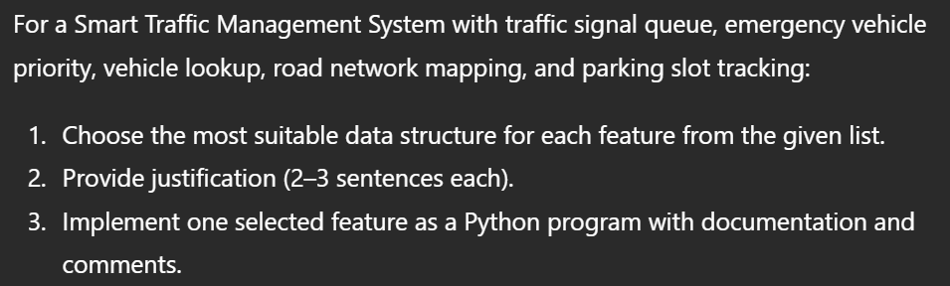
Code:
class EmergencyVehiclePriority:
"""Manages emergency vehicle priority using a custom priority queue logic.

Vehicles are added with a priority, and the system can identify and handle
the next highest priority vehicle, or check the current queue status.
Higher priority numbers indicate a more critical or urgent vehicle.
"""

def __init__(self):
"""Initializes an empty emergency vehicle queue."""
# Stores vehicles as tuples: (priority, vehicle_name)
# Higher numbers mean higher priority. We use a list to maintain
# insertion order for tie-breaking.
self._vehicles = []
print("Emergency Vehicle Priority System Initialized.")

def add_vehicle(self, vehicle_name, priority):
"""Adds a new emergency vehicle to the queue with a specified priority.

Args:
vehicle_name (str): The name or identifier of the vehicle.
priority (int): The priority level of the vehicle. Higher numbers
indicate higher criticality (e.g., 5 > 1).
"""
if not isinstance(priority, int) or priority < 0:
print(f"Warning: Invalid priority '{priority}' for vehicle '{vehicle_name}'. Priority must be a non-negative integer.")
return
self._vehicles.append((priority, vehicle_name))
print(f"Added vehicle '{vehicle_name}' with priority {priority}.")

def handle_next_vehicle(self):
"""Identifies, removes, and returns the vehicle with the highest priority.

In case of a tie in priority, the vehicle that was added earliest (first occurrence
in the internal list) is selected.

Returns:
str: The name of the vehicle with the highest priority.

Raises:
IndexError: If the emergency vehicle queue is empty.
"""
if not self._vehicles:
raise IndexError("No vehicles in the queue to handle.")

highest_priority = -1
vehicle_to_handle_index = -1

# Iterate to find the highest priority vehicle, respecting insertion order for ties.
# The first vehicle encountered with the highest priority will be chosen.
for i, (priority, vehicle_name) in enumerate(self._vehicles):
if priority > highest_priority:
highest_priority = priority
vehicle_to_handle_index = i

# Remove and return the vehicle using its index
handled_vehicle = self._vehicles.pop(vehicle_to_handle_index)
print(f"Handling vehicle '{handled_vehicle[1]}' with priority {handled_vehicle[0]}.")
return handled_vehicle[1]

def check_status(self):
"""Returns a list of vehicles currently in the queue, ordered by priority (highest first).

If priorities are equal, their original insertion order is maintained (stable sort).

Returns:
list: A list of vehicle names (strings) currently in the queue, sorted by priority.
Returns a descriptive string if the queue is empty.
"""
if not self._vehicles:
return "No vehicles currently in the queue."

# Sort vehicles by priority in descending order (highest priority first).
# Python's Timsort is stable, so original insertion order is preserved for equal priorities.
sorted_vehicles = sorted(self._vehicles, key=lambda x: x[0], reverse=True)

status_list = [vehicle_name for priority, vehicle_name in sorted_vehicles]
print("Current vehicle queue status (highest priority first):")
for vehicle in status_list:
print(f"- {vehicle}")
return status_list

# Example Usage:
print("\n--- Initializing Emergency Vehicle Priority System ---")
vehicle_queue = EmergencyVehiclePriority()

print("\n--- Adding Vehicles ---")
vehicle_queue.add_vehicle("Ambulance 1", 3)
vehicle_queue.add_vehicle("Fire Truck 1", 5) # Highest priority
vehicle_queue.add_vehicle("Police Car 1", 2)
vehicle_queue.add_vehicle("Ambulance 2", 5) # Same priority as Fire Truck 1
vehicle_queue.add_vehicle("Emergency Response Van", 1)

print("\n--- Checking Status ---")
vehicle_queue.check_status()

print("\n--- Handling Vehicles ---")
try:
vehicle_queue.handle_next_vehicle() # Should be Fire Truck 1 (priority 5, added earlier)
vehicle_queue.check_status()
vehicle_queue.handle_next_vehicle() # Should be Ambulance 2 (priority 5)
vehicle_queue.check_status()
vehicle_queue.handle_next_vehicle() # Should be Ambulance 1 (priority 3)
vehicle_queue.check_status()
except IndexError as e:
print(f"Error: {e}")

print("\n--- Adding more vehicles and handling ---")
vehicle_queue.add_vehicle("Fire Truck 2", 4)
vehicle_queue.add_vehicle("Police Car 2", 3)
vehicle_queue.check_status()
vehicle_queue.handle_next_vehicle() # Should be Fire Truck 2 (priority 4)
vehicle_queue.handle_next_vehicle() # Should be Police Car 2 (priority 3)
vehicle_queue.handle_next_vehicle() # Should be Police Car 1 (priority 2)
vehicle_queue.handle_next_vehicle() # Should be Emergency Response Van (priority 1)

print("\n--- Checking status after all vehicles handled ---")
print(vehicle_queue.check_status())

print("\n--- Attempting to handle vehicle from empty queue ---")
try:
vehicle_queue.handle_next_vehicle()
except IndexError as e:
print(f"Error: {e}")
Output:
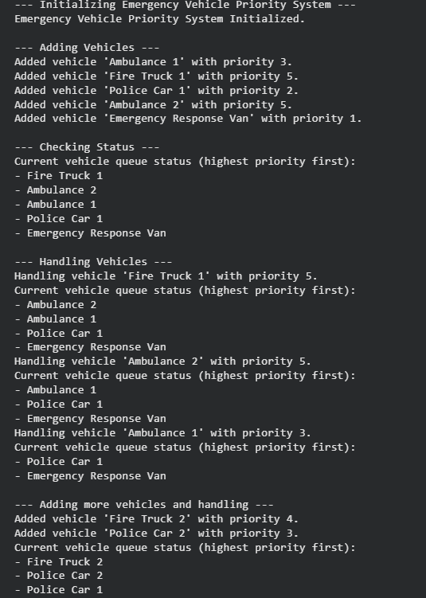
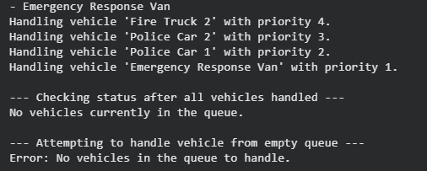
Task 8 – Smart E-Commerce Platform
Prompt:
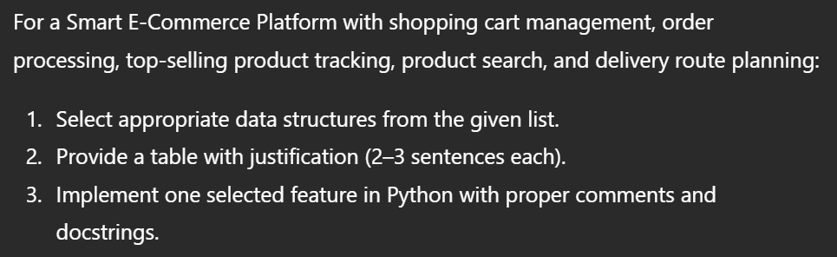
Code:
class ShoppingCart:
"""Manages a shopping cart using a hash table (Python dictionary).

Provides methods to add, remove, update quantities, and view items in the cart.
"""

def __init__(self):
"""Initializes an empty shopping cart.

The cart is represented as a dictionary where keys are product_ids
and values are dictionaries containing 'name' and 'quantity'.
"""
self._items = {}
print("Shopping cart initialized.")

def add_item(self, product_id, name, quantity):
"""Adds an item to the cart or updates its quantity if it already exists.

Args:
product_id (str): A unique identifier for the product.
name (str): The name of the product.
quantity (int): The quantity of the product to add.
"""
if quantity <= 0:
print(f"Warning: Cannot add non-positive quantity ({quantity}) for product ID '{product_id}'.")
return

if product_id in self._items:
self._items[product_id]['quantity'] += quantity
print(f"Updated quantity for '{name}' (ID: {product_id}). New quantity: {self._items[product_id]['quantity']}.")
else:
self._items[product_id] = {'name': name, 'quantity': quantity}
print(f"Added '{name}' (ID: {product_id}) with quantity {quantity} to the cart.")

def remove_item(self, product_id):
"""Removes an item completely from the cart.

Args:
product_id (str): The unique identifier of the product to remove.
"""
if product_id in self._items:
item_name = self._items[product_id]['name']
del self._items[product_id]
print(f"Removed '{item_name}' (ID: {product_id}) from the cart.")
else:
print(f"Item with product ID '{product_id}' not found in the cart.")

def update_quantity(self, product_id, new_quantity):
"""Updates the quantity of an existing item in the cart.

If `new_quantity` is 0 or less, the item is removed from the cart.

Args:
product_id (str): The unique identifier of the product to update.
new_quantity (int): The new quantity for the product.
"""
if product_id in self._items:
item_name = self._items[product_id]['name']
if new_quantity <= 0:
self.remove_item(product_id)
print(f"Quantity for '{item_name}' (ID: {product_id}) set to {new_quantity}. Item removed.")
else:
self._items[product_id]['quantity'] = new_quantity
print(f"Updated quantity for '{item_name}' (ID: {product_id}). New quantity: {new_quantity}.")
else:
print(f"Item with product ID '{product_id}' not found in the cart. Cannot update quantity.")

def view_cart(self):
"""Displays the current contents of the shopping cart.

If the cart is empty, a message indicating this is printed.
"""
print("\n--- Current Shopping Cart Contents ---")
if not self._items:
print("The cart is currently empty.")
else:
for product_id, details in self._items.items():
print(f" Product ID: {product_id}, Name: {details['name']}, Quantity: {details['quantity']}")
print("------------------------------------")

# Example Usage:
print("\n--- Initializing Shopping Cart ---")
my_cart = ShoppingCart()
my_cart.view_cart()

print("\n--- Adding Items ---")
my_cart.add_item("P001", "Laptop", 1)
my_cart.add_item("P002", "Mouse", 2)
my_cart.add_item("P003", "Keyboard", 1)
my_cart.add_item("P001", "Laptop", 1) # Add existing item to increase quantity
my_cart.view_cart()

my_cart.add_item("P004", "Monitor", 0) # Attempt to add with non-positive quantity

print("\n--- Updating Item Quantities ---")
my_cart.update_quantity("P002", 5) # Increase quantity
my_cart.update_quantity("P003", 0) # Decrease to zero, should remove
my_cart.update_quantity("P999", 3) # Update non-existent item
my_cart.view_cart()

print("\n--- Removing Items ---")
my_cart.remove_item("P001") # Remove an existing item
my_cart.remove_item("P999") # Remove a non-existent item
my_cart.view_cart()

print("\n--- Final Cart Status ---")
my_cart.update_quantity("P002", 0) # Remove last item
my_cart.view_cart()
Output:
