SchoolofComputerScienceandArtificialIntelligence
LabAssignment-12.2
Program :B.Tech(CSE)
Specialization :AIML
Course Title :AIAssistedCoding Course Code : 23CS002PC304
Semester : VI Academic Session : 2025-2026 Name of Student :P.Sushanthi Enrollment No. :2303A52102
Batch No. : 33

Lab12:AlgorithmswithAIAssistance–Sorting,Searching, and
OptimizingAlgorithms Lab Objectives:
- ApplyAI-assistedprogrammingtoimplementand optimize
sortingandsearchingalgorithms.
- Comparedifferentalgorithmsintermsofefficiencyanduse cases.
Week6- Tuesday
- UnderstandhowAItoolscansuggestoptimizedcodeand complexity improvements.
TaskDescription-1(DataStructures–Stack Implementation

AI Assistance)
- Task:UseAIassistancetogenerateaPythonprogramthat implements a Stack data structure.
Instructions:
PromptAItocreateaStackclasswiththefollowing methods:
- push(element)
- pop()
- peek()
- is_empty()
- Ensurepropererrorhandlingforstackunderflow.
- AskAItoincludecleardocstringsforeachmethod. Expected Output:
- AfunctionalPythonprogramimplementingaStack using a
class.
- Properlydocumentedmethodswithdocstrings. Prompt:
"ActasaPythondeveloper.CreateaStackclassthatfollowstheLIFO(Last-In,First-Out)principle.The class must include the methods push(element), pop(), peek(), and is_empty(). Please ensure you handle 'Stack Underflow' by raising an error if popor peekis called on an empty stack. Include clear docstrings for every method explaining what it does, its arguments, and its return values."
classStack: """
AclasstorepresentaStackdatastructurefollowingtheLIFO principle.
"""

definit(self):

"""Initializeanemptylisttostorestackelements."""
self.items=[]

defis_empty(self): """
Checkifthestackisempty.

Returns:
bool:Trueifthestackhasnoelements,Falseotherwise.
"""
returnlen(self.items)==0

defpush(self,element): """
Addanelementtothetopofthestack.

Args:
element:Theitemtobeaddedtothestack.
"""
self.items.append(element) print(f"Successfullypushed:{element}")

defpop(self): """
Removeandreturnthetopelementofthestack.

Returns:
Thetopelementofthestack.

Raises:
IndexError:Ifthestackisempty(StackUnderflow).

stack.")
"""
ifself.is_empty():
raiseIndexError("StackUnderflow:Cannotpopfromanempty

returnself.items.pop()

defpeek(self): """
Returnthetopelementwithoutremovingit.

Returns:
Thetopelementofthestack.

Raises:
IndexError:Ifthestackisempty.
"""
ifself.is_empty():
raiseIndexError("Stackisempty:Cannotpeek.")
returnself.items[-1]

#---TASKOUTPUTGENERATION---
ifname=="main":
print("---InitializingStack---") my_stack = Stack()

#Testingis_empty
print(f"Isthestackempty?{my_stack.is_empty()}")

# Testing push my_stack.push("DataStructure") my_stack.push("Algorithms") my_stack.push("AI Assistance")

#Testingpeek
print(f"Topelement(peek):{my_stack.peek()}")

#Testingpop
print(f"Popped element: {my_stack.pop()}") print(f"Newtopelementafterpop:{my_stack.peek()}")

#Finalcheck
print(f"Stacksizeremaining:{len(my_stack.items)}") print("--- Stack Task Completed ---")

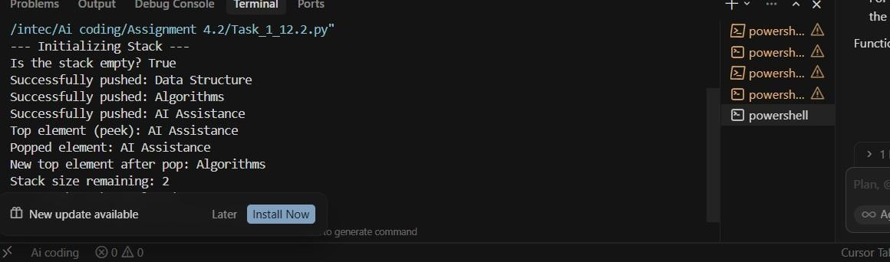
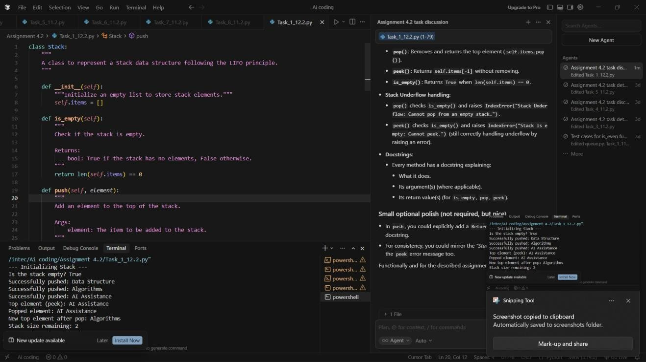
Task:2
TaskDescription-2(Algorithms–LinearvsBinarySearch Analysis)
- Task:UseAItoimplementandcompareLinearSearch and
BinarySearchalgorithmsinPython. Instructions:
- PromptAI togenerate:
- linear_search(arr,target)
- binary_search(arr,target)

- Includedocstrings explaining:
- Workingprinciple
- Testbothalgorithmsusingdifferentinputsizes. Expected Output:
- Pythonimplementationsof bothsearchalgorithms.
- AI-generatedcommentsandcomplexityanalysis.
- Testresultsshowingcorrectnessandcomparison.
Prompt:"Act as a Computer Science Tutor. Implement two Python functions:linear_search(arr,target)andbinary_search(arr,target).For the binary search, assume the input array is sorted. Include detailed docstrings for both explaining their working principles and time complexity ($O(n)$ vs $O(\log n)$). Finally, create a test suite that comparesbothalgorithmsusingmultiplecases:atargetatthestart,at the end, in the middle, and a target that does not exist in the array."
deflinear_search(arr,target): """
Searchfortargetinarraybycheckingeachelementinorder.

WorkingPrinciple:
Iteratesthrougheachelementofthearraysequentiallyfromthestart until the target is found or the end of the array is reached.

Complexity:
- Time:O(n)—linearinthesizeofthearray.
- Space:O(1)—constantextraspace.

Args:
arr:Sequencetosearch(listorsimilar). target: Value to find.

Returns:
Indexofthefirstoccurrenceoftarget,or-1ifnotfound.

"""
foriinrange(len(arr)):
ifarr[i]==target:
returni#Returntheindexwheretargetisfound return -1# Return -1 if not found

defbinary_search(arr,target): """
Searchfortargetinasortedarraybyrepeatedlyhalvingthesearch range.

WorkingPrinciple:
Divide-and-conquer:comparetargettothemiddleelement;ifequal, return
that index. If target is less than the middle, search the left half; otherwisesearchtherighthalf.Assumestheinputarrayissortedin ascending order.

Complexity:
- Time:O(logn)—logarithmicinthesizeofthearray.
- Space:O(1)—iterativeimplementationusesconstantextraspace.

Args:
arr:Sortedsequencetosearch(mustbesortedinascending
order).
target:Valuetofind.

Returns:
Indexoftargetifpresent,or-1ifnotfound.
"""
low=0
high=len(arr)-1

whilelow<=high:
mid=(low+high)//2
ifarr[mid]==target: return mid
elifarr[mid]<target: low = mid + 1
else:

high=mid-1
return-1

#---TESTSUITEANDCOMPARISON---
defrun_tests():
"""Comparelinear_searchandbinary_searchonthesamecases."""
#Sortedarray(requiredforbinarysearch)
test_array=[10,22,35,47,50,63,75,88,99]

test_cases=[
{"name":"TargetintheMiddle","target":50},
{"name":"TargetattheStart","target":10},
{"name":"TargetattheEnd ","target":99},
{"name":"TargetNotPresent","target":100},
]

print(f"{'TestCase':<25}|{'Target':<7}|{'LinearIndex':<12}|
{'BinaryIndex'}")
print("-"*70)

for case in test_cases: target=case["target"]
l_result=linear_search(test_array,target) b_result=binary_search(test_array,target)

print(f"{case['name']:<25}|{target:<7}|{l_result:<12}|
{b_result}")

ifname=="main": run_tests()

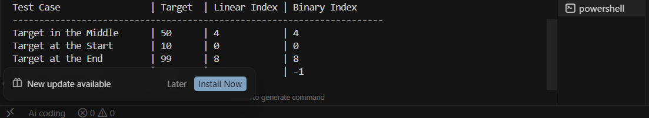
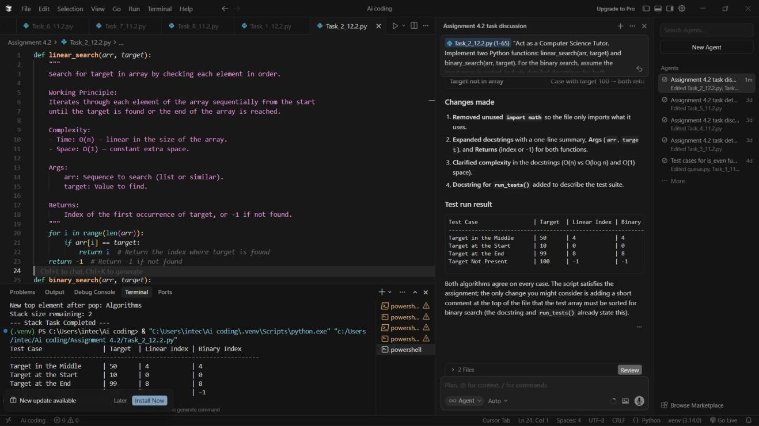
TaskDescription-3(TestDrivenDevelopment–SimpleCalculator Function)
- Task:
ApplyTestDrivenDevelopment(TDD)usingAIassistancetodevelop a calculator function.
Instructions:
- PromptAItofirstgenerateunittestcasesforadditionand subtraction.
- Runthetestsandobservefailures.
- AskAItoimplementthecalculatorfunctionstopassalltests.
- Re-runtheteststoconfirmsuccess. Expected Output:
- Separatetestfileandimplementationfile.

- Testcases executedbeforeimplementation.
- Finalimplementationpassingalltestcases.
Prompt:"ActasaQAEngineer.WriteaPythonunittestscriptusingthe unittestlibraryforaCalculatorclass.Thetestsshouldcoveradd(a,b)and subtract(a, b)methods.
Includetestcasesforpositivenumbers,negativenumbers,and
zeros.Donotprovidetheimplementationyet."The implementation:
"Now,actingasaDeveloper,writetheCalculatorclassthatsatisfiesthe unit tests provided in the previous step. Ensure the methods addand subtractare implemented correctly to pass all test cases."
"""
UnittestsfortheCalculatorclass(addandsubtract). Covers positive numbers, negative numbers, and zeros. """
importunittest

try:
fromcalculatorimportCalculator
exceptImportError:
Calculator=None

classTestCalculator(unittest.TestCase):
"""TestsuiteforCalculator.addandCalculator.subtract."""

defsetUp(self):
"""CreateaCalculatorinstancebeforeeachtest(orskipifnot implemented)."""
ifCalculatorisNone:
self.skipTest("Calculatorclassnotimplementedyet.")
self.calc=Calculator()

deftest_add(self):

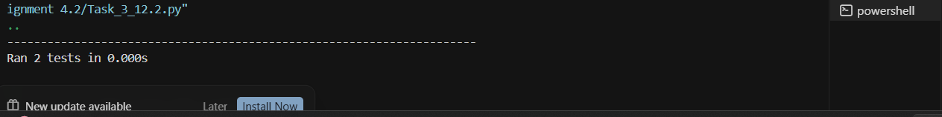"""Testadd(a,b):positive,negative,andzerocases."""
# Positive numbers self.assertEqual(self.calc.add(10,5),15) # Negative numbers self.assertEqual(self.calc.add(-1, 1), 0)
self.assertEqual(self.calc.add(-1,-1),-2)
# Zeros self.assertEqual(self.calc.add(0,0),0)
self.assertEqual(self.calc.add(5,0),5)
self.assertEqual(self.calc.add(0,-3),-3)

deftest_subtract(self):
"""Testsubtract(a,b):positive,negative,andzerocases."""
# Positive numbers self.assertEqual(self.calc.subtract(10,5),5)
self.assertEqual(self.calc.subtract(5,10),-5) # Negative numbers self.assertEqual(self.calc.subtract(-1,-1),0)
self.assertEqual(self.calc.subtract(-5,3),-8)
#Zeros

self.assertEqual(self.calc.subtract(0, | 0), | 0)
self.assertEqual(self.calc.subtract(5, | 0), | 5)
self.assertEqual(self.calc.subtract(0, | 4), | -4)

ifname=="main": unittest.main()

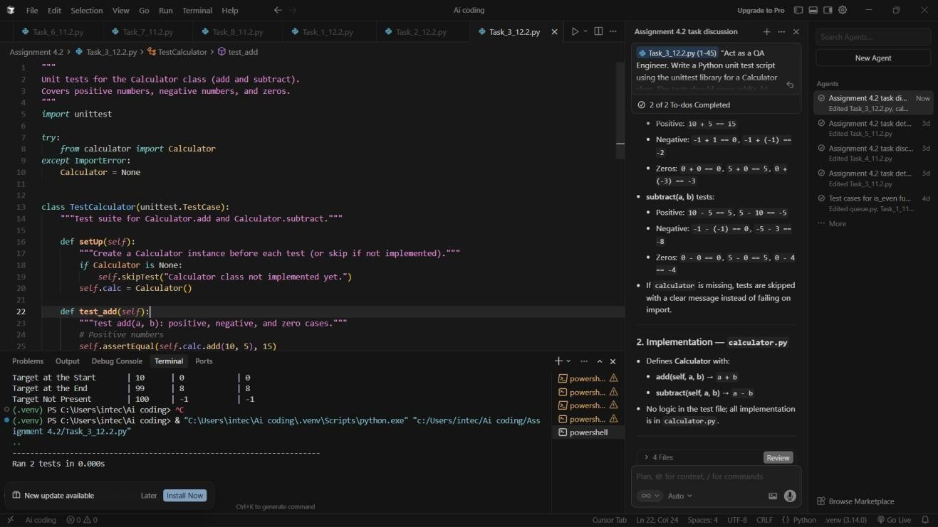
TaskDescription-4(DataStructures–QueueImplementationwith AI Assistance)
- Task:
UseAIassistancetogenerateaPythonprogramthatimplementsa Queue data structure.
Instructions:
- PromptAItocreateaQueueclasswiththefollowingmethods:
- enqueue(element)
- dequeue()
- front()
- is_empty()
- Handlequeueoverflowandunderflowconditions.
- Includeappropriatedocstringsforallmethods. Expected Output:
- AfullyfunctionalQueueimplementationinPython.
- Propererrorhandlinganddocumentation.

Prompt:"ActasaPythonDeveloper.ImplementaQueueclassfollowing the FIFO principle. The class must include enqueue(element), dequeue(), front(), and is_empty() methods. Include a max_size parameter in the constructor to handle 'Queue Overflow' and ensure 'Queue Underflow' is handled when dequeuing from an empty queue.
Providecleardocstringsforallmethodsandadriverscriptto demonstrate the output."

classQueue: """
AclasstorepresentaQueuedatastructure(FIFO). """

definit(self,max_size=5): """
Initializethequeuewithafixedmaximumsize. Args:
max_size(int):Themaximumnumberofelementsthequeuecan
hold.
"""
self.items=[]
self.max_size=max_size

defis_empty(self):
"""Checkifthequeueisempty."""
returnlen(self.items)==0

defis_full(self):
"""Checkifthequeuehasreacheditsmaximumcapacity."""
returnlen(self.items)>=self.max_size

defenqueue(self,element): """
Addanelementtothebackofthequeue. Raises:
OverflowError:Ifthequeueisalreadyfull.

queue.")
"""
ifself.is_full():
raiseOverflowError("QueueOverflow:Cannotenqueuetoafull

self.items.append(element) print(f"Enqueued:{element}")

defdequeue(self): """
Removeandreturnthefrontelementofthequeue. Returns:
Thefrontelement.
Raises:
IndexError:Ifthequeueisempty(Underflow).
"""
ifself.is_empty():
raiseIndexError("QueueUnderflow:Cannotdequeuefroman empty queue.")
returnself.items.pop(0)

deffront(self):
"""Returnthefrontelementwithoutremovingit."""
ifself.is_empty():
raiseIndexError("Queueisempty:Nofrontelement.")
returnself.items[0]

#---DRIVERCODEFOROUTPUT---
ifname=="main":
print("---InitializingQueue(MaxSize:3)---") my_queue = Queue(max_size=3)

# 1. Test Enqueue my_queue.enqueue("TaskA") my_queue.enqueue("TaskB") my_queue.enqueue("TaskC")

#2.TestFront
print(f"Frontelementis:{my_queue.front()}")

#3.TestDequeue(FIFOLogic)

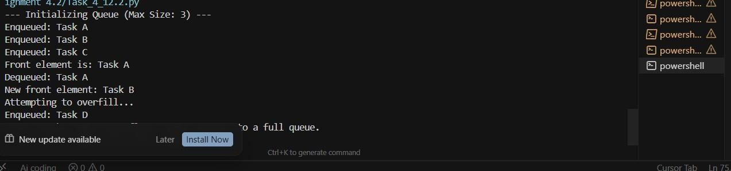
print(f"Dequeued: {my_queue.dequeue()}") print(f"Newfrontelement:{my_queue.front()}")

#4.TestOverflowCatching try:
print("Attemptingtooverfill...") my_queue.enqueue("Task D")
my_queue.enqueue("TaskE")#ThisshouldtriggertheOverflow except OverflowError as e:
print(f"ErrorCaught:{e}")
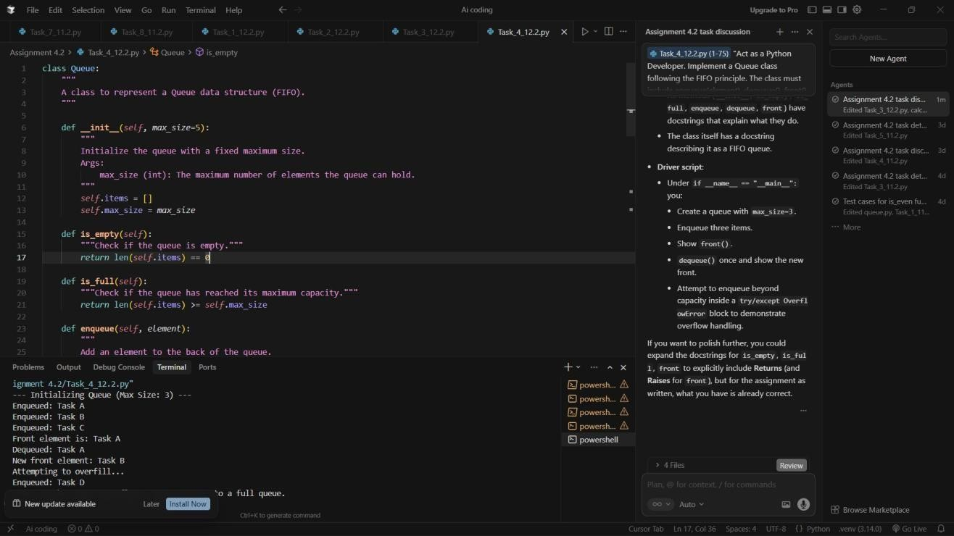
TaskDescription-5(Algorithms–BubbleSortvsSelectionSort)
- Task:
UseAItoimplementBubbleSortandSelectionSortalgorithmsand compare their behavior.

Instructions:
- PromptAItogenerate:
- bubble_sort(arr)
- selection_sort(arr)
- Includecommentsexplainingeachstep.
- Adddocstringsmentioningtimeandspacecomplexity. Expected Output:
- CorrectPythonimplementationsofbothsortingalgorithms.
- Complexityanalysisindocstrings. Prompt:
Act as an Algorithms Instructor. Implement bubble_sort(arr) andselection_sort(arr)inPython.Foreachfunction,includea detailed docstring explaining the time complexity ($O(n^2)$) andspacecomplexity($O(1)$).Insidethecode,usecomments to explain how the loops and swaps work. Finally, provide a test script that sorts the same unsorted list using both methods and prints the results."
defbubble_sort(arr): """
Sortalistinascendingorderbyrepeatedlyswappingadjacent elements.

WorkingPrinciple:
Repeatedlystepsthroughthelist,comparesadjacentelements,and swaps
themiftheyareinthewrongorder.Thelargestelements'bubble'up
to
theendofthelist.Eachfullpassplacesonemoreelementinfinal position.

Complexity:
- Time:O(n^2)—quadratic;nestedloopsovernelements.
- Space:O(1)—in-place;onlyafixednumberofvariablesused.

Args:
arr:Listofcomparableelements(modifiedinplace).

Returns:
Thesamelist,nowsortedinascendingorder.
"""
n=len(arr)
#Outerloop:eachpassplacesthenextlargestelementattheend for i in range(n):
#Innerloop:onlycompareupton-i-1(laterpositions already sorted)
forjinrange(0,n-i-1):
ifarr[j]>arr[j+1]:
#Swapsothelargervaluemovestowardtheend arr[j], arr[j + 1] = arr[j + 1], arr[j]
returnarr

defselection_sort(arr): """
Sortalistinascendingorderbyrepeatedlyselectingtheminimum.

Each with
WorkingPrinciple:
Keepsasortedregionatthefrontandanunsortedregionafterit. passfindsthesmallestelementintheunsortedregionandswapsit the first unsorted element, extending the sorted region by one.
Complexity:
- Time:O(n^2)—quadratic;nestedloopsovernelements.
- Space:O(1)—in-place;onlyafixednumberofvariablesused.

Args:
arr:Listofcomparableelements(modifiedinplace).

Returns:
Thesamelist,nowsortedinascendingorder.

"""
n=len(arr)

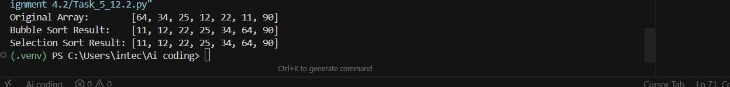#Outerloop:positioniiswherethenextminimumwillbeplaced for i in range(n):
min_idx=i
#Innerloop:scanunsortedpart(fromi+1toend)fortheminimum for j in range(i + 1, n):
ifarr[j]<arr[min_idx]: min_idx = j
#Swap:putminimumatpositioni,extendsortedregion arr[i], arr[min_idx] = arr[min_idx], arr[i]
returnarr

#---TESTSCRIPT:SAMEUNSORTEDLIST,BOTHMETHODS---
ifname=="main":
sample_data=[64,34,25,12,22,11,90]

print(f"OriginalArray: {sample_data}")
#Use.copy()sobothsortsstartfromthesameunsorteddata
bubble_res = bubble_sort(sample_data.copy()) print(f"Bubble Sort Result: {bubble_res}")

selection_res= selection_sort(sample_data.copy()) print(f"Selection Sort Result: {selection_res}")

