Assignment-3.2
A. Rohith
2303A52110

Task Description-1
• Progressive Prompting for Calculator Design: Ask the AI to design a simple calculator
program by initially providing only the function name. Gradually enhance the prompt by
adding comments and usage examples.
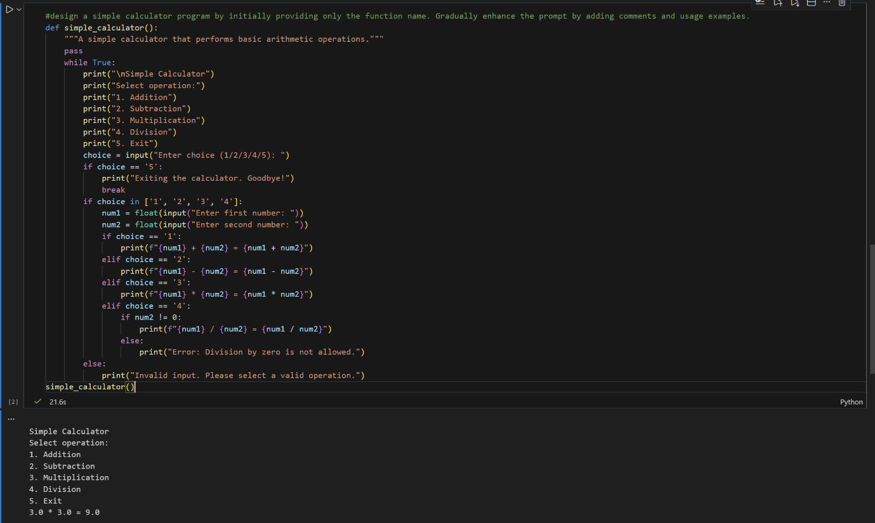
Explanation:
This task demonstrates how gradually enriching a prompt (function name → comments → examples) improves the clarity, logic, and structure of the generated calculator program.
The final output is more readable, modular, and accurate compared to the initial vague version.
Task Description-2
• Refining Prompts for Sorting Logic: Start with a vague prompt for sorting student marks,then refine it to clearly specify sorting order and constraints.
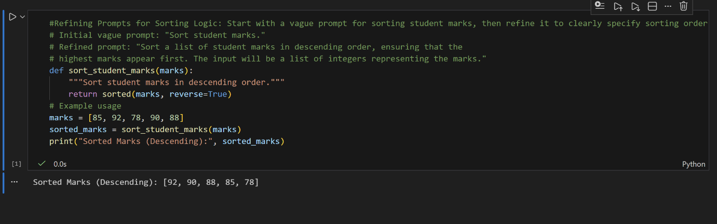
Explanation:
Starting with an unclear sorting request leads to ambiguous logic, but refining the prompt with order and constraints results in correct and efficient code. This highlights how precise instructions directly impact algorithm correctness.
Task Description-3
• Few-Shot Prompting for Prime Number Validation: Provide multiple input-output
examples for a function that checks whether a number is prime. Observe how few-shot
prompting improves correctness.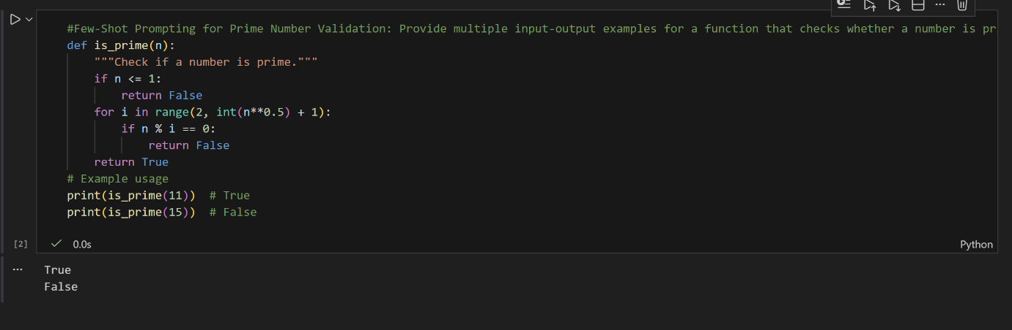
Explanation:
Providing multiple input-output examples helps the AI infer correct prime-checking rules.
The final solution handles edge cases like numbers ≤ 1 and improves overall accuracy.
Task Description-4
• Prompt-Guided UI Design for Student Grading System: Create a user interface for a
student grading system that calculates total marks, percentage, and grade based on user input.
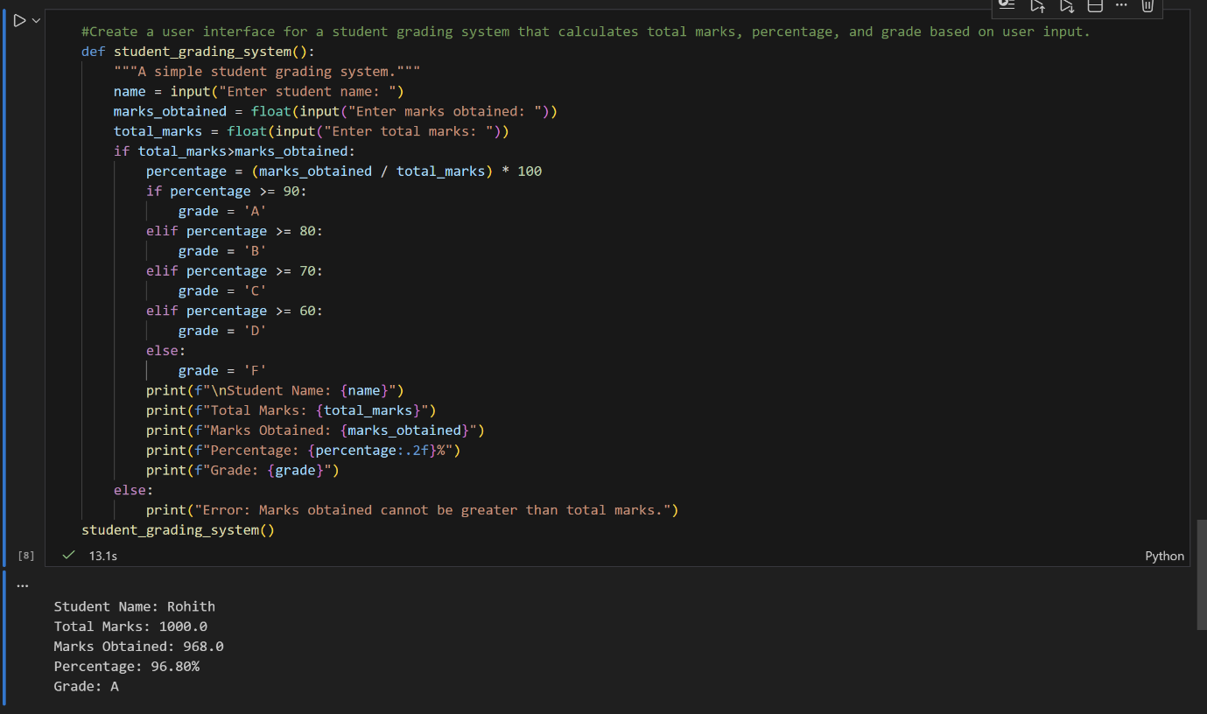
Explanation:
Clear prompts guide the AI to design a structured UI that accepts input, computes results, and displays grades correctly.
The output benefits from logical flow, proper calculations, and user-friendly presentation.
Task Description-5
• Analyzing Prompt Specificity in Unit Conversion Functions: Improving a Unit
Conversion Function (Kilometers to Miles and Miles to Kilometers) Using Clear
Instructions.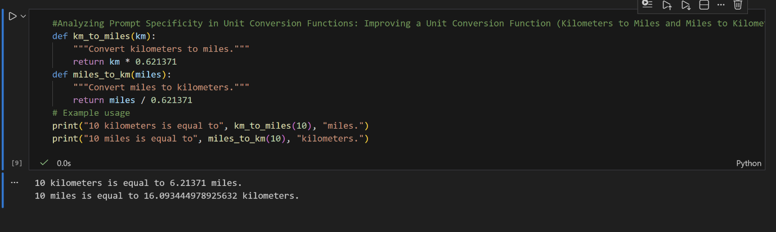
Explanation:
Explicit instructions for conversion formulas and direction significantly improve code accuracy and reliability. The comparison shows how specific prompts lead to cleaner, bug-free, and maintainable functions.

