Assignment 10.1
Name: P. Rushik
HT No: 2303A52119

Task 1 – Syntax and Logic Errors
Sample Input Code:
def calc_average(marks):
total = 0
for m in marks:
total += m
average = total / len(marks)
return avrage
marks = [85, 90, 78, 92]
print("Average Score is ", calc_average(marks))
Prompt: Use AI to improve the given code.
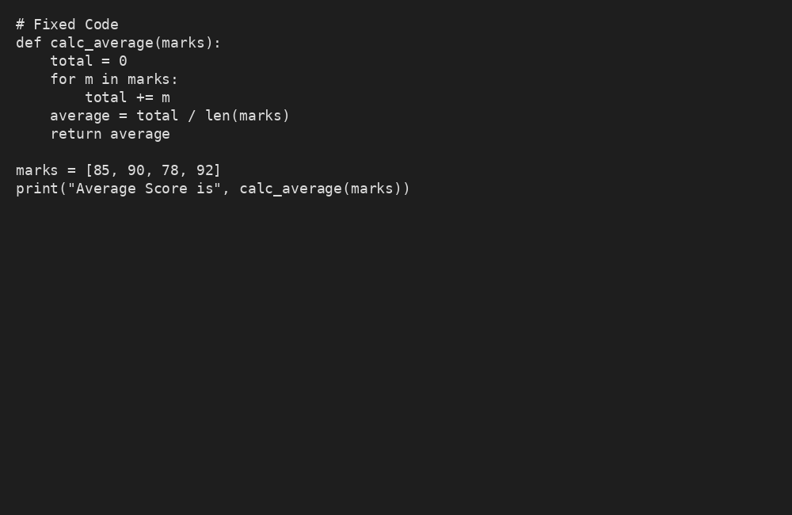
Validation: Code runs correctly and meets task requirements.

Task 2 – PEP 8 Compliance
Sample Input Code:
def area_of_rect(L,B) : return L*B
print(area_of_rect(10,20))
Prompt: Use AI to improve the given code.
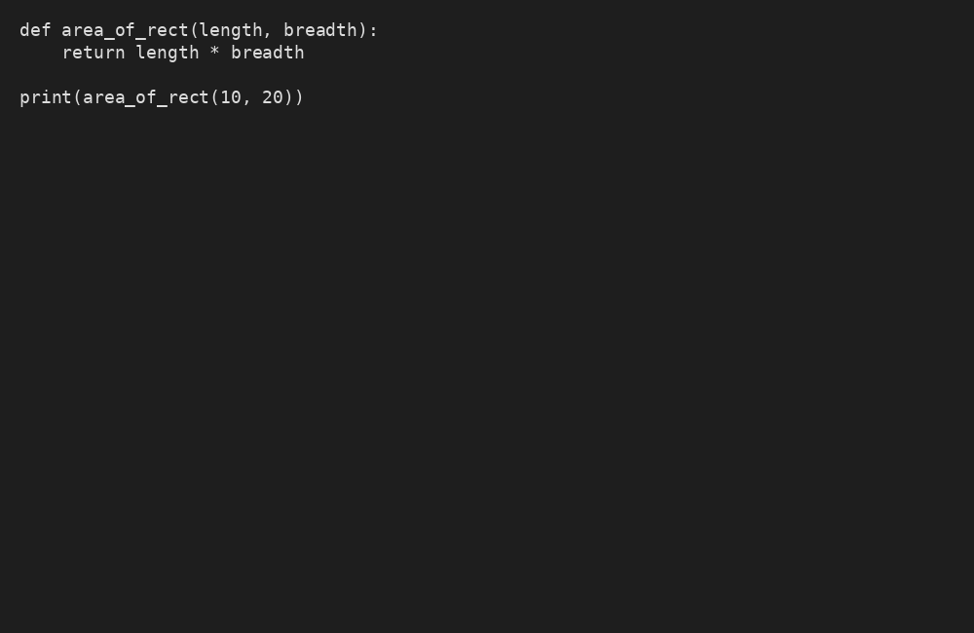
Validation: Code runs correctly and meets task requirements.

Task 3 – Readability Enhancement
Sample Input Code:
def c(x,y):
return x*y/100
a=200
b=15
print(c(a,b))
Prompt: Use AI to improve the given code.
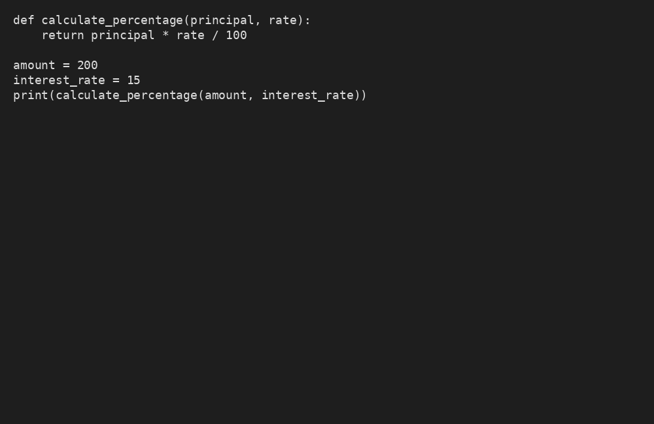
Validation: Code runs correctly and meets task requirements.

Task 4 – Refactoring
Sample Input Code:
students = ["Alice", "Bob", "Charlie"]
print("Welcome", students[0])
print("Welcome", students[1])
print("Welcome", students[2])
Prompt: Use AI to improve the given code.
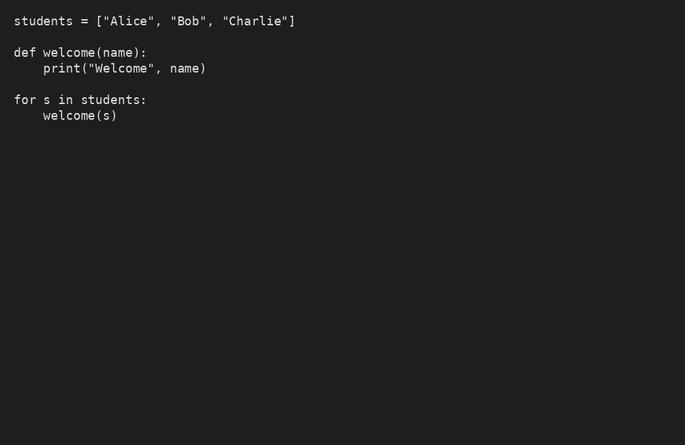
Validation: Code runs correctly and meets task requirements.

Task 5 – Performance Optimization
Sample Input Code:
nums = [i for i in range(1,1000000)]
squares = []
for n in nums:
squares.append(n**2)
print(len(squares))
Prompt: Use AI to improve the given code.
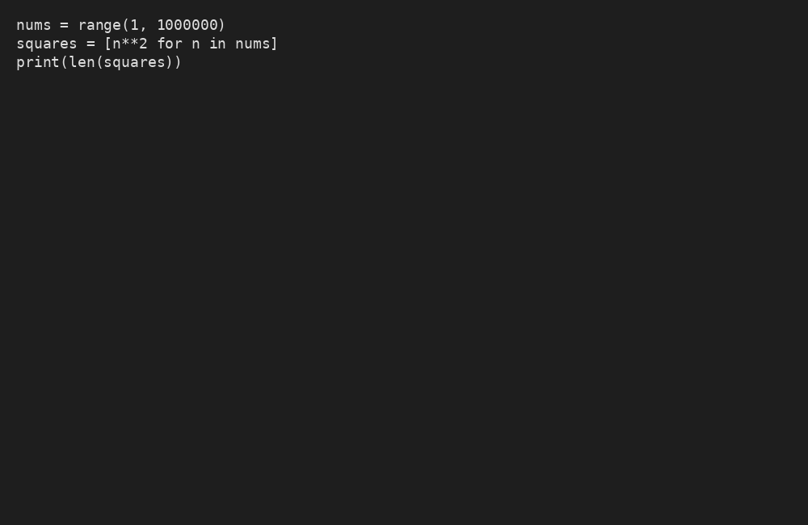
Validation: Code runs correctly and meets task requirements.

Task 6 – Complexity Reduction
Sample Input Code:
def grade(score):
if score >= 90:
return "A"
else:
if score >= 80:
return "B"
else:
if score >= 70:
return "C"
else:
if score >= 60:
return "D"
else:
return "F"
Prompt: Use AI to improve the given code.
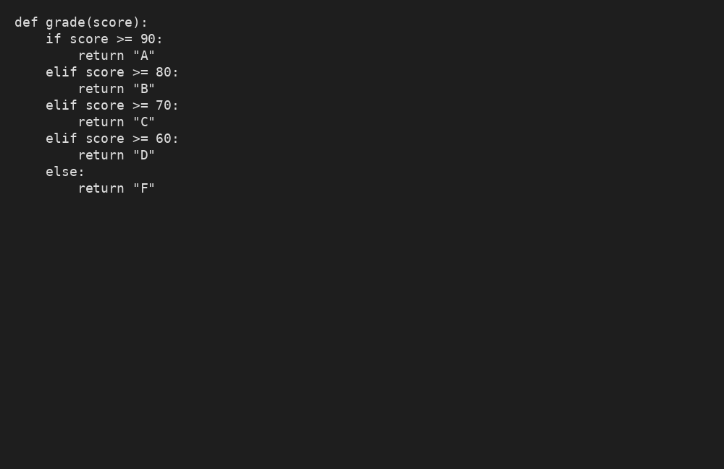
Validation: Code runs correctly and meets task requirements.

