School of Computer Science and Artificial Intelligence

Lab Assignment #3.2

Program : B. Tech (CSE)
Specialization :AIML
Course Title :AI Assisted Coding
Course Code :23CS002PC304
Semester : VI
Academic Session : 2025-2026
Name of Student :N.Lasya Priya
Enrollment No. : 2303A52129
Batch No. : 34
Date :13/01/26

Task 1 – Progressive Prompting (Calculator)
Prompt1:
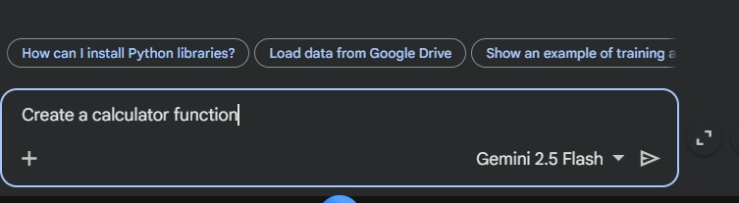
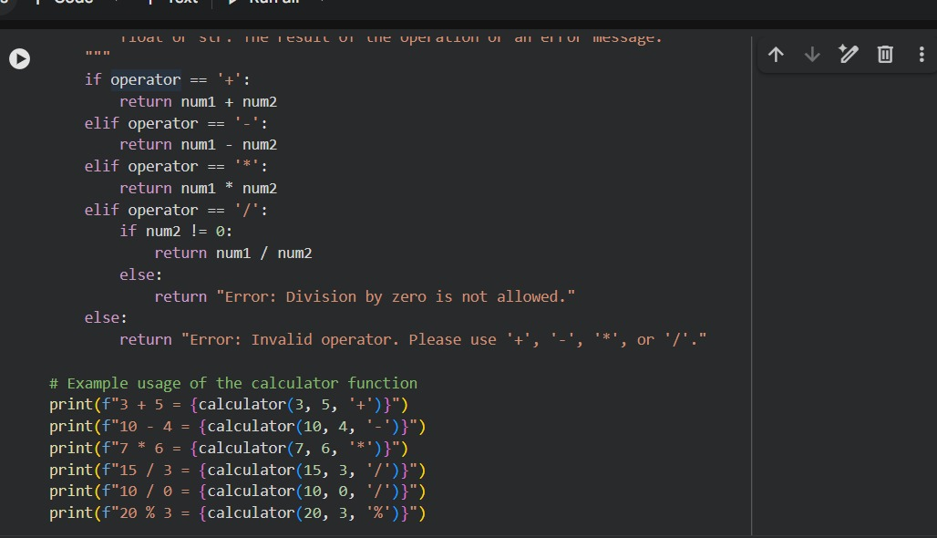
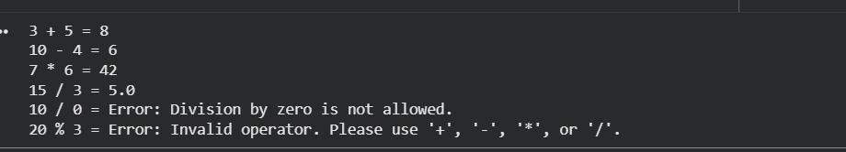

Prompt2:
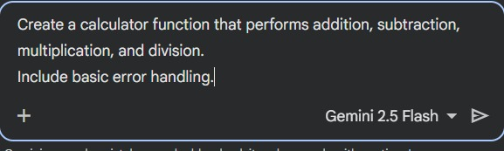
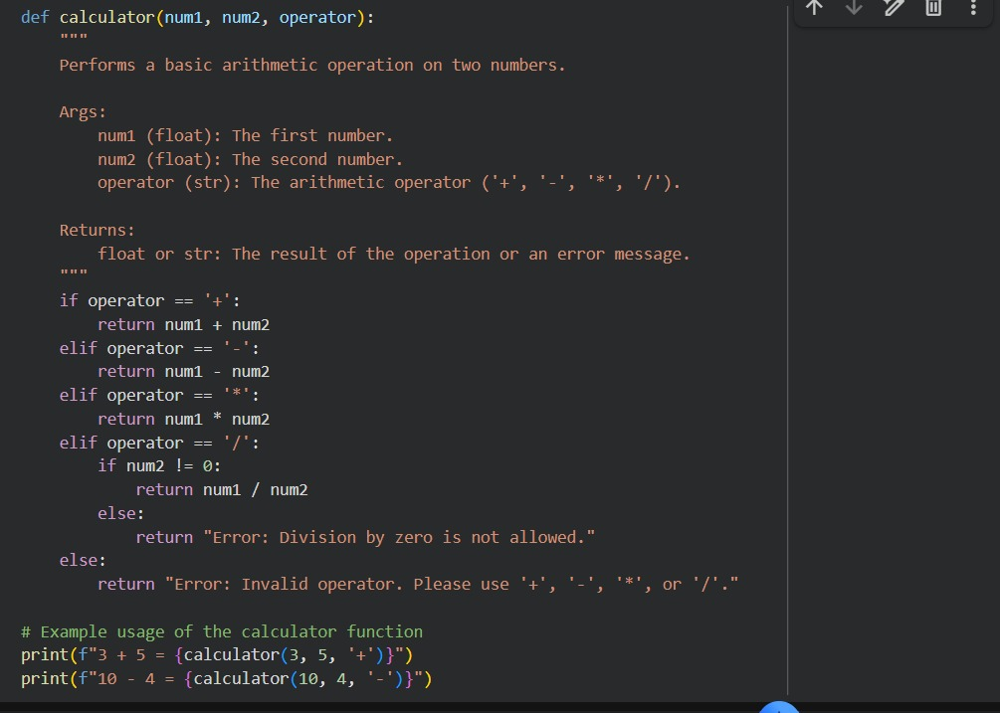
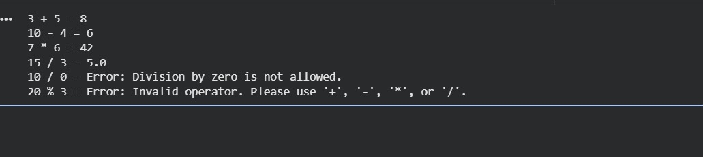

Prompt 3:
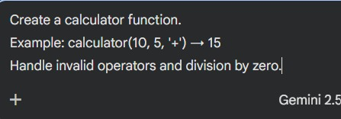
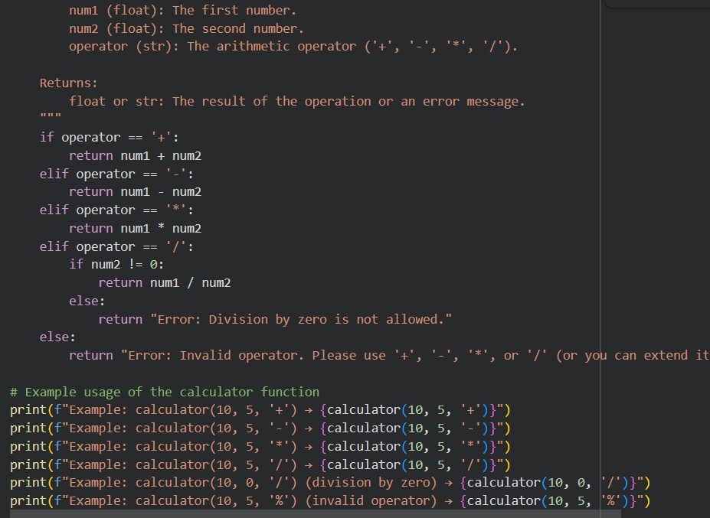
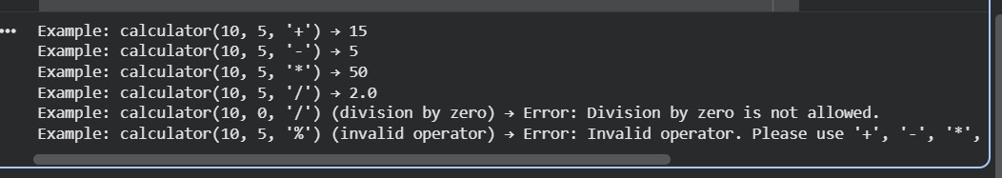

Task 2 – Sorting Student Marks
Initial Prompt:
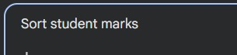
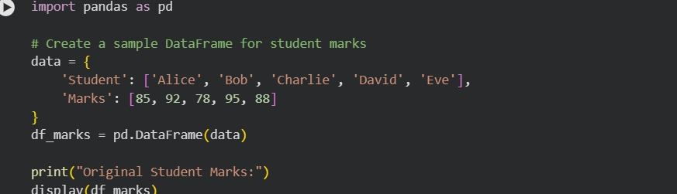
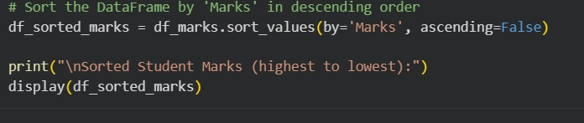
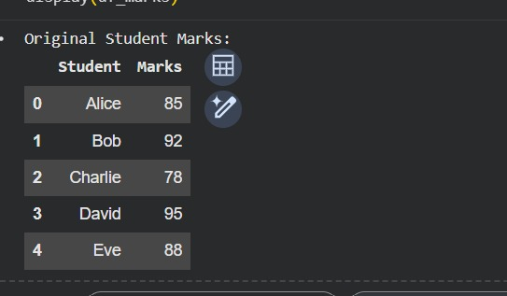
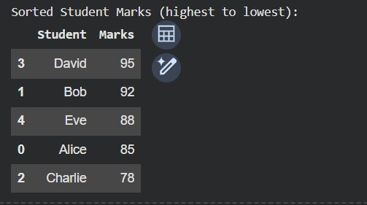

Task 3 – Few-Shot Prompting (Prime Number)
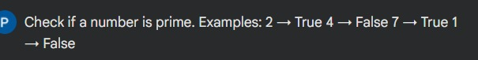
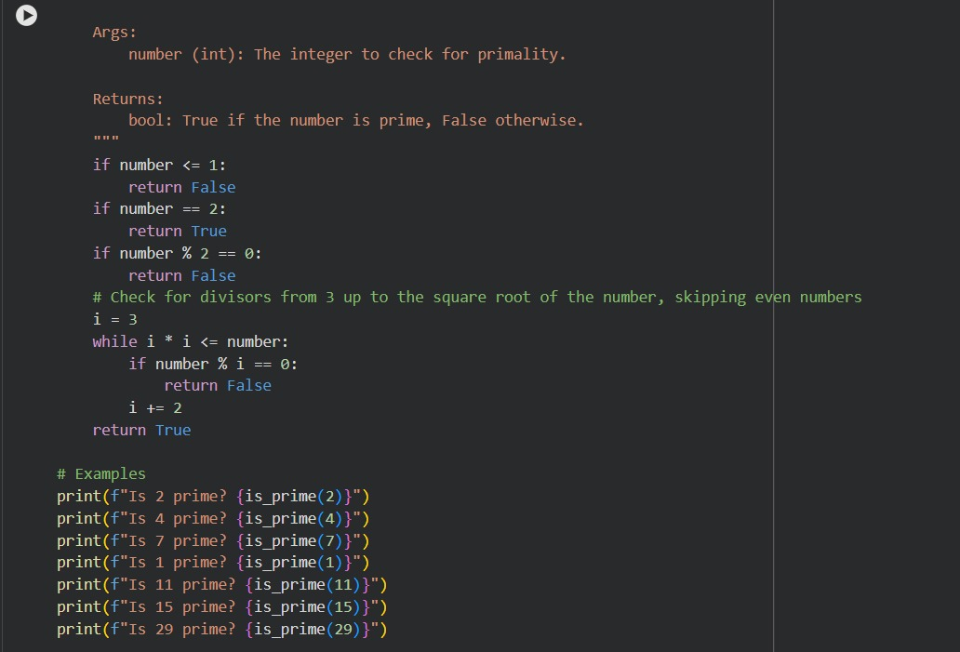
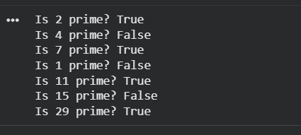

Task 4 – Prompt-Guided UI Design
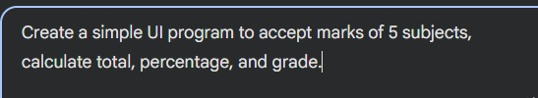
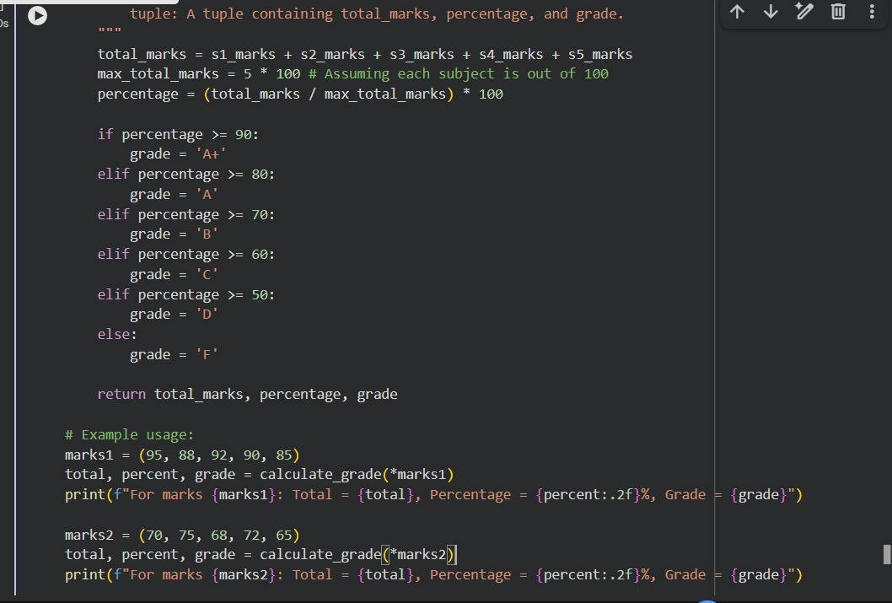
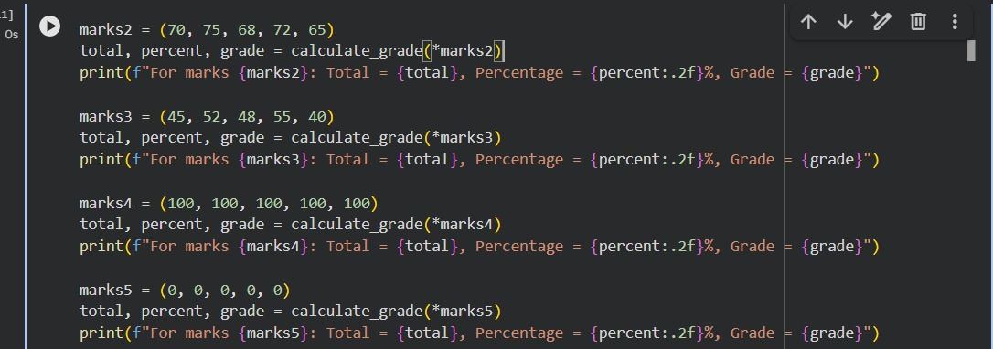
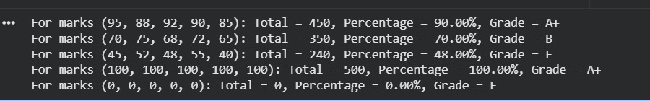

Task 5 – Unit Conversion Analysis
Basic Prompt:
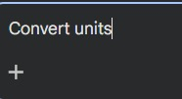
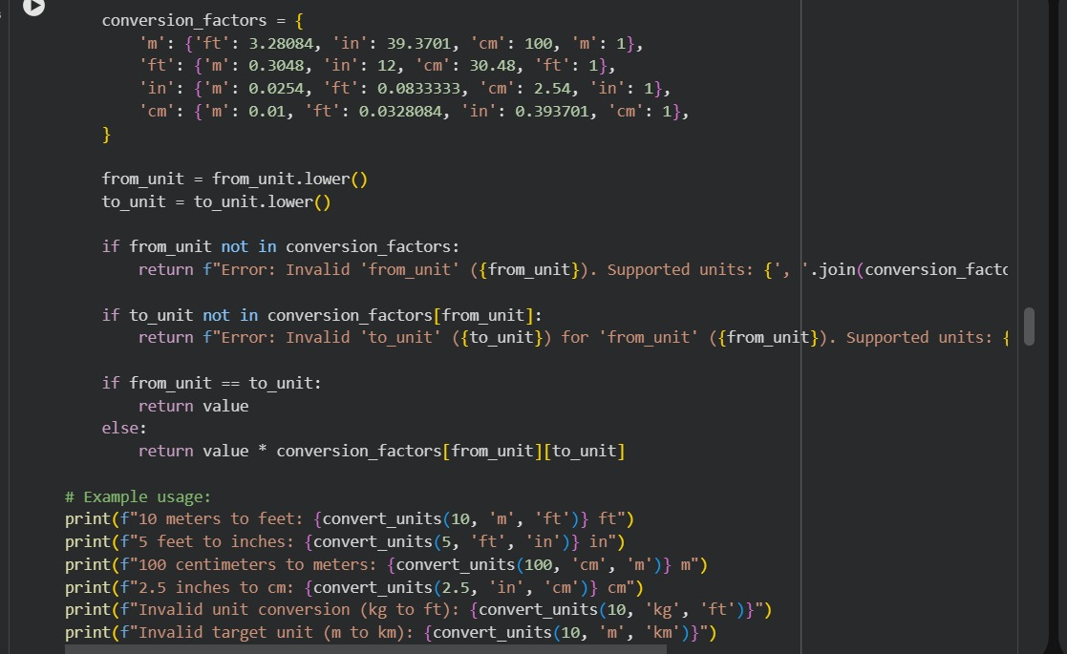
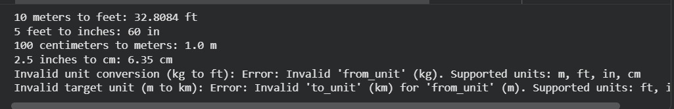

Improved Prompt:
