School of Computer Science and Artificial Intelligence

Lab Assignment - 13.5

Program : B. Tech (CSE)
Specialization :AIML
Course Title :AI Assisted Coding
Course Code :23CS002PC304
Semester : VI
Academic Session : 2025-2026
Name of Student :N.Lasya Priya
Enrollment No. : 2303A52102
Batch No. : 34
Date :27/2/26

Lab 13: Code Refactoring – Improving Legacy Code with AI Suggestions:

Task Description #1 (Refactoring – Removing Global Variables)
* Sample Legacy Code:
rate = 0.1
def calculate_interest(amount):
return amount * rate
print(calculate_interest(1000))

Prompt
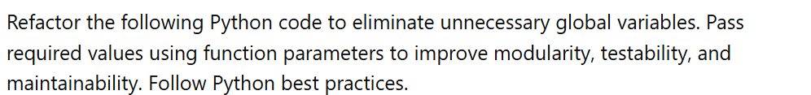

*Refactored Code (Passing Parameter):
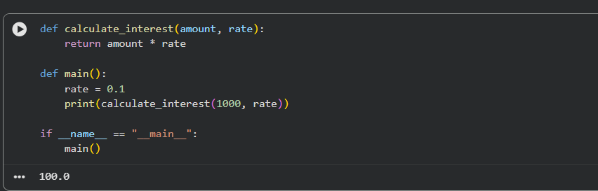
Improvement:
Removed global dependency
Increased modularity
Easier unit testing

Task Description #2 : (Refactoring Deeply Nested Conditionals):
* Sample Legacy Code:
score = 78
if score >= 90:
print("Excellent")
else:
if score >= 75:
print("Very Good")
else:
if score >= 60:
print("Good")
else:
print("Needs Improvement")

Prompt :
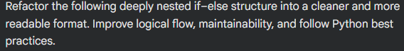
Refactored Code
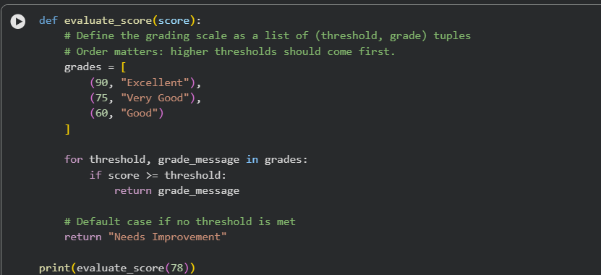
Output:

Improvement:
Easily extendable
Logical simplification
Cleaner structure
Centralized rule definition

Task 3 (Refactoring Repeated File Handling Code):
* Sample Legacy Code:
f = open("data1.txt")
print(f.read())
f.close()
f = open("data2.txt")
print(f.read())
f.close()
Prompt :
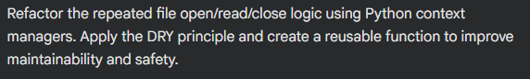

Refactored Code
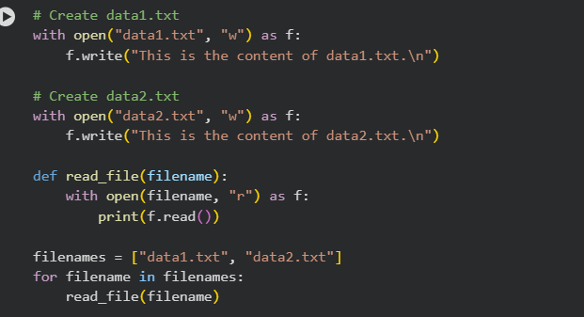
Output:
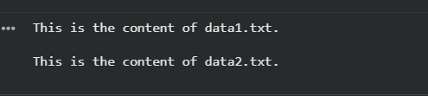
Improvement:
Better testability
Separation of logic and output
More flexible for future use

Task 4 (Optimizing Search Logic)
• Task: Refactor inefficient linear searches using appropriate data structures.
* Sample Legacy Code:
users = ["admin", "guest", "editor", "viewer"]

name = input("Enter username: ")
found = False

for u in users:
if u == name:
found = True

print("Access Granted" if found else "Access Denied")

prompt:
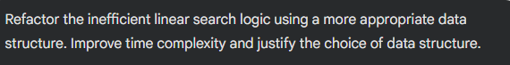

Refactored Code:
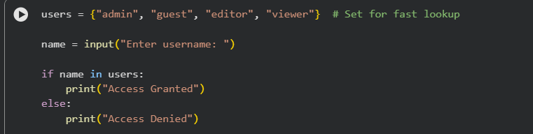
Output:
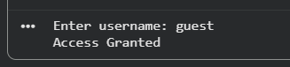
Improvement:
Faster for large user databases
Cleaner and more readable
Better data structure choice

Task 5 (Refactoring Procedural Code into OOP Design)
• Task: Use AI to refactor procedural code into a class-based design.

* Sample Legacy Code:
salary = 50000
tax = salary * 0.2
net = salary - tax
print(net)
prompt:
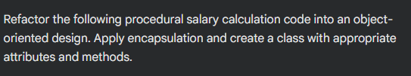
Refactored Code:
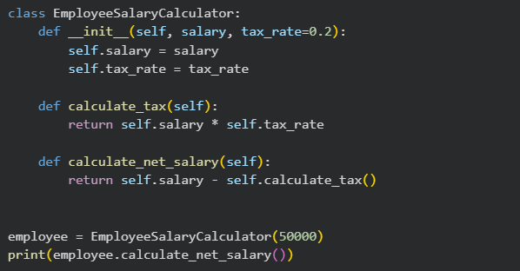
Output:
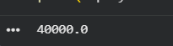
Improvement:
Encapsulation
Salary and tax rate are stored inside the object.
Logic is wrapped inside methods.
✔ Reusability
Can create multiple employee objects.
Different tax rates can be passed.
✔ Maintainability
Easy to modify tax logic.
Code is structured and organized.
✔ Scalability
Can extend class with:
Bonus calculation
Allowances
Deductions
Annual salary reports

Task 6 (Refactoring for Performance Optimization)
Task: Use AI to refactor a performance-heavy loop handling large data.

* Sample Legacy Code:
total = 0
for i in range(1, 1000000):
if i % 2 == 0:
total += i

print(total)
prompt:
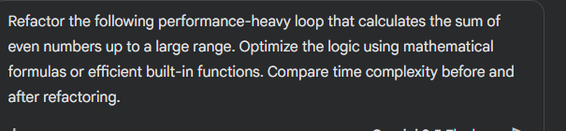

Refactored Code:
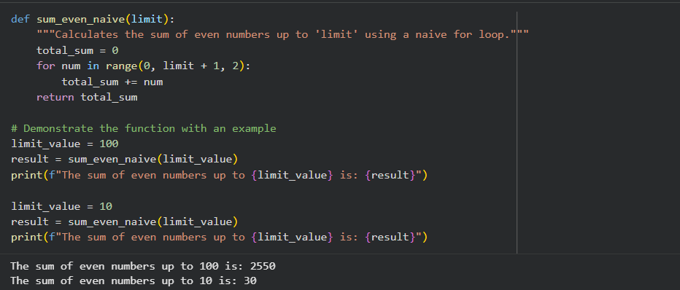
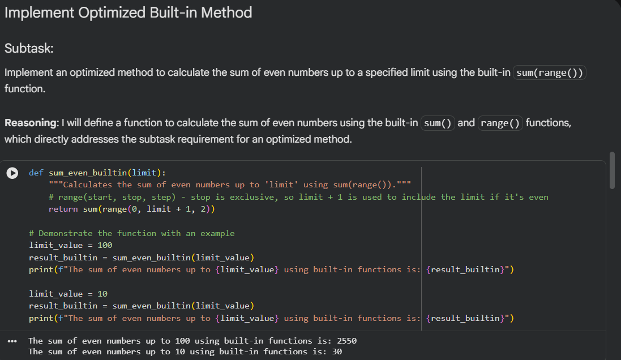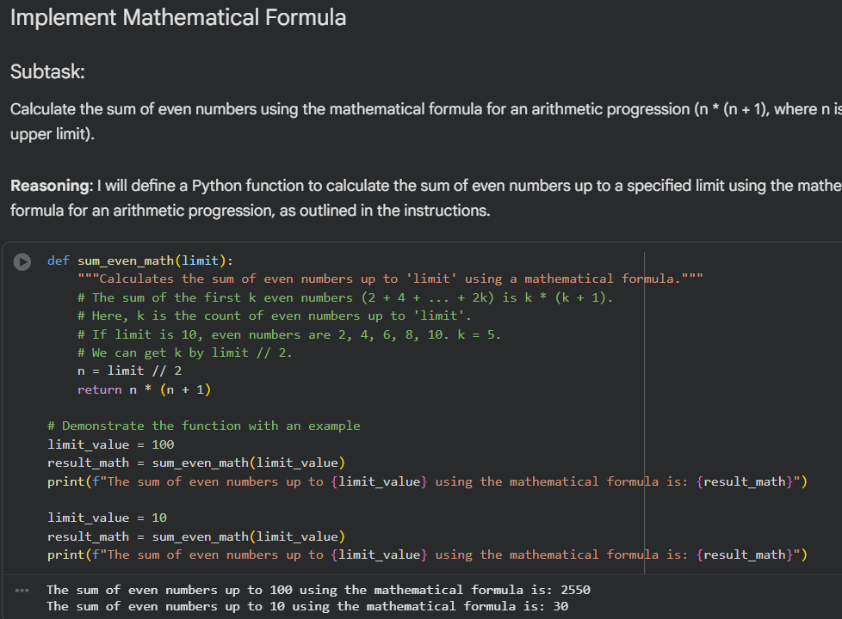
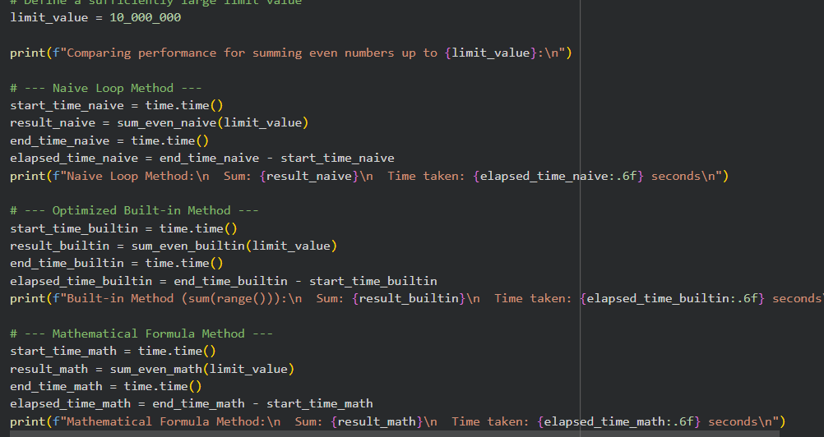
Output:
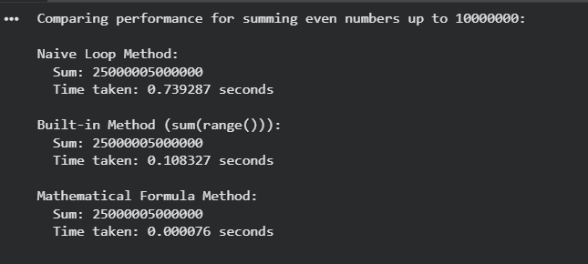
Improvement
Removes conditional check
Cleaner and more Pythonic
Still O(n/2) ≈ O(n) but faster in practice

Task 7 (Removing Hidden Side Effects)
• Task: Refactor code that modifies shared mutable state:
* Sample Legacy Code:
Legacy Code:
data = []
def add_item(x):
data.append(x)
add_item(10)
add_item(20)
print(data)
prompt:
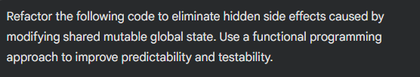
Refactored Code:
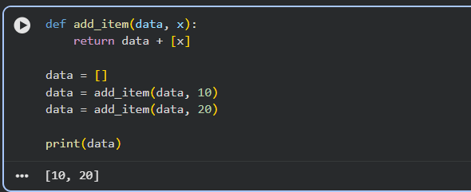
Output:
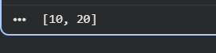
Improvement
No global variable modification
No hidden side effects
Function is pure (same input → same output)
Easier to test
More predictable behaviour

Task 8 (Refactoring Complex Input Validation Logic)
• Task: Use AI to simplify and modularize complex validation rules.
* Sample Legacy Code:
password = input("Enter password: ")
if len(password) >= 8:
if any(c.isdigit() for c in password):
if any(c.isupper() for c in password):
print("Valid Password")
else:
print("Must contain uppercase")
else:
print("Must contain digit")
else:
print("Password too short")

prompt:
Refactored Code:
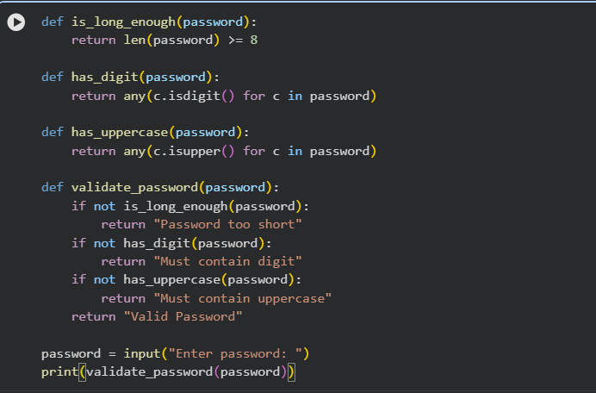
Output:

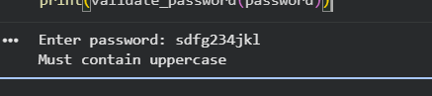
Improvement:
Modular design
Easy testing
Clear responsibility per function

